ELECTRONIC BASICS

By Great Scott

Contents

Electronic Basics #1: The Multimeter 4

Electronic Basics #2: Dimming all kinds of LEDs!? 7

Electronic Basics #3: Programming an Attiny + Homemade Arduino Shield 12

Electronic Basics #4: Arduino+Bluetooth+Android=Awesome 16

Electronic Basics #5: How to Multiplex 19

Electronic Basics #6: Standalone Arduino Circuit 23

Electronic Basics #7: 7 Segment Display 27

Electronic Basics #8: Everything about LEDs and current limiting resistors 32

Electronic Basics #9: Diodes & Bridge Rectifiers 34

Electronic Basics #10: Digital to Analog Converter (DAC) 37

Electronic Basics #11: Sending SMS with Arduino || TC35 GSM Module 41

Electronic Basics #12: Coils / Inductors (Part 1) 47

Electronic Basics #13: Coils / Inductors (Part 2) || Reactance 52

Electronic Basics #14: Capacitors 57

Electronic Basics #15: Temperature Measurement (Part 1) || NTC, PT100, Wheatstone Bridge 61

Electronic Basics #16: Resistors 67

Electronic Basics #17: Oscillators || RC, LC, Crystal 70

Electronic Basics #18: DC & Brushless DC Motor + ESC 79

Electronic Basics #19: I2C and how to use it 83

Electronic Basics #20: Thyristor, Triac || Phase Angle Control 86

Electronic Basics #21: OpAmp (Operational Amplifier) 91

Electronic Basics #22: Transistor (BJT) as a Switch 96

Electronic Basics #23: Transistor (MOSFET) 101

Electronic Basics #24: Stepper Motors and how to use them 106

Electronic Basics #25: Servos and how to use them 111

Electronic Basics #26: 555 Timer IC 117

Electronic Basics #27: ADC (Analog to Digital Converter) 123

Electronic Basics #28: IGBT and when to use them 127

Electronic Basics #29: Solar Panel & Charge Controller 131

Electronic Basics #30: Microcontroller (Arduino) Timers 136

Electronic Basics #31: Schottky Diode & Zener Diode 140

Electronic Basics #32: Relays & Optocouplers 145

Electronic Basics #33: Strain Gauge/Load Cell and how to use them to measure weight 150

Electronic Basics #35: Schmitt Trigger and When to Use Them 154

Electronic Basics #36: SPI and how to use it 159

Electronic Basics #37: What is Impedance? (AC Resistance?) 164

Electronic Basics #38: True, Reactive, Apparent & Deformed Power 168

Controlling a BIG LED Matrix?! How Shift Registers work! || EB#39 172

How safe is contactless payment? || How does RFID & NFC work? || EB#40 177

Does a DIY Audio Crossover make sense? How passive filters work! || EB#41 181

Is it easy to create your own Transformer? Everything you need to know about Transformers! || EB#42 187

Controlling Mechanical 7-Segment Displays?! How RS-485 and UART works! || EB#43 192

Improving my electric longboard with a CAN Bus! What can the CAN Bus do? EB#44 197

Building a Digital Music Player with I2S?! What is I2S! || EB#45 200

Does this old Induction Motor still work? || How do Asynchronous Motors work? EB#46 205

Building a Tube Amp! Does it produce better audio quality though? || EB#47 208

The Best Protection for your Circuits? eFuse! Here is why they are awesome! EB#48 214

Everything you need to know when buying/using an Oscilloscope! || EB#49 218

Probably the most used component nobody knows of! TL431 Guide! EB#50 222

This component can control tons of circuits! Digital Potentiometer Guide! EB#51 226

Negative Voltages are more important than you think! So here is how to make them! EB#52 230

Mechanical Switches are Obsolete?! Switch to a Latch Circuit! EB#53 236

The Best Protection for your Circuit is NOT a Fuse!.....but a Resettable Fuse? EB#54 241

The Most Important Circuit for our Electrical Future?! (PFC) || EB#55 244

These 3 Cent Components are actually USEFUL?! (Color Ring Inductor) EB#56 249

Ground is MORE IMPORTANT than you think! EB#57 254

This Component solves "All" Motor Problems?! (Motor Encoder) || EB#58 258

This $0.70 Component SAVES your Circuit?! (Surge Protection) EB#59 263

Is This the NEW GOLDEN Standard for Communication? (I3C) EB#60 268

The World's Simplest Audio Amp just got BETTER?! (MOSFET Amp) EB#61 273

Not a Microcontroller!...This is Better?! (PLC) EB#62 277

Sources : 283

All Components : 284

Electronic Basics #1: The Multimeter

**🔧 List of Components Used**

**1. Multimeter**

**2. Resistor**

**3. LED (Light Emitting Diode)**

**4. Cables/Wires**

**5. Fuse (Inside Multimeter)**

**📘 Detailed Breakdown of Each Component**

**1. Multimeter**

* **What is it?**  
  A multimeter is an electronic measuring instrument that combines several measurement functions in one unit. It can measure voltage, current, and resistance.([Wikipedia](https://en.wikipedia.org/wiki/Multimeter?utm_source=chatgpt.com))
* **Structure:**  
  Typically, a multimeter has a digital display, a rotary switch to select measurement modes, and three input jacks:
  + **COM (Common):** Connects to the black probe.
  + **VΩmA:** Connects to the red probe for measuring voltage, resistance, and current up to a certain limit (usually 200mA).
  + **10A:** Connects to the red probe for measuring current up to 10A.([The Spruce](https://www.thespruce.com/multimeter-symbols-8414239?utm_source=chatgpt.com))
* **What is it used for?**  
  Used to measure electrical parameters:
  + **Voltage (V):** Measures the potential difference between two points.
  + **Current (A):** Measures the flow of electric charge.
  + **Resistance (Ω):** Measures how much a component resists the flow of current.
  + **Continuity Test:** Checks if there is a complete path for current flow.([The Spruce](https://www.thespruce.com/multimeter-symbols-8414239?utm_source=chatgpt.com))
* **In the project:**  
  The multimeter is the central tool demonstrated throughout the video. It is used to:
  + Measure the resistance of a resistor.
  + Check continuity in cables.
  + Measure voltage across a battery and an LED circuit.
  + Measure current in a circuit and demonstrate the importance of using the correct input jack to prevent blowing a fuse.([The Spruce](https://www.thespruce.com/how-to-use-a-multimeter-5194980?utm_source=chatgpt.com))

**2. Resistor**

* **What is it?**  
  A resistor is a passive electrical component that limits or regulates the flow of electrical current in a circuit.
* **Structure:**  
  Resistors are typically cylindrical with two leads (pins) for connection. They have colored bands that indicate their resistance value.
* **What is it used for?**

Used to control current flow, divide voltages, and protect components by limiting current.

* **In the project:**  
  A 68 Kilo Ohm resistor is used to demonstrate how to measure resistance with a multimeter. The video also shows how measuring resistance in-circuit can give inaccurate results due to parallel paths.

**3. LED (Light Emitting Diode)**

* **What is it?**  
  An LED is a semiconductor device that emits light when an electric current passes through it.
* **Structure:**  
  LEDs have two leads:
  + **Anode (+):** The longer lead, connected to the positive voltage.
  + **Cathode (-):** The shorter lead, connected to the negative voltage.
* **What is it used for?**  
  Used as indicator lights, in displays, and for lighting.
* **In the project:**  
  An LED is connected to a power supply, and the video demonstrates how to measure voltage across the LED. It also shows troubleshooting when the LED doesn't light up, leading to checking the continuity of the connecting cables.

**4. Cables/Wires**

* **What is it?**  
  Conductive materials used to connect different components in a circuit.
* **Structure:**  
  Typically consist of a metal conductor (like copper) surrounded by insulating material.
* **What is it used for?**  
  Used to establish electrical connections between components.
* **In the project:**  
  Cables are used to connect the LED to the power supply. The video demonstrates using the multimeter's continuity function to check if the cables are intact or broken.

**5. Fuse (Inside Multimeter)**

* **What is it?**  
  A fuse is a safety device that protects electrical circuits by breaking the connection if the current exceeds a certain level.
* **Structure:**  
  A thin wire enclosed in a casing; when excessive current flows, the wire melts, breaking the circuit.
* **What is it used for?**  
  Protects devices from overcurrent conditions.
* **In the project:**  
  The video shows that if the multimeter's fuse blows (due to measuring current beyond its capacity), it needs to be replaced. It demonstrates opening the multimeter, locating the fuse, and replacing it with one of the same rating.

**📝 Summary:**

Provides an introduction to using a digital multimeter (DMM), an essential tool for measuring electrical properties in circuits. It covers the basics of measuring voltage, current, and resistance, explaining how to select the appropriate settings and connect the multimeter to components. The video also touches on advanced features like auto-ranging and continuity testing, which simplify the measurement process.

Electronic Basics #2: Dimming all kinds of LEDs!?

**🔧 List of Components Used**

1. **Potentiometer**
2. **Arduino Microcontroller**
3. **555 Timer IC**
4. **N-Channel MOSFET**
5. **LED Strip**
6. **Bench Power Supply**
7. **Resistors**
8. **Oscilloscope(**[**Electronics Projects**](https://easyelectronicsproject.com/mini-projects/dimmable-led-using-555-timer/?utm_source=chatgpt.com)**,** [**arXiv**](https://arxiv.org/abs/2111.08511?utm_source=chatgpt.com)**,** [**Wikipedia**](https://en.wikipedia.org/wiki/Light-emitting_diode?utm_source=chatgpt.com)**)**

**📘 Detailed Breakdown of Each Component**

**1. 5mm Green LED**

* **What is it?**  
  A Light Emitting Diode (LED) is a semiconductor device that emits light when an electric current passes through it.([Wikipedia](https://en.wikipedia.org/wiki/Light-emitting_diode?utm_source=chatgpt.com))
* **Structure:**  
  Typically has two leads:
  + **Anode (+):** Longer lead, connected to positive voltage.
  + **Cathode (−):** Shorter lead, connected to ground.([TCP Lighting](https://www.tcpi.com/breaking-led-anatomy/?utm_source=chatgpt.com), [YouTube](https://www.youtube.com/watch?v=jQ3JHknsM4o&utm_source=chatgpt.com), [Instructables](https://www.instructables.com/Easy-LED-Circuit/?utm_source=chatgpt.com))
* **What is it used for?**  
  Used as a basic indicator to demonstrate dimming techniques.
* **In the project:**  
  Serves as the primary subject to showcase various dimming methods, illustrating how PWM affects LED brightness.

**2. Potentiometer**

* **What is it?**  
  A variable resistor that allows adjustment of resistance, thereby controlling voltage in a circuit.
* **Structure:**  
  Three terminals:
  + **Two outer terminals:** Connected to a voltage source and ground.
  + **Middle terminal (wiper):** Provides variable voltage output.([Instructables](https://www.instructables.com/Easy-LED-Circuit/?utm_source=chatgpt.com))
* **What is it used for?**  
  Adjusts the duty cycle of the PWM signal, effectively controlling LED brightness.
* **In the project:**  
  Connected to the Arduino's analog input to vary the PWM output, and also used in the 555 timer circuit to adjust the PWM signal.

**3. Arduino Microcontroller**

* **What is it?**  
  An open-source microcontroller platform used for building digital devices and interactive objects.
* **Structure:**  
  Features multiple digital and analog I/O pins, PWM outputs, and serial communication interfaces.
* **What is it used for?**  
  Generates PWM signals using the analogWrite() function to control LED brightness.
* **In the project:**  
  Reads analog input from the potentiometer and outputs a corresponding PWM signal to dim the LED.

**4. 555 Timer IC**

* **What is it?**  
  A versatile integrated circuit used for generating precise time delays and oscillations.
* **Structure:**  
  8-pin DIP package:
  + **Pin 1:** Ground
  + **Pin 2:** Trigger
  + **Pin 3:** Output
  + **Pin 4:** Reset
  + **Pin 5:** Control Voltage
  + **Pin 6:** Threshold
  + **Pin 7:** Discharge
  + **Pin 8:** VCC([Wikipedia](https://en.wikipedia.org/wiki/Light-emitting_diode?utm_source=chatgpt.com), [Arduino Forum](https://forum.arduino.cc/t/basic-info-about-a-led-pwm-dimmer-circuit-at-3amps/127485?utm_source=chatgpt.com))
* **What is it used for?**  
  Configured in astable mode to produce a continuous PWM signal for dimming LEDs.
* **In the project:**  
  Provides an alternative to the Arduino for generating PWM signals, allowing LED dimming without a microcontroller.

**5. N-Channel MOSFET**

* **What is it?**  
  A type of transistor used for switching and amplifying electronic signals, especially in high-power applications.
* **Structure:**  
  Three terminals:
  + **Gate (G):** Controls the transistor's operation.
  + **Drain (D):** Current flows from drain to source when the transistor is on.
  + **Source (S):** Connected to ground.([Analog Devices](https://www.analog.com/en/resources/technical-articles/guide-to-led-circuit-designs-and-led-basics-operation.html?utm_source=chatgpt.com))
* **What is it used for?**  
  Acts as a switch controlled by the PWM signal to modulate power to high-current LEDs or LED strips.
* **In the project:**  
  Used to handle higher current loads from LED strips, with the PWM signal applied to the gate to control brightness.

**6. LED Strip**

* **What is it?**  
  A flexible circuit board populated with multiple LEDs, used for decorative or functional lighting.
* **Structure:**  
  Consists of a series of LEDs with resistors, typically powered by 12V DC.
* **What is it used for?**  
  Provides a practical example of dimming multiple LEDs simultaneously.([Reddit](https://www.reddit.com/r/AskElectronics/comments/108r9jv/for_dimming_multiple_leds_at_the_same_time_which/?utm_source=chatgpt.com))
* **In the project:**  
  Demonstrates the application of PWM dimming on a larger scale, using the MOSFET to handle increased current.

**7. Bench Power Supply**

* **What is it?**  
  A laboratory device that provides adjustable voltage and current to power electronic circuits.
* **Structure:**  
  Features adjustable knobs for voltage and current, with digital displays for monitoring.
* **What is it used for?**  
  Supplies precise voltage to test and demonstrate the effects of voltage changes on LED brightness.
* **In the project:**  
  Used to illustrate how varying voltage affects LED brightness, emphasizing the efficiency of PWM over voltage control.

**8. Resistors**

* **What is it?**  
  Passive electrical components that limit or regulate the flow of electrical current in a circuit.
* **Structure:**  
  Two-terminal components with a specific resistance value, measured in ohms (Ω).
* **What is it used for?**  
  Protect LEDs from excessive current and set timing intervals in the 555 timer circuit.
* **In the project:**  
  Used in series with LEDs to prevent damage and in the 555 timer circuit to determine the frequency of the PWM signal.([Wikipedia](https://en.wikipedia.org/wiki/Light-emitting_diode?utm_source=chatgpt.com))

**9. Oscilloscope**

* **What is it?**  
  An electronic test instrument that graphically displays varying signal voltages, typically as a two-dimensional plot.
* **Structure:**  
  Comprises a display screen, input channels, and control knobs for adjusting the signal view.
* **What is it used for?**  
  Visualizes the PWM signal, allowing observation of duty cycle changes and signal behavior.
* **In the project:**  
  Used to demonstrate the nature of PWM signals and how adjusting the duty cycle affects LED brightness.

**📝 Summary:**

This video explains how to dim LEDs using Pulse Width Modulation (PWM). The presenter demonstrates how to dim LEDs using a bench power supply, a potentiometer, an Arduino, and a 555 timer chip. They also discuss the benefits and drawbacks of each method.

Electronic Basics #3: Programming an Attiny + Homemade Arduino Shield

**🔧 List of Components Used**

1. **ATtiny85 Microcontroller**
2. **WS2801 LED Strip**
3. **Arduino Uno (as ISP Programmer)**
4. **Push Button**
5. **10µF Capacitor**
6. **Homemade Arduino Shield (Custom PCB with IC Socket and Headers)**

**📘 Detailed Breakdown of Each Component :**

**1. ATtiny85 Microcontroller**

* **What is it?**  
  The ATtiny85 is a compact, low-power 8-bit microcontroller from Atmel's AVR series, offering 8KB of flash memory and 5 I/O pins.([Components101](https://components101.com/microcontroller/attiny85-pinout-datasheet?utm_source=chatgpt.com))
* **Structure:**  
  An 8-pin Dual In-line Package (DIP) with the following pinout:
  + **Pin 1 (PB5):** RESET (can also serve as I/O)
  + **Pin 2 (PB3):** Analog Input 3 (ADC3), Digital I/O
  + **Pin 3 (PB4):** Analog Input 2 (ADC2), Digital I/O
  + **Pin 4:** GND
  + **Pin 5 (PB0):** Digital I/O, PWM Output, SPI MOSI
  + **Pin 6 (PB1):** Digital I/O, PWM Output, SPI MISO
  + **Pin 7 (PB2):** Analog Input 1 (ADC1), Digital I/O, SPI SCK
  + **Pin 8:** VCC([Microchip](https://ww1.microchip.com/downloads/en/devicedoc/atmel-2586-avr-8-bit-microcontroller-attiny25-attiny45-attiny85_datasheet.pdf?utm_source=chatgpt.com))
* **What is it used for?**  
  Serves as the main controller for small-scale projects requiring limited I/O, such as controlling LEDs or reading sensor inputs.
* **Role in the Project:**  
  Used to control a WS2801 LED strip and handle input from a push button to cycle through different LED animations.

**2. WS2801 LED Strip**

* **What is it?**  
  A digital RGB LED strip featuring the WS2801 driver IC, allowing individual control of each LED's color and brightness.([bestlightingbuy.com](https://www.bestlightingbuy.com/ws2801-addressable-rgb-led-strip.html?utm_source=chatgpt.com))
* **Structure:**  
  Typically consists of multiple RGB LEDs, each paired with a WS2801 IC. The strip has four main connections:
  + **VCC:** 5V Power Supply
  + **GND:** Ground
  + **DATA:** Serial Data Input
  + **CLK:** Clock Signal([bestlightingbuy.com](https://www.bestlightingbuy.com/ws2801-addressable-rgb-led-strip.html?utm_source=chatgpt.com), [homemadehardware.com](https://homemadehardware.com/guides/programming-an-attiny85/?utm_source=chatgpt.com), [suntechleds.com](https://www.suntechleds.com/info/ws2801-vs-ws2811-vs-ws2812-digital-pixel-led-s-36671801.html?utm_source=chatgpt.com))
* **What is it used for?**  
  Enables the creation of complex lighting effects by allowing individual control over each LED's color and intensity.
* **Role in the Project:**  
  Displays various animations controlled by the ATtiny85, with the ability to change patterns via a push button.([forums.4fips.com](https://forums.4fips.com/viewtopic.php?t=1080&utm_source=chatgpt.com))

**3. Arduino Uno (as ISP Programmer)**

* **What is it?**  
  A microcontroller board based on the ATmega328P, commonly used for prototyping and programming other microcontrollers.
* **Structure:**  
  Features multiple digital and analog I/O pins, USB connection, and power jack.([Wikipedia](https://en.wikipedia.org/wiki/List_of_Arduino_boards_and_compatible_systems?utm_source=chatgpt.com))
* **Usage:**  
  In this context, it's configured as an In-System Programmer (ISP) to upload code to the ATtiny85.([Arduino Forum](https://forum.arduino.cc/t/how-to-connect-attiny85-for-in-system-programming-isp-while-already-hooked-up-to-sensors-and-output-devices/1072282?utm_source=chatgpt.com))
* **Role in the Project:**  
  Acts as a bridge between the computer and the ATtiny85, facilitating the programming process.([Arduino Forum](https://forum.arduino.cc/t/how-to-connect-attiny85-for-in-system-programming-isp-while-already-hooked-up-to-sensors-and-output-devices/1072282?utm_source=chatgpt.com))

**4. Push Button**

* **What is it?**  
  A simple mechanical switch used to provide user input to electronic circuits.
* **Structure:**  
  Typically has two or four pins; when pressed, it completes an electrical circuit.
* **What is it used for?**  
  Detects user interaction, such as button presses, to trigger events in the microcontroller.
* **Role in the Project:**  
  Connected to the ATtiny85 to allow the user to cycle through different LED animations.

**5. 10µF Capacitor**

* **What is it?**  
  An electrolytic capacitor used to stabilize voltage and filter noise in electronic circuits.
* **Structure:**  
  Polarized component with positive and negative leads; must be connected correctly.
* **What is it used for?**  
  Placed between the Arduino's RESET and GND pins to prevent the Arduino from resetting during the programming of the ATtiny85.
* **Role in the Project:**  
  Ensures stable programming of the ATtiny85 by the Arduino Uno.([forums.4fips.com](https://forums.4fips.com/viewtopic.php?t=1080&utm_source=chatgpt.com))

**6. Homemade Arduino Shield (Custom PCB with IC Socket and Headers)**

* **What is it?**  
  A custom-made printed circuit board designed to simplify the programming of the ATtiny85 using an Arduino Uno.
* **Structure:**  
  Includes an 8-pin IC socket for the ATtiny85, male headers to connect to the Arduino Uno, and necessary wiring to facilitate programming.
* **What is it used for?**  
  Provides a convenient and reusable platform for programming ATtiny85 microcontrollers without the need for a breadboard setup each time.
* **Role in the Project:**  
  Streamlines the process of uploading code to the ATtiny85, reducing setup time and potential wiring errors.([Flux](https://www.flux.ai/p/blog/introduction-to-the-attiny85-microcontroller?utm_source=chatgpt.com))

**📝 Summary:**

This video demonstrates how to program an ATtiny 85 microcontroller using an Arduino Uno as a programmer. The creator shows how to set up the Arduino software and download the necessary board data for the ATtiny. They then build a custom shield for the ATtiny, allowing for easier programming and connection to other components. The video concludes with a brief overview of using the ATtiny with a WS 2801 LED strip, promising a future video with more details.  
  
*Repo Link:* [*https://github.com/damellis/attiny*](https://github.com/damellis/attiny)

Electronic Basics #4: Arduino+Bluetooth+Android=Awesome

**🔧 List of Components Used**

1. **HC-05 Bluetooth Module**
2. **Arduino Nano**
3. **Common Anode RGB LED**
4. **Resistors for Voltage Divider: 2 kΩ and 4.7 kΩ**
5. **Current-Limiting Resistors for RGB LED: Approximately 460 Ω each**
6. **\*\*Android Smartphone with Serial Terminal App (e.g., S2 Terminal)([ElectronicsHub](https://www.electronicshub.org/arduino-android-communication-using-bluetooth?utm_source=chatgpt.com" \o "How to Connect Arduino Uno to Android via Bluetooth),** [**RoboticsBD Store**](https://store.roboticsbd.com/97-bluetooth-robotics-bangladesh?utm_source=chatgpt.com)**)**

**📘 Detailed Breakdown of Each Component**

**1. HC-05 Bluetooth Module**

* **What is it?**  
  The HC-05 is a Bluetooth module that enables wireless serial communication between devices, such as an Arduino and a smartphone.([Cirkit Designer](https://docs.cirkitdesigner.com/component/6be7fcda-41bf-450a-ba3f-dc790fe08fbb/hc-05-bluetooth-module?utm_source=chatgpt.com" \o "How to Use HC-05 Bluetooth Module: Examples, Pinouts, and Specs))
* **Structure (Pinout):**  
  The HC-05 module typically has six pins:
  1. **Enable/Key**: Used to toggle between Data Mode (set low) and AT Command Mode (set high).
  2. **VCC**: Connects to a 5V power supply.
  3. **GND**: Ground connection.
  4. **TXD (Transmitter)**: Sends serial data to the Arduino's RX pin.
  5. **RXD (Receiver)**: Receives serial data from the Arduino's TX pin.
  6. **State**: Indicates the connection status (optional).([Instructables](https://www.instructables.com/Interfacing-HC-05-Bluetooth-Module-With-Arduino/?utm_source=chatgpt.com), [Components101](https://components101.com/wireless/hc-05-bluetooth-module?utm_source=chatgpt.com), [Arduino](https://content.arduino.cc/assets/Pinout-NANO_latest.pdf?utm_source=chatgpt.com))
* **What is it used for?**  
  Facilitates wireless communication between the Arduino and an Android smartphone, allowing for remote control of devices.
* **Role in Project:**  
  In the video, the HC-05 module receives commands from an Android application (such as "red," "green," or "blue") and transmits them to the Arduino. The Arduino then processes these commands to control the RGB LED accordingly.

**2. Arduino Nano**

* **What is it?**  
  The Arduino Nano is a compact microcontroller board based on the ATmega328P, designed for embedded applications and breadboard-friendly projects.([Arduino Documentation](https://docs.arduino.cc/hardware/nano?utm_source=chatgpt.com))
* **Structure (Pinout):**  
  The Arduino Nano features:
  + **14 Digital I/O Pins (D0–D13)**: Can be used as input or output.
  + **8 Analog Input Pins (A0–A7)**: For analog signal input.
  + **Power Pins**: Includes 5V, 3.3V, GND, and VIN.
  + **Communication Pins**: TX (D1) and RX (D0) for serial communication.([NEXTPCB](https://www.nextpcb.com/blog/arduino-nano-pinout?utm_source=chatgpt.com), [Arduino Official Store](https://store.arduino.cc/products/arduino-nano?srsltid=AfmBOoqOLCWQWbRNVrtaVru3lB3pOQPRGTntkKcPJxodzI00T2LGhfDF&utm_source=chatgpt.com))
* **What is it used for?**  
  Acts as the central processing unit, interpreting commands received via Bluetooth and controlling connected components like LEDs.
* **Role in Project:**  
  The Arduino Nano receives serial commands from the HC-05 module and adjusts the RGB LED's color output based on these commands.

**3. Common Anode RGB LED**

* **What is it?**  
  An RGB LED combines red, green, and blue LEDs into a single package, allowing for a wide range of colors through additive mixing. A common anode RGB LED shares a common positive terminal.
* **Structure (Pinout):**  
  Typically, a 4-pin configuration:
  1. **Common Anode (Longest Pin)**: Connected to the positive voltage supply (e.g., 5V).
  2. **Red Cathode**: Connected to a current-limiting resistor and then to the Arduino.
  3. **Green Cathode**: Connected similarly to the Arduino.
  4. **Blue Cathode**: Connected similarly to the Arduino.
* **What is it used for?**  
  Displays various colors by adjusting the intensity of each color channel through Pulse Width Modulation (PWM).
* **Role in Project:**  
  The RGB LED visually represents the commands received via Bluetooth. For instance, sending "red" from the smartphone turns on the red channel of the LED.

**4. Voltage Divider (Using Resistors)**

* **What is it?**  
  A voltage divider is a simple circuit that reduces voltage to a desired level using two resistors.
* **Structure:**  
  In the project, a voltage divider is created using:
  + **1 kΩ Resistor (R1)**
  + **2 kΩ Resistor (R2)**  
    The configuration steps down the Arduino's 5V TX signal to approximately 3.3V, suitable for the HC-05's RX pin.([Instructables](https://www.instructables.com/Interfacing-HC-05-Bluetooth-Module-With-Arduino/?utm_source=chatgpt.com))
* **What is it used for?**  
  Protects the HC-05 module from voltage levels higher than its operating range, preventing potential damage.
* **Role in Project:**  
  Ensures safe communication between the Arduino Nano and the HC-05 module by matching voltage levels.

**5. Current-Limiting Resistors for RGB LED**

* **What is it?**  
  Resistors used to limit the current flowing through each LED channel, preventing excessive current that could damage the LEDs.
* **Structure:**  
  Each color channel (Red, Green, Blue) of the RGB LED is connected in series with a resistor, typically around 220Ω to 470Ω, depending on the desired brightness and LED specifications.
* **What is it used for?**  
  Controls the current to each LED channel, ensuring safe operation and consistent brightness levels.
* **Role in Project:**  
  Allows the Arduino to safely drive each color channel of the RGB LED, enabling accurate color representation based on received commands.

**6. Android Smartphone with Serial Terminal App**

* **What is it?**  
  An Android device running a serial terminal application, such as "S2 Terminal," which can send and receive data over Bluetooth.
* **What is it used for?**  
  Serves as the user interface, allowing users to send specific text commands (e.g., "red," "green," "blue") to the Arduino via the HC-05 module.
* **Role in Project:**  
  Acts as the control mechanism, enabling users to interact with the Arduino system wirelessly and change the RGB LED's color output in real-time.

**📝 Summary:**

This video demonstrates how to connect a Bluetooth module to an Arduino Nano to control LEDs using an Android app. The creator explains how to wire the module, overcome voltage differences, and program the Arduino. They also provide a free Android app recommendation and share their code for controlling the LEDs.  
  
*Repo Link:* [*https://github.com/Preetam21022/Color-Changing-Bluetooth-Controlled-LED*](https://github.com/Preetam21022/Color-Changing-Bluetooth-Controlled-LED)

Electronic Basics #5: How to Multiplex

**🔧 List of Components Used**

1. **Arduino Nano**
2. **TLC5940 LED Driver**
3. **F9540N P-Channel MOSFETs (×5)**
4. **2KΩ Resistor (×1)**
5. **1KΩ Resistors (×5)**
6. **LEDs (50 total, arranged in a 5x10 matrix)**
7. **Female Header Pins**
8. **PCB (for mounting the LEDs)**

**📘 Detailed Breakdown of Each Component**

**1. Arduino Nano**

* **What is it?**  
  A compact microcontroller board based on the ATmega328P, designed for embedded applications.
* **Structure:**  
  The Arduino Nano features 30 pins, including:
  + 14 digital I/O pins (D0–D13)
  + 8 analog input pins (A0–A7)
  + Power pins: VIN, +5V, +3.3V, GND
  + Other pins: Reset, AREF  
    Each digital I/O pin can provide or receive a maximum of 40 mA current and operates at 5V. ([NEXTPCB](https://www.nextpcb.com/blog/arduino-nano-pinout?utm_source=chatgpt.com), [Arduino](https://content.arduino.cc/assets/Pinout-NANO_latest.pdf?utm_source=chatgpt.com), [Arduino Official Store](https://store.arduino.cc/products/arduino-nano?srsltid=AfmBOoqOLCWQWbRNVrtaVru3lB3pOQPRGTntkKcPJxodzI00T2LGhfDF&utm_source=chatgpt.com))
* **What is it used for?**  
  Serves as the central controller, managing the multiplexing process by rapidly switching rows and controlling LED states through the TLC5940 driver.([Texas Instruments](https://www.ti.com/lit/ds/symlink/tlc5940.pdf?utm_source=chatgpt.com))
* **Project Role:**  
  In the LED matrix project, the Arduino Nano orchestrates the timing and control signals necessary for multiplexing, enabling individual control of each LED despite limited I/O pins.

**2. TLC5940 LED Driver**

* **What is it?**  
  A 16-channel, constant-current sink LED driver with 12-bit PWM control and dot correction capabilities.([PMD Way](https://pmdway.com/products/tlc5940-16-channel-led-driver-ic-2-pack?srsltid=AfmBOopAP3iO1ydBDP3kIN_sDuRKUjs9Nv8hc4MxyPyylDTmt38-tiCr&utm_source=chatgpt.com))
* **Structure:**  
  The TLC5940 comes in a 28-pin package. Key pins include:
  + **OUT0–OUT15**: Constant-current outputs for LEDs
  + **VCC**: Supply voltage
  + **GND**: Ground
  + **SIN**: Serial data input
  + **SCLK**: Serial clock input
  + **XLAT**: Data latch
  + **BLANK**: Blanking input
  + **GSCLK**: Grayscale clock
  + **IREF**: Sets the reference current with an external resistor  
    The IREF pin uses a resistor (e.g., 2KΩ) to set the output current per channel. ([RadioLocman](https://www.radiolocman.com/datasheet/data.html?%2FTLC5940=&di=330313&utm_source=chatgpt.com" \o "TLC5940 Datasheet Texas Instruments, Download PDF), [Texas Instruments](https://www.ti.com/lit/ds/symlink/tlc5940.pdf?utm_source=chatgpt.com), [NEXTPCB](https://www.nextpcb.com/blog/arduino-nano-pinout?utm_source=chatgpt.com), [Texas Instruments](https://www.ti.com/lit/pdf/slvu139?utm_source=chatgpt.com), [PMD Way](https://pmdway.com/products/tlc5940-16-channel-led-driver-ic-2-pack?srsltid=AfmBOopAP3iO1ydBDP3kIN_sDuRKUjs9Nv8hc4MxyPyylDTmt38-tiCr&utm_source=chatgpt.com))
* **What is it used for?**  
  Controls the LED columns by sinking current through its output channels, allowing for precise brightness control via PWM.
* **Project Role:**  
  In the LED matrix, the TLC5940 manages the cathode connections of the LEDs, enabling individual brightness control and facilitating the multiplexing process.

**3. F9540N P-Channel MOSFET**

* **What is it?**  
  A P-Channel power MOSFET used for high-side switching applications.([Infineon](https://www.infineon.com/cms/en/product/power/mosfet/p-channel/irf9540n/?utm_source=chatgpt.com))
* **Structure:**  
  Typically housed in a TO-220 package with three pins:
  + **Gate (G)**: Controls the MOSFET's switching
  + **Drain (D)**: Connected to the load
  + **Source (S)**: Connected to the positive supply voltage  
    The F9540N can handle drain-source voltages up to -100V and continuous drain currents up to -23A. ([Infineon](https://www.infineon.com/cms/en/product/power/mosfet/p-channel/irf9540n/?utm_source=chatgpt.com), [Alldatasheet](https://www.alldatasheet.com/datasheet-pdf/pdf/68328/IRF/IRF9540N.html?utm_source=chatgpt.com))
* **What is it used for?**  
  Acts as a switch to control the power supplied to the LED rows. When the gate is pulled low, the MOSFET conducts, allowing current to flow through the row.
* **Project Role:**  
  In the LED matrix, five F9540N MOSFETs are used to switch the five anode rows. The Arduino Nano controls these MOSFETs to select which row is active during multiplexing.

**4. Resistors**

* **What are they?**  
  Passive electrical components that limit or regulate the flow of electrical current in a circuit.
* **Structure:**
  + **5 × 1KΩ Resistors**: Used as pull-up resistors between the gate of each MOSFET and the 5V supply to ensure the MOSFETs remain off when not actively driven.
  + **1 × 2KΩ Resistor**: Connected to the IREF pin of the TLC5940 to set the constant current for the LED outputs.
* **What is it used for?**  
  The 1KΩ resistors ensure proper gate voltage levels for the MOSFETs, preventing unintended conduction. The 2KΩ resistor sets the reference current for the TLC5940, determining the brightness of the LEDs.
* **Project Role:**  
  These resistors are critical for the reliable operation of the MOSFETs and the TLC5940, ensuring consistent LED brightness and proper switching behavior during multiplexing.

**5. LED Matrix (5x10 Configuration)**

* **What is it?**  
  An arrangement of LEDs in a grid format, allowing individual control of each LED through multiplexing techniques.
* **Structure:**  
  The matrix consists of 5 rows (anodes) and 10 columns (cathodes), totaling 50 LEDs. Each LED is positioned at the intersection of a specific row and column.
* **What is it used for?**  
  By controlling the voltage applied to specific rows and columns, individual LEDs can be illuminated. Multiplexing involves rapidly switching through rows while controlling columns to create the illusion of continuous illumination.
* **Project Role:**  
  Serves as the primary visual output in the project. The Arduino Nano, TLC5940, and MOSFETs work in unison to control the matrix, enabling dynamic patterns such as moving sine waves and scrolling text.

**📝 Summary:**

In summary, the project demonstrates how to control a large number of LEDs with limited microcontroller I/O pins by employing multiplexing techniques. The Arduino Nano acts as the controller, the TLC5940 manages the LED columns, the F9540N MOSFETs switch the LED rows, and resistors ensure proper operation of the MOSFETs and LED driver. This setup allows for complex LED patterns and displays using efficient hardware configurations.

*Repo Link:* [*https://github.com/Preetam21022/Multiplex*](https://github.com/Preetam21022/Multiplex)

Electronic Basics #6: Standalone Arduino Circuit

**🔧 List of Components Used**

1. **ATmega328P Microcontroller**
2. **16 MHz Clock Crystal**
3. **22pF Capacitors (2 units)**
4. **10kΩ Resistor**
5. **FTDI Chip (USB-to-Serial Converter)**
6. **Arduino Uno (temporarily used for programming)**

**📘 Detailed Breakdown of Each Component**

**1. ATmega328P Microcontroller**

* **What is it?**  
  A microcontroller chip used in the Arduino Uno. It's the "brain" of the Arduino board.
* **Structure:**
  + 28 pins in DIP (Dual In-line Package) format.
  + Key pins for standalone use:
    - **Pin 7 (VCC), 20 (AVCC), 21 (AREF)**: Connected to 5V
    - **Pin 8, 22 (GND)**: Connected to Ground
    - **Pin 9, 10**: Connected to external 16 MHz crystal
    - **Pin 1 (RESET)**: Connected to 5V via 10kΩ resistor
    - **Pin 2 (RX), Pin 3 (TX)**: For serial communication
    - Corresponds to Arduino digital/analog pins internally (e.g., digital pin 9 on Arduino = pin 15 on chip)
* **What is it used for?**  
  It's the central processing unit that runs the Arduino sketches/code.
* **In the project:**  
  Used to build a **standalone Arduino circuit** on a breadboard and later on a PCB. It replaced the full Arduino Uno board, allowing a compact, permanent build inside a gadget box.

**2. 16 MHz Clock Crystal**

* **What is it?**  
  A crystal oscillator that provides the timing signal (clock) for the microcontroller.
* **Structure:**
  + Two pins.
  + Connected to **Pin 9 and 10** of the ATmega328P.
  + Each pin also connected to GND via a **22pF capacitor**.
* **What is it used for?**  
  Provides a precise 16 MHz clock required by the ATmega328P for accurate timing and program execution.
* **In the project:**  
  Ensured that the standalone ATmega328P runs at the same clock speed as it does on the Arduino Uno board.

**3. 22pF Capacitors (2x)**

* **What is it?**  
  Ceramic capacitors used with the crystal oscillator to stabilize the clock signal.
* **Structure:**
  + Each has 2 leads.
  + Connected between each pin of the crystal and **GND**.
* **What is it used for?**  
  To ensure stable oscillation of the 16 MHz crystal, which is necessary for the ATmega’s operation.
* **In the project:**  
  Part of the crystal oscillator circuit in the standalone setup.

**4. 10kΩ Resistor**

* **What is it?**  
  A resistor used in a pull-up configuration.
* **Structure:**
  + 2 leads
  + Connected between **RESET pin (Pin 1)** of the ATmega328P and **5V (VCC)**
* **What is it used for?**  
  Prevents the microcontroller from randomly resetting by keeping the RESET pin HIGH.
* **In the project:**  
  Ensured stable operation by preventing unwanted resets in the standalone setup.

**5. FTDI Chip (USB-to-Serial Converter)**

* **What is it?**  
  A module/chip that allows USB communication between a computer and the microcontroller via serial interface.
* **Structure:**
  + Typically comes in a breakout board.
  + Key connections:
    - **TX (FTDI) → RX (Pin 2 of ATmega328P)**
    - **RX (FTDI) → TX (Pin 3 of ATmega328P)**
    - **Reset → Reset (Pin 1)**
    - **VCC and GND** appropriately connected
* **What is it used for?**  
  To upload code from the Arduino IDE to the ATmega328P without using an Arduino board.
* **In the project:**  
  Used as the third (and best) method of programming the microcontroller after it's embedded in the circuit.

**6. Arduino Uno**

* **What is it?**  
  A development board based on the ATmega328P microcontroller.
* **Structure:**
  + Includes built-in USB interface, voltage regulation, and headers.
  + 28-pin ATmega328P is socketed for easy removal.
* **What is it used for?**
  + Used temporarily to test or reprogram the ATmega328P:
    1. By physically inserting the chip.
    2. By using its TX/RX/reset pins.
    3. Or by burning bootloaders.
* **In the project:**  
  Initially used to test the LED color organ. Later used in 2 methods to upload sketches to the standalone chip.

**📝 Summary:**

This video demonstrates how to build a standalone Arduino circuit using an ATmega328p microcontroller. The video covers the necessary components, wiring, and programming methods, including using an FTDI chip for USB to serial conversion. The video also discusses the advantages and disadvantages of using a standalone circuit compared to a traditional Arduino board.

Electronic Basics #7: 7 Segment Display

**🔧 List of Components Used**

1. **LTS-546A 7-Segment Display**
2. **SN74LS247 BCD to 7-Segment Decoder/Driver**
3. **SN74290 4-bit Binary Counter**
4. **SAA1064 4-Digit 7-Segment LED Driver with I²C Interface**
5. **BC337 NPN Transistor**
6. **220Ω Resistors**
7. **4.7kΩ Resistor**
8. **2.2nF Capacitor**

**📘 Detailed Breakdown of Each Component**

**1. LTS-546A 7-Segment Display**

* **What is it?**  
  A single-digit 7-segment LED display used to show numerical digits.
* **Structure:**
  + **13.2mm (0.52 inch)** digit height.
  + **10 pins**:
    - **Pins 3 & 8**: Common anodes.
    - **Pins 1, 2, 4, 5, 6, 7, 9, 10**: Segments labeled A to G and DP (decimal point).
  + **Common anode configuration**: All anodes are connected together.
* **What is it used for?**  
  Displaying numerical digits by illuminating specific segments.
* **In the project:**  
  Demonstrates how to control a 7-segment display using various methods, including direct control, BCD decoder, and I²C driver.

**2. SN74LS247 BCD to 7-Segment Decoder/Driver**

* **What is it?**  
  A BCD (Binary-Coded Decimal) to 7-segment decoder/driver IC.
* **Structure:**
  + **16-pin DIP package**.
  + **Inputs:** A, B, C, D (BCD inputs).
  + **Outputs:** a, b, c, d, e, f, g (segment outputs).
  + **Additional pins:** Lamp Test (LT), Ripple Blanking Input (RBI), Ripple Blanking Output (RBO).
  + **Active-low outputs**: Suitable for common anode displays.
* **What is it used for?**  
  Converts BCD inputs into signals to drive a 7-segment display.
* **In the project:**  
  Used to drive the LTS-546A display by converting binary inputs into the appropriate segment controls.

**3. SN74290 4-bit Binary Counter**

* **What is it?**  
  A 4-bit binary counter IC that counts in binary from 0 to 9 (decade counter).
* **Structure:**
  + **14-pin DIP package**.
  + **Inputs:** Clock A (pin 1), Clock B (pin 14), Reset (pins 2 & 3).
  + **Outputs:** QA, QB, QC, QD (pins 12, 9, 8, 11).
  + **Power:** VCC (pin 5), GND (pin 10).
* **What is it used for?**  
  Counting events and providing binary outputs corresponding to the count.
* **In the project:**  
  Provides BCD outputs to the SN74LS247 to display a count on the 7-segment display. Demonstrated with manual clocking using a push-button.

**4. SAA1064 4-Digit 7-Segment LED Driver with I²C Interface**

* **What is it?**  
  An LED driver IC capable of controlling up to four 7-segment digits via the I²C bus.
* **Structure:**
  + **24-pin DIP package**.
  + **I²C Interface:** SDA (pin 23), SCL (pin 24).
  + **Digit drivers:** D1-D4.
  + **Segment drivers:** a-g, DP.
  + **Power:** VDD (pin 1), GND (pin 12).
  + **Additional components:**
    - **2.2nF capacitor** on pin 2 to set multiplexing frequency.
    - **4.7kΩ pull-up resistors** on SDA and SCL lines.
* **What is it used for?**  
  Driving multiple 7-segment displays using minimal microcontroller pins via I²C communication.
* **In the project:**  
  Controls a 4-digit 7-segment display using I²C communication with the Arduino, reducing the number of required I/O pins.

**5. BC337 NPN Transistor**

* **What is it?**  
  A general-purpose NPN bipolar junction transistor.
* **Structure:**
  + **TO-92 package**.
  + **Leads:** Collector, Base, Emitter.
  + **Maximum ratings:**
    - **Collector-Emitter Voltage (VCEO):** 45V.
    - **Collector Current (IC):** 800mA.
* **What is it used for?**  
  Switching and amplification in electronic circuits.
* **In the project:**  
  Used to multiplex the common anode lines of the 7-segment displays, allowing control of multiple digits with fewer microcontroller pins.

**6. 220Ω Resistors**

* **What is it?**  
  Fixed resistors with a resistance of 220 ohms.
* **Structure:**
  + **2 leads**.
  + **Color code:** Red-Red-Brown-Gold.
* **What is it used for?**  
  Limiting current to prevent damage to LEDs or IC outputs.
* **In the project:**  
  Placed between the SN74LS247 outputs and the 7-segment display segments to limit current and protect the LEDs.

**7. 4.7kΩ Resistor**

* **What is it?**  
  Fixed resistor with a resistance of 4.7 kilo-ohms.
* **Structure:**
  + **2 leads**.
  + **Color code:** Yellow-Violet-Red-Gold.
* **What is it used for?**  
  Pull-up resistor to ensure a defined logic level on a line.
* **In the project:**  
  Used as pull-up resistors on the SDA and SCL lines of the I²C bus connected to the SAA1064.

**8. 2.2nF Capacitor**

* **What is it?**  
  A capacitor with a capacitance of 2.2 nanofarads.
* **Structure:**
  + **2 leads**.
  + **Typically ceramic dielectric.**
* **What is it used for?**  
  Setting timing characteristics or filtering in electronic circuits.
* **In the project:**  
  Connected to pin 2 of the SAA1064 to set the multiplexing frequency for the disp

**📝 Summary:**

The video explains how to control 7-segment displays using three methods: direct wiring with a BCD to 7-segment decoder, using a binary counter for standalone operation, and driving multiple digits efficiently with the SAA1064 I²C display driver. This video also explores the use of 7-segment displays, both with and without an Arduino microcontroller. It covers different types of displays, how to use a BCD to 7-segment display driver, and how to multiplex multiple displays using an IC specifically designed for this purpose. The video also includes a demonstration of how to use a library to control the displays with an Arduino.

*Repo Link:* [*https://github.com/Preetam21022/7-Segment-Display*](https://github.com/Preetam21022/7-Segment-Display)

Electronic Basics #8: Everything about LEDs and current limiting resistors

**🔧 List of Components Used**

1. **LED (Light Emitting Diode)**
2. **Current Limiting Resistor**
3. **LM317 Voltage Regulator (used as constant current source)**

**📘 Detailed Breakdown of Each Component**

**1. LED (Light Emitting Diode)**

* **What is it?**  
  A semiconductor device that emits light when an electric current passes through it.
* **Structure:**
  + Two leads: Anode (+) and Cathode (-)
  + Forward voltage drop typically around 3.0 to 3.3 volts depending on color/type
  + Forward current rating typically around 20 mA for standard indicator LEDs
* **What is it used for?**
  + To emit visible light in electronic circuits as an indicator or for illumination.
* **In the project:**
  + Demonstrates how LEDs require a current-limiting resistor to avoid damage and how voltage and current ratings affect their operation.
  + Shows differences when connecting LEDs in series versus parallel and the consequences on current and brightness.

**2. Current Limiting Resistor**

* **What is it?**  
  A resistor used in series with an LED to limit the current flowing through the LED to a safe value.
* **Structure:**
  + Standard resistor (typically carbon film or metal film)
  + Value calculated using Ohm’s law: R = (Vsupply - Vforward) / Iforward
  + Power rating chosen based on power dissipation: P = V * I
* **What is it used for?**
  + To protect LEDs from excessive current that could otherwise destroy them.
  + To control the brightness of the LED by controlling current.
* **In the project:**
  + Used to demonstrate the importance of selecting the correct resistor value for different power supplies and LED combinations.
  + Shows calculations for resistor value and power rating based on supply voltage and LED forward voltage/current.

**3. LM317 Voltage Regulator (used as Constant Current Source)**

* **What is it?**  
  An adjustable voltage regulator IC often used to build a simple constant current source circuit.
* **Structure:**
  + Typically a 3-pin TO-220 package (Input, Output, Adjust)
  + Can be combined with a resistor to maintain a fixed current output
* **What is it used for?**
  + To supply a constant current to LEDs, overcoming variations in forward voltage between individual LEDs.
  + Improves LED lifespan by providing stable current rather than relying on constant voltage with series resistors.
* **In the project:**
  + Mentioned as a better alternative for driving LEDs at a constant current to avoid damage and brightness inconsistency.
  + Shows a schematic example of how to use the LM317 plus resistor for this purpose.

**📝 Summary**

The video explains how to use LEDs safely with current limiting resistors, showing how to calculate resistor values to protect LEDs. It covers connecting LEDs in series vs. parallel and highlights problems with using one resistor for many LEDs. It also introduces using an LM317 as a constant current source for more reliable LED operation and explores more advanced topics like variations in LED forward voltage and how to use constant current sources to drive LEDs.

Electronic Basics #9: Diodes & Bridge Rectifiers

**🔧 List of Components Used**

1. **1N4007 Diode**
2. **Bridge Rectifier (made from four diodes)**
3. **Capacitor (for smoothing DC output)**
4. **Transformer (220V to 15V AC)**

**📘 Detailed Breakdown of Each Component**

**1. 1N4007 Diode**

* **What is it?**  
  A general-purpose silicon rectifier diode.
* **Structure:**
  + Standard DO-41 axial package
  + Two terminals: Anode (+) and Cathode (-)
  + Max repetitive peak reverse voltage: 1000 V
  + Forward current: 1 A typical
  + Forward voltage drop: ~0.7 V
* **What is it used for?**
  + Allows current to flow only in one direction, protecting circuits from reverse polarity and rectifying AC to DC.
* **In the project:**
  + Used to prevent damage by blocking reverse polarity.
  + Forms part of the bridge rectifier to convert AC to DC.

**2. Bridge Rectifier**

* **What is it?**  
  A configuration of four diodes arranged to convert AC input into pulsating DC output.
* **Structure:**
  + Four diodes connected in a bridge arrangement
  + Two AC input terminals and two DC output terminals (+ and -)
* **What is it used for?**
  + Converts both halves of an AC sine wave into a unidirectional DC output.
* **In the project:**
  + Demonstrates how the bridge rectifier outputs a unidirectional current regardless of input polarity, improving DC power supply quality.

**3. Capacitor (for smoothing DC output)**

* **What is it?**  
  An electronic component that stores and releases electrical energy.
* **Structure:**
  + Usually an electrolytic capacitor with two leads (positive and negative)
  + Rated for voltage higher than the rectified output voltage
* **What is it used for?**
  + To smooth out the pulsating DC voltage from the rectifier by charging and discharging to reduce voltage ripple.
* **In the project:**
  + Added after the bridge rectifier to reduce voltage ripple and produce a more stable DC output.

**4. Transformer (220V to 15V AC)**

* **What is it?**  
  An electromagnetic device that steps down high voltage AC to a lower AC voltage.
* **Structure:**
  + Primary winding (high voltage input)
  + Secondary winding (low voltage output)
* **What is it used for?**
  + To safely reduce mains AC voltage to a lower AC voltage suitable for electronic circuits.
* **In the project:**
  + Supplies a lower AC voltage to the bridge rectifier for conversion to DC.

**📝 Summary**

The video explains how diodes control current flow, protect circuits from reverse polarity, how they can be used to create a simple DC power supply and how they are used in DC circuits and AC-to-DC conversion. It shows using four diodes in a bridge rectifier to convert AC to pulsating DC. Adding a capacitor smooths the output for better DC power. A transformer lowers mains voltage to a safer level before rectification.

Electronic Basics #10: Digital to Analog Converter (DAC)

**🔧 List of Components Used**

1. **DAC0800**
2. **PCF8591**
3. **MCP4725**
4. **Arduino Nano**
5. **Resistors (10kΩ, 20kΩ)**
6. **Operational Amplifier (e.g., LM741)**
7. **Speaker**
8. **Capacitor (for filtering)**

**📘 Detailed Breakdown of Each Component**

**1. DAC0800**

* **What is it?**  
  An 8-bit current-output digital-to-analog converter (DAC).
* **Structure:**
  + 8-bit parallel input (pins D0–D7)
  + Output: Current (IOUT)
  + Requires an external operational amplifier for voltage output
* **What is it used for?**  
  Converts 8-bit digital input into a corresponding analog current.
* **In the project:**  
  Demonstrates basic DAC operation using a resistor ladder to generate analog voltage levels.

**2. PCF8591**

* **What is it?**  
  An 8-bit A/D and D/A converter with I2C interface.
* **Structure:**
  + 4 analog inputs (AIN0–AIN3)
  + 1 analog output (AOUT)
  + I2C interface for communication (SDA, SCL)
  + Address pins (A0, A1, A2) for I2C addressing
* **What is it used for?**  
  Provides both analog-to-digital and digital-to-analog conversion capabilities.
* **In the project:**  
  Used to generate analog waveforms (e.g., sine, triangle) by sending digital values via I2C.

**3. MCP4725**

* **What is it?**  
  A 12-bit voltage-output DAC with I2C interface and internal EEPROM.
* **Structure:**
  + 12-bit digital input
  + I2C interface (SDA, SCL)
  + Output: Analog voltage (VOUT)
  + EEPROM for storing DAC settings
* **What is it used for?**  
  Converts 12-bit digital input into a corresponding analog voltage.
* **In the project:**  
  Provides high-resolution analog output for generating precise waveforms.

**4. Arduino Nano**

* **What is it?**  
  A compact microcontroller board based on the ATmega328.
* **Structure:**
  + 14 digital I/O pins
  + 8 analog input pins
  + USB interface for programming
  + Operating voltage: 5V
* **What is it used for?**  
  Controls DACs and generates digital signals for waveform creation.
* **In the project:**  
  Programs to output digital values to DACs, controlling waveform generation.

**5. Resistors (10kΩ, 20kΩ)**

* **What are they?**  
  Passive electronic components that resist the flow of current.
* **Structure:**
  + Cylindrical body with color bands indicating resistance value
* **What are they used for?**
  + Current limiting
  + Voltage division
  + Signal conditioning
* **In the project:**  
  Used in resistor ladder networks to generate analog voltage levels from digital signals.

**6. Operational Amplifier (e.g., LM741)**

* **What is it?**  
  A high-gain electronic voltage amplifier.
* **Structure:**
  + Inverting and non-inverting inputs
  + Output
  + Power supply pins
* **What is it used for?**  
  Amplifies voltage signals and can be configured as a voltage follower.
* **In the project:**  
  Used to buffer DAC output, providing a stable voltage signal to drive speakers.

**7. Speaker**

* **What is it?**  
  An electroacoustic transducer that converts electrical signals into sound.
* **Structure:**
  + Diaphragm
  + Voice coil
  + Magnet
* **What is it used for?**  
  Converts electrical audio signals into audible sound.
* **In the project:**  
  Driven by the analog output from the DAC to produce sound waves.

**8. Capacitor (for filtering)**

* **What is it?**  
  A passive electronic component that stores and releases electrical energy.
* **Structure:**
  + Two conductive plates separated by an insulating material (dielectric)
* **What is it used for?**
  + Filtering noise
  + Smoothing voltage signals
  + Coupling and decoupling applications
* **In the project:**  
  Used to smooth the output of the DAC, reducing ripple and noise.

**📝 Summary**

The video explains how DACs like 8-bit R-2R ladders, PCF8591, and MCP4725 convert Arduino’s digital signals into analog waveforms (sine, ramp, triangle). It covers building a resistor-ladder DAC, using I2C for precise DACs, and stabilizing output with op-amps (voltage followers) and capacitors. It also compares true DACs to Arduino’s analogWrite() (PWM).

*Repo Link:* [*https://github.com/Preetam21022/DAC*](https://github.com/Preetam21022/DAC)

Electronic Basics #11: Sending SMS with Arduino || TC35 GSM Module

**🔧 List of Components Used**

1. **Siemens TC35 GSM Module**
2. **MAX232 IC**
3. **FTDI Breakout Board (FT232RL)**
4. **Arduino Uno**
5. **SIM Card**
6. **Voltage Regulator (onboard)**
7. **Push Button (Power/Login)**
8. **Status LED**
9. **Jumper Wire (for automating power-on)(**[**stak.com**](https://stak.com/Siemens_TC35_GSM_Module_-_SMS_Text_Message_Voice_Call_Data?utm_source=chatgpt.com)**,** [**ElProCus**](https://www.elprocus.com/max232-ic/?utm_source=chatgpt.com)**,** [**Mouser Electronics**](https://www.mouser.com/pdfDocs/1979357_SparkFunLilyPadFTDIBasicBreakout-5V.pdf?srsltid=AfmBOoqfmQ9S1o-ARCB07VaKEpzPMWpTn66PKgLmfWFdLucKz-B4GVj0&utm_source=chatgpt.com)**,** [**CodeProject**](https://www.codeproject.com/Articles/5360327/Exploring-the-SIEMENS-TC35-SMS-GSM-Module?utm_source=chatgpt.com)**,** [**Engineers Garage**](https://www.engineersgarage.com/max232-pin-out-and-description/?utm_source=chatgpt.com)**)**

**📘 Detailed Breakdown of Each Component**

**1. Siemens TC35 GSM Module**

* **What is it?**
  + A GSM communication module enabling SMS, voice, and data transmission.([M2M Nordic ApS](https://m2m.dk/wp-content/uploads/2018/11/TC35i_HW.pdf?utm_source=chatgpt.com))
* **Structure:**
  + SIM card slot
  + RS232 interface
  + UART (TTL) interface
  + SMA antenna connector
  + 3.5mm audio jacks for mic and speaker
  + Power input via DC jack or VCC/GND pins
  + Status LED
  + Power-on push button([energiazero.org](https://energiazero.org/cartelle/arduino_sensori/siemens%20tc35%20gsm%20module.pdf?utm_source=chatgpt.com), [ToughDev](https://www.toughdev.com/content/2015/09/gsm-siemens-tc35-sms-wireless-module-uart232/?utm_source=chatgpt.com), [Allel Coelec](https://www.allelcoelec.com/blog/Everything-You-Need-to-Know-About-the-MAX232-IC.html?srsltid=AfmBOoqI5yPeRus6GpEbCaB2KjUx6QhnnU2M8qXNAE6DDV87TdKFwv5q&utm_source=chatgpt.com))
* **What is it used for?**
  + Sending and receiving SMS
  + Voice calls
  + Data transmission over GSM networks([stak.com](https://stak.com/Siemens_TC35_GSM_Module_-_SMS_Text_Message_Voice_Call_Data?utm_source=chatgpt.com), [M2M Nordic ApS](https://m2m.dk/wp-content/uploads/2018/11/TC35i_HW.pdf?utm_source=chatgpt.com))
* **In the project:**
  + Facilitates sending SMS messages via Arduino using AT commands.

**2. MAX232 IC**

* **What is it?**
  + A voltage level converter IC that translates signals between RS232 and TTL levels.([Wikipedia](https://en.wikipedia.org/wiki/MAX232?utm_source=chatgpt.com" \o "MAX232))
* **Structure:**
  + 16-pin DIP/SOIC package
  + Requires four external capacitors for charge pump operation
  + Key pins:
    - T1IN/T1OUT, T2IN/T2OUT: Transmit data lines
    - R1IN/R1OUT, R2IN/R2OUT: Receive data lines
    - VCC, GND: Power supply
    - C1+, C1-, C2+, C2-: Capacitor connections for voltage conversion
* **What is it used for?**
  + Converting TTL logic levels to RS232 voltage levels and vice versa.([Engineers Garage](https://www.engineersgarage.com/max232-pin-out-and-description/?utm_source=chatgpt.com))
* **In the project:**
  + Enables communication between the TC35 module and devices using RS232 protocol.

**3. FTDI Breakout Board (FT232RL)**

* **What is it?**
  + A USB-to-serial converter module based on the FT232RL chip.([SparkFun Electronics](https://www.sparkfun.com/sparkfun-ftdi-basic-breakout-5v.html?utm_source=chatgpt.com" \o "SparkFun FTDI Basic Breakout - 5V))
* **Structure:**
  + 6-pin header: DTR, RX, TX, VCC, CTS, GND
  + USB mini-B connector
  + Configurable for 3.3V or 5V operation
  + TX and RX LEDs for data transmission indication([Tinyos Shop](https://www.tinyosshop.com/index.php?product_id=186&route=product%2Fproduct&utm_source=chatgpt.com" \o "FTDI Basic Breakout 5V/3.3V With USB cable - Tinysine), [CanaKit](https://www.canakit.com/ftdi-basic-breakout-3-3v-dev-10009.html?srsltid=AfmBOooO0hOhDMwVxXh8HXFuGlujeCQh0rsgn66OV03r2xphvYJInn6E&utm_source=chatgpt.com))
* **What is it used for?**
  + Facilitating serial communication between a computer's USB port and microcontrollers or serial devices.
* **In the project:**
  + Used to send AT commands to the TC35 module and receive responses during testing.

**4. Arduino Uno**

* **What is it?**
  + A microcontroller board based on the ATmega328P, commonly used in DIY electronics projects.
* **Structure:**
  + 14 digital I/O pins (6 PWM outputs)
  + 6 analog inputs
  + USB connection
  + Power jack
  + ICSP header
  + Reset button([Instructables](https://www.instructables.com/Sending-SMS-with-Arduino-TC35-GSM-Module/?utm_source=chatgpt.com), [Tinyos Shop](https://www.tinyosshop.com/index.php?product_id=186&route=product%2Fproduct&utm_source=chatgpt.com))
* **What is it used for?**
  + Controlling electronic components and modules
  + Reading sensor data
  + Executing programmed instructions
* **In the project:**
  + Sends AT commands to the TC35 module to automate SMS sending.([Arduino Forum](https://forum.arduino.cc/t/siemens-tc35-guide-for-noobs/197197?utm_source=chatgpt.com))

**5. SIM Card**

* **What is it?**
  + A subscriber identity module used to connect to GSM networks.
* **Structure:**
  + Contains unique identification information
  + Stores network authorization data
* **What is it used for?**
  + Authenticating and connecting to a mobile network
  + Enabling SMS and voice services([Arduino Forum](https://forum.arduino.cc/t/siemens-tc35-guide-for-noobs/197197?utm_source=chatgpt.com), [M2M Nordic ApS](https://m2m.dk/wp-content/uploads/2018/11/TC35i_HW.pdf?utm_source=chatgpt.com))
* **In the project:**
  + Inserted into the TC35 module to enable GSM connectivity for sending SMS.

**6. Voltage Regulator (onboard)**

* **What is it?**
  + A component that maintains a constant output voltage level.
* **Structure:**
  + Integrated into the TC35 module's PCB
  + Steps down input voltage to 3.3V required by the GSM module
* **What is it used for?**
  + Providing stable voltage to the GSM module
  + Protecting the module from voltage fluctuations
* **In the project:**
  + Ensures the TC35 module operates at the correct voltage when powered via VCC pin.

**7. Push Button (Power/Login)**

* **What is it?**
  + A manual switch used to initiate the module's login process to the GSM network.
* **Structure:**
  + Mounted on the TC35 module's PCB
  + Connected to the module's power control circuitry([Google Docs](https://docs.google.com/document/d/1Nmkcos20_gqYwU-mR7i0QlRpGSKiNO6yEP1d-Kf2b2o/edit?utm_source=chatgpt.com))
* **What is it used for?**
  + Starting the GSM module's network registration process([M2M Nordic ApS](https://m2m.dk/wp-content/uploads/2018/11/TC35i_HW.pdf?utm_source=chatgpt.com))
* **In the project:**
  + Replaced by a digital signal from Arduino pin 10 to automate the power-on sequence.

**8. Status LED**

* **What is it?**
  + An indicator light showing the GSM module's operational status.
* **Structure:**
  + LED connected to the module's status output
* **What is it used for?**
  + Providing visual feedback on network connection status
* **In the project:**
  + Blinks every 2–3 seconds to indicate successful network registration.

**9. Jumper Wire (for automating power-on)**

* **What is it?**
  + A short wire used to establish electrical connections between components.
* **Structure:**
  + Flexible insulated wire with exposed ends
* **What is it used for?**
  + Connecting Arduino pin 10 to the TC35 module's power-on line
* **In the project:**
  + Allows the Arduino to control the GSM module's power-on sequence programmatically.

**📝 Summary**

The video demonstrates how to interface a Siemens TC35 GSM module with an Arduino Uno to send SMS messages. Key components include the TC35 module for GSM communication, MAX232 IC for voltage level conversion, and an FTDI breakout board for serial communication during testing. The Arduino Uno automates the SMS sending process by sending AT commands to the TC35 module.

*Repo Link:* [*https://github.com/Preetam21022/Sending-SMS-with-Arduino*](https://github.com/Preetam21022/Sending-SMS-with-Arduino)

Electronic Basics #12: Coils / Inductors (Part 1)

**🔧 List of Components Used**

1. **Siemens TC35 GSM Module**
2. **MAX232 IC**
3. **SIM Card**
4. **Arduino Uno**
5. **FTDI USB-to-Serial Adapter**
6. **Push Button (Power-On Switch)**
7. **Status LED**
8. **Jumper Wire (for remote power-on control)**

**📘 Detailed Breakdown of Each Component**

**1. Siemens TC35 GSM Module**

* **What is it?**
  + A GSM communication module designed for sending SMS, voice calls, and data transmission.
* **Structure:**
  + Operates on 900/1800/1900 MHz GSM bands.
  + Includes a SIM card holder, SMA antenna connector, UART (2.65V TTL) and RS232 interfaces.
  + Powered by 3.3V DC.([energiazero.org](https://energiazero.org/cartelle/arduino_sensori/siemens_tc35_gsm%20module.pdf?utm_source=chatgpt.com), [energiazero.org](https://energiazero.org/cartelle/arduino_sensori/siemens%20tc35%20gsm%20module.pdf?utm_source=chatgpt.com))
* **What is it used for?**
  + Facilitates GSM communication in embedded systems.
  + Supports SMS, voice, and data services.([energiazero.org](https://energiazero.org/cartelle/arduino_sensori/siemens_tc35_gsm%20module.pdf?utm_source=chatgpt.com))
* **In the project:**
  + Serves as the primary module for sending SMS messages via Arduino.

**2. MAX232 IC**

* **What is it?**
  + A dual driver/receiver IC that converts signals between RS-232 and TTL voltage levels.([simplecpudesign.com](https://simplecpudesign.com/simple_cpu_v1a_hello/Datasheet/max232.pdf?utm_source=chatgpt.com))
* **Structure:**
  + 16-pin DIP or SOIC package.
  + Requires four external capacitors for voltage level conversion.
  + Operates from a single 5V supply.([simplecpudesign.com](https://simplecpudesign.com/simple_cpu_v1a_hello/Datasheet/max232.pdf?utm_source=chatgpt.com), [SparkFun](https://cdn.sparkfun.com/datasheets/Dev/Arduino/Shields/max232.pdf?utm_source=chatgpt.com))
* **What is it used for?**
  + Enables serial communication between devices with differing voltage levels.
  + Converts RS-232 signals to TTL levels and vice versa.([Texas Instruments](https://www.ti.com/lit/gpn/MAX232?utm_source=chatgpt.com), [AllDatasheet](https://www.alldatasheet.com/view.jsp?Searchword=max232&utm_source=chatgpt.com))
* **In the project:**
  + Facilitates communication between the TC35 module and the Arduino or FTDI adapter.

**3. SIM Card**

* **What is it?**
  + A subscriber identity module used to connect to GSM networks.([remaxcz.com](https://remaxcz.com/old/katalog/rsystem/micropel/man-siemens-gsm-tc35t.pdf?utm_source=chatgpt.com))
* **Structure:**
  + Standard SIM card with contacts for network authentication.
* **What is it used for?**
  + Provides network access for GSM communication modules.
* **In the project:**
  + Inserted into the TC35 module to enable SMS functionality.

**4. Arduino Uno**

* **What is it?**
  + A microcontroller board based on the ATmega328P.
* **Structure:**
  + 14 digital I/O pins, 6 analog inputs, USB connection, power jack.
* **What is it used for?**
  + Controls and interfaces with various electronic components and modules.
* **In the project:**
  + Sends AT commands to the TC35 module to send SMS messages.([energiazero.org](https://energiazero.org/cartelle/arduino_sensori/siemens_tc35_gsm%20module.pdf?utm_source=chatgpt.com))

**5. FTDI USB-to-Serial Adapter**

* **What is it?**
  + A USB to serial UART interface module.
* **Structure:**
  + Provides TX, RX, and GND connections for serial communication.([Texas Instruments](https://www.ti.com/lit/gpn/MAX232?utm_source=chatgpt.com))
* **What is it used for?**
  + Allows serial communication between a computer and microcontroller or module.
* **In the project:**
  + Used to test the TC35 module by sending AT commands from a computer.

**6. Push Button (Power-On Switch)**

* **What is it?**
  + A momentary switch used to initiate power or reset functions.
* **Structure:**
  + Two terminals connected to ground and the module's power-on pin.
* **What is it used for?**
  + Manually starts the TC35 module's login process to the mobile network.
* **In the project:**
  + Initially used to power on the TC35 module before automating the process via Arduino.

**7. Status LED**

* **What is it?**
  + A light-emitting diode indicating the operational status of a device.
* **Structure:**
  + Connected to the TC35 module, blinks to show network connection status.
* **What is it used for?**
  + Provides visual feedback on the module's connection to the GSM network.
* **In the project:**
  + Used to confirm successful network registration of the TC35 module.

**8. Jumper Wire (for remote power-on control)**

* **What is it?**
  + A short wire used to establish electrical connections between components.
* **Structure:**
  + Connects the Arduino digital pin to the TC35 module's power-on pin.
* **What is it used for?**
  + Allows the Arduino to control the power-on sequence of the TC35 module.
* **In the project:**
  + Automates the TC35 module's startup process via Arduino code.

**📝 Summary**

The video demonstrates how to interface a Siemens TC35 GSM module with an Arduino Uno to send SMS messages. Key components include the TC35 module for GSM communication, MAX232 IC for voltage level conversion, and a SIM card for network access. The Arduino controls the module via AT commands, with an FTDI adapter used for initial testing. A push button and jumper wire facilitate manual and automated power-on sequences, respectively, while a status LED provides visual feedback on network connectivity.

Electronic Basics #13: Coils / Inductors (Part 2) || Reactance

**🔧 List of Components Used**

1. **Inductor (Iron Core)**
2. **LED**
3. **Transformer (230V to 15V RMS)**
4. **Resistor (10Ω)**
5. **Function Generator**
6. **LTspice Simulation**
7. **N-channel MOSFET**
8. **Transistor Tester**

**📘 Detailed Breakdown of Each Component**

**1. Inductor (Iron Core)**

* **What is it?**  
  A passive two-terminal electrical component that stores energy in its magnetic field when an electric current flows through it.
* **Structure:**
  + Typically consists of a coil of conducting material, usually insulated copper wire, wound around a core made of ferromagnetic material (e.g., iron or ferrite).
  + Two terminals for connection.
* **What is it used for?**
  + Opposes changes in current by generating a back electromotive force (emf).
  + Exhibits inductive reactance in AC circuits, which increases with frequency.
* **In the project:**
  + Used in series with an LED to limit current and prevent damage.
  + Demonstrates how inductance affects current flow and voltage in AC circuits.
* **Summary:**  
  Inductors store energy in magnetic fields and oppose changes in current. In AC circuits, they create reactance that varies with frequency.

**2. LED**

* **What is it?**  
  A semiconductor light source that emits light when current flows through it in the forward direction.
* **Structure:**
  + Two terminals: Anode (+) and Cathode (-).
  + Made from semiconductor materials like gallium arsenide.
* **What is it used for?**
  + Provides visual indication of current flow.
  + Commonly used in displays, indicators, and lighting applications.
* **In the project:**
  + Connected in series with an inductor to visualize the effect of inductive reactance on current flow.
* **Summary:**  
  LEDs emit light when current passes through them, serving as indicators in electronic circuits.

**3. Transformer (230V to 15V RMS)**

* **What is it?**  
  An electrical device that transfers electrical energy between two or more circuits through electromagnetic induction.
* **Structure:**
  + Consists of primary and secondary coils wound around a magnetic core.
  + The primary coil receives input voltage, and the secondary coil provides output voltage.
* **What is it used for?**
  + Steps down high AC voltage to a lower level suitable for electronic circuits.
  + Provides electrical isolation between circuits.
* **In the project:**
  + Steps down 230V AC mains voltage to 15V AC to power the circuit.
  + Demonstrates the role of transformers in voltage conversion.
* **Summary:**  
  Transformers adjust voltage levels and provide isolation in electrical circuits.

**4. Resistor (10Ω)**

* **What is it?**  
  A passive two-terminal component that implements electrical resistance as a circuit element.
* **Structure:**
  + Typically made from carbon, metal oxide, or wire-wound materials.
  + Two terminals for connection.
* **What is it used for?**
  + Limits current flow.
  + Divides voltages.
  + Provides biasing in active devices.
* **In the project:**
  + Used in series with the inductor to limit the current through the LED.
  + Helps in controlling the current and protecting components.
* **Summary:**  
  Resistors manage current and voltage levels in electronic circuits.

**5. Function Generator**

* **What is it?**  
  An electronic device that generates various types of electrical waveforms over a wide range of frequencies.
* **Structure:**
  + Typically includes controls for frequency, amplitude, and waveform type.
  + Outputs waveforms through one or more channels.
* **What is it used for?**
  + Provides test signals for electronic circuits.
  + Used in waveform analysis and simulation.
* **In the project:**
  + Provides a sine wave signal to the circuit.
  + Demonstrates how frequency affects inductive reactance and current flow.
* **Summary:**  
  Function generators supply variable waveforms for testing and analysis.

**6. LTspice Simulation**

* **What is it?**  
  A high-performance SPICE simulator, schematic capture, and waveform viewer with enhancements and models for easing the simulation of switching regulators.
* **Structure:**
  + Software-based tool.
  + Allows users to design and simulate electronic circuits.
* **What is it used for?**
  + Simulates the behavior of electronic circuits.
  + Analyzes circuit performance before physical implementation.
* **In the project:**
  + Used to model and simulate the LED circuit with inductive reactance.
  + Helps visualize and understand circuit behavior.
* **Summary:**  
  LTspice is a simulation tool for designing and analyzing electronic circuits.

**7. N-channel MOSFET**

* **What is it?**  
  A type of transistor used for amplifying or switching electronic signals.
* **Structure:**
  + Three terminals: Gate (G), Drain (D), and Source (S).
  + Conducts when a voltage is applied to the gate relative to the source.
* **What is it used for?**
  + Acts as a switch or amplifier in electronic circuits.
  + Controls the flow of current between the drain and source.
* **In the project:**
  + Used in the simulation to model the behavior of the circuit.
  + Demonstrates the role of transistors in controlling current flow.
* **Summary:**  
  N-channel MOSFETs control current flow and are fundamental in digital and analog circuits.

**8. Transistor Tester**

* **What is it?**  
  A device used to test the functionality of transistors and other electronic components.
* **Structure:**
  + Typically includes a display and test probes.
  + Automatically detects and tests components.
* **What is it used for?**
  + Identifies component type and parameters.
  + Checks for faults in components.
* **In the project:**
  + Used to measure the inductance of coils.
  + Helps in identifying component specifications.
* **Summary:**  
  Transistor testers facilitate the identification and testing of electronic components.

**📝 Summary**

The video demonstrates the behavior of inductors in AC circuits, highlighting concepts like inductive reactance, phase shift, and the impact of frequency on current flow. It uses various components such as inductors, LEDs, resistors, transformers, and simulation tools to illustrate these principles.

Electronic Basics #14: Capacitors

**🔧 List of Components Used**

1. **Capacitor (DIY Plate Capacitor)**
2. **LED (Light Emitting Diode)**
3. **Function Generator**
4. **Microwave Motor**
5. **Transistor Tester**

**📘 Detailed Breakdown of Each Component**

**1. Capacitor (DIY Plate Capacitor)**

* **What is it?**
  + A passive electronic component that stores electrical energy in an electric field.
* **Structure:**
  + Two conductive plates separated by a dielectric material.
  + Capacitance value: Approximately 110 pF.
* **What is it used for?**
  + Stores and releases electrical energy.
  + Blocks DC while allowing AC signals to pass.
* **In the project:**
  + Demonstrated the basic principle of capacitance and its ability to store energy.
* **Summary:**
  + The DIY capacitor effectively demonstrated the fundamental concept of capacitance.([Wikipedia](https://en.wikipedia.org/wiki/Capacitor?utm_source=chatgpt.com), [Free Online PCB CAD Library](https://www.ultralibrarian.com/2022/07/21/factors-at-play-when-choosing-the-right-capacitor-for-your-design-ulc?utm_source=chatgpt.com), [Pinterest](https://www.pinterest.com/pin/electronics--847028642387865231/?utm_source=chatgpt.com))

**2. LED (Light Emitting Diode)**

* **What is it?**
  + A semiconductor device that emits light when current flows through it.
* **Structure:**
  + Two leads: Anode (+) and Cathode (-).
  + Typically encased in a transparent plastic package.
* **What is it used for?**
  + Indicates the presence of current in a circuit.
* **In the project:**
  + Used to visually demonstrate the charging and discharging of the capacitor.
* **Summary:**
  + The LED served as a simple indicator to show the capacitor's behavior in the circuit.

**3. Function Generator**

* **What is it?**
  + An electronic device that generates various types of electrical waveforms.
* **Structure:**
  + Typically has a frequency control, waveform selection, and amplitude adjustment.
* **What is it used for?**
  + Provides AC signals of varying frequencies to test circuit responses.
* **In the project:**
  + Supplied a 50 Hz sine wave to observe the capacitor's charging behavior.
* **Summary:**
  + The function generator was essential for providing a controlled AC signal to test the capacitor.

**4. Microwave Motor**

* **What is it?**
  + A small electric motor typically found in microwave ovens.
* **Structure:**
  + Comprises a rotor and stator, powered by an AC supply.
* **What is it used for?**
  + Drives the turntable in microwave ovens.
* **In the project:**
  + Demonstrated the phase shift caused by inductive loads.
* **Summary:**
  + The microwave motor illustrated the effects of inductance on AC circuits.([Reddit](https://www.reddit.com/r/AskElectronics/comments/voxa79/how_to_learn_electronics_for_the_overwhelmed/?utm_source=chatgpt.com))

**5. Transistor Tester**

* **What is it?**
  + A device used to measure the characteristics of transistors and other components.
* **Structure:**
  + Typically includes a display and test leads for component connections.
* **What is it used for?**
  + Identifies component types and measures parameters like resistance and capacitance.
* **In the project:**
  + Used to measure the inductance of coils.
* **Summary:**
  + The transistor tester provided a convenient means to measure component values.

**📝 Summary**

The video explores the behavior of capacitors in AC circuits, demonstrating their ability to store and release energy, and their interaction with inductive loads. Through practical experiments, it highlights the importance of understanding capacitive reactance and phase shifts in electronic circuits.

Electronic Basics #15: Temperature Measurement (Part 1) || NTC, PT100, Wheatstone Bridge

**🔧 List of Components Used**

1. **NTC Thermistor**
2. **PT100 RTD (Resistance Temperature Detector)**
3. **LM317 Voltage Regulator**
4. **Wheatstone Bridge**
5. **Operational Amplifier (Op-Amp) - Non-inverting amplifier**
6. **10-turn Potentiometer**
7. **Pre-made PT100 Transmitter Module**
8. **Microcontroller (with ADC input)**
9. **16x2 LCD Display**
10. **LM35 Temperature Sensor IC**
11. **DS18B20 Digital Temperature Sensor**

**📘 Detailed Breakdown of Each Component**

**1. NTC Thermistor**

* **What is it?**  
  A Negative Temperature Coefficient resistor whose resistance decreases with increasing temperature.
* **Structure:**
  + Usually a two-terminal resistor-like component
  + Comes in various nominal resistances (1kΩ, 10kΩ, 100kΩ at 25°C)
  + Resistance vs temperature curve is nonlinear
* **What is it used for?**
  + Measures temperature by correlating resistance to temperature using characteristic curves.
* **In the project:**
  + Introduced as a common, simple temperature sensing element, but nonlinear behavior complicates accurate measurement.

**2. PT100 RTD**

* **What is it?**  
  A Resistance Temperature Detector with nominal 100Ω resistance at 0°C, resistance increases linearly with temperature.
* **Structure:**
  + Usually 2, 3, or 4 wire configuration
  + Made of platinum
  + Requires constant current excitation (~1mA) to measure voltage drop
* **What is it used for?**
  + Accurate temperature measurement over wide range (up to ~850°C) with mostly linear resistance-temperature relationship.
* **In the project:**
  + Used for more precise temperature sensing compared to NTC; wired with constant current and measurement circuitry.

**3. LM317 Voltage Regulator**

* **What is it?**  
  An adjustable voltage regulator IC used here to provide a stable low constant current.
* **Structure:**
  + 3-pin device: Input, Output, Adjust
  + Configured with resistors to set output current/voltage
* **What is it used for?**
  + Supplies constant current (~1mA) for PT100 measurement to prevent self-heating and power loss.
* **In the project:**
  + Powers PT100 sensor with stable current for accurate resistance measurement.

**4. Wheatstone Bridge**

* **What is it?**  
  A circuit configuration using four resistors to precisely measure small changes in resistance.
* **Structure:**
  + Four resistors arranged in a diamond shape
  + One resistor (PT100) varies with temperature
  + Measures voltage difference between midpoints of two resistor pairs
* **What is it used for?**
  + To eliminate offset voltages and measure small resistance changes accurately.
* **In the project:**
  + Used to measure PT100 resistance changes with improved accuracy and offset cancellation.

**5. Operational Amplifier (Op-Amp) - Non-inverting amplifier**

* **What is it?**  
  An amplifier circuit used to boost the small voltage signal from the Wheatstone bridge or voltage divider.
* **Structure:**
  + Typically 8-pin IC (e.g. LM358)
  + Connected as non-inverting amplifier with feedback resistor network controlling gain
* **What is it used for?**
  + Amplifies the sensor output voltage to a measurable range for the ADC.
* **In the project:**
  + Boosts output signal for microcontroller ADC input to increase resolution and accuracy.

**6. 10-turn Potentiometer**

* **What is it?**  
  A precision adjustable resistor used to calibrate circuits.
* **Structure:**
  + Rotary potentiometer with 10 turns for fine tuning
  + Three terminals: two fixed ends and a wiper
* **What is it used for?**
  + Allows precise adjustment of resistance values for calibration.
* **In the project:**
  + Used to fine-tune the Wheatstone bridge for zero offset and accurate temperature measurement.

**7. Pre-made PT100 Transmitter Module**

* **What is it?**  
  A compact module that converts PT100 resistance changes into a standardized current or voltage output.
* **Structure:**
  + Connects to PT100 with 2 or 3 wire inputs
  + Outputs a current signal (4-20 mA) proportional to temperature
* **What is it used for?**
  + Simplifies measurement by handling constant current supply, amplification, and signal linearization internally.
* **In the project:**
  + Used as an easier, precise solution instead of building the measurement circuit from scratch.

**8. Microcontroller (with ADC input)**

* **What is it?**  
  A programmable integrated circuit that reads analog voltage and processes data.
* **Structure:**
  + Has analog input pins connected to sensor output
  + 10-bit ADC resolution used in this project
* **What is it used for?**
  + Converts analog voltage from sensors into digital temperature values.
* **In the project:**
  + Reads sensor voltage, performs calculations/mapping, and controls display output.

**9. 16x2 LCD Display**

* **What is it?**  
  A character LCD module that displays alphanumeric data.
* **Structure:**
  + 16 columns by 2 rows
  + Typically 16 pins for power, control, and data
  + Controlled via microcontroller using library functions
* **What is it used for?**
  + Visual output for temperature readings.
* **In the project:**
  + Displays calculated temperature values from microcontroller.

**10. LM35 Temperature Sensor IC**

* **What is it?**  
  An analog temperature sensor IC that outputs voltage proportional to temperature.
* **Structure:**
  + 3-pin IC (Vcc, Output, GND)
  + Outputs linear voltage ~10mV/°C
* **What is it used for?**
  + Provides easy and linear analog voltage proportional to temperature.
* **In the project:**
  + Mentioned as an alternative sensor IC simplifying temperature measurement.

**11. DS18B20 Digital Temperature Sensor**

* **What is it?**  
  A digital temperature sensor communicating via one-wire interface.
* **Structure:**
  + 3 pins: Data, Vcc, GND
  + Requires a pull-up resistor on data line
* **What is it used for?**
  + Provides digital temperature data with decent accuracy.
* **In the project:**
  + Mentioned as a popular digital sensor alternative to analog methods.

**📝 Summary**

This video explores several temperature measurement methods, focusing on resistive sensors like NTC thermistors and PT100 RTDs. It explains challenges in accurate measurement, such as nonlinearities and offset voltages, and shows circuits like Wheatstone bridges and amplifiers to address them. A microcontroller reads sensor signals and displays temperature on an LCD. The video also mentions integrated sensor ICs and modules for easier implementations.

Electronic Basics #16: Resistors

**🔧 List of Components Used**

1. **Fixed Through-Hole Resistors (e.g. 680 Ω, 524 Ω calculation)**
2. **Power Resistors (higher wattage types)**
3. **Potentiometer (≈50 kΩ, single-turn variable resistor)**
4. **10 kΩ Pull-Down / Pull-Up Resistor**
5. **Shunt (Current-Sense) Resistor (very low Ω)**

**📘 Detailed Breakdown of Each Component**

**1. Fixed Through-Hole Resistors**

* **What is it?**  
  A constant-value two-terminal resistor used to limit current or drop voltage.
* **Structure:**
  + Axial leaded package (e.g. ¼ W film or carbon)
  + Two terminals: each lead connected to resistor element
  + Color-band marking for value (e.g. 680 Ω = blue–gray–brown–gold)
* **What is it used for?**
  + LED current limiting (calculates ~524 Ω for LED at 20 mA)
  + Sets voltage drop by Ohm’s law: R = ΔV / I
* **In the project:**
  + Limits current through a 5 mm LED to prevent burnout when powered by a 9 V battery.

**2. Power Resistors**

* **What is it?**  
  Resistors designed to safely dissipate higher power (watts) as heat.
* **Structure:**
  + Larger body (wirewound or ceramic)
  + Rated for several watts (e.g. 2 W, 5 W)
  + Same two-terminal configuration
* **What is it used for?**
  + Handle higher currents or larger voltage drops without overheating
* **In the project:**
  + Used when simple ¼ W resistors would overheat in high-power LED or load applications.

**3. Potentiometer (≈50 kΩ)**

* **What is it?**  
  A three-terminal adjustable resistor acting as a variable voltage divider.
* **Structure:**
  + Three pins: two fixed ends, one wiper (middle)
  + Rotary shaft or slider for adjustment
  + Total resistance ≈50 kΩ
* **What is it used for?**
  + Adjust output voltage “on the fly” (e.g. calibrating analog input levels)
* **In the project:**
  + Used to vary the voltage fed into a microcontroller or external module for testing different signal levels.

**4. 10 kΩ Pull-Down / Pull-Up Resistor**

* **What is it?**  
  A resistor tying a digital input to a defined logic level when a switch is open.
* **Structure:**
  + Two terminals: one to input pin, one to GND (pull-down) or VCC (pull-up)
  + Standard ¼ W axial package
* **What is it used for?**
  + Prevents “floating” inputs by holding them at logic 0 (pull-down) or logic 1 (pull-up)
* **In the project:**
  + Pull-down on Arduino PIN 2 ensures a stable LOW when the pushbutton is released; prevents random HIGH/LOW transitions.

**5. Shunt (Current-Sense) Resistor**

* **What is it?**  
  A very low-value resistor used to measure current via voltage drop.
* **Structure:**
  + Two terminals: inserted in series with load
  + Resistance typically milliohms to a few ohms
* **What is it used for?**
  + Converts current to a small voltage (V = I·R), readable by differential amplifier or ADC
* **In the project:**
  + Demonstrates measuring load current by placing a small resistor in series, then reading ΔV across it with a differential circuit.

**📝 Summary**

This video reviews the versatile roles of resistors: from simple current-limiters in LED circuits, through high-power dissipation types, to variable potentiometers for signal tuning. It covers pull-up/down resistors for stable digital inputs, shunt resistors for current sensing, and even how resistors can act as fuses or exhibit parasitic inductance and capacitance at higher frequencies. Understanding these functions helps in designing reliable, precise electronic circuits.

Electronic Basics #17: Oscillators || RC, LC, Crystal

**🔧 List of Components Used**

1. **Bipolar Junction Transistors (for RC multivibrator)**
2. **Capacitors (C1, C2 in RC multivibrator)**
3. **Resistors (timing resistors in RC multivibrator)**
4. **555 Timer IC**
5. **100 nF Capacitor (timing capacitor for 555 circuit)**
6. **680 Ω Resistor (timing resistor for 555 circuit)**
7. **150 kΩ Potentiometer (adjustable resistor for 555 circuit)**
8. **Inductor (L) in LC tank circuit**
9. **Capacitor (C) in LC tank circuit**
10. **NPN Transistor (amplifier for LC tank output)**
11. **Quartz Crystal (16 MHz crystal oscillator)**

**📘 Detailed Breakdown of Each Component**

**1. Bipolar Junction Transistors (for RC Multivibrator)**

* **What is it?**A semiconductor device with three regions (emitter, base, collector) that can switch or amplify electronic signals.
* **Structure:**
  + Three pins: Base (B), Collector (C), Emitter (E).
  + Packaged typically as TO-92 for small-signal transistors.
  + Two complementary transistors wired cross-coupled: each transistor’s collector feeds the other’s base via a coupling capacitor.
* **What is it used for?**
  + Forms a bistable or astable multivibrator circuit when paired with resistors and capacitors.
  + Generates a square-wave oscillator by alternately switching each transistor on and off.
* **In the project:**
  + Used in the RC relaxation (astable) oscillator: C1 charges through a resistor until one transistor’s base–emitter junction reaches ~0.3 V, turning it on and discharging the opposite capacitor.
  + The cross-coupled action causes the two transistors to switch alternately, creating a rectangle (square) waveform, visualized by LEDs in the demonstration.

**2. Capacitors (C1, C2 in RC Multivibrator)**

* **What is it?**Electronic components that store electrical energy in an electric field; their voltage lags changes in current.
* **Structure:**
  + Two-lead polarized or non-polarized capacitors (often ceramic or film) labeled C1 and C2.
  + Typical values for visible oscillation might be in the nanofarad (nF) to microfarad (µF) range (exact values not specified).
* **What is it used for?**
  + In the RC multivibrator, each capacitor alternately charges toward the supply voltage through a resistor until the respective transistor switches.
  + Determines the timing (frequency) of the oscillation together with the resistor values.
* **In the project:**
  + C1 and C2 charge and discharge alternately through resistors, establishing the basic time constant (τ = R·C) for the square-wave frequency.
  + When one capacitor reaches the ~0.3 V base–emitter threshold, it toggles the corresponding transistor, causing the other capacitor to discharge, thus sustaining oscillation.

**3. Resistors (Timing Resistors in RC Multivibrator)**

* **What is it?**Passive two-terminal components that oppose current flow, dissipating energy as heat.
* **Structure:**
  + Standard axial lead resistors (e.g., carbon film or metal film) with color-code bands to indicate resistance.
  + Values chosen so that R × C yields the desired charge/discharge period (frequency).
* **What is it used for?**
  + Sets the charging current for C1 and C2, thereby controlling how long each capacitor takes to reach the transistor’s threshold voltage.
  + Together with the capacitance, defines the oscillation frequency: f ≈ 1/(ln(2)·(R1·C1 + R2·C2)) for a symmetric astable.
* **In the project:**
  + Provide the necessary RC time constants so that each transistor switches at roughly equal intervals, creating a stable square wave.
  + If R or C is decreased, the charging/discharging is faster and the oscillation frequency increases.

**4. 555 Timer IC**

* **What is it?**A highly popular timer/integrated circuit that can be configuredin astable, monostable, or bistable modes for generating precisetiming pulses or oscillations.
* **Structure:**
  + 8-pin DIP (dual in-line package) or surface-mount footprint.
  + Internal block diagram includes two comparators, an SR flip-flop, a discharge transistor, and a voltage divider (three 5 kΩ resistors).
  + Pinout:
    - GND (ground)
    - Trigger (input to set flip-flop)
    - Output
    - Reset (active low)
    - Control Voltage (threshold reference)
    - Threshold (input to comparator)
    - Discharge (connects to timing capacitor)
    - VCC (supply voltage)
* **What is it used for?**
  + Generates a stable, variable square-wave by repeatedly charging and discharging an external timing capacitor between 1/3 and 2/3 of VCC.
  + Frequency and duty cycle are determined by two resistors (or one fixed resistor and one potentiometer) and one capacitor.
* **In the project:**
  + Configured in astable mode using a 100 nF timing capacitor, a 680 Ω resistor, and a 150 kΩ potentiometer.
  + The capacitor charges through the 680 Ω + wiper-to-VCC portion of the potentiometer until it hits 2/3 VCC, causing the output to switch LOW and discharge the capacitor through pin 7.
  + When voltage falls to 1/3 VCC, the output switches HIGH again, and the cycle repeats—producing a square wave whose frequency can be adjusted via the potentiometer.

**5. 100 nF Capacitor (Timing Capacitor for 555 Circuit)**

* **What is it?**A small-value capacitor that stores charge to set timing intervals in oscillator and filter circuits.
* **Structure:**
  + Typically a ceramic or film capacitor with two leads, marked “104” (100 nF).
  + Non-polarized, can charge/discharge in either direction.
* **What is it used for?**
  + Acts as the timing element in the 555 astable circuit: when charging through the resistors, its voltage passes the 2/3 VCC threshold to toggle the internal comparator.
  + Determines the oscillation period as t_high = 0.693 × (R1 + R2) × C and t_low = 0.693 × (R2) × C.
* **In the project:**
  + Connected between pin 6 (Threshold) and pin 1 (GND), and also tied to pin 7 (Discharge).
  + Its charge/discharge cycle defines the square-wave frequency in conjunction with the 680 Ω resistor and 150 kΩ potentiometer.

**6. 680 Ω Resistor (Timing Resistor for 555 Circuit)**

* **What is it?**A fixed-value resistor used to limit current and set time constantin RC circuits.
* **Structure:**
  + Standard ¼ W axial resistor with color-code bands: blue–gray–black–brown–brown (680 Ω ±1%).
  + Two terminals: one end to VCC via potentiometer, the other end to pin 7 (Discharge) of the 555 and to the timing capacitor.
* **What is it used for?**
  + Works with the 150 kΩ potentiometer and 100 nF capacitor to set the total resistance through which the capacitor charges.
  + Controls minimum resistance for charging, therefore limiting maximum frequency.
* **In the project:**
  + Sits between VCC and pin 7; the other side of the potentiometer wiper also ties to pin 7, so the capacitor sees between 680 Ω and (680 Ω + potentiometer setting) when charging.
  + Helps define both the charging path (for t_high) and the discharge path (for t_low) through the 555’s discharge transistor.

**7. 150 kΩ Potentiometer (Adjustable Resistor for 555 Circuit)**

* **What is it?**A three-terminal variable resistor that allows continuous adjustment of resistance between the outer terminals by moving the wiper.
* **Structure:**
  + Rotary or slider style with three pins:
    - Pin 1: One end of the resistive track (to VCC)
    - Pin 2: Wiper (adjustable tap to pin 7 of 555)
    - Pin 3: Other end of resistive track (connected through 680 Ω to pin 7)
  + Total resistance = 150 kΩ.
* **What is it used for?**
  + Adjusts the charge time (t_high) of the timing capacitor and thus tunes the oscillator’s frequency and duty cycle.
  + Provides fine-grained control (150 kΩ range) over oscillation speed.
* **In the project:**
  + Connected between VCC and pin 7; the wiper feeds pin 7 sothat as you rotate, the effective charging resistance (680 Ω + wiper resistance) changes.
  + By turning the shaft, the video author increases or decreases the oscillation frequency, demonstrating a variable clock source.

**8. Inductor (L) in LC Tank Circuit**

* **What is it?**A passive component consisting of a coil of wire that stores energy in a magnetic field when current flows, and resists changes in current.
* **Structure:**
  + Typically a wire-wound coil around a ferrite core or aircore.
  + Two terminals: each connected to one end of the coil.
  + Value expressed in microhenries (µH) or millihenries (mH), chosen to resonate with a capacitor at the desired frequency (e.g., MHz range).
* **What is it used for?**
  + Forms one half of an LC (inductor-capacitor) resonant (“tank”) circuit.
  + Together with the capacitance, sets the resonance frequency f_res = 1/(2π·√(L·C)).
  + At resonance, the inductor and capacitor exchange energy, creating a sinusoidal oscillation.
* **In the project:**
  + Paired with a capacitor to form a tank circuit.
  + Initially charged by a DC source; when supply is removed, the inductor’s stored magnetic energy forces current to continue, charging the capacitor in reverse, creating an oscillating sinusoid that gradually decays due to parasitic resistance.

**9. Capacitor (C) in LC Tank Circuit**

* **What is it?**A capacitor used alongside an inductor to store energy in an electric field and create resonance with the inductor.
* **Structure:**
  + Two-terminal component (often ceramic or film) selected so that L and C resonate at the target frequency (e.g., for MHz-range oscillation, C might be in the tens to hundreds of picofarads).
* **What is it used for?**
  + Works in tandem with the inductor to form an LC tank, storing energy alternately in the electric (capacitance) and magnetic (inductance) fields.
  + Determines the oscillation frequency according to f_res = 1/(2π·√(L·C)).
* **In the project:**
  + Initially charged to VCC; when the supply is disconnected, itdischarges through the inductor, creating a sinusoidaloscillation until losses damp it out.
  + The author notes that in practice, parasitic resistance quickly attenuates this oscillation, so active feedback (amplifier) is needed to sustain it.

**10. NPN Transistor (Amplifier for LC Tank Output)**

* **What is it?**A transistor used in amplifier configuration to provide positivefeedback to the LC tank, compensating for resistive losses and sustaining oscillation.
* **Structure:**
  + Three pins: Base (B), Collector (C), Emitter (E), typically in a TO-92 or small SMD package.
  + Configured so that part of the LC tank’s output is fed back to the base with the correct phase.
  + Biasing resistors (not explicitly specified in the transcript) set the transistor’s operating point.
* **What is it used for?**
  + Restores the energy lost in one LC cycle by amplifying and feeding back the oscillation at exactly the resonance frequency, resulting in a continuous sine wave.
  + Acts as the active element in a basic LC oscillator (e.g., Colpitts or common-emitter design).
* **In the project:**
  + The author demonstrates connecting the LC tank’s output node back to the transistor’s base; when biased correctly, the transistor maintains a continuous megahertz-range sine wave at the output.
  + Emphasizes that breadboard parasitics hamper stability, so construction on a PCB is recommended.

**11. Quartz Crystal (16 MHz Crystal Oscillator)**

* **What is it?**A piezoelectric resonator that vibrates at a precise mechanicalresonance when voltage is applied, behaving electrically like avery high-Q LC circuit.
* **Structure:**
  + Sealed “can” package (commonly metal or ceramic), containing a quartz wafer cut to resonate at 16 MHz.
  + Two external leads connect to the crystal’s electrodes; often accompanied by two small load capacitors (e.g., 18 pF) to ground, which help set the exact resonance.
* **What is it used for?**
  + Provides an extremely stable frequency reference far superior to discrete LC tanks, thanks to quartz’s high mechanical Q (~10⁴–10⁶).
  + Used as the clock source for microcontrollers, microprocessors, and other digital circuits requiring precise timing.
* **In the project:**
  + Shown as a more stable alternative to LC tank oscillators.
  + Connected to a simple inverter or amplifier stage (similar to the transistor amplifier for the LC tank) to produce a 16 MHz square- or sine-wave clock, commonly found next to microcontroller chips to set their operating speed.

**📝 Summary**

This video surveys three popular oscillator types: the basic RC multivibrator using two transistors and coupling capacitors to generate a low-frequency square wave; the ubiquitous 555 timer IC configured in astable mode with a 100 nF capacitor, a 680 Ω resistor, and a 150 kΩ potentiometer to create an adjustable rectangular oscillator; and higher-frequency resonant oscillators based on LC tank circuits, which require an inductor, a capacitor, and an amplifier transistor to sustain a sinusoidal output. Finally, it highlights quartz crystal oscillators—relying on the piezoelectric resonance of a 16 MHz crystal and a simple amplifier—to deliver highly stable clock signals for microcontrollers. By adjusting R and C (or L and C), one can tune each oscillator’s frequency, but only crystal‐based resonators provide the precision needed for modern digital and RF applications.

Electronic Basics #18: DC & Brushless DC Motor + ESC

**🔧 List of Components Used**

1. **Brushed DC Motor**
2. **Brushless DC Motor (BLDC Motor)**
3. **ESC (Electronic Speed Controller)**
4. **Carbon Brushes (part of brushed motor)**
5. **Permanent Magnets (part of both motor types)**
6. **Coils / Windings (stator coils)**
7. **Commutator (in brushed DC motor)**
8. **MOSFETs (in ESC, P-Channel and N-Channel)**

**📘 Detailed Breakdown of Each Component**

**1. Brushed DC Motor**

* **What is it?**  
  A DC motor using brushes and a commutator to switch current and create rotation.
* **Structure:**
  + Rotor with coils (5 coils in original, 2 coils in diagram)
  + Commutator divided into parts equal to coils (e.g., 5 parts)
  + Two carbon brushes contacting the commutator
  + Permanent magnets fixed in the stator (stationary) with opposite polarities
* **What is it used for?**
  + Converts DC electrical energy into mechanical rotation via magnetic interaction
  + In the video: Used as a basic example to explain motor operation and the role of brushes and commutator.

**2. Brushless DC Motor (BLDC Motor)**

* **What is it?**  
  A DC motor without brushes, using electronically commutated coils and permanent magnets on the rotor.
* **Structure:**
  + Rotor with permanent magnets (4 magnets in example, alternating polarity)
  + Stator with multiple coils (12 coils, star-connected in 3 pairs)
  + Star (Y) connection of coils (3 coil pairs in series with reverse winding)
  + Metal case used as heat sink
* **What is it used for?**
  + More efficient and reliable motor compared to brushed types
  + Used in electric longboards, quadcopters, HDDs, DVD drives
  + In video: Main motor type discussed for high-performance applications.

**3. ESC (Electronic Speed Controller)**

* **What is it?**  
  An electronic device controlling the speed of brushless DC motors by switching coils electronically.
* **Structure:**
  + Input control voltage (e.g., yellow wire) for setting speed via PWM
  + Output stages using arrays of P-Channel and N-Channel MOSFETs (e.g., six MOSFETs per output)
  + Three output phases to energize coil pairs in sequence (6-step commutation)
  + Can include programmable software features
* **What is it used for?**
  + Replaces mechanical commutator and brushes with electronic switching
  + Controls motor speed by adjusting frequency and pulse width of voltage bursts
  + In video: Used to demonstrate motor speed control and how it affects RPM and torque.

**4. Carbon Brushes**

* **What is it?**  
  Conductive brushes made of carbon that provide electrical contact to the rotating commutator.
* **Structure:**
  + Two carbon blocks pressed against the commutator segments
  + Physically connect DC power to coils via commutator
* **What is it used for?**
  + Transfer current to rotor coils in brushed motors
  + Enable mechanical switching of current for rotation
  + In video: Shown inside brushed motor for illustration of operation.

**5. Permanent Magnets**

* **What is it?**  
  Magnets that provide a constant magnetic field without external power.
* **Structure:**
  + Fixed in the stator (brushed motor) or rotor (brushless motor)
  + Arranged with alternating polarity (North-South-North-South)
* **What is it used for?**
  + Creates the magnetic field that interacts with current in coils to produce torque
  + In video: Key part of motor operation for generating rotational force.

**6. Coils / Windings**

* **What is it?**  
  Wire coils that create magnetic fields when current passes through.
* **Structure:**
  + Multiple coils connected in series or star (Y) configuration
  + Coils have reverse winding directions to create alternating magnetic poles
  + Number varies (e.g., 12 coils in brushless motor)
* **What is it used for?**
  + Generate magnetic fields for interaction with permanent magnets
  + In video: Used in both motor types to create motion by switching current.

**7. Commutator**

* **What is it?**  
  Mechanical rotary switch connected to rotor coils in brushed motors.
* **Structure:**
  + Segmented ring attached to rotor shaft
  + Number of segments equals number of coils (5 segments for 5 coils)
* **What is it used for?**
  + Reverses current direction in rotor coils to maintain continuous rotation
  + In video: Shown as a mechanical solution replaced by ESC in brushless motors.

**8. MOSFETs (Metal-Oxide-Semiconductor Field-Effect Transistors)**

* **What is it?**  
  Semiconductor switches used to control power to motor coils electronically.
* **Structure:**
  + P-Channel and N-Channel types arranged in pairs
  + Multiple MOSFETs in parallel per output (e.g., six per phase) to handle current
* **What is it used for?**
  + Act as high-speed electronic switches in ESC to energize motor coils
  + Control current flow precisely and efficiently
  + In video: Essential for the electronic commutation of brushless motor coils.

**📝 Summary**

The video explains the internal workings of brushed and brushless DC motors, highlighting differences in construction like brushes/commutator versus electronic control. It shows how ESCs use MOSFETs to electronically switch coil currents, enabling efficient brushless motor operation and speed control. Key motor properties like RPM, torque, and KV rating are connected to these components and their control.

Electronic Basics #19: I2C and how to use it

**🔧 List of Components Used**

1. **TEA5767 FM Radio Module**
2. **Arduino Nano**
3. **10kΩ Pull-up Resistors**
4. **Headphones or External Amplifier**

**📘 Detailed Breakdown of Each Component**

**1. TEA5767 FM Radio Module**

* **What is it?**  
  A single-chip FM radio receiver IC capable of receiving FM broadcasts in the 76–108 MHz range.
* **Structure:**
  + **Pins:**
    - **VCC:** Power supply (5V)
    - **GND:** Ground
    - **SDA:** Serial Data Line (I2C)
    - **SCL:** Serial Clock Line (I2C)
    - **AUDIO:** Audio output (headphones or external amplifier)
    - **ANT:** Antenna input
  + **Package:** Typically a small SMD or through-hole module with a 3.5mm headphone jack and antenna input.
* **What is it used for?**
  + Receives FM radio signals and demodulates them into audio signals.
  + In the project: Used to receive FM radio broadcasts, which are then output through headphones or an amplifier.

**2. Arduino Nano**

* **What is it?**  
  A compact microcontroller board based on the ATmega328P, featuring digital and analog I/O pins.
* **Structure:**
  + **Pins:**
    - **SDA (A4):** Serial Data Line (I2C)
    - **SCL (A5):** Serial Clock Line (I2C)
    - **VCC:** Power supply (5V)
    - **GND:** Ground
    - **Digital I/O Pins:** D0–D13
    - **Analog Input Pins:** A0–A7
  + **Package:** Small form factor with a USB interface for programming.
* **What is it used for?**
  + Acts as the master controller in the I2C communication setup.
  + In the project: Sends commands to the TEA5767 module to tune to specific FM frequencies and manage other functionalities.

**3. 10kΩ Pull-up Resistors**

* **What is it?**  
  Resistors used to ensure that the I2C lines (SDA and SCL) are pulled to a known voltage level when not actively driven.
* **Structure:**
  + **Value:** 10kΩ
  + **Placement:** One resistor between VCC and SDA, and another between VCC and SCL.
* **What is it used for?**
  + Ensures proper I2C communication by maintaining the integrity of the data and clock lines.
  + In the project: Used to stabilize the I2C lines for reliable communication between the Arduino and the TEA5767 module.

**4. Headphones or External Amplifier**

* **What is it?**
  + **Headphones:** Personal audio output device.
  + **External Amplifier:** A device used to amplify audio signals to drive larger speakers.
* **Structure:**
  + **Headphones:** Typically have a 3.5mm audio jack.
  + **External Amplifier:** May include various input/output ports, power supply, and amplification circuitry.
* **What is it used for?**
  + **Headphones:** Direct audio output from the TEA5767 module.
  + **External Amplifier:** Amplifies the audio signal for playback through larger speakers.
  + In the project: Used to listen to the FM radio broadcasts received by the TEA5767 module.

**📝 Summary**

The video demonstrates how to interface the TEA5767 FM radio module with an Arduino Nano using the I2C protocol. The Arduino sends commands to the TEA5767 to tune into specific FM frequencies, which are then output through headphones or an external amplifier. The use of 10kΩ pull-up resistors ensures stable I2C communication between the Arduino and the TEA5767 module. This setup allows for the creation of a simple digital FM radio receiver.

Electronic Basics #20: Thyristor, Triac || Phase Angle Control

**🔧 List of Components Used**

1. **Thyristor (SCR)**
2. **Triac**
3. **Optocoupler (Optoisolator)**
4. **Arduino Nano**
5. **10kΩ Potentiometer**
6. **Bridge Rectifier**
7. **Inductive Load (e.g., Light Bulb or Fan)**
8. **Heat Sink**

**📘 Detailed Breakdown of Each Component**

**1. Thyristor (SCR)**

* **What is it?**  
  A four-layer semiconductor device that acts as a bistable switch, allowing current to flow in one direction when triggered.
* **Structure:**
  + **Pins:**
    - **Anode (A):** Positive terminal
    - **Cathode (K):** Negative terminal
    - **Gate (G):** Trigger terminal
  + **Package:** Typically TO-220 or TO-92 for low-power applications.
* **What is it used for?**
  + Controls high-power AC circuits by switching on when the gate is triggered and remaining on until the current drops below a certain threshold.
  + In the project: Used to demonstrate basic switching behavior with DC voltage.

**2. Triac**

* **What is it?**  
  A bidirectional three-terminal semiconductor device that can conduct current in both directions, making it suitable for AC applications.
* **Structure:**
  + **Pins:**
    - **MT1 (Main Terminal 1):** One side of the AC load
    - **MT2 (Main Terminal 2):** Other side of the AC load
    - **Gate (G):** Trigger terminal
  + **Package:** Typically TO-220 or TO-92.
* **What is it used for?**
  + Controls power in AC circuits by triggering at a specific phase angle, allowing for dimming or speed control.
  + In the project: Used in phase angle control circuits to regulate power delivery to an inductive load.

**3. Optocoupler (Optoisolator)**

* **What is it?**  
  A component that transfers electrical signals between two isolated circuits by using light, providing electrical isolation.
* **Structure:**
  + **Pins:**
    - **Anode (A):** LED side input
    - **Cathode (K):** LED side input
    - **Collector (C):** Phototransistor side output
    - **Emitter (E):** Phototransistor side output
  + **Package:** Typically 4-pin DIP or 4-pin SMD.
* **What is it used for?**
  + Provides isolation between low-voltage control circuits and high-voltage power circuits.
  + In the project: Used to safely interface the Arduino with the triac gate.

**4. Arduino Nano**

* **What is it?**  
  A compact microcontroller board based on the ATmega328P, featuring digital and analog I/O pins.
* **Structure:**
  + **Pins:**
    - **Digital I/O Pins (D0–D13):** General-purpose input/output
    - **Analog Input Pins (A0–A7):** Analog signal input
    - **VCC:** Power supply (5V)
    - **GND:** Ground
    - **SDA (A4), SCL (A5):** I2C communication
  + **Package:** Small form factor with a USB interface for programming.
* **What is it used for?**
  + Acts as the central controller in the phase angle control circuit.
  + In the project: Reads input from a potentiometer and controls the timing of the triac triggering.

**5. 10kΩ Potentiometer**

* **What is it?**  
  A variable resistor used to adjust voltage levels in a circuit.
* **Structure:**
  + **Pins:**
    - **Pin 1:** One end terminal
    - **Pin 2:** Wiper (adjustable middle terminal)
    - **Pin 3:** Other end terminal
  + **Package:** Typically a three-terminal component with a rotating shaft.
* **What is it used for?**
  + Provides an adjustable voltage input to control the phase angle.
  + In the project: Allows the user to adjust the timing of the triac triggering, thereby controlling the power delivered to the load.

**6. Bridge Rectifier**

* **What is it?**  
  A circuit configuration using four diodes to convert AC voltage to DC voltage.
* **Structure:**
  + **Pins:**
    - **AC Input (2 pins):** Connects to AC source
    - **DC Output (+ and -):** Provides rectified DC output
  + **Package:** Typically a four-pin component or discrete diodes arranged in a bridge configuration.
* **What is it used for?**
  + Converts AC voltage to DC voltage.
  + In the project: Used to convert the AC mains voltage to DC for the control circuitry.

**7. Inductive Load (e.g., Light Bulb or Fan)**

* **What is it?**  
  A device that consumes electrical power and typically has inductive characteristics.
* **Structure:**
  + **Pins:**
    - **Live (L):** Connects to live AC supply
    - **Neutral (N):** Connects to neutral AC supply
  + **Package:** Varies depending on the device (e.g., bulb socket or fan terminals).
* **What is it used for?**
  + Consumes electrical power.
  + In the project: Serves as the load whose power is controlled by the triac.

**8. Heat Sink**

* **What is it?**  
  A component used to dissipate heat from electronic devices.
* **Structure:**
  + **Material:** Typically aluminum or copper
  + **Design:** Finned structure to increase surface area for heat dissipation
* **What is it used for?**
  + Prevents overheating of electronic components.
  + In the project: Attached to the triac to dissipate heat generated during operation.

**📝 Summary**

The video demonstrates the operation of thyristors and triacs in controlling AC power through phase angle control. A thyristor allows current to flow in one direction when triggered, while a triac can conduct in both directions, making it suitable for AC applications. The Arduino Nano reads input from a potentiometer and controls the timing of the triac triggering via an optocoupler, allowing for adjustable power delivery to an inductive load. A bridge rectifier converts the AC mains voltage to DC for the control circuitry. A heat sink is used to dissipate heat from the triac during operation.

Electronic Basics #21: OpAmp (Operational Amplifier)

**🔧 List of Components Used**

1. **LM358 Dual Op-Amp IC**
2. **10 kΩ Pulldown Resistor**
3. **5.1 kΩ Feedback Resistor**
4. **1 kΩ Feedback Resistor**
5. **PT100 Platinum RTD Temperature Sensor**
6. **Electret Condenser Microphone**
7. **DC Power Supply (±12 V rails)**
8. **Speaker (or headphones) as Output Load**

**📘 Detailed Breakdown of Each Component**

**1. LM358 Dual Op-Amp IC**

* **What is it?**  
  A widely used, single-supply dual operational amplifier containing two independent amplifiers in one package, suitable for signal conditioning, filtering, and amplification ([Texas Instruments](https://www.ti.com/lit/ds/symlink/lm358.pdf?utm_source=chatgpt.com), [RS Components](https://docs.rs-online.com/5ff7/0900766b814b2dcf.pdf?utm_source=chatgpt.com)).
* **Structure:**
  + Package: 8-pin DIP or SOIC
  + Pins (DIP-8):
    1. Output 1
    2. Inverting Input 1 (–)
    3. Non-Inverting Input 1 (+)
    4. V– (Ground)
    5. Non-Inverting Input 2 (+)
    6. Inverting Input 2 (–)
    7. Output 2
    8. V+ (Supply) ([onsemi](https://www.onsemi.com/download/data-sheet/pdf/lm358-d.pdf?utm_source=chatgpt.com" \o "[PDF] LM358 - Single Supply Dual Operational Amplifiers - Onsemi), [PCBasic](https://www.pcbasic.com/blog/lm358_pinout.html?utm_source=chatgpt.com)).
* **What is it used for?**
  + Provides high-gain amplification of differential inputs.
  + In the video: Used both in non-inverting and inverting configurations to demonstrate amplification of DC (temperature sensor) and AC (microphone) signals, and as a comparator when no feedback is applied.

**2. 10 kΩ Pulldown Resistor**

* **What is it?**  
  A fixed resistor used to pull a node to ground when no other active drive is present.
* **Structure:**
  + Two-lead through-hole resistor, color code brown-black-orange.
  + Connected between the non-inverting (+) input and ground to set reference at 0 V {{input bias}}.
* **What is it used for?**
  + Stabilizes the + input at ground potential when no sensor voltage is present.
  + In the video: Ensures the op-amp’s reference input is held at 0 V for proper DC amplification.

**3. 5.1 kΩ Feedback Resistor**

* **What is it?**  
  A fixed resistor used in the feedback network of a non-inverting amplifier to set gain.
* **Structure:**
  + Two-lead through-hole resistor, color code green-brown-brown.
  + Connected between the output pin and the inverting (–) input.
* **What is it used for?**
  + Together with the 1 kΩ resistor, sets the closed-loop gain:

Gain=1+RfRin=1+5.1 kΩ1 kΩ≈6.1 \text{Gain} = 1 + \frac{R_\mathrm{f}}{R_\mathrm{in}} = 1 + \frac{5.1\,\text{kΩ}}{1\,\text{kΩ}} \approx 6.1

* + In the video: Used to amplify the PT100 sensor’s 1 V input to ~6.1 V output ([RealPars](https://www.realpars.com/blog/pt100?utm_source=chatgpt.com" \o "Pt100 Sensors: How They Work & Key Applications - RealPars)).

**4. 1 kΩ Feedback Resistor**

* **What is it?**  
  A fixed resistor in the feedback network of the non-inverting amplifier.
* **Structure:**
  + Two-lead through-hole resistor, color code brown-black-red.
  + Connected between the inverting (–) input and ground (or DC offset).
* **What is it used for?**
  + Works with the 5.1 kΩ resistor to set the amplifier gain according to the formula above.
  + In the video: Adjusted later (to 47 kΩ) for higher gain (~48×) when amplifying the microphone signal ([Texas Instruments](https://www.ti.com/lit/ds/symlink/lm358.pdf?utm_source=chatgpt.com)).

**5. PT100 Platinum RTD Temperature Sensor**

* **What is it?**  
  A Resistance Temperature Detector (RTD) made of platinum that changes resistance linearly with temperature, 100 Ω at 0 °C ([RealPars](https://www.realpars.com/blog/pt100?utm_source=chatgpt.com" \o "Pt100 Sensors: How They Work & Key Applications - RealPars), [Dwyer Omega](https://www.dwyeromega.com/en-us/resources/rtd-pt100?utm_source=chatgpt.com)).
* **Structure:**
  + Two-wire element encapsulated in a protective probe.
  + Resistance follows Rt=R0[1+α(T–T0)]R_t = R_0 [1 + \alpha (T – T_0)], with α≈0.00385\alpha \approx 0.00385/°C.
* **What is it used for?**
  + Provides a precise voltage input (via a sensor circuit) that is proportional to temperature.
  + In the video: Supplied ~1 V to the op-amp’s non-inverting input for DC amplification demonstration.

**6. Electret Condenser Microphone**

* **What is it?**  
  A small omnidirectional microphone that converts sound pressure into a small AC voltage, requiring a bias voltage for the internal FET ([SameSky Devices](https://www.sameskydevices.com/product/resource/cma-4544pf-w.pdf?srsltid=AfmBOoqBBLgmbxQ7RD-iwd5XOZOlS2_ByIg9uRIIs5d-h6lFI728Rdjs&utm_source=chatgpt.com" \o "[PDF] CMA-4544PF-W Datasheet - Electret Condenser Microphones)).
* **Structure:**
  + Two terminals: V_bias (+2 V to 10 V) and ground.
  + Contains a diaphragm, backplate, and internal JFET.
* **What is it used for?**
  + Captures audio signals (∼100 mV peak).
  + In the video: Connected to the non-inverting input of the inverting op-amp (with DC offset) to amplify the AC audio signal.

**7. DC Power Supply (±12 V rails)**

* **What is it?**  
  A bench power supply providing symmetrical rails (e.g., +12 V and –12 V) and ground.
* **Structure:**
  + Three terminals: +V, –V, and GND.
  + Regulated output with current limiting.
* **What is it used for?**
  + Powers the op-amp so its output can swing both positive and negative.
  + In the video: Demonstrated full AC amplification without clipping by using ±12 V rails.

**8. Speaker (or Headphones) as Output Load**

* **What is it?**  
  An audio transducer that converts electrical signals into sound.
* **Structure:**
  + Two-wire device (positive and negative terminals).
  + Impedance typically 8 Ω (speaker) or 32 Ω (headphones).
* **What is it used for?**
  + Renders the amplified audio signal audible.
  + In the video: Connected to the op-amp output to demonstrate audio amplification (though volume was low due to limited output current).

**📝 Summary**

This video uses an LM358 dual op-amp to demonstrate non-inverting and inverting amplifier configurations. A PT100 sensor’s DC output is amplified ~6×, while an electret microphone’s AC signal is amplified ~48× after swapping feedback resistors. The LM358’s 8-pin DIP package provides two op-amps, each powered by ±12 V rails, allowing full swing of both positive and negative signals. Key passive components (10 kΩ, 5.1 kΩ, and 1 kΩ resistors) set reference levels and gains, and a speaker or headphones display the audible result. Understanding these basics enables building more complex analog circuits like filters, summing amplifiers, and comparators.

Electronic Basics #22: Transistor (BJT) as a Switch

A series of bipolar junction transistors (BJTs) are demonstrated as electronic switches for increasingly higher loads. First, a **BC637** NPN small-signal transistor in TO-92 package switches a 1 W LED; its three terminals (base, collector, emitter) require a calculated base resistor to limit input current and drive the load without destroying the device ([onsemi](https://www.onsemi.com/pdf/datasheet/bc637-d.pdf?utm_source=chatgpt.com" \o "[PDF] BC639 - Onsemi), [alltransistors.com](https://alltransistors.com/transistor.php?transistor=23488&utm_source=chatgpt.com)). For higher currents, a medium-power **BD535** NPN transistor in a TO-220 package (8 A, 60 V) handles a 6 V/21 W bulb but dissipates several watts and runs hot ([Futurlec](https://www.futurlec.com/Datasheet/Transistor/BD535.pdf?utm_source=chatgpt.com" \o "BD533/535/537 NPN Epitaxial Silicon Transistor - Futurlec), [DigiKey](https://www.digikey.com/en/products/detail/stmicroelectronics/BD535/1037691?utm_source=chatgpt.com)). Finally, a Darlington **TIP142** (TO-247, 10 A, 100 V) delivers the same load current with only ~8.5 mA of base drive, thanks to its high gain ([STMicroelectronics](https://www.st.com/resource/en/datasheet/tip142.pdf?utm_source=chatgpt.com), [alltransistors.com](https://alltransistors.com/transistor.php?transistor=46817&utm_source=chatgpt.com)). Throughout, an external DC supply provides the appropriate voltage, and heat sinks are used where needed.

**🔧 List of Components Used**

1. **BC637 NPN BJT**
2. **1 W High-Power LED**
3. **Calculated Base Resistor**
4. **BD535 NPN Power Transistor**
5. **Heat Sink for BD535**
6. **Darlington TIP142 Transistor**
7. **DC Power Supply**

**📘 Detailed Breakdown of Each Component**

**1. BC637 NPN BJT**

* **What is it?**  
  A medium‐power NPN bipolar junction transistor used for switching and small-signal amplification ([onsemi](https://www.onsemi.com/pdf/datasheet/bc637-d.pdf?utm_source=chatgpt.com" \o "[PDF] BC639 - Onsemi), [alltransistors.com](https://alltransistors.com/transistor.php?transistor=23488&utm_source=chatgpt.com)).
* **Structure:**
  + **Package:** TO-92 plastic ([Utmel](https://www.utmel.com/components/bc637-npn-transistor-circuit-pinout-and-datasheet?id=1934&utm_source=chatgpt.com" \o "BC637 NPN Transistor: Circuit, Pinout, and Datasheet - Utmel), [TME](https://www.tme.eu/Document/aa873a3a455ba8f13e3474bd76bcc1d9/BC635_40.pdf?utm_source=chatgpt.com))
  + **Pins (flat side down, leads downwards):**
    1. Base (B)
    2. Collector (C)
    3. Emitter (E)
  + **Key ratings:** VCEO = 60 V; IC (max) = 1 A; PD ≈ 0.8 W; hFE ≈ 40–250 ([onsemi](https://www.onsemi.com/pdf/datasheet/bc637-d.pdf?utm_source=chatgpt.com" \o "[PDF] BC639 - Onsemi), [alltransistors.com](https://alltransistors.com/transistor.php?transistor=23488&utm_source=chatgpt.com)).
* **What is it used for?**
  + Acts as an electronic switch: when the base is driven through a resistor above ~1 V, it conducts from collector to emitter.
  + In video: Switches a 1 W LED on/off under a ~3.1 V supply (LED forward voltage).

**2. 1 W High-Power LED**

* **What is it?**  
  A single-die white LED designed for ~1 W operation, used as the load in switch demonstrations ([PC Board](https://www.pcboard.ca/high-power-led-1-watt.html?utm_source=chatgpt.com)).
* **Structure:**
  + **Forward Voltage (VF):** ~3.1 V–3.5 V at 350 mA
  + **Pins:** Anode (+) and Cathode (–) on star-mount package
  + **Thermal Pad:** Mounted to a heat sink for heat dissipation
* **What is it used for?**
  + Provides visible load to demonstrate transistor switching.
  + In video: Illuminated when BC637 saturates, showing on/off control.

**3. Calculated Base Resistor**

* **What is it?**  
  A resistor sized to limit transistor base current, preventing damage from excessive base-emitter forward bias.
* **Structure:**
  + **Value:** Calculated via

RB=Vdrive−VBEIB=3.1 V−1.0 VIC/βmin R_B = \frac{V_\text{drive} - V_{BE}}{I_B} = \frac{3.1\,\text{V} - 1.0\,\text{V}}{I_C / \beta_\text{min}}

* + Typical values: a few kilo-ohms (e.g., 4.7 kΩ).
* **What is it used for?**
  + Ensures base current is sufficient (IB = IC/β) without overstressing the base-emitter junction.
  + In video: Protects BC637 when switching the LED, and later recalculated for BD535 and TIP142.

**4. BD535 NPN Power Transistor**

* **What is it?**  
  A medium-power NPN transistor in TO-220 for switching loads up to 8 A ([Futurlec](https://www.futurlec.com/Datasheet/Transistor/BD535.pdf?utm_source=chatgpt.com" \o "BD533/535/537 NPN Epitaxial Silicon Transistor - Futurlec), [DigiKey](https://www.digikey.com/en/products/detail/stmicroelectronics/BD535/1037691?utm_source=chatgpt.com)).
* **Structure:**
  + **Package:** JEDEC TO-220 plastic
  + **Pins:**
    1. Base
    2. Collector (tab)
    3. Emitter
  + **Key ratings:** VCEO = 60 V; IC (max) = 8 A; PD = 50 W; VCE(sat) ≈ 0.8 V @ IC=6 A, IB=0.6 A ([Futurlec](https://www.futurlec.com/Datasheet/Transistor/BD535.pdf?utm_source=chatgpt.com" \o "BD533/535/537 NPN Epitaxial Silicon Transistor - Futurlec), [DigiKey](https://www.digikey.com/en/products/detail/stmicroelectronics/BD535/1037691?utm_source=chatgpt.com)).
* **What is it used for?**
  + Handles higher currents (e.g., a 6 V, 21 W bulb) where the BC637 cannot.
  + In video: Switches the bulb but runs at ~70 °C due to ~6 W dissipation in saturation.

**5. Heat Sink for BD535**

* **What is it?**  
  A finned metal (usually aluminum) attachment that increases surface area to dissipate heat.
* **Structure:**
  + Mounts to the transistor’s metal tab with thermal compound and screw
  + Finned design for airflow
* **What is it used for?**
  + Keeps BD535 junction temperature within safe limits when switching multi-watt loads.
  + In video: Shown on the BD535 to prevent thermal runaway during the 6 A test.

**6. Darlington TIP142 Transistor**

* **What is it?**  
  An NPN Darlington power transistor (monolithic pair) in TO-247 for very high gain switching up to 10 A ([STMicroelectronics](https://www.st.com/resource/en/datasheet/tip142.pdf?utm_source=chatgpt.com), [alltransistors.com](https://alltransistors.com/transistor.php?transistor=46817&utm_source=chatgpt.com)).
* **Structure:**
  + **Package:** TO-247 plastic
  + **Pins:**
    1. Base
    2. Collector (tab)
    3. Emitter
  + **Key ratings:** VCEO = 100 V; IC (max) = 10 A; PD = 125 W; hFE (min) = 500 ([STMicroelectronics](https://www.st.com/resource/en/datasheet/tip142.pdf?utm_source=chatgpt.com), [alltransistors.com](https://alltransistors.com/transistor.php?transistor=46817&utm_source=chatgpt.com)).
* **What is it used for?**
  + Switches the same ~3.8 A load with only ~8.5 mA base drive, directly from logic/Arduino.
  + In video: Demonstrates Darlington’s high gain and small drive requirement, at cost of higher VCE(sat) (~2 V).

**7. DC Power Supply**

* **What is it?**  
  A laboratory bench supply providing adjustable voltage (e.g., 0–30 V) and current limiting.
* **Structure:**
  + Digital or analog front panel
  + Outputs: Vout, Ilimit, Ground
* **What is it used for?**
  + Provides safe, adjustable DC for each switching demonstration (3.1 V for LED, 6 V for bulb, etc.).
  + In video: Powers BC637/LED, BD535/bulb, and TIP142 tests.

**📝 Summary**

The progression from BC637 to BD535 to TIP142 illustrates increasing load capability and switching efficiency. A BC637 (TO-92) drives a 1 W LED with a calculated base resistor; a BD535 (TO-220) switches up to 6 A but dissipates several watts and requires a heat sink; and a Darlington TIP142 (TO-247) delivers the same current with only a few milliamps of base drive, at the expense of a higher saturation voltage. This demonstrates how choice of transistor topology and package balances gain, dissipation, and drive requirements for electronic switching applications.

**Key References for Component Specs:**

* BC637 datasheet pinout & ratings ([onsemi](https://www.onsemi.com/pdf/datasheet/bc637-d.pdf?utm_source=chatgpt.com" \o "[PDF] BC639 - Onsemi), [alltransistors.com](https://alltransistors.com/transistor.php?transistor=23488&utm_source=chatgpt.com))
* BD535 power transistor specifications ([Futurlec](https://www.futurlec.com/Datasheet/Transistor/BD535.pdf?utm_source=chatgpt.com" \o "BD533/535/537 NPN Epitaxial Silicon Transistor - Futurlec), [DigiKey](https://www.digikey.com/en/products/detail/stmicroelectronics/BD535/1037691?utm_source=chatgpt.com))
* TIP142 Darlington transistor ratings ([STMicroelectronics](https://www.st.com/resource/en/datasheet/tip142.pdf?utm_source=chatgpt.com), [alltransistors.com](https://alltransistors.com/transistor.php?transistor=46817&utm_source=chatgpt.com))
* LED forward-voltage/current typical data ([PC Board](https://www.pcboard.ca/high-power-led-1-watt.html?utm_source=chatgpt.com))
* BJT fundamentals (base, collector, emitter) ([en.wikipedia.org](https://en.wikipedia.org/wiki/Bipolar_junction_transistor?utm_source=chatgpt.com))

Electronic Basics #23: Transistor (MOSFET)

**🔧 List of Components Used**

1. **IRLZ44N N-Channel MOSFET**
2. **P-Channel MOSFET (unnamed)**
3. **High-Power LED**
4. **10kΩ Pulldown Resistor**
5. **Potentiometer**
6. **1.15Ω Gate Resistor**
7. **470Ω Gate Resistor**
8. **Arduino (PWM source)**
9. **Oscilloscope**

**📘 Detailed Breakdown of Each Component**

**1. IRLZ44N N-Channel MOSFET**

* **What is the component?**  
  A logic-level N-channel MOSFET used for switching medium to high loads using low gate voltage (e.g. from Arduino).
* **Structure:**
  + **Package:** TO-220
  + **Pins:** Gate (G), Drain (D), Source (S)
  + **Threshold Voltage (VGS(th)):** ~1–2 V
  + **RDS(on):** ~0.022Ω
  + **Max ID:** ~49 A
  + **VDS(max):** 55 V
* **What is it used for?**  
  Acts as a switch controlled by Arduino to turn loads like LEDs and light bulbs on/off.
* **In which project was it used in the video?**  
  Used to create an LED dimmer and to switch higher-power loads. Demonstrated with PWM for dimming and showed switching inefficiencies due to gate charge and parasitic effects.

**2. P-Channel MOSFET (unspecified model)**

* **What is the component?**  
  A MOSFET that turns **on** when gate voltage is **lower** than the source.
* **Structure:**
  + Same three terminals: Gate, Drain, Source
  + Requires a **pull-up** resistor to keep gate high when not driven
  + Turns on when gate pulled low
* **What is it used for?**  
  Used when high-side switching is required and bootstrapping is difficult.
* **In which project was it used in the video?**  
  Briefly mentioned as an alternative to bootstrapping for high-side load switching when the load is above the MOSFET.

**3. High-Power LED**

* **What is the component?**  
  A bright LED capable of operating at higher current (e.g., 350 mA or more).
* **Structure:**
  + Anode (+), Cathode (–)
  + Forward voltage ~3.1V
  + Mounted on a star base or heatsink
* **What is it used for?**  
  Visual load to show MOSFET switching performance.
* **In which project was it used in the video?**  
  Switched on/off and dimmed by the IRLZ44N through Arduino PWM.

**4. 10kΩ Pulldown Resistor**

* **What is the component?**  
  A resistor used to ensure that the gate of a MOSFET stays low when not driven.
* **Structure:**
  + Standard axial or SMD resistor
  + Value: 10,000 ohms
* **What is it used for?**  
  Prevents floating gate from turning the MOSFET on unintentionally due to electrostatic charge.
* **In which project was it used in the video?**  
  Placed between gate and source of the IRLZ44N to prevent false triggering.

**5. Potentiometer**

* **What is the component?**  
  A variable resistor used to provide an adjustable analog voltage.
* **Structure:**
  + Three terminals: two fixed ends, one wiper
  + Rotating knob
* **What is it used for?**  
  To vary analog input from Arduino, controlling PWM duty cycle.
* **In which project was it used in the video?**  
  Used to create a user-adjustable LED dimmer with the Arduino.

**6. 1.15Ω Gate Resistor**

* **What is the component?**  
  A small resistor placed between Arduino and MOSFET gate.
* **Structure:**
  + Low-ohm resistor (1.15Ω)
  + Handles brief current spikes
* **What is it used for?**  
  Used to measure gate charging current (113 mA observed) and illustrate gate drive power needs.
* **In which project was it used in the video?**  
  Temporarily inserted to observe high gate current and its effect on switching time.

**7. 470Ω Gate Resistor**

* **What is the component?**  
  A resistor limiting current into the gate to slow down switching.
* **Structure:**
  + Value: 470Ω
  + Slows down voltage change rate on the gate
* **What is it used for?**  
  Reduces switching speed to minimize voltage overshoot and oscillation from parasitics.
* **In which project was it used in the video?**  
  Solved high-voltage (~64 V) overshoot problem during MOSFET turn-off by reducing gate drive current.

**8. Arduino (PWM source)**

* **What is the component?**  
  Microcontroller board used for controlling electronics via code.
* **Structure:**
  + USB, digital/analog pins
  + 5V logic output
  + PWM frequency: 490 Hz
* **What is it used for?**  
  Drives the gate of the MOSFET using PWM to turn load on/off or dim it.
* **In which project was it used in the video?**  
  Controlled LED dimming and switching at various frequencies (including 1 MHz test case).

**9. Oscilloscope**

* **What is the component?**  
  Electronic instrument to visualize voltage waveforms.
* **Structure:**
  + Probes, screen, time/div controls
  + Measures VGS, VDS, PWM signals
* **What is it used for?**  
  Visualize switching behavior, gate voltage, drain-source overshoot, and ringing.
* **In which project was it used in the video?**  
  Measured rise/fall times, high voltage ringing (~64 V), and switching losses.

**📝 Summary**

This video demonstrates how MOSFETs, especially logic-level N-channel types like IRLZ44N, can be used for efficient electronic switching. The Arduino provides gate control using PWM, with a pulldown resistor ensuring the MOSFET doesn’t falsely trigger. For high loads, gate resistors are shown to significantly affect performance by controlling switching speed and reducing voltage overshoot due to parasitic capacitance. Alternatives like P-channel MOSFETs are mentioned for high-side switching. The video emphasizes practical considerations like switching losses, gate drive current, and the need for driver ICs in high-frequency or high-power applications.

Electronic Basics #24: Stepper Motors and how to use them

**🔧 List of Components Used**

1. **Hybrid Synchronous Stepper Motor**
2. **DC Power Supply (Lab Bench)**
3. **Multimeter**
4. **Homemade H-Bridge Circuit**
5. **N-Channel MOSFETs (4x)**
6. **P-Channel MOSFETs (4x)**
7. **Arduino**
8. **A4988 Stepper Motor Driver**
9. **555 Timer IC Circuit**
10. **12V Power Supply**

**📘 Detailed Breakdown of Each Component**

**1. Hybrid Synchronous Stepper Motor**

* **What is the component?**  
  A stepper motor with both permanent magnets and toothed rotors/stators, combining features of PM and variable reluctance types.
* **Structure:**
  + Rotor: Four permanent magnets (north/south poles) with offset 50-tooth pole shoes
  + Stator: Eight coils (wired as 2 coil pairs), also with 50 teeth
  + 1.8° step angle = 200 steps per rotation
* **What is it used for?**  
  Precision motion control, especially for applications like 3D printers.
* **In which project was it used in the video?**  
  Taken from an old 3D printer, this motor was used to demonstrate how stepper motors work, including manual stepping, wave/full/half/micro-stepping.

**2. DC Power Supply (Lab Bench)**

* **What is the component?**  
  A regulated power source with variable voltage and current settings.
* **Structure:**
  + Voltage/current display
  + VCC and GND terminals
* **What is it used for?**  
  To manually power the coils of the stepper motor for demonstration purposes.
* **In which project was it used in the video?**  
  Used to test coil polarity and manually rotate the motor in 4 steps.

**3. Multimeter**

* **What is the component?**  
  An instrument for measuring electrical properties (voltage, current, resistance).
* **Structure:**
  + Digital display
  + Probes for connecting to the circuit
* **What is it used for?**  
  To identify which wires belong to which coil in the stepper motor.
* **In which project was it used in the video?**  
  Helped verify the two coil pairs (red-blue and black-green) in the 4-wire stepper motor.

**4. Homemade H-Bridge Circuit**

* **What is the component?**  
  A custom circuit using MOSFETs to drive current through the stepper motor coils in both directions.
* **Structure:**
  + Two H-bridges
  + Each made of 2 N-channel and 2 P-channel MOSFETs
  + Controlled by Arduino
* **What is it used for?**  
  Drives the stepper motor by switching coil current direction.
* **In which project was it used in the video?**  
  Created by the host to demonstrate wave driving using an Arduino and MOSFETs.

**5. N-Channel MOSFETs (4x)**

* **What is the component?**  
  Transistors that conduct when gate voltage is high relative to source.
* **Structure:**
  + Three terminals: Gate, Drain, Source
  + Low-side switching
* **What is it used for?**  
  Form the bottom part of the H-bridge to drive current through coils.
* **In which project was it used in the video?**  
  Used in the homemade H-bridge driver.

**6. P-Channel MOSFETs (4x)**

* **What is the component?**  
  Transistors that conduct when gate voltage is low relative to source.
* **Structure:**
  + Used for high-side switching in H-bridges
* **What is it used for?**  
  Form the top part of the H-bridge circuit.
* **In which project was it used in the video?**  
  Combined with N-channel MOSFETs in the homemade stepper driver.

**7. Arduino**

* **What is the component?**  
  Microcontroller board for programmable logic and signal output.
* **Structure:**
  + Digital and analog I/O pins
  + PWM capable
  + Powered via USB or external voltage
* **What is it used for?**  
  To control the gate signals of the MOSFETs and sequence step signals.
* **In which project was it used in the video?**  
  Controlled the homemade H-bridge to demonstrate stepper rotation via software.

**8. A4988 Stepper Motor Driver**

* **What is the component?**  
  A motor driver IC that handles coil current regulation and microstepping internally.
* **Structure:**
  + Inputs: STEP, DIR, MS1–MS3 (microstep mode)
  + Constant-current chopper
  + Internal H-bridges
* **What is it used for?**  
  Simplifies control of stepper motors, allows microstepping and current control.
* **In which project was it used in the video?**  
  Replaced the custom driver for smoother, quieter operation in 1/16 microstep mode.

**9. 555 Timer IC Circuit**

* **What is the component?**  
  A versatile timer chip configured to generate square waves.
* **Structure:**
  + Components: resistors, capacitor, 555 chip
  + Output frequency determined by RC network
* **What is it used for?**  
  Acts as a pulse generator for the A4988 driver (STEP pin) to rotate the motor.
* **In which project was it used in the video?**  
  Used to drive the motor without a microcontroller, showcasing basic automation.

**10. 12V Power Supply**

* **What is the component?**  
  A power source for the motor and driver circuitry.
* **Structure:**
  + DC output
  + Stable voltage level suitable for motors
* **What is it used for?**  
  Provides power to the A4988 and stepper motor.
* **In which project was it used in the video?**  
  Powered the stepper motor setup using the A4988 driver.

**📝 Summary**

This video explains the construction and operation of a hybrid stepper motor, showing how precise step-based rotation works. Components like MOSFETs, Arduino, and a custom H-bridge circuit were used to manually demonstrate wave stepping. The video then introduces the A4988 driver for microstepping, along with a 555 timer for basic signal generation, improving smoothness and reducing noise. The overall setup illustrates how stepper motors are ideal for precise, position-controlled applications such as 3D printing.

Electronic Basics #25: Servos and how to use them

**🔧 List of Components Used**

1. **Standard Servo Motor (e.g., SG90, MG996R)**
2. **Potentiometer (inside the servo)**
3. **KC5188 Servo Control IC**
4. **Integrated H-Bridge (inside the servo)**
5. **Metal Gears (in MG996R)**
6. **N-Channel and P-Channel MOSFETs (in upgraded servo)**
7. **Arduino**
8. **Servo Library (Arduino)**
9. **External DC Power Supply**
10. **555 Timer IC**
11. **Two Resistors**
12. **Two Capacitors**
13. **One Diode**
14. **Potentiometer (external, for manual control)**
15. **Two 10kΩ Resistors (for 360° servo mod)**

**📘 Detailed Breakdown of Each Component**

**1. Standard Servo Motor (e.g., SG90, MG996R)**

* **What is the component?**  
  A small motor unit that includes a DC motor, control electronics, gears, and a position feedback system.
* **Structure:**
  + DC motor
  + Gear train (usually 4-stage)
  + Position feedback potentiometer
  + Control PCB with IC and H-bridge
  + Three wires: Brown (GND), Red (VCC), Orange (PWM signal)
* **What is it used for?**  
  For precise angular positioning, commonly in robotics, RC vehicles, and actuators.
* **In which project was it used in the video?**  
  Demonstrated for how servo motors interpret PWM to achieve specific angles. Used both in stock and modified form.

**2. Potentiometer (inside the servo)**

* **What is the component?**  
  A variable resistor that outputs voltage based on shaft position.
* **Structure:**
  + Connected to the shaft via gears
  + Acts as a voltage divider
* **What is it used for?**  
  Provides position feedback to the control IC inside the servo.
* **In which project was it used in the video?**  
  Internally used in the servo to compare actual and target shaft position.

**3. KC5188 Servo Control IC**

* **What is the component?**  
  A dedicated integrated circuit used for servo position control.
* **Structure:**
  + Takes PWM input
  + Compares it to potentiometer feedback
  + Controls H-bridge output
* **What is it used for?**  
  Determines direction and duration of motor movement to match shaft position with PWM target.
* **In which project was it used in the video?**  
  Shown as the main controller inside the standard servo.

**4. Integrated H-Bridge (inside the servo)**

* **What is the component?**  
  An electronic circuit that allows current to flow in either direction through the motor.
* **Structure:**
  + Typically includes 4 switching transistors (MOSFETs or BJTs)
* **What is it used for?**  
  Enables bidirectional rotation of the DC motor.
* **In which project was it used in the video?**  
  Controlled by the KC5188 IC inside the servo.

**5. Metal Gears (in MG996R)**

* **What is the component?**  
  Durable, high-torque mechanical gears.
* **Structure:**
  + Hardened metal (compared to plastic in cheaper servos)
  + Same 4-stage reduction system
* **What is it used for?**  
  Increase torque and improve durability.
* **In which project was it used in the video?**  
  Demonstrated in the MG996R servo as an upgrade over typical plastic-geared servos.

**6. N-Channel and P-Channel MOSFETs (in upgraded servo)**

* **What is the component?**  
  Transistors used in high/low-side switching of an H-bridge.
* **Structure:**
  + N-channel: conducts when gate is high
  + P-channel: conducts when gate is low
* **What is it used for?**  
  Used inside MG996R servo's improved H-bridge to handle higher currents.
* **In which project was it used in the video?**  
  Shown in MG996R’s internal circuit for better motor control.

**7. Arduino**

* **What is the component?**  
  Microcontroller board that can output PWM signals and read analog inputs.
* **Structure:**
  + Atmega microcontroller
  + Digital/analog I/O pins
  + USB powered
* **What is it used for?**  
  Controls servo angle by sending PWM via Servo Library.
* **In which project was it used in the video?**  
  Used to control the servo with input from a potentiometer.

**8. Servo Library (Arduino)**

* **What is the component?**  
  Software library for controlling servos with simplified commands.
* **Structure:**
  + Servo.attach(), Servo.write() functions
  + Handles PWM generation internally
* **What is it used for?**  
  Makes servo control easy and precise in Arduino code.
* **In which project was it used in the video?**  
  Demonstrated to drive the servo to various positions, including full range beyond the typical 1–2 ms.

**9. External DC Power Supply**

* **What is the component?**  
  Provides regulated voltage (4.8–7.2V) to the servo.
* **Structure:**
  + Adjustable output
  + GND and VCC terminals
* **What is it used for?**  
  Prevents voltage drop and resets when servo draws high current.
* **In which project was it used in the video?**  
  Powered the servo separately while Arduino provided signal.

**10. 555 Timer IC**

* **What is the component?**  
  A widely used timer chip that can generate PWM signals in astable mode.
* **Structure:**
  + 8-pin IC
  + Used with external R and C components
* **What is it used for?**  
  Generates PWM signals without a microcontroller.
* **In which project was it used in the video?**  
  Used to generate PWM for servo using analog control via potentiometer.

**11. Two Resistors**

* **What is the component?**  
  Passive components used to set timing with 555 timer.
* **Structure:**
  + Fixed resistance values
* **What is it used for?**  
  Helps determine the pulse duration in the PWM output of the 555 circuit.
* **In which project was it used in the video?**  
  Set up the pulse width with 555 to mimic Arduino-generated PWM.

**12. Two Capacitors**

* **What is the component?**  
  Energy storage components used for timing.
* **Structure:**
  + Electrolytic or ceramic
  + Placed between pins of 555 timer
* **What is it used for?**  
  Determines on/off time in the 555 PWM output.
* **In which project was it used in the video?**  
  Part of the analog PWM circuit for servo control.

**13. One Diode**

* **What is the component?**  
  A unidirectional current-flow component.
* **Structure:**
  + Silicon or Schottky diode
* **What is it used for?**  
  Adjusts the charging path in the 555 timer for different on/off times.
* **In which project was it used in the video?**  
  Used in the 555 timer PWM generator.

**14. Potentiometer (external)**

* **What is the component?**  
  A variable resistor used as an analog input.
* **Structure:**
  + Three terminals
  + Center pin gives variable voltage based on position
* **What is it used for?**  
  Allows user to manually control the PWM pulse width.
* **In which project was it used in the video?**  
  Let the user vary servo angle with Arduino or 555 timer.

**15. Two 10kΩ Resistors (for 360° servo mod)**

* **What is the component?**  
  Fixed-value resistors used to spoof potentiometer feedback.
* **Structure:**
  + Equal resistance creates a 50% voltage divider
* **What is it used for?**  
  Replaces the potentiometer to “trick” the IC into always thinking the servo is at 0°.
* **In which project was it used in the video?**  
  Used in the hack to convert a regular servo into a continuous rotation (360°) servo.

**📝 Summary**

This video explores servo motors as compact positioning tools integrating a DC motor, gears, and control electronics. It explains how PWM signals control servo angles via a feedback loop involving a potentiometer and control IC. Components like the 555 timer and Arduino allow servo control with or without microcontrollers. The video also covers servo upgrades (metal gears, higher torque) and shows a simple hardware mod to convert standard servos into continuous-rotation ones.

Electronic Basics #26: 555 Timer IC

**🔧 List of Components Used**

1. **555 Timer IC (NE555, TLC555)**
2. **Three 5 kΩ Resistors (internal)**
3. **Two Comparators (internal)**
4. **SR Flip-Flop (internal)**
5. **NPN Bipolar Junction Transistor (internal)**
6. **Output Driver (internal)**
7. **Capacitor (External – e.g., for timing or stabilization)**
8. **Resistors (External – R1, R2)**
9. **Push Buttons**
10. **Diodes (for PWM modification)**
11. **Potentiometer**
12. **LED (as a visual output example)**

**📘 Detailed Breakdown of Each Component**

**1. 555 Timer IC (NE555, TLC555)**

* **What is it?**  
  A versatile integrated circuit used for timing, pulse generation, and oscillator applications.
* **Structure:**
  + 8 pins
  + Internally includes 3 resistors, 2 comparators, 1 SR flip-flop, 1 discharge transistor, and an output driver.
* **What is it used for?**  
  Can operate in monostable, bistable, and astable modes for delay, toggle, or pulse generation.
* **In which project was it used in the video?**  
  Used in all three configuration examples: monostable, bistable, and astable multivibrators. Also compared TTL-based NE555 vs CMOS-based TLC555.

**2. Three 5 kΩ Resistors (internal)**

* **What is it?**  
  Three fixed resistors forming a voltage divider.
* **Structure:**
  + Internally connected between VCC and GND across pins 8 to 1.
* **What is it used for?**  
  Creates two reference voltages: 1/3 and 2/3 of supply voltage for the comparators.
* **In which project was it used in the video?**  
  Explained as the naming origin of "555" and central to comparator reference voltages.

**3. Two Comparators (internal)**

* **What is it?**  
  Analog voltage comparators inside the IC.
* **Structure:**
  + One compares the trigger voltage to 1/3 Vcc
  + One compares threshold to 2/3 Vcc
* **What is it used for?**  
  Controls set/reset inputs of the flip-flop based on external voltages.
* **In which project was it used in the video?**  
  Functional in all 555 modes—monostable, bistable, astable.

**4. SR Flip-Flop (internal)**

* **What is it?**  
  A set-reset latch that holds the state of the output.
* **Structure:**
  + Controlled by the outputs of the two comparators.
* **What is it used for?**  
  Maintains the logic state for controlling the output and discharge pin.
* **In which project was it used in the video?**  
  Core element that switches the output high or low based on comparator inputs.

**5. NPN Bipolar Junction Transistor (internal)**

* **What is it?**  
  A transistor used to discharge the timing capacitor.
* **Structure:**
  + Collector to pin 7 (Discharge)
  + Emitter to GND
  + Base driven by flip-flop
* **What is it used for?**  
  Grounds pin 7 to discharge the capacitor when output switches low.
* **In which project was it used in the video?**  
  Operates in monostable and astable modes to reset timing capacitor.

**6. Output Driver (internal)**

* **What is it?**  
  Push-pull stage that outputs the final voltage signal.
* **Structure:**
  + NE555 uses bipolar transistors
  + TLC555 uses MOSFETs
* **What is it used for?**  
  Drives the output pin (pin 3) high or low.
* **In which project was it used in the video?**  
  Described when comparing voltage swing and current capabilities of NE555 vs TLC555.

**7. Capacitor (External – e.g., for timing or stabilization)**

* **What is it?**  
  Energy storage component.
* **Structure:**
  + Polarized electrolytic or ceramic
  + Typical values: µF or nF
* **What is it used for?**  
  In timing circuits to control pulse duration or stabilize reference voltages.
* **In which project was it used in the video?**
  + Used in monostable and astable timing circuits
  + 10nF recommended at pin 5 for stabilization

**8. Resistors (External – R1, R2)**

* **What is it?**  
  Fixed-value resistors used in timing configurations.
* **Structure:**
  + Often R1 and R2 in astable mode
* **What is it used for?**  
  Sets charging and discharging times of the capacitor.
* **In which project was it used in the video?**  
  Central to the frequency and duty cycle settings in the astable multivibrator.

**9. Push Buttons**

* **What is it?**  
  Momentary switches used to provide manual input.
* **Structure:**
  + NO contact that shorts to GND when pressed
* **What is it used for?**
  + Trigger the monostable pulse
  + Toggle bistable states
* **In which project was it used in the video?**
  + Pressed to create trigger in monostable
  + Used for toggling output in bistable setup

**10. Diodes (for PWM modification)**

* **What is it?**  
  Semiconductor components that allow current in one direction.
* **Structure:**
  + Silicon or Schottky
* **What is it used for?**  
  Direct charge/discharge current along different resistor paths.
* **In which project was it used in the video?**  
  Added to improve astable design for better PWM control.

**11. Potentiometer**

* **What is it?**  
  A variable resistor.
* **Structure:**
  + Rotary or slide-adjustable
  + 3 terminals
* **What is it used for?**  
  Dynamically adjust resistance to change frequency or duty cycle.
* **In which project was it used in the video?**  
  Used in the final PWM design to adjust signal properties.

**12. LED (as a visual output example)**

* **What is it?**  
  Light-emitting diode.
* **Structure:**
  + Anode and cathode
  + Lights up when current flows
* **What is it used for?**  
  Visual indicator of the 555 output state.
* **In which project was it used in the video?**  
  Mentioned as a typical application in bistable mode to manually toggle an LED.

**📝 Summary**

This video breaks down the internal structure and working principles of the 555 timer IC. It explains the roles of internal resistors, comparators, flip-flop, and transistors in creating three key modes: monostable (one-shot delay), bistable (toggle), and astable (oscillator). It also highlights practical upgrades like using diodes and potentiometers for PWM generation and compares the classic NE555 with the low-power CMOS-based TLC555.

Electronic Basics #27: ADC (Analog to Digital Converter)

**🔧 List of Components Used**

1. **Arduino Uno (ATmega328P)**
2. **ADS7816 ADC**
3. **Flash ADC (DIY with Comparators and Resistors)**
4. **Capacitor (Sample-and-Hold Circuit)**
5. **Voltage Reference (e.g., 5V Source)**

**📘 Detailed Breakdown of Each Component**

**1. Arduino Uno (ATmega328P)**

* **What is it?**
  + A microcontroller board with built-in 10-bit ADC.
* **Structure:**
  + **Analog Pins:** A0–A5
  + **Resolution:** 10-bit (0–1023)
  + **Reference Voltage (Vref):** Typically 5V
  + **ADC Formula:**

Voltage=(ADC Value×Vref1024)\text{Voltage} = \left( \frac{\text{ADC Value} \times V_{\text{ref}}}{1024} \right)

* **What is it used for?**
  + Converts analog voltages (0–5V) to digital values.
  + Reads sensor outputs and analog signals.
* **In the project:**
  + Demonstrates internal ADC capabilities.
  + Samples analog signals and displays digital values.

**2. ADS7816 ADC**

* **What is it?**
  + A 12-bit, 200kHz sampling analog-to-digital converter.
* **Structure:**
  + **Package:** 8-pin DIP/SOIC/MSOP
  + **Pins:**
    - **VREF:** Reference voltage input (100mV to 5V)
    - **IN+:** Positive analog input
    - **IN−:** Negative analog input
    - **CS:** Chip select
    - **DOUT:** Serial data output
    - **SCLK:** Serial clock input
    - **GND:** Ground
    - **VCC:** Supply voltage (4.5V to 5.25V)
  + **Interface:** 3-wire SPI
* **What is it used for?**
  + High-precision analog-to-digital conversion.
  + Suitable for battery-operated and remote data acquisition systems.
* **In the project:**
  + Demonstrates interfacing an external ADC with Arduino.
  + Provides higher resolution (12-bit) compared to Arduino's internal ADC.

**3. Flash ADC (DIY with Comparators and Resistors)**

* **What is it?**
  + A type of ADC using multiple comparators for fast conversion.
* **Structure:**
  + **Components:**
    - 4 Comparators
    - 5 Resistors forming a voltage divider
  + **Operation:**
    - Each comparator compares the input voltage to a reference voltage.
    - Outputs are encoded into a binary value.
* **What is it used for?**
  + Ultra-fast analog-to-digital conversion.
  + Suitable for applications requiring high-speed data acquisition.
* **In the project:**
  + Demonstrates building a simple 2-bit flash ADC.
  + Highlights the trade-off between speed and resolution.

**4. Capacitor (Sample-and-Hold Circuit)**

* **What is it?**
  + An electronic component that stores electrical energy temporarily.
* **Structure:**
  + Two terminals: Positive and Negative
  + Value typically in microfarads (µF)
* **What is it used for?**
  + Holds the analog voltage steady during ADC conversion.
  + Ensures accurate sampling by preventing voltage fluctuations.
* **In the project:**
  + Part of the sample-and-hold mechanism in the ADC process.
  + Stabilizes the input voltage for precise conversion.

**5. Voltage Reference (e.g., 5V Source)**

* **What is it?**
  + A stable voltage source used as a reference for ADCs.
* **Structure:**
  + Can be an internal or external voltage regulator.
  + Provides a constant voltage regardless of load variations.
* **What is it used for?**
  + Sets the maximum voltage level for ADC conversion.
  + Determines the resolution and accuracy of the ADC.
* **In the project:**
  + Provides a reference voltage for both internal and external ADCs.
  + Ensures consistent and accurate analog-to-digital conversion.

**📝 Summary**

The video explores analog-to-digital conversion using both Arduino's internal ADC and an external ADS7816 ADC. It demonstrates the principles of sampling rate, resolution, and the importance of reference voltage. Additionally, it showcases building a simple flash ADC using comparators and resistors, emphasizing the trade-offs between speed and resolution in ADC designs.

Electronic Basics #28: IGBT and when to use them

**🔧 List of Components Used**

1. **IGBT (Insulated Gate Bipolar Transistor – RGP50B60PD1)**
2. **MOSFET (N-channel)**
3. **Light Bulb (Resistive Load)**
4. **Gate Resistor**
5. **Pull-Down Resistor (10 kΩ)**
6. **Driver ICs (TC4420, IR2113)**
7. **Capacitor (internal model of gate)**
8. **Power Supply (DC Source)**

**📘 Detailed Breakdown of Each Component**

**1. IGBT (Insulated Gate Bipolar Transistor – RGP50B60PD1)**

* **What is it?**  
  A semiconductor device that combines a MOSFET input with a BJT output for switching high voltage and current.
* **Structure:**
  + Gate (G), Collector (C), Emitter (E) terminals
  + Internally consists of an N-channel MOSFET and a PNP BJT
* **What is it used for?**  
  Acts as a high-current, high-voltage switch in circuits below ~200 kHz frequency.
* **In which project was it used in the video?**  
  Used in a light bulb switching demo and proposed for use in a solid-state Tesla coil as a robust inverter switch.

**2. MOSFET (N-channel)**

* **What is it?**  
  A fast-switching transistor with voltage-controlled gate.
* **Structure:**
  + Gate, Drain, Source terminals
  + Operates in ohmic or saturation region depending on gate voltage
* **What is it used for?**  
  Ideal for fast switching applications and low-power loss at high frequencies.
* **In which project was it used in the video?**  
  Compared against IGBT in terms of switching speed, efficiency, and power loss for the same light bulb load.

**3. Light Bulb (Resistive Load)**

* **What is it?**  
  A simple resistive component that converts electrical energy into light and heat.
* **Structure:**
  + Incandescent filament inside a glass bulb
* **What is it used for?**  
  Acts as a test load to observe how transistors switch current and dissipate power.
* **In which project was it used in the video?**  
  Connected in series with the collector of IGBT or drain of MOSFET to measure power losses.

**4. Gate Resistor**

* **What is it?**  
  A resistor in series with the gate terminal.
* **Structure:**
  + Fixed-value resistor
* **What is it used for?**  
  Limits inrush current into the gate, prevents ringing, and controls switching speed.
* **In which project was it used in the video?**  
  Not shown physically, but discussed in context of controlling gate charge current for proper IGBT/MOSFET switching.

**5. Pull-Down Resistor (10 kΩ)**

* **What is it?**  
  A resistor placed between the gate and emitter (or source) to discharge the gate.
* **Structure:**
  + 10 kΩ fixed resistor
* **What is it used for?**  
  Automatically discharges gate capacitance when gate drive is removed, ensuring the transistor turns off.
* **In which project was it used in the video?**  
  Shown with the IGBT circuit to explain auto turn-off behavior without external driver.

**6. Driver ICs (TC4420, IR2113)**

* **What is it?**  
  Gate driver ICs used to control switching of power transistors.
* **Structure:**
  + TC4420: Single high-current MOSFET/IGBT driver
  + IR2113: Dual high- and low-side driver with bootstrap capability
* **What is it used for?**
  + TC4420: Efficiently switch gates at high frequency (up to 6A current)
  + IR2113: Use in half-bridge/full-bridge circuits with bootstrap gate drive
* **In which project was it used in the video?**  
  Recommended for switching IGBTs in high-frequency or high-side applications like Tesla coil inverters.

**7. Capacitor (internal model of gate)**

* **What is it?**  
  Electrical model of the gate input of MOSFET/IGBT.
* **Structure:**
  + Modeled as a capacitor due to oxide gate layer
* **What is it used for?**  
  Explains why IGBT stays on after gate voltage is removed (holds charge).
* **In which project was it used in the video?**  
  Used conceptually to explain why pull-down resistor or driver is necessary to turn IGBT off.

**8. Power Supply (DC Source)**

* **What is it?**  
  Source of energy to drive the transistor and the load.
* **Structure:**
  + DC voltage, e.g., 12V or higher
* **What is it used for?**  
  Provides voltage across the transistor and load to measure voltage drops and switching behavior.
* **In which project was it used in the video?**  
  Powers the light bulb circuit and is referenced in gate driver voltage supply examples.

**📝 Summary**

This video explains how IGBTs combine the input control of a MOSFET with the current-handling capability of a BJT. The IGBT is shown in a simple switching circuit, compared to a MOSFET in terms of speed and power loss. While IGBTs switch slower and waste more power at low currents, they outperform MOSFETs at high voltages and currents. They're ideal for medium-speed, high-power applications like Tesla coil inverters. The video also covers driver ICs and gate charging concepts needed for effective control.

Electronic Basics #29: Solar Panel & Charge Controller

**🔧 List of Components Used**

1. **Solar Cell**
2. **Solar Panel**
3. **Bypass Diode**
4. **Blocking Diode**
5. **LED (Red, Green, Blue)**
6. **Resistors (Variable Load)**
7. **DIY Power Logger (with MicroSD)**
8. **MPPT Charge Controller**
9. **PWM Charge Controller([Renogy](https://www.renogy.com/charge-controllers/mppt-charge-controllers/?srsltid=AfmBOoqZPtoGhAzdBD3wT4mwR8rDBkQ-GNS_HK04KJby_02OiXJ-pIy6&utm_source=chatgpt.com" \o "MPPT solar charge controller for Sale, DC Voltage Converter - Renogy),** [**Unbound Solar**](https://unboundsolar.com/solar-information/mppt-article?srsltid=AfmBOopp0Iivv5AnkYNN9K0jz7V7028sMTCkMYyK6iRAqS0TKzE75RT2&utm_source=chatgpt.com)**,** [**Victron Energy**](https://www.victronenergy.com/solar-charge-controllers?utm_source=chatgpt.com)**)**

**📘 Detailed Breakdown of Each Component**

**1. Solar Cell**

* **What is it?**  
  A photovoltaic device that converts sunlight into electrical energy.
* **Structure:**
  + Typically two terminals: positive and negative.
  + Each cell outputs approximately 0.5V under standard test conditions.([Victron Energy](https://www.victronenergy.com/solar-charge-controllers?utm_source=chatgpt.com))
* **What is it used for?**
  + Converts solar energy into electrical energy.
  + Multiple cells are connected in series to form a solar panel with higher voltage output.([Victron Energy](https://www.victronenergy.com/solar-charge-controllers?utm_source=chatgpt.com))
* **In the project:**
  + Demonstrated the basic unit of a solar panel.
  + Showed how individual cells contribute to the overall voltage of a panel.

**2. Solar Panel**

* **What is it?**  
  An assembly of multiple solar cells connected in series and/or parallel to generate higher voltage and current.
* **Structure:**
  + Composed of multiple solar cells (e.g., 36 cells for a 100W panel).
  + Encased in protective materials with terminals for electrical connections.
* **What is it used for?**
  + Generates electrical power from sunlight for various applications.
* **In the project:**
  + Used to demonstrate power generation and the effects of shading on performance.
  + Showed how connecting cells in series affects voltage output.

**3. Bypass Diode**

* **What is it?**  
  A diode connected in parallel with solar cells or panels to allow current to bypass shaded or faulty cells.([SunWize | Power Independence](https://www.sunwize.com/tech-notes/pv-module-bypass-diodes-what-are-they-and-what-do-they-do/?srsltid=AfmBOoo9PbtzNPkxCH8UsIOb1iEPG8-nmVtP6KfVqBr4NXfIrIQCvcfc&utm_source=chatgpt.com" \o "SunWize-PV Module Bypass Diodes-What are they and What do ...))
* **Structure:**
  + Typically Schottky diodes for low forward voltage drop.
  + Connected across subsets of cells within a panel.
* **What is it used for?**
  + Prevents power loss due to shading by allowing current to flow around affected cells.
  + Protects cells from overheating and damage.([Electrical Technology](https://www.electricaltechnology.org/2019/10/blocking-bypass-diode-solar-panel-junction-box.html?utm_source=chatgpt.com))
* **In the project:**
  + Explained the role of bypass diodes in maintaining panel performance under partial shading.
  + Demonstrated how they help in sustaining power output.([Reddit](https://www.reddit.com/r/solar/comments/rtm73b/help_me_understand_bypass_diodes_on_a_solar_panel/?utm_source=chatgpt.com))

**4. Blocking Diode**

* **What is it?**  
  A diode connected in series with a solar panel to prevent reverse current flow from the battery to the panel.
* **Structure:**
  + Typically Schottky diodes for low forward voltage drop.
  + Installed in series with the positive output of the panel.
* **What is it used for?**
  + Prevents battery discharge through the solar panel during low or no sunlight conditions.([Electrical Technology](https://www.electricaltechnology.org/2019/10/blocking-bypass-diode-solar-panel-junction-box.html?utm_source=chatgpt.com))
* **In the project:**
  + Discussed the importance of blocking diodes in systems with parallel-connected panels.
  + Highlighted their role in preventing reverse current flow.([Greentech Renewables](https://www.greentechrenewables.com/article/what-blocking-diode?utm_source=chatgpt.com))

**5. LED (Red, Green, Blue)**

* **What is it?**  
  Light Emitting Diodes used as indicators or for testing purposes.
* **Structure:**
  + Two terminals: anode and cathode.
  + Forward voltage varies by color (e.g., red ~1.8V, green ~2.2V, blue ~3.0V).
* **What is it used for?**
  + Visual indicators of power output.
  + Used to test the current and voltage output of solar panels.
* **In the project:**
  + Connected to solar panels to demonstrate power generation capabilities.
  + Showed how different loads affect panel voltage and current.

**6. Resistors (Variable Load)**

* **What is it?**  
  Electrical components that resist the flow of current, used to simulate different load conditions.
* **Structure:**
  + Two terminals with a specific resistance value.
  + Variable resistors (potentiometers) allow adjustment of resistance.
* **What is it used for?**
  + Simulate different load conditions on the solar panel.
  + Help in determining the Maximum Power Point (MPP) of the panel.
* **In the project:**
  + Used to vary the load on the solar panel and measure corresponding voltage and current.
  + Assisted in plotting power curves to find the MPP.

**7. DIY Power Logger (with MicroSD)**

* **What is it?**  
  A custom-built device for logging electrical parameters like voltage and current over time.
* **Structure:**
  + Microcontroller-based system with voltage and current sensors.
  + Equipped with a MicroSD card slot for data storage.
* **What is it used for?**
  + Records performance data of the solar panel under various conditions.
  + Facilitates analysis of power output and efficiency.
* **In the project:**
  + Collected data while varying the load on the solar panel.
  + Data was used to plot power curves and identify the MPP.([Victron Energy](https://www.victronenergy.com/solar-charge-controllers?utm_source=chatgpt.com))

**8. MPPT Charge Controller**

* **What is it?**  
  Maximum Power Point Tracking charge controller that optimizes the match between the solar panel and the battery.([Unbound Solar](https://unboundsolar.com/solar-information/mppt-article?srsltid=AfmBOopp0Iivv5AnkYNN9K0jz7V7028sMTCkMYyK6iRAqS0TKzE75RT2&utm_source=chatgpt.com))
* **Structure:**
  + Includes a microcontroller, DC-DC converter, and algorithms to track the MPP.
  + Connects between the solar panel and battery.
* **What is it used for?**
  + Maximizes energy harvest by operating the panel at its MPP.
  + Improves charging efficiency, especially under varying light conditions.
* **In the project:**
  + Discussed as the preferred method for charging batteries efficiently.
  + Highlighted its ability to adjust to changing environmental conditions.

**9. PWM Charge Controller**

* **What is it?**  
  Pulse Width Modulation charge controller that regulates battery charging by switching the power on and off rapidly.
* **Structure:**
  + Simpler design with a microcontroller and switching mechanism.
  + Connects between the solar panel and battery.
* **What is it used for?**
  + Controls battery charging by adjusting the duty cycle of the connection.
  + Less efficient compared to MPPT controllers, especially under variable conditions.
* **In the project:**
  + Mentioned as a less efficient alternative to MPPT controllers.
  + Noted for its simplicity and lower cost.

**📝 Summary**

The video explores the fundamentals of solar panels, emphasizing the importance of proper configuration and components to maximize efficiency. It demonstrates how solar cells are combined into panels, the role of bypass and blocking diodes in maintaining performance, and the significance of using appropriate charge controllers. By analyzing power output under different loads, the video illustrates how to identify the Maximum Power Point, highlighting the advantages of MPPT charge controllers over PWM types in optimizing energy harvest.

Electronic Basics #30: Microcontroller (Arduino) Timers

**🔧 List of Components Used**

1. **Arduino Uno (ATmega328P microcontroller)**
2. **LED**
3. **Resistor (for LED current limiting)**
4. **Push Button**
5. **Potentiometers (x2)**
6. **Serial Monitor**
7. **Timer Registers (TCCR1A, TCCR1B, TCNT1, OCR1A/B, ICR1, TIMSK1, TIFR1)** — not physical but part of the microcontroller
8. **Digital Pins (Pin 3, Pin 9, Pin 10)**

**📘 Detailed Breakdown of Each Component**

**1. Arduino Uno (ATmega328P Microcontroller)**

* **What is it?**  
  A microcontroller board used for embedded electronics projects.
* **Structure:**  
  Contains the ATmega328P chip, with onboard voltage regulation, crystal oscillator, USB-to-serial converter, and GPIO pins.
* **What is it used for?**  
  Acts as the main platform to run timer-based experiments.
* **In which project was it used in the video?**  
  Used for demonstrating timer modes, interrupt-based LED blinking, and generating PWM signals with variable frequency and duty cycle.

**2. LED**

* **What is it?**  
  A Light Emitting Diode that lights up when current flows through it.
* **Structure:**  
  Two terminals: anode (+) and cathode (−), emits light when forward-biased.
* **What is it used for?**  
  Used to visualize timing events and PWM behavior.
* **In which project was it used in the video?**  
  Connected to digital pin 3 for basic blinking and to pin 9/10 to visualize PWM signal changes.

**3. Resistor (for LED current limiting)**

* **What is it?**  
  Limits current through the LED to prevent burning it out.
* **Structure:**  
  Passive component with fixed resistance value (e.g., 220Ω or 330Ω).
* **What is it used for?**  
  Protects the LED by controlling the current flow.
* **In which project was it used in the video?**  
  Placed in series with the LED in all LED-related timing/PWM demos.

**4. Push Button**

* **What is it?**  
  A simple mechanical switch that connects or disconnects a circuit when pressed.
* **Structure:**  
  Normally-open contacts that close when pressed.
* **What is it used for?**  
  Demonstrates that delay() blocks responsiveness to inputs.
* **In which project was it used in the video?**  
  Added to test whether the microcontroller can respond to inputs while blinking an LED using delay() vs timer-based methods.

**5. Potentiometers (x2)**

* **What is it?**  
  Variable resistors used to adjust voltage levels.
* **Structure:**  
  Three-terminal device with a rotatable knob to vary resistance.
* **What is it used for?**
  + One controls PWM **duty cycle**
  + The other controls PWM **frequency** when using ICR1 as top value
* **In which project was it used in the video?**  
  Used in the final circuit to dynamically adjust duty cycle and frequency of the PWM signal.

**6. Serial Monitor**

* **What is it?**  
  A feature in the Arduino IDE to display data sent via serial communication.
* **Structure:**  
  Not hardware — it's a software tool.
* **What is it used for?**  
  Displays calculated overflow times and timer values for debugging.
* **In which project was it used in the video?**  
  Used to verify that timer overflows and compare match times are correct.

**7. Timer Registers (TCCR1A, TCCR1B, TCNT1, OCR1A/B, ICR1, TIMSK1, TIFR1)**

* **What is it?**  
  Special function registers in the ATmega328P to control and monitor timers.
* **Structure:**  
  8- or 16-bit registers accessed via C/C++ code in Arduino.
* **What is it used for?**
  + Configure timer modes (normal, CTC, PWM)
  + Set compare values
  + Enable interrupts
  + Read/write the counter
* **In which project was it used in the video?**  
  Essential to every demonstration of timers and PWM. These registers are programmed to generate interrupts or set PWM frequency/duty.

**8. Digital Pins (Pin 3, Pin 9, Pin 10)**

* **What is it?**  
  General-purpose input/output pins on the Arduino Uno.
* **Structure:**  
  Electrically connected to ATmega328P GPIO registers.
* **What is it used for?**
  + Pin 3: simple blinking
  + Pin 9: PWM output (OC1A)
  + Pin 10: PWM output (OC1B)
* **In which project was it used in the video?**  
  Pin 3 used for delay-based blinking, while pins 9 and 10 are used for hardware PWM generation via timer1.

**📝 Summary**

This video explores how to use Arduino's hardware **timers** for precise time-based events and **PWM generation** without relying on the blocking delay() function. Using the 16-bit **Timer1** of the ATmega328P, it demonstrates how to generate accurate interrupts using **normal**, **CTC**, and **PWM** modes. Components like LEDs, resistors, push buttons, and potentiometers help visualize the behavior. Registers like **TCCR1A**, **OCR1A**, and **ICR1** allow full control of frequency and duty cycle, enabling precise control even at up to **8 MHz** PWM frequency.

Electronic Basics #31: Schottky Diode & Zener Diode

**🔧 List of Components Used**

1. **Schottky Diode (1N5819)**
2. **Zener Diode (5.1 V Zener)**
3. **Common Rectifier Diode (1N4007)**
4. **MOSFET (in boost converter)**
5. **Inductor (in boost converter)**
6. **Capacitor (in boost converter)**
7. **Function Generator (AC source)**
8. **Resistors**

**📘 Detailed Breakdown of Each Component**

**1. Schottky Diode (1N5819)**

* **What is it?**  
  A fast‐switching diode with low forward voltage drop, used to improve efficiency in power circuits.
* **Structure:**
  + Two terminals: anode and cathode
  + Forward drop ≈ 0.45 V at 1 A
  + Fast recovery time (suitable up to hundreds of kHz)
  + Reverse leakage current higher than standard diodes
* **What is it used for?**
  + Reverse‐voltage protection
  + High‐frequency rectification in switching supplies
  + Reducing conduction losses
* **In the project:**
  + Compared to 1N4007 to show lower voltage drop and power loss (0.45 W vs. 0.87 W at 1 A)
  + Shown in a boost converter running at up to 1.2 MHz to demonstrate clean rectification at high frequency

**2. Zener Diode (5.1 V Zener)**

* **What is it?**  
  A diode designed to conduct in reverse once its breakdown (Zener) voltage is reached, acting as a voltage clamp or reference.
* **Structure:**
  + Two terminals: cathode (positive when reverse-biased) and anode
  + Zener voltage: 5.1 V
  + Power rating: e.g., 500 mW maximum
* **What is it used for?**
  + Simple voltage regulation (crude voltage reference)
  + Over-voltage protection (clipping)
  + AC peak clipping when used in pairs
* **In the project:**
  + Reverse-biased with a series resistor (1 kΩ) to regulate at 5.1 V
  + Clamped MOSFET gate voltage at 15 V using a 15 V Zener
  + Demonstrated series pair for AC clipping

**3. Common Rectifier Diode (1N4007)**

* **What is it?**  
  A general-purpose silicon rectifier diode used for low-speed switching and rectification.
* **Structure:**
  + Two terminals: anode and cathode
  + Forward drop ≈ 0.87 V at 1 A
  + Slow recovery: unsuitable above a few kHz
* **What is it used for?**
  + AC to DC rectification at mains frequencies
  + Reverse-polarity protection in low-frequency circuits
* **In the project:**
  + Used as a baseline to compare forward drop and switching speed against the Schottky diode

**4. MOSFET**

* **What is it?**  
  A metal-oxide-semiconductor field-effect transistor used as a high-speed electronic switch.
* **Structure:**
  + Terminals: Gate, Drain, Source
  + Gate-to-Drain voltage limited (e.g., 16 V max in example)
* **What is it used for?**
  + Switching element in boost converter
  + Controlled by PWM to charge inductor and release energy
* **In the project:**
  + Demonstrated clamping its gate voltage with a Zener diode to protect against over-voltage

**5. Inductor (in Boost Converter)**

* **What is it?**  
  A coil that stores energy in a magnetic field when current flows through it.
* **Structure:**
  + Wire winding around a core
  + Inductance chosen based on switching frequency formula
* **What is it used for?**
  + Energy storage for DC-DC boost conversion
  + Determines ripple and size of converter
* **In the project:**
  + Shown in simplified boost schematic to illustrate need for high switching frequency to minimize inductor size

**6. Capacitor (in Boost Converter)**

* **What is it?**  
  An energy‐storage component that smooths voltage by charging and discharging.
* **Structure:**
  + Two leads: positive and negative
  + Value chosen to filter output ripple
* **What is it used for?**
  + Smoothing the boosted DC output
  + Providing a low‐impedance source at switching frequency
* **In the project:**
  + Part of the boost converter circuit to stabilize output voltage

**7. Function Generator (AC Source)**

* **What is it?**  
  A signal source capable of producing sine waves at variable frequencies.
* **Structure:**
  + Output terminal and ground
  + Frequency control knob
* **What is it used for?**
  + Testing diode rectification performance at different frequencies
* **In the project:**
  + Demonstrated standard diode failings above ~5 kHz and Schottky’s clean rectification up to ~100 kHz+

**8. Resistors**

* **What is it?**  
  Passive components that provide a specific resistance to current flow.
* **Structure:**
  + Two terminals
  + Fixed or variable values
* **What is it used for?**
  + Current limiting in Zener regulator circuits
  + Setting bias and operating points
* **In the project:**
  + Series resistor in Zener regulator (1 kΩ, later chosen 100 Ω for power limits)
  + Calculated by R=Vin−VZImax\displaystyle R = \frac{V_{in} - V_Z}{I_{max}}

**📝 Summary**

This video compares Schottky and Zener diodes against standard diodes, highlighting Schottky’s low forward drop and fast switching—crucial in high-frequency boost converters—and Zener’s ability to regulate and clamp voltages for protection and simple regulation. The MOSFET, inductor, and capacitor illustrate a boost converter where Schottky diodes excel, while resistors and Zener diodes provide crude but effective voltage regulation and safety clamping.

Electronic Basics #32: Relays & Optocouplers

**🔧 List of Components Used**

1. **Relay (Electromechanical Switch)**
2. **Optocoupler (e.g., PC817 or TRIAC-based)**
3. **Fuse**
4. **HX2272 IC (Remote control decoder)**
5. **Push Button**
6. **LED (Infrared in optocoupler)**
7. **Flyback Diode**
8. **Transistor**
9. **Triac**
10. **Potentiometer or load (e.g., Light Bulb)**
11. **Microcontroller (implicitly referenced for control)**

**📘 Detailed Breakdown of Each Component**

**1. Relay**

* **What is it?**  
  An electromechanical switch used to control high-voltage circuits using low-voltage signals.
* **Structure:**  
  Contains a coil, moving anchor, spring, and metal contacts. Enclosed in a plastic or epoxy case.
* **What is it used for?**  
  To control appliances or circuits with electrical isolation and minimal power loss.
* **In which project was it used in the video?**  
  Found inside a remote-controlled socket to switch AC appliances. Also demonstrated in a light bulb circuit for basic switching.

**2. Optocoupler (e.g., PC817 or TRIAC-based)**

* **What is it?**  
  A component that transfers electrical signals using light for isolation.
* **Structure:**  
  Internal infrared LED paired with a phototransistor or TRIAC inside an IC package.
* **What is it used for?**  
  Galvanic isolation and signal switching, particularly in AC control or as a trigger for other components like TRIACs or relays.
* **In which project was it used in the video?**  
  Shown as a safe, fast switch to activate TRIACs or transistors, and used in tandem with a relay for double isolation.

**3. Fuse**

* **What is it?**  
  A safety component that protects against overcurrent by breaking the circuit.
* **Structure:**  
  Thin wire encased in glass or ceramic, melts when current exceeds rated value.
* **What is it used for?**  
  To protect devices from short circuits or overloads.
* **In which project was it used in the video?**  
  Found inside the remote-controlled socket, protecting its internal circuitry.

**4. HX2272 IC (Remote control decoder)**

* **What is it?**  
  A decoder IC used to receive and process RF signals from remote controls.
* **Structure:**  
  18-pin integrated circuit that decodes signals from matching encoders.
* **What is it used for?**  
  Decodes radio signals to switch the relay inside the remote-controlled socket.
* **In which project was it used in the video?**  
  Found on the PCB inside the remote socket to process RF commands.

**5. Push Button**

* **What is it?**  
  A manual switch that makes or breaks a connection when pressed.
* **Structure:**  
  Simple mechanical switch, typically normally open.
* **What is it used for?**  
  Demonstrated to trigger the relay coil and highlight voltage spike issues.
* **In which project was it used in the video?**  
  Used in a simple relay circuit to activate the coil.

**6. LED (Infrared in optocoupler)**

* **What is it?**  
  A Light Emitting Diode used as the emitter in optocouplers.
* **Structure:**  
  Infrared LED enclosed inside the optocoupler package.
* **What is it used for?**  
  Sends a signal optically to the internal sensor (transistor or TRIAC) in optocouplers.
* **In which project was it used in the video?**  
  Internally part of the optocoupler, lighting up to switch the output component.

**7. Flyback Diode**

* **What is it?**  
  A diode placed across an inductive load to absorb voltage spikes when the current flow is interrupted.
* **Structure:**  
  Standard diode placed in reverse bias across the coil.
* **What is it used for?**  
  Prevents voltage spikes from damaging switching components like transistors.
* **In which project was it used in the video?**  
  Added to the relay coil circuit to protect the transistor or switch from high-voltage transients.

**8. Transistor**

* **What is it?**  
  A semiconductor device used to amplify or switch signals.
* **Structure:**  
  Three-terminal component: base, collector, and emitter.
* **What is it used for?**  
  To switch the relay coil or as a second stage after an optocoupler.
* **In which project was it used in the video?**  
  Suggested as a replacement for the push button, but shown to be vulnerable to voltage spikes without protection.

**9. Triac**

* **What is it?**  
  A semiconductor device for switching AC loads.
* **Structure:**  
  Three-terminal (MT1, MT2, gate) bidirectional switch.
* **What is it used for?**  
  Efficiently controls AC power flow, often in light dimmers and motor controllers.
* **In which project was it used in the video?**  
  Paired with an optocoupler for AC load switching with galvanic isolation.

**10. Load (e.g., Light Bulb)**

* **What is it?**  
  The output device being controlled (resistive in this case).
* **Structure:**  
  Incandescent bulb with a filament.
* **What is it used for?**  
  As a visible indicator for switching performance.
* **In which project was it used in the video?**  
  The relay controls the bulb’s on/off state in demonstration circuits.

**11. Microcontroller (implicitly referenced)**

* **What is it?**  
  A compact computer on a chip used for embedded control.
* **Structure:**  
  CPU, memory, and I/O ports on a single IC.
* **What is it used for?**  
  To safely control high-voltage devices via relay or optocoupler.
* **In which project was it used in the video?**  
  Mentioned as a source of 5V control signals, kept isolated from mains AC.

**📝 Summary**

This video explains **relays** and **optocouplers**—two essential components for safely switching high-voltage or high-current loads using low-voltage signals. Relays are robust and isolated but slow and wear out, while optocouplers are fast, require less current, and also offer **galvanic isolation**, making them ideal for microcontroller interfaces. When used together (e.g., optocoupler → transistor → relay), they create a **double-isolated** control system, ensuring both performance and safety.

Electronic Basics #33: Strain Gauge/Load Cell and how to use them to measure weight

**🔧 List of Components Used**

1. **Foil Strain Gauge**
2. **Wheatstone Bridge Resistors & Trimmers**
3. **Differential Instrumentation Op-Amp**
4. **Aluminum Load Cell (4-strain-gauge bridge)**
5. **HX711 Load Cell Amplifier Breakout**
6. **Microcontroller ADC (e.g., ATmega328P on Arduino)**
7. **Adhesive & Mounting Hardware**

**📘 Detailed Breakdown of Each Component**

**1. Foil Strain Gauge**

* **What is it?**  
  A sensor whose electrical resistance varies with applied mechanical strain, realized by etching a zig-zag metal foil pattern on a flexible backing ([Wikipedia](https://en.wikipedia.org/wiki/Strain_gauge?utm_source=chatgpt.com)).
* **Structure:**
  + Typical resistances: 120 Ω, 350 Ω, or 1000 Ω ([Dwyer Omega](https://www.dwyeromega.com/en-us/resources/strain-gages?srsltid=AfmBOopkoQ9BVBdAfkH1eXM2VElsBVB8SVMs6w2ohWaEKt4o9XEA-EH3&utm_source=chatgpt.com)).
  + Two soldered leads attached to the foil ends.
* **What is it used for?**
  + Measures tension/compression by detecting resistance changes proportional to strain ([Wikipedia](https://en.wikipedia.org/wiki/Strain_gauge?utm_source=chatgpt.com)).
* **In the project:**
  + Bonded beneath the longboard’s deck to detect rider weight, triggering automatic braking on loss of control.

**2. Wheatstone Bridge Resistors & Trimmers**

* **What is it?**  
  A four-resistor network that converts small resistance changes into a measurable differential voltage.
* **Structure:**
  + Quarter-bridge: one active gauge + three fixed resistors.
  + Half-bridge: two active gauges (temperature compensation).
  + Full-bridge: four active gauges for maximum sensitivity and non-axial error correction ([Wikipedia](https://en.wikipedia.org/wiki/Strain_gauge?utm_source=chatgpt.com)).
  + Ten-turn potentiometers (“trimmers”) used for precise bridge balance.
* **What is it used for?**
  + Balances the bridge output to zero with no load, ensuring that any differential voltage reflects true strain ([Wikipedia](https://en.wikipedia.org/wiki/Strain_gauge?utm_source=chatgpt.com)).
* **In the project:**
  + A half-bridge configuration (two gauges) minimized thermal drift without needing full-bridge complexity.

**3. Differential Instrumentation Op-Amp**

* **What is it?**  
  An amplifier that boosts small differential voltages (e.g., millivolts) while rejecting common-mode signals.
* **Structure:**
  + Four or more precision resistors setting gain (e.g., gain = 196).
  + Dual input pins for bridge outputs and single-ended output to feed the microcontroller ADC.
* **What is it used for?**
  + Amplifies the bridge’s microvolt-level output to a level (e.g., ±2.5 V) readable by a 10-bit ADC.
* **In the project:**
  + Provided a gain of ~196 to convert the bridge output into the MCU’s input voltage range.

**4. Aluminum Load Cell (4-Gauge Bridge)**

* **What is it?**  
  A mechanical assembly with four strain gauges pre-mounted in a Wheatstone bridge on an aluminum flexure.
* **Structure:**
  + Aluminum profile with four tapped holes for mounting.
  + Four-wire bridge: Red (E+), Black (E–), White (A–), Green (A+) ([Random Nerd Tutorials](https://randomnerdtutorials.com/arduino-load-cell-hx711/?utm_source=chatgpt.com)).
* **What is it used for?**
  + Provides a rugged, calibrated sensing element for weight scales, eliminating manual gauge wiring.
* **In the project:**
  + Offered a “plug-and-play” alternative to discrete gauges, simplifying mechanical integration.

**5. HX711 Load Cell Amplifier Breakout**

* **What is it?**  
  A dedicated 24-bit ADC with integrated low-noise amplifier optimized for strain gauge bridges.
* **Structure:**
  + Five cell-side connections: E+, E–, A–, A+, optional shield (yellow) ([SparkFun Learn](https://learn.sparkfun.com/tutorials/load-cell-amplifier-hx711-breakout-hookup-guide/all?utm_source=chatgpt.com" \o "Load Cell Amplifier HX711 Breakout Hookup Guide - SparkFun Learn)).
  + Microcontroller interface: DT (data) and SCK (clock) pins for two-wire synchronous serial communication ([Random Nerd Tutorials](https://randomnerdtutorials.com/arduino-load-cell-hx711/?utm_source=chatgpt.com)).
* **What is it used for?**
  + Provides high resolution (2^24 steps) and selectable gains up to 128, enabling microvolt-level sensitivity.
* **In the project:**
  + Replaced the external op-amp + MCU ADC path for the simplest integration, driving data directly into the Arduino via a library.

**6. Microcontroller ADC (ATmega328P on Arduino)**

* **What is it?**  
  A built-in 10-bit ADC on the Arduino Uno used for general analog input.
* **Structure:**
  + 6 single-ended channels, reference voltage up to 5 V, resolution ≈4.9 mV per step.
* **What is it used for?**
  + Reads amplified Wheatstone bridge voltage when not using the HX711.
* **In the project:**
  + Originally demonstrated with an external op-amp stage before migrating to HX711 for higher resolution.

**7. Adhesive & Mounting Hardware**

* **What is it?**  
  Specialized glue (e.g., cyanoacrylate for short-term, epoxy for long-term) and spacers/screws.
* **Structure:**
  + Glue cures at controlled temperature; hardware ensures proper gauge strain transfer.
* **What is it used for?**
  + Securely bonds strain gauges or load cells to the object under test, ensuring accurate strain transmission ([Wikipedia](https://en.wikipedia.org/wiki/Strain_gauge?utm_source=chatgpt.com)).
* **In the project:**
  + Silicon overcoat protected the gauge; M4 spacers used to mount the load cell assembly.

**📝 Summary**

By combining **foil strain gauges** in a **Wheatstone bridge** with either an **instrumentation amplifier** or the **HX711** 24-bit ADC, the video demonstrates how to achieve accurate, temperature-compensated weight sensing. Discrete gauges offer flexibility for custom mounts, while integrated aluminum load cells with the HX711 simplify assembly and provide microvolt-level resolution. This setup underpins the longboard’s safety feature, automatically detecting rider weight loss and initiating braking.

Electronic Basics #35: Schmitt Trigger and When to Use Them

**🔧 List of Components Used**

1. **Operational Amplifier (Op-Amp)**
2. **Comparator**
3. **Resistors**
4. **Schmitt Trigger IC (74HC14)**
5. **Push Button**
6. **Pull-up Resistor (10kΩ)**
7. **RC Network (Resistor + Capacitor)**
8. **Potentiometer**
9. **Capacitor**
10. **Oscilloscope**
11. **Microcontroller (e.g., Arduino)**

**📘 Detailed Breakdown of Each Component**

**1. Operational Amplifier (Op-Amp)**

* **What is it?**  
  A high-gain voltage amplifier with differential inputs.
* **Structure:**  
  Integrated circuit with inverting and non-inverting inputs and one output. Usually powered by dual supply.
* **What is it used for?**  
  To act as a comparator in the video, turning analog triangle waves into digital square waves.
* **In which project was it used in the video?**  
  Demonstrated at the beginning as a basic comparator without hysteresis to show how noise can cause erratic output.

**2. Comparator**

* **What is it?**  
  A circuit that compares two input voltages and outputs high or low based on which is greater.
* **Structure:**  
  Often implemented with an op-amp or a dedicated comparator IC.
* **What is it used for?**  
  To trigger a response (like activating an alarm) when voltage passes a certain threshold.
* **In which project was it used in the video?**  
  Shown in the first example to explain why a Schmitt trigger is needed for clean transitions.

**3. Resistors**

* **What is it?**  
  Components that resist current flow and drop voltage.
* **Structure:**  
  Cylindrical or SMD parts with defined resistance value (ohms).
* **What is it used for?**  
  Used to create feedback in op-amp Schmitt triggers and RC filters.
* **In which project was it used in the video?**  
  Used to form the hysteresis loop in Schmitt triggers and in the RC debounce circuit.

**4. Schmitt Trigger IC (74HC14)**

* **What is it?**  
  A digital logic IC with 6 inverting Schmitt triggers.
* **Structure:**  
  14-pin DIP or SMD chip containing six inverters with hysteresis on inputs.
* **What is it used for?**  
  To clean up noisy signals, create oscillators, or generate digital transitions.
* **In which project was it used in the video?**  
  Used in several demonstrations to create clean digital signals and to build a relaxation oscillator.

**5. Push Button**

* **What is it?**  
  A mechanical switch used to make or break a connection.
* **Structure:**  
  Metal contacts enclosed in plastic housing.
* **What is it used for?**  
  As an input device, it causes bouncing when pressed.
* **In which project was it used in the video?**  
  Used to demonstrate contact bounce and how a Schmitt trigger cleans the signal.

**6. Pull-up Resistor (10kΩ)**

* **What is it?**  
  A resistor used to keep a pin high when not actively pulled low.
* **Structure:**  
  Fixed resistor, typically 10kΩ.
* **What is it used for?**  
  Ensures a defined logic level for the push button when not pressed.
* **In which project was it used in the video?**  
  Connected between 5V and the push-button to maintain a high signal when the button is open.

**7. RC Network (Resistor + Capacitor)**

* **What is it?**  
  A filter circuit used to smooth transitions or create timing effects.
* **Structure:**  
  A resistor and capacitor connected in series or parallel.
* **What is it used for?**  
  To debounce mechanical switch signals before feeding them to a Schmitt trigger.
* **In which project was it used in the video?**  
  Added to the push-button circuit to reduce voltage bounce.

**8. Potentiometer**

* **What is it?**  
  A variable resistor.
* **Structure:**  
  A rotary or sliding knob that adjusts resistance.
* **What is it used for?**  
  To vary the input voltage or resistance in an oscillator circuit.
* **In which project was it used in the video?**  
  Used in the relaxation oscillator to vary the frequency.

**9. Capacitor**

* **What is it?**  
  Stores electrical energy and resists changes in voltage.
* **Structure:**  
  Two conductive plates separated by a dielectric.
* **What is it used for?**  
  To charge and discharge in the relaxation oscillator circuit.
* **In which project was it used in the video?**  
  Used with a resistor and Schmitt trigger to create a square wave oscillator.

**10. Oscilloscope**

* **What is it?**  
  An instrument to visualize electrical signals.
* **Structure:**  
  Display with time vs. voltage axes, input probes.
* **What is it used for?**  
  To observe signal transitions and verify behavior of Schmitt triggers and bouncing.
* **In which project was it used in the video?**  
  Used to monitor the push-button transitions and oscillator output.

**11. Microcontroller (e.g., Arduino)**

* **What is it?**  
  A programmable integrated circuit that handles digital I/O.
* **Structure:**  
  Contains CPU, memory, and GPIO pins.
* **What is it used for?**  
  Digital pins behave like Schmitt triggers by default, so they can filter noise to some extent.
* **In which project was it used in the video?**  
  Mentioned as not needing external Schmitt triggers because its inputs already have threshold detection.

**📝 Summary**

This video explains how a **Schmitt trigger** helps eliminate noise and false transitions by introducing **hysteresis**—a high and low threshold for signal switching. It compares basic comparators with Schmitt triggers and shows how ICs like the **74HC14** make it easy to add signal stability, debounce push buttons, and build oscillators. The components used help highlight real-world issues like **mechanical bounce** and **signal noise**, and how Schmitt triggers solve them effectively.

Electronic Basics #36: SPI and how to use it

Serial Peripheral Interface (SPI) is a four-wire, full-duplex synchronous bus originally developed by Motorola, providing significantly higher data rates than I²C by using separate data-in (MISO), data-out (MOSI), clock (SCK/CLK), and chip-select (SS) lines ([Wikipedia](https://en.wikipedia.org/wiki/Serial_Peripheral_Interface?utm_source=chatgpt.com), [SparkFun Learn](https://learn.sparkfun.com/tutorials/serial-peripheral-interface-spi/all?utm_source=chatgpt.com)). The DS3234 real-time clock (RTC) IC leverages SPI—exposing CLK, MISO, MOSI, and SS pins—to transfer register data at speeds up to 4 MHz, enabling precise timekeeping and square-wave output control ([SparkFun Learn](https://learn.sparkfun.com/tutorials/deadon-rtc-breakout-hookup-guide/all?utm_source=chatgpt.com" \o "DeadOn RTC Breakout Hookup Guide - SparkFun Learn), [Analog Devices](https://www.analog.com/media/en/technical-documentation/data-sheets/ds3234.pdf?utm_source=chatgpt.com)). On an Arduino Uno (ATmega328P), the hardware SPI pins PB5/SCK, PB3/MOSI, PB4/MISO map to D13, D11, and D12 respectively, while any digital pin (commonly D10) can serve as SS ([Wikipedia](https://en.wikipedia.org/wiki/ATmega328?utm_source=chatgpt.com), [content.arduino.cc](https://content.arduino.cc/assets/Pinout-UNOrev3_latest.pdf?utm_source=chatgpt.com)). In Arduino code, one initializes SPI via SPI.begin(), sets SPI.setBitOrder(MSBFIRST) to match the DS3234’s requirement for Most-Significant-Bit first, and selects SPI mode 1 (clock idle low, data sampled on falling edge) as specified by the DS3234 datasheet ([Wikipedia](https://en.wikipedia.org/wiki/Serial_Peripheral_Interface?utm_source=chatgpt.com), [Analog Devices](https://www.analog.com/media/en/technical-documentation/data-sheets/ds3234.pdf?utm_source=chatgpt.com)). Pulling SS low starts each transaction; sending an 8-bit register address (e.g., 0x8E for the Control register) followed by the data bits allows configuration of alarms or square-wave outputs; pulling SS high ends the transaction ([GitHub](https://github.com/Makuna/Rtc/blob/master/examples/DS3234_Alarms/DS3234_Alarms.ino?utm_source=chatgpt.com)). Compared to 100 kHz I²C, SPI’s flexibility in clock polarity/phase (four modes) and lack of flow-control overhead make it ideal for high-speed peripherals such as SD cards, displays, and ADCs ([Microcontrollers Lab](https://microcontrollerslab.com/introduction-to-spi-communication-protocol/?utm_source=chatgpt.com), [Wikipedia](https://en.wikipedia.org/wiki/Serial_Peripheral_Interface?utm_source=chatgpt.com)).

**🔧 List of Components Used**

1. **DS3234 Real-Time Clock IC**
2. **Arduino Uno (ATmega328P)**
3. **SPI Bus Lines: SCK/CLK, MOSI, MISO, SS**
4. **Jumper Wires & Breadboard**
5. **SPI Library (Arduino IDE)**
6. **Oscilloscope**
7. **Hookup Cables**

**📘 Detailed Breakdown of Each Component**

**1. DS3234 Real-Time Clock IC**

* **What is it?**  
  A high-accuracy SPI-bus RTC with integrated crystal and SRAM, offering timekeeping, programmable alarms, and square-wave outputs ([Analog Devices](https://www.analog.com/media/en/technical-documentation/data-sheets/ds3234.pdf?utm_source=chatgpt.com)).
* **Structure:**
  + **Pins:** CLK (serial clock), MISO (master-in/slave-out), MOSI (master-out/slave-in), SS/CS (chip select), VCC, GND, SQW/INT ([SparkFun Learn](https://learn.sparkfun.com/tutorials/deadon-rtc-breakout-hookup-guide/all?utm_source=chatgpt.com" \o "DeadOn RTC Breakout Hookup Guide - SparkFun Learn)).
  + **Registers:** Control register at address 0x0E/0x8E for enabling oscillator (EOSC), square-wave (BBSQW), temperature conversion (CONV), and selecting output frequency (RS2/RS1).
* **What is it used for?**
  + Maintains real-time date and time even across power cycles via backup battery.
  + Provides precise square-wave outputs up to 8.192 kHz for timing applications.
* **In the project:**
  + Wired to Arduino SPI pins to configure and read time/date registers.
  + Used to generate an 8.192 kHz square wave (RS2=RS1=1) to verify SPI communication on an oscilloscope.

**2. Arduino Uno (ATmega328P)**

* **What is it?**  
  A microcontroller board featuring an 8-bit AVR ATmega328P with built-in hardware SPI.
* **Structure:**
  + **SPI Hardware Pins:**
    - PB5 → D13 (SCK)
    - PB3 → D11 (MOSI)
    - PB4 → D12 (MISO) ([Wikipedia](https://en.wikipedia.org/wiki/ATmega328?utm_source=chatgpt.com), [content.arduino.cc](https://content.arduino.cc/assets/Pinout-UNOrev3_latest.pdf?utm_source=chatgpt.com)).
  + **Software SS Pin:** Any digital I/O (commonly D10) configured as output to select the slave device.
* **What is it used for?**
  + Acts as SPI master to send commands and read data from the DS3234.
  + Provides power and ground to the RTC breakout.
* **In the project:**
  + Configures SPI bus via SPI.begin(), SPI.setBitOrder(MSBFIRST), SPI.setDataMode(SPI_MODE1), and SPI.setClockDivider() as needed.
  + Drives SS low/high to start/end each SPI transaction.

**3. SPI Bus Lines (SCK, MOSI, MISO, SS)**

* **What is it?**  
  Four-wire interface supporting full-duplex communication:
  + **MOSI:** Master → Slave data ([Raspberry Pi Stack Exchange](https://raspberrypi.stackexchange.com/questions/62802/what-is-mosi-in-pi?utm_source=chatgpt.com))
  + **MISO:** Slave → Master data ([Wikipedia](https://en.wikipedia.org/wiki/Serial_Peripheral_Interface?utm_source=chatgpt.com))
  + **SCK/CLK:** Clock from master to synchronize data ([SparkFun Learn](https://learn.sparkfun.com/tutorials/serial-peripheral-interface-spi/all?utm_source=chatgpt.com" \o "Serial Peripheral Interface (SPI) - SparkFun Learn))
  + **SS/CS:** Active-low chip select per slave; must be low for the addressed device to participate ([Wikipedia](https://en.wikipedia.org/wiki/Serial_Peripheral_Interface?utm_source=chatgpt.com)).
* **Structure:**
  + Digital I/O lines on both master and slave with push-pull drivers.
  + Shared MOSI, MISO, and SCK across all slaves; each slave needs a unique SS.
* **What is it used for?**
  + Transfers register addresses and data bytes between microcontroller and peripheral.
* **In the project:**
  + Connect the DS3234’s CLK→D13, MOSI→D11, MISO→D12, SS→D10.
  + Use SS to frame each 8-bit write/read operation (e.g., sending 0x8E then control byte).

**4. Jumper Wires & Breadboard**

* **What is it?**  
  Interconnect components on a prototyping board.
* **Structure:**
  + Male-to-female and male-to-male jumper cables.
* **What is it used for?**
  + Connects SPI lines and power between Arduino and DS3234 breakout.
* **In the project:**
  + Enabled rapid wiring and rerouting during prototyping.

**5. SPI Library (Arduino IDE)**

* **What is it?**  
  A built-in software library providing functions to control hardware SPI.
* **Structure:**
  + SPI.begin(), SPI.setBitOrder(), SPI.setDataMode(), SPI.transfer() etc.
* **What is it used for?**
  + Abstracts low-level register manipulation for easy SPI communication.
* **In the project:**
  + Used to initialize SPI, set MSB-first ordering (MSBFIRST), configure mode 1, and transfer bytes to/from the DS3234.

**6. Oscilloscope**

* **What is it?**  
  An electronic instrument for visualizing voltage waveforms over time.
* **Structure:**
  + Probes, vertical/horizontal controls, and trigger system.
* **What is it used for?**
  + Verifies the DS3234’s square-wave output after writing to its control register.
* **In the project:**
  + Confirmed an 8.192 kHz output on the SQW pin, indicating successful SPI write.

**7. Hookup Cables**

* **What is it?**  
  Additional wiring for power, ground, and I/O.
* **Structure:**
  + Various colored insulated wires.
* **What is it used for?**
  + Ensures reliable connections and reduces cross-talk.
* **In the project:**
  + Provided clean routing for SPI and power lines on the breadboard.

**📝 Summary of SPI vs. I²C**

SPI offers **higher throughput** (no fixed clock limit) and straightforward hardware—only four lines—compared to I²C’s two lines with addressing and pull-ups. However, SPI requires a dedicated SS line per slave and has no built-in device-addressing or arbitration, making it best for **high-speed**, point-to-point or small-scale multi-slave scenarios such as SD cards, fast converters, and real-time clocks like the DS3234 ([Wikipedia](https://en.wikipedia.org/wiki/Serial_Peripheral_Interface?utm_source=chatgpt.com), [Microcontrollers Lab](https://microcontrollerslab.com/introduction-to-spi-communication-protocol/?utm_source=chatgpt.com)).

Electronic Basics #37: What is Impedance? (AC Resistance?)

**🔧 List of Components Used**

1. **Resistor**
2. **Inductor**
3. **Capacitor**
4. **Function Generator**
5. **Power Amplifier**
6. **Current Clamp**
7. **Oscilloscope**
8. **LCR Meter**
9. **TI-83 Plus Calculator**

**📘 Detailed Breakdown of Each Component**

**1. Resistor**

* **What is it?**  
  A passive component that opposes the flow of current.
* **Structure:**  
  Made of a resistive material, often carbon film or metal oxide, with color bands to indicate resistance value.
* **What is it used for?**  
  In both DC and AC circuits to limit current and control voltage.
* **In which project was it used in the video?**  
  Used in series with a capacitor (50Ω resistor) to show the resistive component of impedance in AC analysis.

**2. Inductor**

* **What is it?**  
  A coil of wire that stores energy in a magnetic field when current flows.
* **Structure:**  
  A wire wound into a coil, often around a core material.
* **What is it used for?**  
  Opposes changes in current (especially in AC), creates inductive reactance.
* **In which project was it used in the video?**  
  Connected to an AC sine wave to demonstrate inductive reactance and phase shift (voltage leading current).

**3. Capacitor**

* **What is it?**  
  A passive component that stores energy in an electric field.
* **Structure:**  
  Two conductive plates separated by a dielectric material.
* **What is it used for?**  
  Blocks DC, allows AC to pass depending on frequency, creates capacitive reactance.
* **In which project was it used in the video?**  
  Used with a sine wave to demonstrate how capacitive reactance causes current to lead voltage. Also used in a series circuit with a resistor to calculate total impedance.

**4. Function Generator**

* **What is it?**  
  A device that generates various types of electrical waveforms.
* **Structure:**  
  Front panel controls, waveform output jacks, internal signal generator circuits.
* **What is it used for?**  
  To create controlled AC waveforms (e.g., sine wave) for circuit testing.
* **In which project was it used in the video?**  
  Provided the input sine wave signal to drive the circuits containing inductors and capacitors.

**5. Power Amplifier**

* **What is it?**  
  An amplifier that boosts the power level of signals from low to high.
* **Structure:**  
  Input and output terminals, internal transistor/amplifier circuitry.
* **What is it used for?**  
  Amplifies the low-power sine wave from the function generator to a level usable for testing components.
* **In which project was it used in the video?**  
  Used to power inductors and capacitors with a stronger signal suitable for measurement.

**6. Current Clamp**

* **What is it?**  
  A device for measuring current without direct electrical contact.
* **Structure:**  
  Clamp mechanism around the conductor with sensing coil inside.
* **What is it used for?**  
  To measure RMS current flowing through the circuit.
* **In which project was it used in the video?**  
  Used to measure current through the inductor and capacitor and observe phase shifts.

**7. Oscilloscope**

* **What is it?**  
  An instrument for viewing changing voltage signals over time.
* **Structure:**  
  Display screen with waveform view, probe inputs, time/voltage scaling knobs.
* **What is it used for?**  
  To visualize voltage and current waveforms and determine phase differences.
* **In which project was it used in the video?**  
  Used to compare voltage and current waveforms through inductors and capacitors and show phase relationships.

**8. LCR Meter**

* **What is it?**  
  A device that measures inductance (L), capacitance (C), and resistance (R).
* **Structure:**  
  Digital display, test leads, internal signal source for AC measurements.
* **What is it used for?**  
  To measure real-world values of components including parasitics and complex impedance.
* **In which project was it used in the video?**  
  Mentioned to demonstrate that real inductors and capacitors have parasitic resistances and inductances affecting actual impedance.

**9. TI-83 Plus Calculator**

* **What is it?**  
  A scientific calculator capable of trigonometric and complex number calculations.
* **Structure:**  
  LCD screen with alphanumeric input, programmable functions.
* **What is it used for?**  
  To compute magnitude and phase angle of impedance using complex numbers and trigonometry.
* **In which project was it used in the video?**  
  Used to calculate total impedance and resulting current/phase angle in an example RC circuit.

**📝 Summary**

This video introduces **impedance**, the AC equivalent of resistance, and explains how it arises from a combination of resistance, inductive reactance, and capacitive reactance. Components like **resistors, capacitors, and inductors** are used to demonstrate how AC current and voltage interact, especially with changing **frequency**. Instruments like the **function generator, oscilloscope, and current clamp** help visualize these interactions, while tools like an **LCR meter** and **TI-83 calculator** allow real and calculated impedance values to be compared.

Electronic Basics #38: True, Reactive, Apparent & Deformed Power

**🔧 List of Components Used**

1. **Energy Multimeter**
2. **Transformer**
3. **Inductor**
4. **Resistor**
5. **Oscilloscope**
6. **Synchronous Motor (from a microwave)**
7. **Capacitor (0.068 µF x2 in parallel)**
8. **Laptop Power Supply**
9. **Fourier Series (concept/tool, not a component)**

**📘 Detailed Breakdown of Each Component**

**1. Energy Multimeter**

* **What is it?**  
  A digital multimeter that can also measure power and energy over time.
* **Structure:**  
  Features three probes (voltage, current, neutral) and a display showing wattage, energy, power factor, etc.
* **What is it used for?**  
  Measures true power (watts), apparent power (VA), reactive power (VAR), and power factor.
* **In which project was it used in the video?**  
  Used to measure the power consumption and power factor of various appliances, including a transformer, motor, and laptop power supply.

**2. Transformer**

* **What is it?**  
  A passive electrical device that transfers energy between circuits via electromagnetic induction.
* **Structure:**  
  Two coils (primary and secondary) wound on a magnetic core.
* **What is it used for?**  
  Converts voltage levels while ideally maintaining power.
* **In which project was it used in the video?**  
  Demonstrated how a transformer can draw significant reactive power even without a load, due to its inductive nature.

**3. Inductor**

* **What is it?**  
  A coil that stores energy in a magnetic field when current flows.
* **Structure:**  
  Wire wound around a core (air or ferromagnetic material).
* **What is it used for?**  
  Introduces inductive reactance in AC circuits, causing phase shift between voltage and current.
* **In which project was it used in the video?**  
  Replaced the transformer in a simplified setup to show pure inductive reactive power and how current lags voltage by 90°.

**4. Resistor**

* **What is it?**  
  A component that resists current flow and converts electrical energy to heat.
* **Structure:**  
  Cylindrical body with color-coded resistance values.
* **What is it used for?**  
  To demonstrate true power consumption where voltage and current are in phase.
* **In which project was it used in the video?**  
  Shown in comparison to inductors, highlighting that resistors consume only real power (no reactive component).

**5. Oscilloscope**

* **What is it?**  
  An instrument for visualizing time-varying signals.
* **Structure:**  
  Screen, probes, and internal signal processing.
* **What is it used for?**  
  To view voltage and current waveforms and calculate real-time phase differences and power.
* **In which project was it used in the video?**  
  Used to:
  + Visualize current and voltage phase shift in inductors/motors.
  + Calculate apparent and reactive power with the math function.
  + Analyze current waveform harmonics using the harmonics display.

**6. Synchronous Motor (from microwave)**

* **What is it?**  
  A type of AC motor where the rotor rotates at the same rate as the AC supply frequency.
* **Structure:**  
  Small stator and rotor inside a metal housing.
* **What is it used for?**  
  Drives mechanical loads; often used in timers and small appliances.
* **In which project was it used in the video?**  
  Connected directly to AC mains to show:
  + It rotates the shaft.
  + Draws both real and reactive power due to internal inductance.
  + Power factor can be improved with a capacitor.

**7. Capacitor (0.068 µF × 2 in parallel)**

* **What is it?**  
  A passive component that stores energy in an electric field.
* **Structure:**  
  Two plates separated by a dielectric.
* **What is it used for?**  
  To supply leading reactive power, counteracting inductive reactive power.
* **In which project was it used in the video?**  
  Two 0.068 µF capacitors connected in parallel (to form 0.136 µF) used to partially cancel the reactive power drawn by the synchronous motor.

**8. Laptop Power Supply**

* **What is it?**  
  A switch-mode power supply (SMPS) that provides DC power to a laptop.
* **Structure:**  
  Contains high-frequency transformers, rectifiers, and smoothing capacitors.
* **What is it used for?**  
  Converts AC mains to low-voltage DC.
* **In which project was it used in the video?**  
  Used to demonstrate **deformed power**, a kind of reactive power caused by non-sinusoidal (harmonic-rich) current waveform even when there is no phase shift.

**9. Fourier Series (concept/tool)**

* **What is it?**  
  A mathematical method to decompose any periodic waveform into sinusoidal components (harmonics).
* **Structure:**  
  Infinite sum of sines and cosines at integer multiples of the fundamental frequency.
* **What is it used for?**  
  Helps explain why non-sinusoidal current waveforms (like in SMPS) still create oscillating power components.
* **In which project was it used in the video?**  
  Used conceptually to explain harmonic distortion in current and its contribution to deformed (non-phase-related) reactive power.

**📝 Summary**

This video explains the **four types of power in AC circuits** — true, reactive, apparent, and deformed. It uses instruments like an **energy multimeter** and **oscilloscope** to demonstrate how **transformers and motors** draw reactive power due to inductive elements, while **capacitors** can cancel it. A **laptop charger** is used to introduce **deformed power**, where current is non-sinusoidal due to harmonics. Finally, the video relates all power types on the **power triangle** and explains **power factor** as a measure of system efficiency.

Controlling a BIG LED Matrix?! How Shift Registers work! || EB#39

**🔧 List of Components Used**

1. **10 mm LEDs (per matrix: 32×12 = 384 LEDs)**
2. **74HC595 (or STP16CP05) 16-bit constant-current LED driver (SPI-like shift register + output latch)**
3. **SN74FLS14 (or SN74LS14) Hex Schmitt-trigger inverters**
4. **P-channel MOSFETs (for row multiplexing)**
5. **Resistors (current-set for drivers, pull-ups on MOSFET gates)**
6. **Arduino Nano (ATmega328P)**
7. **Hook-up wires & breadboard (or soldered headers)**
8. **Oscilloscope (for debugging timing)**

**📘 Detailed Breakdown of Each Component**

**1. 10 mm LEDs**

* **What is it?**  
  Discrete light-emitting diodes sized at 10 mm, used as individual pixels in the matrix.
* **Structure:**
  + Two leads: anode (+) and cathode (–)
  + Forward voltage: ~2 V (red), ~3 V (green/blue)
  + Packaged in a round epoxy lens for wide viewing angle
* **What is it used for?**  
  Provides visible indication (“on” or “off”) when current flows.
* **In the project:**  
  Form the 32×12 dot matrix; anodes are grouped by row, cathodes by columns through driver ICs.

**2. 74HC595 / STP16CP05 LED Driver**

* **What is it?**  
  A 16-bit serial-in parallel-out shift register with built-in constant-current sinks (often STP16CP05).
* **Structure:**
  + **Shift register**: 16 D-type flip-flops chained (serial data → parallel outputs)
  + **Storage latch**: 16 D-type latches to “freeze” outputs on latch pin
  + **Constant-current sink**: internal resistor network + current-set pin
  + **Pins**: SDI, CLK, RCLK (latch), OE, ISET, VCC, GND, and 16 output pins
* **What is it used for?**  
  Expands microcontroller I/O: uses 3 signals (data, clock, latch) to drive 16 LED column sinks at constant current.
* **In the project:**  
  Four of these ICs handle 4×96 = 384 LED cathode lines; data shifted in and latched rapidly to control columns.

**3. SN74FLS14 (Hex Schmitt-Trigger Inverter)**

* **What is it?**  
  A six-channel inverter with Schmitt-trigger inputs to clean up noisy digital signals.
* **Structure:**
  + Six independent inverters, each with input hysteresis (two thresholds)
  + Standard 14-pin DIP or SOIC package
* **What is it used for?**  
  Converts push-button or microcontroller outputs to sharp TTL-level signals, prevents glitching on data/clock lines.
* **In the project:**  
  Buffers the serial data, clock, and latch signals before feeding them to the LED driver ICs, ensuring reliable shifting at high speed.

**4. P-Channel MOSFETs**

* **What is it?**  
  Field-effect transistors used as high-side switches to multiplex LED rows.
* **Structure:**
  + Three terminals: gate, source (to VCC), drain (to LED anode row)
  + Gate threshold arranged so pulling gate low turns MOSFET on
* **What is it used for?**  
  Selects which group of three rows is powered at any given time; prevents back-feeding when off.
* **In the project:**  
  Four MOSFETs correspond to each 3-row segment; driven by Arduino pins to sequence multiplexed scanning.

**5. Resistors**

* **What is it?**  
  Passive components providing precise resistance.
* **Structure:**
  + Through-hole or SMD, values sized for current-setting or pull-ups
* **What is it used for?**
  + **ISET pin** (LED driver): sets per-channel current
  + **Gate pull-ups** (MOSFETs): default MOSFETs off when Arduino pins float
* **In the project:**  
  Calculated to yield desired LED brightness and clean MOSFET switching.

**6. Arduino Nano (ATmega328P)**

* **What is it?**  
  A compact microcontroller board with ATmega328P, 5 V logic, hardware timers, and limited GPIO.
* **Structure:**
  + 14 digital I/O pins (6 PWM), 8 analog inputs
  + Hardware SPI and timers used for precise timing
* **What is it used for?**
  + Generates shift-clock, data, and latch pulses (via Timer1 interrupts)
  + Toggles MOSFET gate lines for row multiplexing (via Timer2 interrupts)
* **In the project:**  
  Drives entire 384-LED matrix by rapidly shifting data and multiplexing rows, creating static-appearing patterns.

**7. Hook-up Wires & Headers**

* **What is it?**  
  Conductive connectors for easy prototyping and modular assembly.
* **Structure:**
  + Male/female headers soldered on PCB
  + Jumper wires of various colors
* **What is it used for?**
  + Quick reconfiguration during reverse-engineering
  + Clean wiring of control signals and power rails
* **In the project:**  
  Allowed mapping which header pins corresponded to rows/columns before final soldering.

**8. Oscilloscope**

* **What is it?**  
  Instrument to visualize voltage waveforms over time.
* **Structure:**
  + Probe, vertical/horizontal controls, and triggering
* **What is it used for?**
  + Verifies timing and integrity of clock, latch, and data pulses
  + Ensures correct scan rate to avoid flicker
* **In the project:**  
  Used during debugging to confirm that shifting and multiplexing occur at intended frequencies (e.g., ~100 µs shift, ~10 ms row refresh).

**📝 Short Summary**

A large 32×12 LED matrix (384 LEDs) is driven by mapping its anodes into four row-groups and sinking columns via four 16-bit constant-current driver ICs (shift registers + latches). Control signals (data, clock, latch) are cleaned by Schmitt-trigger inverters and timed by Arduino hardware timers to shift 16 bits per driver every ~100 µs. P-channel MOSFETs multiplex the anode power across row-groups at ~10 ms intervals, creating a flicker-free display of user-defined patterns. Pull-up and ISET resistors calibrate brightness and ensure proper switching. This architecture minimizes GPIO usage while allowing complex, high-resolution LED graphics.

How safe is contactless payment? || How does RFID & NFC work? || EB#40

**🔧 List of Components Used**

1. **RC522 RFID Module**
2. **PN532 NFC Module**
3. **RDM6300 RFID Reader**
4. **Mifare Classic 1K Tag**
5. **Arduino UNO**

**📘 Detailed Breakdown of Each Component**

**1. RC522 RFID Module**

* **What is it?**  
  A compact RFID reader/writer module operating at 13.56 MHz, based on the MFRC522 chip.([ElectronicWings](https://www.electronicwings.com/esp32/rfid-rc522-interfacing-with-esp32?utm_source=chatgpt.com" \o "RFID RC522 Interfacing with ESP32 - ElectronicWings))
* **Structure:**
  + 8 pins: VCC, RST, GND, IRQ, MISO, MOSI, SCK, SS/SDA
  + Operates at 3.3V and communicates via SPI, I2C, or UART([ElectronicWings](https://www.electronicwings.com/esp32/rfid-rc522-interfacing-with-esp32?utm_source=chatgpt.com" \o "RFID RC522 Interfacing with ESP32 - ElectronicWings), [Hardware libre](https://en.hwlibre.com/How-to-use-the-RFID-reader-pn532-with-Arduino/?utm_source=chatgpt.com))
* **What is it used for?**
  + Reading and writing data to RFID tags
  + Access control systems
  + Inventory management([Circuit Digest](https://circuitdigest.com/microcontroller-projects/interfacing-rdm6300-rfid-reader-module-interfacing-with-arduino-nano?utm_source=chatgpt.com), [ESP Boards](https://www.espboards.dev/sensors/pn532/?utm_source=chatgpt.com), [eBay](https://www.ebay.com/itm/221709925922?utm_source=chatgpt.com))
* **In the project:**
  + Interfaced with Arduino UNO to demonstrate RFID communication
  + Used to read data from RFID tags and display it on the serial monitor([robotix.in](https://www.robotix.in/tutorial/auto/RFID/?utm_source=chatgpt.com), [Instructables](https://www.instructables.com/Interfacing-RFID-RC522-With-Arduino-MEGA-a-Simple-/?utm_source=chatgpt.com))
* **Summary:**  
  The RC522 module facilitates wireless communication with RFID tags, enabling various applications like access control and data logging.([SunFounder Documents](https://docs.sunfounder.com/projects/inventor-lab-kit/en/latest/33_rfid_module.html?utm_source=chatgpt.com" \o "33. Exploring the RF522-RFID Module — SunFounder Inventor Lab ...))

**2. PN532 NFC Module**

* **What is it?**  
  A versatile NFC module supporting ISO/IEC 14443 Type A/B, MIFARE, and FeliCa standards.([ESP Boards](https://www.espboards.dev/sensors/pn532/?utm_source=chatgpt.com))
* **Structure:**
  + Pins: VCC, GND, SDA, SCL, IRQ, RSTO
  + Supports I2C, SPI, and UART communication protocols([ESP Boards](https://www.espboards.dev/sensors/pn532/?utm_source=chatgpt.com))
* **What is it used for?**
  + NFC communication between devices
  + Reading/writing NFC tags
  + Peer-to-peer data exchange([Hardware libre](https://en.hwlibre.com/How-to-use-the-RFID-reader-pn532-with-Arduino/?utm_source=chatgpt.com), [ESP Boards](https://www.espboards.dev/sensors/pn532/?utm_source=chatgpt.com))
* **In the project:**
  + Demonstrated the working of NFC technology in contactless payments
  + Explored the differences between RFID and NFC
* **Summary:**  
  The PN532 module enables advanced NFC functionalities, supporting a wide range of applications from simple tag reading to complex device communication.([Hardware libre](https://en.hwlibre.com/How-to-use-the-RFID-reader-pn532-with-Arduino/?utm_source=chatgpt.com))

**3. RDM6300 RFID Reader**

* **What is it?**  
  A 125 kHz RFID reader module designed for reading EM4100-compatible tags.([Cirkit Designer](https://docs.cirkitdesigner.com/component/eaf1c6b4-8199-4668-bb42-9dd522d3b5a2/rdm6300?utm_source=chatgpt.com" \o "How to Use RDM6300: Pinouts, Specs, and Examples | Cirkit Designer))
* **Structure:**
  + 4 pins: VCC, GND, TX, ANT
  + Operates at 5V and communicates via UART([Cirkit Designer](https://docs.cirkitdesigner.com/component/eaf1c6b4-8199-4668-bb42-9dd522d3b5a2/rdm6300?utm_source=chatgpt.com" \o "How to Use RDM6300: Pinouts, Specs, and Examples | Cirkit Designer))
* **What is it used for?**
  + Reading low-frequency RFID tags
  + Access control and identification systems([ESP Boards](https://www.espboards.dev/sensors/rdm6300/?utm_source=chatgpt.com))
* **In the project:**
  + Used to demonstrate the basic operation of RFID technology
  + Showed how RFID tags transmit data to the reader
* **Summary:**  
  The RDM6300 module provides a simple interface for reading 125 kHz RFID tags, suitable for basic identification applications.

**4. Mifare Classic 1K Tag**

* **What is it?**  
  A contactless smart card operating at 13.56 MHz, based on the MIFARE Classic 1K chip.
* **Structure:**
  + 1 KB EEPROM memory
  + Uses a 7-byte UID for identification([HandsOn Tech](https://www.handsontec.com/dataspecs/module/RDM6300.pdf?utm_source=chatgpt.com), [Amazon](https://www.amazon.com/SunFounder-Mifare-Reader-Arduino-Raspberry/dp/B07KGBJ9VG?utm_source=chatgpt.com))
* **What is it used for?**
  + Access control systems
  + Public transportation fare cards
  + Event ticketing([ESP Boards](https://www.espboards.dev/sensors/rdm6300/?utm_source=chatgpt.com), [eBay](https://www.ebay.com/itm/221709925922?utm_source=chatgpt.com), [Amazon](https://www.amazon.com/SunFounder-Mifare-Reader-Arduino-Raspberry/dp/B07KGBJ9VG?utm_source=chatgpt.com))
* **In the project:**
  + Utilized to demonstrate how RFID tags store and transmit data
  + Showed the interaction between the tag and the reader module([Cirkit Designer](https://docs.cirkitdesigner.com/component/af6496b7-1867-4ae3-bf92-eb77e34dc716/rdm-6300?utm_source=chatgpt.com" \o "How to Use RDM 6300: Examples, Pinouts, and Specs), [Circuit Digest](https://circuitdigest.com/microcontroller-projects/interfacing-rdm6300-rfid-reader-module-interfacing-with-arduino-nano?utm_source=chatgpt.com))
* **Summary:**  
  The Mifare Classic 1K tag is widely used in various applications requiring secure and efficient contactless data exchange.

**5. Arduino UNO**

* **What is it?**  
  A microcontroller board based on the ATmega328P, featuring digital and analog I/O pins.
* **Structure:**
  + 14 digital I/O pins
  + 6 analog inputs
  + 16 MHz clock speed
  + USB connection for programming([ESP Boards](https://www.espboards.dev/sensors/rdm6300/?utm_source=chatgpt.com), [HotMCU](https://www.hotmcu.com/mifare-1356mhz-rc522-rfid-card-reader-module-p-84.html?utm_source=chatgpt.com))
* **What is it used for?**
  + Prototyping electronic projects
  + Interfacing with sensors and actuators
  + Learning and experimenting with embedded systems
* **In the project:**
  + Served as the central controller to interface with RFID/NFC modules
  + Processed data from the modules and communicated with the serial monitor
* **Summary:**  
  The Arduino UNO provides a user-friendly platform for developing and testing electronic circuits and systems.

**📝 Summary**

The video explores the safety and functionality of contactless payment systems, focusing on the underlying technologies of RFID and NFC. It demonstrates how these technologies operate using various modules like the RC522, PN532, and RDM6300, interfaced with an Arduino UNO. The discussion highlights the differences between RFID and NFC, emphasizing the security measures in place to protect data during contactless transactions.

Does a DIY Audio Crossover make sense? How passive filters work! || EB#41

**🔧 List of Components Used**

1. **Resistors**
2. **Inductors (Coils)**
3. **Capacitors**
4. **RC Filter Network**
5. **RL Filter Network**
6. **LC Filter Network**
7. **Audio Crossover PCB Assembly**
8. **Witwix CAT2 Crossover Simulation Software**
9. **Function Generator**
10. **Audio Power Amplifier**

**📘 Detailed Breakdown of Each Component**

**1. Resistors**

* **What is it?**  
  A passive two-terminal component that opposes current, converting electrical energy into heat ([GENIUS AUDIO USA](https://www.geniusaudiousa.com/blogs/news/what-is-a-passive-crossover?srsltid=AfmBOoo7w7SePhruefzDs3_NTkS8WTuAOs_1Uq-MTikLFv_5BI19SRl1&utm_source=chatgpt.com)).
* **Structure:**
  + Typically a cylindrical body with color-coded bands indicating resistance value.
  + Leads on each end for PCB mounting or through-hole insertion ([Basic Electronics Tutorials](https://www.electronics-tutorials.ws/filter/filter_2.html?utm_source=chatgpt.com)).
* **What is it used for?**
  + In crossovers, forms part of voltage dividers and sets filter cutoff points.
  + Damps signals uniformly (flat attenuation across frequencies) ([GENIUS AUDIO USA](https://www.geniusaudiousa.com/blogs/news/what-is-a-passive-crossover?srsltid=AfmBOoo7w7SePhruefzDs3_NTkS8WTuAOs_1Uq-MTikLFv_5BI19SRl1&utm_source=chatgpt.com)).
* **In the project:**
  + Used in series with capacitors (RC) or inductors (RL) to shape high-pass and low-pass characteristics.
  + Paired with capacitors and inductors to create second-order and higher-order filters on the PCB.

**2. Inductors (Coils)**

* **What is it?**  
  A passive component that stores energy in a magnetic field when current flows, opposing changes in current ([Basic Electronics Tutorials](https://www.electronics-tutorials.ws/filter/filter_2.html?utm_source=chatgpt.com)).
* **Structure:**
  + Wire wound around a ferrite or air core.
  + Characterized by its inductance value (Henries) and DC resistance.
* **What is it used for?**
  + Acts as a low-pass element: impedance rises with frequency (XL = 2πfL) ([Basic Electronics Tutorials](https://www.electronics-tutorials.ws/filter/filter_2.html?utm_source=chatgpt.com)).
  + Blocks high frequencies while passing low frequencies.
* **In the project:**
  + Installed in series with the woofer path to attenuate frequencies above the crossover point.
  + Combined with capacitors to form higher-order LC sections for steeper attenuation.

**3. Capacitors**

* **What is it?**  
  A passive component that stores energy in an electric field, opposing changes in voltage ([Basic Electronics Tutorials](https://www.electronics-tutorials.ws/filter/filter_2.html?utm_source=chatgpt.com)).
* **Structure:**
  + Two conductive plates separated by a dielectric (e.g., polyester, polypropylene).
  + Value rated in microfarads (µF) with voltage rating.
* **What is it used for?**
  + Acts as a high-pass element: impedance decreases with frequency (XC = 1⁄2πfC) ([Basic Electronics Tutorials](https://www.electronics-tutorials.ws/filter/filter_2.html?utm_source=chatgpt.com)).
  + Blocks low frequencies while passing high frequencies.
* **In the project:**
  + Connected in series with the tweeter path to attenuate low frequencies.
  + Used in LC and RC sections to define the cutoff and shape the filter response.

**4. RC Filter Network**

* **What is it?**  
  A first-order filter combining a resistor and capacitor for straightforward high-pass or low-pass behavior ([Basic Electronics Tutorials](https://www.electronics-tutorials.ws/filter/filter_2.html?utm_source=chatgpt.com)).
* **Structure:**
  + **Low-pass:** resistor in series, capacitor to ground.
  + **High-pass:** capacitor in series, resistor to ground.
* **What is it used for?**
  + Provides a –20 dB/decade roll-off beyond the cutoff frequency (1st order) ([Electrical Engineering Stack Exchange](https://electronics.stackexchange.com/questions/374247/is-the-roll-off-gain-of-filters-always-20-db-dec?utm_source=chatgpt.com)).
  + Defines simple crossover points when steepness isn’t critical.
* **In the project:**
  + Demonstrated with a 10 µF capacitor and 10 Ω resistor yielding a cutoff at ~1.59 kHz ([Basic Electronics Tutorials](https://www.electronics-tutorials.ws/filter/filter_2.html?utm_source=chatgpt.com)).
  + Forms part of the initial DIY crossover before upgrading to LC sections.

**5. RL Filter Network**

* **What is it?**  
  A first-order filter combining a resistor and inductor for basic high-pass or low-pass action ([Electrical Engineering Stack Exchange](https://electronics.stackexchange.com/questions/709489/rc-or-rl-high-pass-audio-filter?utm_source=chatgpt.com)).
* **Structure:**
  + **Low-pass:** inductor in series, resistor to ground.
  + **High-pass:** resistor in series, inductor to ground.
* **What is it used for?**
  + Offers –20 dB/decade roll-off, similar to RC but using inductors ([Electrical Engineering Stack Exchange](https://electronics.stackexchange.com/questions/374247/is-the-roll-off-gain-of-filters-always-20-db-dec?utm_source=chatgpt.com)).
  + Less common in audio due to size, cost, and series resistance of inductors.
* **In the project:**
  + Explored with a 150 µH inductor to show low-pass damping of high frequencies.
  + Compared against RC filters to highlight practical limitations.

**6. LC Filter Network**

* **What is it?**  
  A second-order (two-pole) filter combining inductors and capacitors for steeper roll-off ([Basic Electronics Tutorials](https://www.electronics-tutorials.ws/filter/second-order-filters.html?utm_source=chatgpt.com)).
* **Structure:**
  + **Low-pass LC:** inductor in series, capacitor to ground.
  + **High-pass LC:** capacitor in series, inductor to ground.
* **What is it used for?**
  + Provides –40 dB/decade attenuation (2nd order), improving frequency separation ([Basic Electronics Tutorials](https://www.electronics-tutorials.ws/filter/second-order-filters.html?utm_source=chatgpt.com)).
  + Reduces overlap and distortion around crossover points.
* **In the project:**
  + Replaced simple RC and RL sections with LC sections for 700 Hz low-pass and complementary high-pass responses.
  + Achieved manufacturer-specified filter slopes after simulation.

**7. Audio Crossover PCB Assembly**

* **What is it?**  
  A printed circuit board populated with resistors, inductors, and capacitors arranged into crossover networks.
* **Structure:**
  + Segregated paths for woofer (low-pass) and tweeter (high-pass).
  + Often includes level-attenuation resistors for tweeter level adjustment ([GENIUS AUDIO USA](https://www.geniusaudiousa.com/blogs/news/what-is-a-passive-crossover?srsltid=AfmBOoo7w7SePhruefzDs3_NTkS8WTuAOs_1Uq-MTikLFv_5BI19SRl1&utm_source=chatgpt.com)).
* **What is it used for?**
  + Physically implements the calculated filter designs.
  + Mounts components securely with minimal parasitics.
* **In the project:**
  + Reverse-engineered to identify complex RLC combinations.
  + Guided the comparison between original and replacement crossover curves.

**8. Witwix CAT2 Crossover Simulation Software**

* **What is it?**  
  A PC-based tool for designing and analyzing passive crossover networks.
* **Structure:**
  + GUI for placing R, L, C elements and specifying speaker impedance curves.
  + Plots frequency responses and simulates filter curves.
* **What is it used for?**
  + Calculates cutoff frequencies, slopes, and component values automatically.
  + Validates designs against speaker Thiele-Small parameters.
* **In the project:**
  + Rebuilt the original crossover design to extract its low-pass (~700 Hz) and high-pass characteristics.
  + Highlighted mismatches with the off-the-shelf replacement crossover.

**9. Function Generator**

* **What is it?**  
  An instrument that produces variable waveform signals (sine, square, etc.) at selectable frequencies.
* **Structure:**
  + Signal output, frequency/amplitude controls, and output connectors.
* **What is it used for?**
  + Injects test signals into filter sections to measure frequency response on an oscilloscope.
* **In the project:**
  + Swept sine waves through RC, RL, and LC filters to observe roll-off behaviors and verify cutoff frequencies experimentally.

**10. Audio Power Amplifier**

* **What is it?**  
  A device that amplifies low-level audio signals to drive loudspeakers.
* **Structure:**
  + Pre-amplifier stage, power stage, output transistors/ICs, power supply.
* **What is it used for?**
  + Provides necessary current and voltage drive to test loads (speaker or dummy resistor).
* **In the project:**
  + Ensured consistent drive levels across test frequencies, overcoming the function generator’s power limitations.

**📝 Short Summary**

Passive audio crossovers split a wideband audio signal into separate frequency bands using combinations of resistors, capacitors, and inductors. First-order RC and RL filters offer –20 dB/decade slopes, while second-order LC networks achieve –40 dB/decade for sharper separation. Practical crossover design combines these elements on a PCB, often simulated with tools like Witwix CAT2, then validated through frequency sweeps via a function generator and oscilloscope. A custom replacement crossover must match the speaker’s original filter curves—otherwise, sound quality suffers—highlighting the importance of precise component selection and simulation in DIY audio crossover projects.

Is it easy to create your own Transformer? Everything you need to know about Transformers! || EB#42

**🔧 List of Components Used**

1. **Mains Transformer (230 VAC → 13.5 VAC, 1.6 A)**
2. **Electrical Steel Laminations (Transformer Core)**
3. **Primary Winding**
4. **Secondary Winding**
5. **Multimeter (Resistance & AC Voltage/Current Measurement)**
6. **LCR Meter (Inductance Measurement)**
7. **10 Ω Load Resistor**
8. **3.3 Ω Load Resistor**

**📘 Detailed Breakdown of Each Component**

**1. Mains Transformer (230 VAC → 13.5 VAC, 1.6 A)**

* **What is it?**  
  A passive electrical device that steps down high-voltage AC mains to a lower AC voltage suitable for low-voltage circuits.
* **Structure:**
  + Sealed enclosure with input (primary) and output (secondary) leads labeled for 230 VAC in, 13.5 VAC out.
  + Nameplate indicates maximum output current (1.6 A) and no-load losses.
* **What is it used for?**  
  Provides galvanic isolation and converts mains voltage to a safer low voltage for downstream electronics.
* **In the video:**  
  Used as the exemplar under test—its open-circuit and loaded performance (voltage regulation, efficiency, no-load current) were characterized.

**2. Electrical Steel Laminations (Transformer Core)**

* **What is it?**  
  A stack of thin, insulated silicon-steel sheets forming the magnetic core, minimizing eddy currents and supporting flux linkage.
* **Structure:**
  + Multiple high-permeability steel laminations, insulated from each other.
  + Core cross-section sized to handle design flux without saturation.
* **What is it used for?**  
  Channels and concentrates the alternating magnetic flux between windings, determining coupling, leakage, and core losses.
* **In the video:**  
  Identified as the heart of the transformer; core losses (hysteresis and eddy currents) were discussed and linked to no-load power consumption.

**3. Primary Winding**

* **What is it?**  
  The coil connected to the mains supply; creates the primary magnetic flux.
* **Structure:**
  + High-turn count of enamelled copper wire; measured ≈97 Ω DC resistance and 5.1 H inductance.
  + Designed for 230 VAC at 50 Hz.
* **What is it used for?**  
  When energized, draws magnetizing current and induces a changing flux in the core.
* **In the video:**  
  Its impedance was measured to calculate the theoretical no-load current (~143 mA), contrasted with the actual (~41 mA) due to induced opposing voltage.

**4. Secondary Winding**

* **What is it?**  
  The coil that picks up induced voltage from the core flux; provides the transformed output.
* **Structure:**
  + Lower-turn count copper winding with very low DC resistance (a few ohms).
  + Rated for ~13.5 VAC output at up to 1.6 A.
* **What is it used for?**  
  Delivers the stepped-down AC voltage to a load.
* **In the video:**  
  Its unloaded output (~15.4 VAC meas.) and loaded behavior (voltage sag under 10 Ω and 3.3 Ω loads) were characterized, illustrating regulation and saturation effects.

**5. Multimeter (Resistance & AC Voltage/Current Measurement)**

* **What is it?**  
  A handheld digital meter that measures voltage, current, resistance, and other electrical parameters.
* **Structure:**
  + Two test leads, selection dial, and LCD display.
  + AC/DC measurement ranges, resistance and continuity modes.
* **What is it used for?**
  + Measuring primary and secondary resistances and voltages.
  + Recording input and output currents under various loads.
* **In the video:**  
  Employed to quantify coil resistances, no-load and full-load voltages, and currents to calculate efficiency.

**6. LCR Meter (Inductance Measurement)**

* **What is it?**  
  An instrument for measuring inductance (L), capacitance (C), and resistance (R) of components.
* **Structure:**
  + Component fixture or leads, selection buttons, and digital readout.
  + Measures at a specified frequency (e.g., 1 kHz).
* **What is it used for?**  
  Determines the primary winding’s inductance to model its reactive impedance.
* **In the video:**  
  Used to find the primary’s 5.1 H inductance, enabling calculation of its complex impedance at 50 Hz.

**7. 10 Ω Load Resistor**

* **What is it?**  
  A power resistor used to draw a controlled current from the transformer secondary.
* **Structure:**
  + Wire-wound or metal-film resistor rated for several watts, color-band coded.
* **What is it used for?**  
  Simulates a moderate load (~1.4 A at 14 VAC) to evaluate voltage regulation and efficiency.
* **In the video:**  
  Applied to the secondary to measure loaded output current, input current increase, and efficiency (~82%).

**8. 3.3 Ω Load Resistor**

* **What is it?**  
  A low-value power resistor for drawing heavier loads.
* **Structure:**
  + Wire-wound, typically rated 5 W or higher.
* **What is it used for?**  
  Stresses the transformer near its rated output (~4.2 A potential) to reveal voltage collapse and core saturation.
* **In the video:**  
  Demonstrated extreme loading: output voltage collapsed, input current rose, and efficiency dropped (~72%), illustrating saturation limits.

**📝 Short Summary**

This video dissects a mains transformer’s operation by measuring its **primary resistance/inductance**, **secondary unloaded/loaded voltages**, and core **no-load losses**. Using a **multimeter** and **LCR meter**, it computes winding impedances and theoretical currents, contrasting them with real measurements that reveal the self-regulating induced EMF and iron losses. **Load resistors** (10 Ω and 3.3 Ω) illustrate voltage regulation, efficiency (~82 % at nominal load), and eventual **magnetic saturation** under heavy current draw (efficiency drop to ~72 %). Core design (laminated steel) and winding ratios dictate size, power handling, and efficiency, showing that while winding your own transformer is theoretically straightforward, obtaining the proper core material and lamination quality poses practical challenges.

Controlling Mechanical 7-Segment Displays?! How RS-485 and UART works! || EB#43

**🔧 List of Components Used**

1. **Mechanical Seven-Segment Display Array (×10)**
2. **ATmega32A Microcontroller**
3. **High-Voltage Source Driver ICs**
4. **Darlington Transistor Array ICs (e.g. ULN2003)**
5. **RJ11 Female Connectors (2×)**
6. **MAX485 RS-485 Transceiver Breakout**
7. **Arduino Nano (for initial UART test)**
8. **ESP8266 Module (for YouTube subscriber counter)**
9. **Twisted-Pair Cable (A/B data lines)**
10. **12 V DC Power Supply**

**📘 Detailed Breakdown of Each Component**

**1. Mechanical Seven-Segment Display Array (×10)**

* **What is it?**  
  A set of ten “flip-dot” style seven-segment displays where each segment is a small plastic piece with an embedded magnet.
* **Structure:**
  + 7 electromagnet coils per digit (one coil per segment)
  + Common magnetized plastic segments that flip position under the coil’s magnetic field
  + Retains its state when coils are unpowered
* **What is it used for?**
  + Visual numeric readout without LEDs
  + Low-power retention display (no holding current needed)
* **In the project:**
  + Displays counts on ten digits for the subscriber counter
  + Driven sequentially via RS-485 commands

**2. ATmega32A Microcontroller**

* **What is it?**  
  An 8-bit AVR microcontroller with on-chip flash, SRAM, and multiple I/O/peripheral interfaces.
* **Structure:**
  + 40-pin PDIP/SOIC package
  + 32 KB flash, 2 KB SRAM, 1 KB EEPROM
  + USART, SPI, I²C interfaces; 32 I/O pins; 8-bit timers; ADC
* **What is it used for?**
  + Embedded control of peripheral hardware
  + Protocol handling (UART/RS-485) and display multiplexing
* **In the project:**
  + Core controller on the AlfaZeta display module
  + Receives serial data, drives source drivers and transistor arrays

**3. High-Voltage Source Driver ICs**

* **What is it?**  
  Specialized driver chips that switch higher voltages (12 V) to each display’s coil common side.
* **Structure:**
  + Multiple high-side MOSFET or PNP transistor outputs
  + Common GPIO-level inputs from microcontroller
* **What is it used for?**
  + Selectively powering one display’s seven coils at a time
  + Providing necessary voltage/current to flip the segments
* **In the project:**
  + Acts as the “digit select” for multiplexing
  + Ensures only one display is energized while segment lines are set

**4. Darlington Transistor Array ICs (e.g. ULN2003)**

* **What is it?**  
  Arrays of Darlington pairs for switching loads from a microcontroller.
* **Structure:**
  + 7 independent Darlington pairs in a single DIP-16/SO-16 package
  + Inputs tied to MCU segment-control pins; outputs to each coil segment line
  + Built-in flyback diodes for inductive loads
* **What is it used for?**
  + Driving the individual segment coils of all digits in common (segments A–G)
  + Protecting MCU from inductive kickback
* **In the project:**
  + Sets the pattern of coils to form each numeral by sinking current
  + Works in tandem with high-side drivers for multiplexed display

**5. RJ11 Female Connectors (2×)**

* **What is it?**  
  Standard 6-position modular jacks used here for RS-485 wiring.
* **Structure:**
  + 6-pin jack, but only a twisted pair (Pins 3 & 4) used for differential A/B lines
* **What is it used for?**
  + Physical interface for RS-485 twisted-pair cable to the display module
* **In the project:**
  + Provides easy plug-and-play connection for control signals

**6. MAX485 RS-485 Transceiver Breakout**

* **What is it?**  
  An integrated IC that converts TTL-level UART signals to RS-485 differential bus signals.
* **Structure:**
  + DE/RE control pins for driver enable/receiver enable
  + RO/TX and DI/RX TTL-level pins to MCU
  + A and B differential bus terminals
* **What is it used for?**
  + Long-distance, noise-resistant serial communication
  + Differential signaling to reject common-mode interference
* **In the project:**
  + Converts Arduino/ESP8266 UART TX/RX to the display’s RS-485 interface
  + Ensures reliable data transfer over the twisted-pair cable

**7. Arduino Nano**

* **What is it?**  
  A compact development board based on the ATmega328P, with built-in USB-to-UART.
* **Structure:**
  + Mini-USB connector, 14 digital I/O, 8 analog inputs, 16 MHz crystal
* **What is it used for?**
  + Quick prototyping and testing of UART/RS-485 communication
* **In the project:**
  + Sent simple “1234” test commands over RS-485 to verify module operation

**8. ESP8266 Module**

* **What is it?**  
  A Wi-Fi–enabled microcontroller (e.g., NodeMCU) with UART and TCP/IP stack.
* **Structure:**
  + Tensilica L106 core, integrated Wi-Fi, UART, GPIOs, SPI, I²C
* **What is it used for?**
  + Fetching live data (YouTube subscriber count) over the internet
  + Sending formatted display commands via UART
* **In the project:**
  + Acts as the network-connected brain of the subscriber counter
  + Combines YouTube API data with RS-485 display protocol

**9. Twisted-Pair Cable**

* **What is it?**  
  Two insulated copper conductors twisted together to reduce electromagnetic interference.
* **Structure:**
  + One conductor carries non-inverted (A) signal, the other inverted (B)
  + Typically CAT5 or custom wound
* **What is it used for?**
  + Differential RS-485 communication to reject noise
* **In the project:**
  + Connects MAX485 breakout A/B lines to the display module RJ11 jack

**10. 12 V DC Power Supply**

* **What is it?**  
  A regulated DC source providing the necessary coil-driving voltage.
* **Structure:**
  + Outputs +12 V at sufficient current (e.g., 2 A+)
* **What is it used for?**
  + Energizing electromagnet coils in the display array
* **In the project:**
  + Powers both the display coils (via source drivers) and logic regulators on the module

**📝 Summary**

This video dissects how mechanical, magnet-based seven-segment displays are driven by an embedded microcontroller system over an RS-485 bus. An ATmega32A MCU multiplexes ten flip-dot displays using high-voltage source drivers and ULN2003 Darlington arrays. Control commands travel over twisted-pair wiring via a MAX485 transceiver, allowing both Arduino Nano and ESP8266 to send data. The ESP8266 fetches YouTube subscriber counts and relays them, creating a network-enabled, low-power, visually striking subscriber counter.

Improving my electric longboard with a CAN Bus! What can the CAN Bus do? EB#44

**🔧 List of Components Used**

1. **Flipsky FSESC 6.6 Dual ESC**
2. **CAN Bus Interface (via 4-pin connector)**
3. **VESC Tool Software**
4. **Electric Longboard (Hub Motors, Battery Pack, Remote Control)**

**📘 Detailed Breakdown of Each Component**

**1. Flipsky FSESC 6.6 Dual ESC**

* **What is it?**
  + An electronic speed controller designed for electric skateboards, capable of controlling two motors simultaneously.
* **Structure:**
  + Dual MOSFETs for motor control
  + Multiple pin headers for connections
  + USB port for firmware updates([Electric Skateboard HQ](https://www.electricskateboardhq.com/how-to-installing-flipsky-fsesc-dual-4-20-plus-on-meepo-nls/?utm_source=chatgpt.com))
* **What is it used for?**
  + Regulates the speed and direction of the motors based on input signals.([Wikipedia](https://en.wikipedia.org/wiki/Electronic_speed_control?utm_source=chatgpt.com))
* **In the project:**
  + Serves as the primary controller for the electric longboard's propulsion system.
* **Summary:**
  + The Flipsky FSESC 6.6 Dual ESC is central to the longboard's motor control, enabling precise speed and direction adjustments.([Esk8 News](https://forum.esk8.news/t/first-build-how-to-connect-wiring-for-flipsky-vx2-remote-to-flipsky-dual-6-6-200a/21377?utm_source=chatgpt.com))

**2. CAN Bus Interface (via 4-pin connector)**

* **What is it?**
  + A communication protocol that allows multiple electronic components to communicate with each other.
* **Structure:**
  + 4-pin connector:
    - Pin 1: 5V
    - Pin 2: GND
    - Pin 3: CAN High (CANH)
    - Pin 4: CAN Low (CANL)
* **What is it used for?**
  + Facilitates communication between the two ESCs to ensure synchronized motor operation.([Electric Skateboard HQ](https://www.electricskateboardhq.com/how-to-installing-flipsky-fsesc-dual-4-20-plus-on-meepo-nls/?utm_source=chatgpt.com))
* **In the project:**
  + Connects the two ESCs, allowing them to share data and operate in unison.
* **Summary:**
  + The CAN Bus interface ensures that both ESCs receive identical commands, leading to synchronized motor performance.([clover.coex.tech](https://clover.coex.tech/en/4in1.html?utm_source=chatgpt.com" \o "Connecting 4 in 1 ESCs - Clover))

**3. VESC Tool Software**

* **What is it?**
  + A software application used to configure and monitor VESC-based controllers.([YouTube](https://www.youtube.com/watch?pp=0gcJCdgAo7VqN5tD&v=1m4qV3n37G4&utm_source=chatgpt.com))
* **Structure:**
  + User interface for settings and diagnostics
  + Firmware update capabilities([CSS Electronics](https://www.csselectronics.com/pages/can-bus-simple-intro-tutorial?utm_source=chatgpt.com))
* **What is it used for?**
  + Adjusts settings such as CAN Bus mode and motor parameters.
* **In the project:**
  + Used to configure the ESCs for CAN Bus communication and synchronize motor behavior.
* **Summary:**
  + The VESC Tool Software allows for precise configuration of the ESCs, ensuring optimal performance and synchronization.([VESC Project](https://vesc-project.com/node/3006?utm_source=chatgpt.com))

**4. Electric Longboard (Hub Motors, Battery Pack, Remote Control)**

* **What is it?**
  + A personal transportation device powered by electric motors.
* **Structure:**
  + Hub motors integrated into the wheels
  + Battery pack providing power
  + Remote control for user input
* **What is it used for?**
  + Provides transportation and is the platform for implementing motor synchronization.
* **In the project:**
  + The longboard's performance is enhanced by synchronizing the motors using the CAN Bus.
* **Summary:**
  + The electric longboard serves as the application platform, benefiting from the synchronized motor control enabled by the CAN Bus system.

**📝 Summary**

The video demonstrates how integrating a CAN Bus system into an electric longboard can synchronize the operation of dual hub motors, ensuring they start at the same time and maintain consistent speeds. By configuring the Flipsky FSESC 6.6 Dual ESCs using the VESC Tool Software and connecting them via a 4-pin CAN Bus interface, the longboard achieves improved traction and stability. This setup eliminates issues like uneven motor speeds, enhancing the overall riding experience.([Esk8 News](https://forum.esk8.news/t/help-with-flipsky-fsesc6-6-plus-and-vx2-remote/83893?utm_source=chatgpt.com))

Building a Digital Music Player with I2S?! What is I2S! || EB#45

**🔧 List of Components Used**

1. **ESP32 Development Board**
2. **Micro SD Card Breakout Module**
3. **MAX98357A I2S Audio Amplifier Breakout**
4. **INMP441 I2S Microphone Breakout**
5. **Speaker**
6. **Breadboard Jumper Wires**
7. **Power Supply (5 V via USB)**

**📘 Detailed Breakdown of Each Component**

**1. ESP32 Development Board**

* **What is it?**  
  A powerful Wi-Fi/Bluetooth-enabled microcontroller based on the Tensilica Xtensa LX6 core.
* **Structure:**
  + Dual-core CPU running up to 240 MHz
  + 520 KB SRAM, flash socket for firmware
  + Multiple GPIO pins, two configurable I²S peripherals
  + Interfaces: SPI, I²C, UART, I²S, ADC, DAC
* **What is it used for?**
  + Running the audio-player firmware
  + Reading .wav files from the SD card over SPI
  + Driving the I²S bus for digital audio output and input
* **In the project:**
  + Reads 16-bit/44.1 kHz audio data from the SD card
  + Streams PCM data out via I²S to the MAX98357A amplifier
  + Optionally reads incoming audio from the INMP441 microphone via I²S

**2. Micro SD Card Breakout Module**

* **What is it?**  
  A small board that provides a socket for a micro SD card and voltage-level translation.
* **Structure:**
  + Micro SD card slot
  + 4–6 pins: CS (chip select), SCK (clock), MOSI, MISO, VCC, GND
  + Usually includes 3.3 V regulator and logic-level shifters
* **What is it used for?**
  + Storing audio files (.wav, .mp3) externally
  + SPI interface to stream data into a microcontroller
* **In the project:**
  + Holds the recorded 16-bit/44.1 kHz “Stay Creative!” clip
  + Feeds raw audio data into the ESP32 over SPI without loss

**3. MAX98357A I2S Audio Amplifier Breakout**

* **What is it?**  
  A class-D amplifier with built-in DAC that accepts I²S digital audio input.
* **Structure:**
  + Pins: SD (Serial Data), SCK (Serial Clock), LRCK (Word Select), VIN (3.3–5 V), GND, SPK+, SPK–
  + Integrated 3 W amplifier into mono speaker outputs
* **What is it used for?**
  + Converting I²S digital stream into an amplified analog signal
  + Driving small speakers directly
* **In the project:**
  + Receives the ESP32’s I²S output (16 bit, 44.1 kHz)
  + Outputs “Stay Creative!” audio to the speaker

**4. INMP441 I2S Microphone Breakout**

* **What is it?**  
  A MEMS microphone module that outputs sampled audio over I²S.
* **Structure:**
  + 6 pins: VCC, GND, SD (Data), WS (Word Select), SCK (Serial Clock), L/R select
  + On-board MEMS capsule, low-noise amplifier, ADC
* **What is it used for?**
  + Capturing environmental sound digitally
  + Sending PCM audio samples via I²S to a host MCU
* **In the project:**
  + Demonstration of I²S receive: ESP32 reads quiescent audio samples
  + Visualizes waveform on serial monitor/plotter

**5. Speaker**

* **What is it?**  
  A small 8 Ω (typically) loudspeaker driven by the MAX98357A output.
* **Structure:**
  + Voice coil with magnet, diaphragm
  + Two terminals: SPK+ and SPK–
* **What is it used for?**
  + Converting amplified analog signal back into audible sound
* **In the project:**
  + Plays back the “Stay Creative!” clip from SD via I²S amplifier

**6. Breadboard Jumper Wires**

* **What is it?**  
  Male/female or male/male wires used for prototyping connections.
* **Structure:**
  + Insulated single-core wires, 20–30 cm length
* **What is it used for?**
  + Establishing wiring between ESP32, breakout boards, and power
* **In the project:**
  + Connects I²S pins, SPI pins, power, and ground among modules

**7. Power Supply (5 V via USB)**

* **What is it?**  
  The USB port provides regulated 5 V and ground to the ESP32 and breakouts.
* **Structure:**
  + USB cable and host (computer or adapter)
* **What is it used for?**
  + Powering the ESP32, SD breakout, I²S amplifier, and microphone
* **In the project:**
  + Delivers stable voltage for reliable audio playback and sampling

**📝 Summary**

This project demonstrates how to build a high-quality digital music player using an ESP32, leveraging I²S—a dedicated inter-IC audio bus—for both playback and recording. Audio files stored on a micro SD card are read over SPI and streamed as 16 bit/44.1 kHz PCM via I²S to a MAX98357A amplifier, driving a speaker with clear sound. Conversely, the INMP441 microphone illustrates capturing audio via I²S into the ESP32 for visualization or processing. By choosing I²S over GPIO-heavy DACs or slower I²C codecs, the setup remains both pin-efficient and audio-faithful, showcasing the ease and versatility of I²S in embedded audio applications.

Does this old Induction Motor still work? || How do Asynchronous Motors work? EB#46

**🔧 List of Components Used**

1. **Asynchronous (Induction) Motor**
2. **Multimeter**
3. **Bridge Connector Pieces (Star/Delta Links)**
4. **3-Phase CEE Power Cable (400 V)**
5. **Tachometer**
6. **Capacitor (in single-phase variant)**

**📘 Detailed Breakdown of Each Component**

**1. Asynchronous (Induction) Motor**

* **What is it?**  
  A three-phase AC motor that generates torque via electromagnetic induction—no permanent magnets required.
* **Structure:**
  + **Stator:** Three separate windings (U1–U2, V1–V2, W1–W2), accessible in the terminal box
  + **Rotor:** “Squirrel-cage” design (conductive bars shorted at both ends)
  + **Terminal box:** Six connection points for the three coils
  + **Fan and housing:** Cools the rotor during operation
* **What is it used for?**  
  Industrial and heavy-duty applications where robustness and simplicity are paramount.
* **In the project:**  
  Tested to see if it still spins when hooked up to the mains; also used to demonstrate asynchronous operation, slip, and pole-count effects.

**2. Multimeter**

* **What is it?**  
  A handheld instrument for measuring voltage, current, and resistance.
* **Structure:**
  + Two probes (positive, negative)
  + Dial or buttons to select measurement mode (V, A, Ω)
* **What is it used for?**  
  Verifying electrical continuity, coil identification, and measuring phase currents.
* **In the project:**  
  Identified which terminal pairs formed each stator coil (U1–U2, V1–V2, W1–W2) and later measured ~450 mA on one phase.

**3. Bridge Connector Pieces (Star/Delta Links)**

* **What is it?**  
  Metal shunts that configure the three stator coils into either a star (wye) or delta connection.
* **Structure:**
  + Small removable bars or jumpers
  + Fit onto adjacent terminals in the motor’s terminal box
* **What is it used for?**  
  Changing the line-voltage configuration:
  + **Star:** All coil ends joined to neutral point (for 400 V)
  + **Delta:** Coils in series loop (for 230 V)
* **In the project:**  
  Ensured the old motor was wired in star configuration to handle 400 V between phases without over-voltage on each coil.

**4. 3-Phase CEE Power Cable (400 V)**

* **What is it?**  
  A heavy-duty cable delivering three-phase AC power.
* **Structure:**
  + Conductors: L1, L2, L3 (hot phases), Neutral (N), Protective Earth (PE)
  + Rated for 400 V between phases (230 V to neutral)
* **What is it used for?**  
  Supplying the motor with the required three-phase voltage.
* **In the project:**  
  Connected directly to the motor’s star-configured terminals to spin the rotor.

**5. Tachometer**

* **What is it?**  
  A device that measures rotational speed (RPM).
* **Structure:**
  + Optical or contact sensor
  + Display showing RPM
* **What is it used for?**  
  Quantifying how fast the motor shaft spins.
* **In the project:**  
  Measured ~2,950 RPM under 50 Hz mains—slightly below the synchronous speed of 3,000 RPM, illustrating slip.

**6. Capacitor (in Single-Phase Variant)**

* **What is it?**  
  An electrical component that stores energy in an electric field.
* **Structure:**
  + Cylindrical canister
  + Two terminals (for connection in the auxiliary winding circuit)
* **What is it used for?**  
  Creating a phase-shifted current in single-phase motors so they develop a rotating magnetic field.
* **In the project:**  
  Shown inside a smaller motor’s terminal box to explain how one-phase induction motors mimic three-phase operation using a capacitor.

**📝 Overall Summary**

In this video, the host overhauls an old three-phase induction motor—identifying its stator coils with a multimeter, selecting the correct star-configuration jumpers for 400 V operation, and powering it via a 3-phase CEE cable. Using a tachometer, he verifies a near-synchronous speed (~2,950 RPM), thereby illustrating the concept of slip. He also dissects how single-phase motors use a capacitor to create a pseudo-third phase. Through hands-on testing, the video demystifies the internal structure and operating principles of asynchronous motors, highlighting their robustness, simplicity, and widespread industrial use.

Building a Tube Amp! Does it produce better audio quality though? || EB#47

**🔧 List of Components Used**

1. **6J4 Triode Vacuum Tube**
2. **Tube Amplifier PCB (with heatsink)**
3. **High-Voltage DC Converter Module**
4. **Function Generator (test signal source)**
5. **Multimeter & Oscilloscope (for measurements)**
6. **BC637 NPN Transistor (for BJT comparison)**
7. **Supporting Passive Components (resistors, capacitors)**
8. **Power Supply (12 V for converter input, heater supply)**
9. **Audio Input/Output Jacks & Knobs**

**📘 Detailed Breakdown of Each Component**

**1. 6J4 Triode Vacuum Tube**

* **What is it?**  
  A small-signal triode vacuum tube used for voltage amplification in audio circuits.
* **Structure:**
  + Four main electrodes: Heater (filament), Cathode, Control Grid, Plate (anode)
  + Heater requires 6.3 V at ~0.3 A to heat the cathode
  + Maximum plate current ~20 mA, plate-to-cathode voltage up to ~150 V
* **What is it used for?**
  + Pre-amplification of low-level audio signals by controlling plate current with grid voltage
  + Imparts characteristic “tube” distortion when overdriven
* **In the project:**
  + Serves as the first gain stage in the purchased tube amp
  + Provides the “warm” audible character before downstream solid-state power stages

**2. Tube Amplifier PCB (with heatsink)**

* **What is it?**  
  The main circuit board housing both the vacuum tube socket and multiple solid-state amplifier ICs.
* **Structure:**
  + Tube socket soldered onto PCB
  + Large aluminum heatsink attached to high-voltage regulators or amplifier ICs
  + Surface-mount op-amps, Class D power amp, headphone driver ICs
* **What is it used for?**
  + Organizes and interconnects pre-amp tube stage, solid-state stages, and I/O controls
  + Provides mechanical support and heat dissipation
* **In the project:**
  + Enables vacuum tube preamp followed by op-amp buffering and Class D power output
  + Houses the audio input (line/Bluetooth) and outputs (speaker/headphone)

**3. High-Voltage DC Converter Module**

* **What is it?**  
  A boost converter module that steps up 12 V DC to ~100–150 V DC for tube plate voltage.
* **Structure:**
  + Inductor, switching MOSFET, feedback trimmer potentiometer, diode and smoothing capacitors
  + Input: 12 V; adjustable output via onboard trim pot
* **What is it used for?**
  + Generating the high plate voltage required by vacuum tube triodes
* **In the project:**
  + Supplies ~96 V DC to the 6J4 tube’s plate pin
  + Powers only the tube’s high-voltage section, separate from logic and solid-state stages

**4. Function Generator**

* **What is it?**  
  A lab instrument that outputs variable waveforms (e.g., sine waves) at set frequencies and amplitudes.
* **Structure:**
  + Frequency control knob (e.g., 20 Hz–20 kHz), amplitude and offset adjustments
  + BNC or banana-jack output
* **What is it used for?**
  + Providing known test signals to examine amplifier gain and waveform fidelity
* **In the project:**
  + Feeds a sine wave into the homemade tube preamp circuit
  + Allows observation of gain and distortion effects on an oscilloscope

**5. Multimeter & Oscilloscope**

* **What is it?**  
  Standard test and measurement tools for electrical parameters and waveform visualization.
* **Structure:**
  + Multimeter: voltage/current resistance measurement functions
  + Oscilloscope: dual-trace display, time/base and voltage/div controls
* **What is it used for?**
  + Verifying supply voltages (heater, plate) and tube bias currents
  + Visualizing output waveform distortion and switching-noise artifacts
* **In the project:**
  + Confirmed heater draws ~1.8 W and plate voltage ~96 V
  + Revealed 24.4 kHz switching noise from the boost converter superimposed on audio

**6. BC637 NPN Transistor**

* **What is it?**  
  A medium-power NPN bipolar junction transistor used here to build a class A amplifier for comparison.
* **Structure:**
  + Three terminals: Collector, Base, Emitter
  + Max collector current ~1 A; V_CE(max) ~45 V
* **What is it used for?**
  + Solid-state alternative for voltage amplification in a single-transistor class A stage
* **In the project:**
  + Constructed a BJT class A amplifier with identical topology to the tube stage
  + Provided a direct comparison of gain, waveform shape, and distortion characteristics

**7. Supporting Passive Components**

* **What is it?**  
  Resistors, capacitors, and sometimes inductors used for biasing, coupling, and filtering.
* **Structure:**
  + Resistors: fixed or variable for setting grid bias and load
  + Capacitors: coupling caps between stages, bypass caps for stability
* **What is it used for?**
  + Establishing correct DC operating points (bias) and AC signal paths
  + Filtering out unwanted frequencies (e.g., boost converter switching noise)
* **In the project:**
  + Bias resistor between cathode and ground sets idle tube current
  + Coupling capacitor blocks DC between preamp and solid-state stages

**8. Power Supply (12 V for Converter Input, Heater Supply)**

* **What is it?**  
  Provides low-voltage DC for both tube heater and solid-state electronics.
* **Structure:**
  + Lab bench supply or regulated adapter delivering 12 V
  + Split rails or separate regulators may feed digital circuitry
* **What is it used for?**
  + Furnace power to heat tube cathode
  + Input to the boost converter for high-voltage generation
* **In the project:**
  + Heater draws ~6.3 V tapped from a dedicated winding or regulator off the 12 V rail
  + 12 V rail also powers op-amps, headphone amp, and Class D stage

**9. Audio Input/Output Jacks & Knobs**

* **What is it?**  
  Standard 3.5 mm or RCA connectors for line-in, speaker terminals or headphone jack, plus potentiometers for volume/tone.
* **Structure:**
  + Mono/stereo TRS jacks, potentiometer shafts, PCB-mounted switches
* **What is it used for?**
  + Physical interface for user to select source, adjust volume, and connect speakers/headphones
* **In the project:**
  + Enables switching between wired line-in and Bluetooth input
  + Adjusts preamp gain before feeding tube stage

**📝 Summary**

This video unpacks a modern tube amp that pairs a 6J4 triode preamplifier with solid-state output stages. The vacuum tube imparts its characteristic non-linear distortion at ~100 V plate voltage—generated by a boost converter—while downstream op-amps and a Class D amplifier drive speakers and headphones. A side-by-side class A BJT stage using a BC637 transistor confirms that tubes actually introduce more harmonic distortion—perceived as “warmth”—and avoid hard clipping when overdriven. Essential support components (biasing resistors, coupling caps, heatsinks) and test equipment (function generator, multimeter, oscilloscope) enable measurement of gain, bias currents, and unwanted switching noise. Ultimately, tube preamps remain prized for their pleasing distortion profile rather than purely “better” fidelity.

The Best Protection for your Circuits? eFuse! Here is why they are awesome! EB#48

Before diving into the component list, here’s a quick overview: this video centers on integrating an eFuse (TPS259621) into a DIY circuit to provide robust protection against undervoltage, overvoltage, overcurrent, and inrush events. The creator configures the eFuse with just a few passive components—resistors and a capacitor—directly on a breadboard alongside an Arduino Nano, and demonstrates optional reverse-voltage safeguarding using a P-channel MOSFET. Below is a breakdown of each key component, its structure, role in general, and its specific function in the showcased project.

**🔧 List of Components Used**

1. **TPS259621 eFuse IC**
2. **Resistors (100 kΩ pull-up, UVLO divider, 470 kΩ OV clamp, ILM sense resistor)**
3. **Capacitor (for dV/dt pin)**
4. **P-Channel MOSFET (reverse-voltage protection)**
5. **Arduino Nano**

**📘 Detailed Breakdown of Each Component**

**1. TPS259621 eFuse IC**

* **What is it?**An integrated “hot-swap” protection device (eFuse) that offers precise current limiting, fast overvoltage clamping, undervoltage lockout, and thermal shutdown in a single package ([Texas Instruments](https://www.ti.com/product/TPS2596/part-details/TPS259621DDAR?utm_source=chatgpt.com)).
* **Structure:**
  + HSOIC-8 package
  + Pins: IN (power input), OUT (protected output), EN/UVLO (enable or undervoltage lockout control), OV (overvoltage clamp selector), ILM (current-limit monitor), FAULT, dV/dt ([MikroElektronika Downloads](https://download.mikroe.com/documents/datasheets/TPS2596_Datasheet.pdf?utm_source=chatgpt.com" \o "[PDF] TPS2596 2.7 to 19 V, 0.125 to 2-A, 89-mΩ eFuse With Accurate ...)).
* **What is it used for?**Protects circuits from overcurrent, short-circuit, overvoltage, undervoltage, and inrush conditions with minimal external parts ([mouser.do](https://www.mouser.do/new/texas-instruments/ti-tps2596-efuses/?utm_source=chatgpt.com)).
* **In the project:**Soldered to a breakout board and added to the breadboard, it safeguards the Arduino Nano’s 5 V rail in the LiPo super-charger and future breadboard circuits by enforcing a 200 mA current limit, 4 V UVLO, and a ~5.35 V clamp ([Texas Instruments](https://www.ti.com/product/TPS2596/part-details/TPS259621DDAR?utm_source=chatgpt.com), [MikroElektronika Downloads](https://download.mikroe.com/documents/datasheets/TPS2596_Datasheet.pdf?utm_source=chatgpt.com)).

**2. Resistors**

* **What is it?**Two-terminal passive components that impede current flow, used for biasing, voltage division, and setting thresholds ([Wikipedia](https://en.wikipedia.org/wiki/Resistor?utm_source=chatgpt.com)).
* **Structure:**
  + Axial or SMD packages, two terminals
  + Values in this design: 100 kΩ (pull-up on EN/UVLO), resistor divider network (~R1 and R2) setting UVLO threshold, 470 kΩ to GND selecting 5.7 V OV clamp, and a sense resistor on ILM to set 0.2 A limit ([MikroElektronika Downloads](https://download.mikroe.com/documents/datasheets/TPS2596_Datasheet.pdf?utm_source=chatgpt.com" \o "[PDF] TPS2596 2.7 to 19 V, 0.125 to 2-A, 89-mΩ eFuse With Accurate ...)).
* **What is it used for?**
  + Pull-up: keeps eFuse enabled above UVLO threshold
  + Divider: programs the turn-on/off points (4–4.5 V) for undervoltage lockout
  + OV clamp resistor: chooses the 5.7 V clamp option
  + Sense resistor: translates output current into a voltage for overcurrent comparator
* **In the project:**Configured the eFuse’s comparator thresholds: UVLO engages at ~4 V and OV clamp at ~5.35 V; ILM resistor sets 200 mA max current ([MikroElektronika Downloads](https://download.mikroe.com/documents/datasheets/TPS2596_Datasheet.pdf?utm_source=chatgpt.com" \o "[PDF] TPS2596 2.7 to 19 V, 0.125 to 2-A, 89-mΩ eFuse With Accurate ...), [Wikipedia](https://en.wikipedia.org/wiki/Resistor?utm_source=chatgpt.com)).

**3. Capacitor (dV/dt Pin)**

* **What is it?**A two-terminal passive device that stores and releases energy, smoothing voltage changes ([Wikipedia](https://en.wikipedia.org/wiki/Capacitor?utm_source=chatgpt.com)).
* **Structure:**
  + **Two leads (through-hole) or pads (SMD)**
  + **Typical value: tens of nanofarads for dV/dt control**
* **What is it used for?**Limits inrush current by slowing the output’s rise time when power is first applied ([Wikipedia](https://en.wikipedia.org/wiki/Capacitor?utm_source=chatgpt.com)).
* **In the project:**Left unpopulated initially; later the creator shows how adding a small capacitor to dV/dt further curbs startup surges.

**4. P-Channel MOSFET**

* **What is it?**A field-effect transistor that uses “holes” (positive charge) for conduction, commonly used for high-side switching and reverse-voltage protection ([Electronics For You](https://www.electronicsforu.com/technology-trends/learn-electronics/mosfet-basics-working-applications?utm_source=chatgpt.com)).
* **Structure:**
  + Three terminals: Gate, Source, Drain
  + Enhancement-mode device: normally off, conducts when gate is sufficiently negative relative to source ([Wikipedia](https://en.wikipedia.org/wiki/MOSFET?utm_source=chatgpt.com)).
* **What is it used for?**Provides ideal reverse-voltage protection by blocking current flow when input is reversed and conducting with low R_DS(on) when correct polarity is applied.
* **In the project:**Added upstream of the eFuse, the P-channel MOSFET blocks any negative voltage from damaging the circuit, complementing the IC’s feature set.

**5. Arduino Nano**

* **What is it?**A compact, breadboard-friendly microcontroller board based on the ATmega328P, with 14 digital I/O pins and 8 analog inputs ([Wikipedia](https://en.wikipedia.org/wiki/Arduino_Nano?utm_source=chatgpt.com)).
* **Structure:**
  + Dimensions: 45 × 18 mm; DIP-30 layout with male headers
  + Powered via Mini-USB (5 V regulated) or VIN pin (7–12 V through onboard LDO)
  + MCU: ATmega328P running at 16 MHz, 32 KB Flash, 2 KB SRAM ([Arduino Official Store](https://store.arduino.cc/products/arduino-nano?srsltid=AfmBOorUTK3eVUGAvAxJK8EaIjlmujwe9VE0g0XTs_XVZDr3U27Nv315&utm_source=chatgpt.com)).
* **What is it used for?**Serves as the test load (blinking LED at 0.5 Hz) to visibly verify that the eFuse protection circuit correctly powers and shuts down the project.
* **In the project:**Placed on a breadboard alongside the eFuse breakout, the Nano indicates power status via an LED, instantly revealing any UVLO, OV, or OC events.

**📝 Summary**

By leveraging the TPS259621 eFuse IC together with just a handful of resistors and a capacitor, the creator builds a robust, programmable protection module for any 2.7–19 V, 0.125–2 A application. An optional P-channel MOSFET adds reverse-voltage defense, while an Arduino Nano visually confirms the circuit’s operation. This approach delivers over- and undervoltage lockout, current limiting, fast overvoltage clamp, inrush control, and thermal shutdown—all in a hand-solderable solution that elevates the reliability of DIY electronics.

Everything you need to know when buying/using an Oscilloscope! || EB#49

**🔧 List of Components Used**

1. **Digital Oscilloscope (200 MHz, 4-channel)**
2. **Passive Oscilloscope Probes (×4, switchable 1×/10×)**
3. **Switched-Mode Power Supply (SMPS) Prototype**
4. **Function Generator**
5. **Differential Probe**
6. **Current Clamp Probe**
7. **BNC Cables & Alligator Ground Clip**

**📘 Detailed Breakdown of Each Component**

**1. Digital Oscilloscope (200 MHz, 4-channel)**

* **What is it?**A bench-top instrument that samples and displays voltage (and, via probes, current) waveforms over time.
* **Structure:**
  + Front panel with vertical (volts/div) and horizontal (time/div) controls
  + Digital ADC sampling up to 2 GSa/s (split across channels)
  + Four BNC inputs supporting ≥200 MHz bandwidth each
  + Built-in trigger, FFT math, cursors, and measurement menus
* **What is it used for?**
  + Visualizing periodic signals (PWM, sine, mains, switching)
  + Measuring amplitude, frequency, rise/fall time, and ripple
  + Capturing single-shot events with “Single” trigger mode
* **In the video project:**
  + Verified 5 V output of the homemade SMPS prototype
  + Demonstrated common mistakes: incorrect probe scaling, improper triggering, and unsafe grounding
  + Showed how to measure switching waveforms, ripple voltage, and transient capacitor charging curves

**2. Passive Oscilloscope Probes (×4, switchable 1×/10×)**

* **What is it?**Standard attenuating probes that connect the oscilloscope to the circuit under test.
* **Structure:**
  + BNC plug on one end; sharp tip + removable ground clip on the other
  + Built-in 1 MΩ || ~12 pF input for 1× mode; 10 MΩ || ~12 pF for 10× mode
  + Switch to select attenuation factor (×1 or ×10)
* **What is it used for?**
  + Scaling down high-voltage signals to protect the scope input
  + Extending bandwidth (×10) to capture fast edges without distortion
* **In the video project:**
  + x1 mode showed a 500 mV view of a 5 V logic waveform (beginner mistake)
  + x10 mode restored correct 5 V amplitude and full bandwidth for clean signal display

**3. Switched-Mode Power Supply (SMPS) Prototype**

* **What is it?**A custom-built converter that steps 230 V AC mains down to regulated 5 V DC.
* **Structure:**
  + Mains input → rectifier → high-frequency switching transistor + inductor → filter caps → 5 V regulator
  + Test points for output voltage and switching node
* **What is it used for?**
  + Providing low-voltage DC power for embedded electronics
  + Demonstrating switching waveforms and ripple under load
* **In the video project:**
  + Powered up and confirmed 5 V output on the scope
  + Displayed the internal high-frequency switching waveform to illustrate scope triggering and bandwidth needs

**4. Function Generator**

* **What is it?**A signal source that produces adjustable waveforms—sine, square, PWM—at set frequencies and amplitudes.
* **Structure:**
  + Frequency knob (e.g., 0.1 Hz–20 MHz), amplitude and offset controls
  + BNC output connector
* **What is it used for?**
  + Injecting known test signals into circuits
  + Calibrating and verifying oscilloscope bandwidth and triggering
* **In the video project:**
  + Generated sine waves to test scope bandwidth at up to 80 MHz
  + Supplied 33 kHz PWM signals to demonstrate edge triggering and voltage division

**5. Differential Probe**

* **What is it?**An isolated probe that measures the voltage difference between two points without referencing chassis ground.
* **Structure:**
  + Two input leads (positive/negative) feeding an isolated amplifier
  + BNC output to scope, sometimes battery-powered for isolation
* **What is it used for?**
  + Safely measuring floating or mains voltages without creating ground loops
  + Capturing high-voltage waveforms (e.g., L-N mains)
* **In the video project:**
  + Illustrated how a differential probe avoids shorting mains PE when measuring live AC
  + Recommended as a safer alternative to ground-referenced passive probes for line voltage

**6. Current Clamp Probe**

* **What is it?**A clamp-on sensor that measures current by detecting the magnetic field around a conductor.
* **Structure:**
  + Split-core clamp that opens to enclose a single conductor
  + Output scaled to a voltage or connected to a specialized oscilloscope input
* **What is it used for?**
  + Nonintrusive current measurements without series shunt resistors
  + Observing AC, DC, or pulsed current waveforms
* **In the video project:**
  + Mentioned as the preferred way to view current waveforms on the oscilloscope
  + Contrasted with shunt resistor methods covered in the creator’s DIY clamp video

**7. BNC Cables & Alligator Ground Clip**

* **What is it?**Standard coaxial cables for scope-to-probe connection; ground clip provides reference.
* **Structure:**
  + 50 Ω coax with BNC connectors
  + Alligator clip attached to probe ground lead
* **What is it used for?**
  + Carrying the probe’s attenuated signal into the oscilloscope’s input
  + Providing a ground reference point on the DUT
* **In the video project:**
  + Demonstrated how incorrect attachment of the alligator clip to mains PE can trip breakers or damage equipment
  + **Emphasized proper grounding and isolation techniques**

**📝 Summary**

This comprehensive overview equips you to select and safely operate an oscilloscope for everything from low-voltage digital debugging to mains and power-electronics measurements. A ≥4-channel, ≥200 MHz scope with ≥2 GSa/s sampling ensures you capture fast edges and switching noise. Using 10× passive probes maximizes bandwidth and protects your scope, while differential and current-clamp probes allow safe isolation and current visualization. Mastering trigger modes (edge, pulse width, Single) and scope math/FFT transforms the oscilloscope into an indispensable tool for analyzing waveforms, measuring ripple, rise time, and frequency, and avoiding common grounding pitfalls when probing live circuits.

Probably the most used component nobody knows of! TL431 Guide! EB#50

**🔧 List of Components Used**

1. **TL431 Precision Programmable Reference (Shunt Regulator)**
2. **Resistors**
3. **Capacitor**
4. **Optocoupler**
5. **Microcontroller (for sawtooth/PWM generation)**

**📘 Detailed Breakdown of Each Component**

**1. TL431 Precision Programmable Reference**

* **What is it?**A three-terminal programmable shunt voltage regulator integrating a bandgap reference, comparator, and open-collector NPN transistor, often replacing discrete Zener diodes and error amplifiers.
* **Structure:**
  + Pins: Reference (REF), Cathode (K), Anode (A)
  + Internal Blocks: 2.495 V bandgap, differential amplifier, transistor sink up to 100 mA
  + Operating Range: V_KA between ~2 V and 36 V, bias current ≥ 1 mA
* **What is it used for?**Provides precise voltage regulation, threshold detection, and error-amplifierfunctionality in power supplies, protection circuits, and precision references.
* **In the project:**Acts as both adjustable Zener (closed-loop) and comparator (open-loop) to enforce undervoltage lock-out at ~4 V, overvoltage clamping at ~5.35 V, and to form the error amplifier in a low-voltage SMPS feedback loop.

**2. Resistors**

* **What is it?**Passive two-terminal components that set voltage thresholds and limit currents.
* **Structure:**
  + Divider Resistances: Two resistors between Cathode-REF-Anode to program output voltage (e.g., 10 kΩ + 10 kΩ for 5 V)
  + UVLO Network: Resistors (e.g., 100 kΩ pull-up and a divider) to set undervoltage turn-on/off points at ~4 V–4.5 V
  + OV Clamp Selector: Single resistor (e.g., 470 kΩ to GND) chooses the 5.7 V OV threshold, resulting in a ~5.35 V clamp
  + ILM Sense Resistor: Sets current-limit by generating a voltage drop sensed by the TL431 comparator
* **What is it used for?**Programs the TL431’s various trip points—undervoltage, overvoltage, and current limit—without modifying the IC itself.
* **In the project:**Configured undervoltage lock-out at 4 V, overvoltage clamp at 5.35 V, and limited current to ~200 mA for an Arduino Nano load.

**3. Capacitor**

* **What is it?**A two-terminal energy storage device used here for timing and stability.
* **Structure:**
  + Value: ~100 nF (for SMPS feedback compensation) or small nF on dV/dt pin
  + Connected to the dV/dt or compensation pin of the TL431
* **What is it used for?**
  + dV/dt Pin: Controls inrush current by slowing output rise during hot-plug
  + SMPS Loop: Provides phase-lead/lag compensation to stabilize the feedback loop
* **In the project:**Added to the SMPS feedback loop around the TL431 and optocoupler to ensure stable regulation at 5 V.

**4. Optocoupler**

* **What is it?**A galvanic isolation device that transmits electrical signals via light, often used in isolated feedback loops.
* **Structure:**
  + LED on input side, phototransistor on output side
  + Provides at least 3 kV isolation between primary and secondary circuits
* **What is it used for?**Transfers the error signal from the isolated TL431 side to the PWM controller on the primary side of an SMPS.
* **In the project:**Couples the TL431’s sink current (through divider and series resistor) to the SMPS PWM IC, completing the closed-loop control.

**5. Microcontroller (Sawtooth/PWM Generation)**

* **What is it?**A small programmable MCU (e.g., Teensy) that generates a 54 kHz sawtooth waveform for the test flyback converter.
* **Structure:**
  + MCU clock and DAC or PWM peripheral configured for fixed-frequency ramp output
* **What is it used for?**Drives the power FET gate for the test SMPS, replacing a dedicated PWM controller for demonstration purposes.
* **In the project:**Supplies the 54 kHz sawtooth to the “flyback” circuit, enabling the TL431-optocoupler feedback to modulate duty cycle.

**📝 Summary**

By leveraging the TL431’s integrated bandgap reference, comparator, and sink transistor, and pairing it with a few resistors, a capacitor, and an optocoupler, you can implement precision voltage regulation, threshold detection, constant-current sinks, battery undervoltage protection, and isolated SMPS feedback loops—all in a compact footprint. In the video, the creator demonstrates both open-loop comparator use and closed-loop adjustable Zener operation for a 2.5 V reference, programs 4 V UVLO and 5.35 V OV clamps, and builds a rudimentary flyback converter regulated at 5 V with a 100 nF compensation capacitor and optocoupler feedback—validating the TL431’s versatility across myriad applications.

This component can control tons of circuits! Digital Potentiometer Guide! EB#51

**🔧 List of Components Used**

1. **X9C103 10 kΩ Digital Potentiometer (**[**Renesas Electronics**](https://www.renesas.com/en/document/dst/x9c102-x9c103-x9c104-x9c503-datasheet?utm_source=chatgpt.com)**)**
2. **X9C104 100 kΩ Digital Potentiometer (**[**Digi-Key Media**](https://media.digikey.com/PDF/Data%20Sheets/Xicor%20PDFs/X9C102%2C103%2C104%2C503.pdf?utm_source=chatgpt.com)**)**
3. **MCP41HV51-103 10 kΩ High-Voltage Digital Potentiometer (**[**microchip.com**](https://www.microchip.com/en-us/product/MCP41HV51?utm_source=chatgpt.com)**,** [**AllDatasheet**](https://www.alldatasheet.com/datasheet-pdf/pdf/514777/MICROCHIP/MCP41HV51.html?utm_source=chatgpt.com)**)**
4. **Mechanical Potentiometer (Trimmer) (**[**Wikipedia**](https://en.wikipedia.org/wiki/Potentiometer?utm_source=chatgpt.com)**)**
5. **Arduino Uno/Nano Microcontroller Board (**[**Arduino Documentation**](https://docs.arduino.cc/hardware/uno-rev3?utm_source=chatgpt.com)**,** [**Wikipedia**](https://en.wikipedia.org/wiki/Arduino_Uno?utm_source=chatgpt.com)**)**
6. **Momentary Push-Buttons with Pull-Up Resistors (**[**Wikipedia**](https://en.wikipedia.org/wiki/Pull-up_resistor?utm_source=chatgpt.com)**)**
7. **Debouncing Capacitors (**[**Pico Technology**](https://www.picotech.com/library/articles/blog/what-is-switch-bounce-how-to-implement-debounce?utm_source=chatgpt.com)**)**
8. **Boost Converter Module**
9. **Breadboard & Jumper Wires**
10. **Multimeter**

**📘 Detailed Breakdown of Each Component**

**1. X9C103 10 kΩ Digital Potentiometer**

* **What is it?**A non-volatile digitally controlled potentiometer (XDCP™) with 100 wiper positionsand internal EEPROM storage ([Renesas Electronics](https://www.renesas.com/en/document/dst/x9c102-x9c103-x9c104-x9c503-datasheet?utm_source=chatgpt.com)).
* **Structure:**
  + 8-pin SOIC/DIP package containing a resistor array of 99 elements, wiper switch network, and control logic ([Digi-Key Media](https://media.digikey.com/PDF/Data%20Sheets/Xicor%20PDFs/X9C102%2C103%2C104%2C503.pdf?utm_source=chatgpt.com)).
  + Three-wire interface: CS (chip select), U/D (up/down), INC (increment) ([Renesas Electronics](https://www.renesas.com/en/products/analog-products/data-converters/digital-controlled-potentiometers-dcp/x9c103-digitally-controlled-potentiometer-xdcp?utm_source=chatgpt.com)).
* **What is it used for?**
  + Acts as an adjustable voltage divider replacing mechanical potentiometers involtage references, gain control, and calibration ([Wikipedia](https://en.wikipedia.org/wiki/Potentiometer?utm_source=chatgpt.com)).
* **In the project:**
  + Driven by push-buttons and Arduino to step the wiper up/down, setting output voltage on the boost converter’s feedback line.

**2. X9C104 100 kΩ Digital Potentiometer**

* **What is it?**Similar XDCP™ device offering 100 kΩ resistance range and non-volatile memory ([Digi-Key Media](https://media.digikey.com/PDF/Data%20Sheets/Xicor%20PDFs/X9C102%2C103%2C104%2C503.pdf?utm_source=chatgpt.com)).
* **Structure:**
  + Shares the same 8-pin pinout and resistor-switch architecture as the X9C103, but with higher end-to-end resistance ([Digi-Key Media](https://media.digikey.com/PDF/Data%20Sheets/Xicor%20PDFs/X9C102%2C103%2C104%2C503.pdf?utm_source=chatgpt.com)).
* **What is it used for?**
  + Suitable where larger resistance spans are needed—for example, setting thresholds in sensor circuits.
* **In the project:**
  + Initially acquired alongside the X9C103 for versatility, but found less suitable for low-voltage control tests.

**3. MCP41HV51-103 High-Voltage 10 kΩ Digital Potentiometer**

* **What is it?**An 8-bit volatile potentiometer with SPI interface capable of ±18 V (36 V total) analog supply ([microchip.com](https://www.microchip.com/en-us/product/MCP41HV51?utm_source=chatgpt.com), [AllDatasheet](https://www.alldatasheet.com/datasheet-pdf/pdf/514777/MICROCHIP/MCP41HV51.html?utm_source=chatgpt.com)).
* **Structure:**
  + 14-pin TSSOP package, 256 wiper positions, separate digital (1.8–5.5 V) and analog (up to ±18 V) supplies ([Arrow Electronics](https://www.arrow.com/en/products/mcp41hv51-104est/microchip-technology?utm_source=chatgpt.com)).
  + SPI pins: CS, SCK (clock), SDI (data in), SDO (data out) ([AllDatasheet](https://www.alldatasheet.com/datasheet-pdf/pdf/514777/MICROCHIP/MCP41HV51.html?utm_source=chatgpt.com)).
* **What is it used for?**
  + Replaces potentiometers in high-voltage feedback loops (e.g., boost converters up to 25 V) without overvoltage damage.
* **In the project:**
  + Soldered onto a breakout, controlled by Arduino over SPI (“u”/“d” commands) to dynamically adjust boost converter output.

**4. Mechanical Potentiometer (Trimmer)**

* **What is it?**A three-terminal variable resistor with a wiper, typically used for one-time or infrequent calibration ([Wikipedia](https://en.wikipedia.org/wiki/Potentiometer?utm_source=chatgpt.com)).
* **Structure:**
  + Resistive track (e.g., 10 kΩ or 100 kΩ) with a sliding wiper making contact at any point ([Wikipedia](https://en.wikipedia.org/wiki/Potentiometer?utm_source=chatgpt.com)).
  + Two end terminals (VH, VL) and one wiper terminal (VW).
* **What is it used for?**
  + Manual adjustment of reference voltages, thresholds, and gains in analog circuits.
* **In the project:**
  + Removed and replaced by digital potentiometers to enable automated dimming and calibration.

**5. Arduino Uno/Nano Microcontroller Board**

* **What is it?**A development board based on the ATmega328P MCU with integrated USB-to-UART and I/O headers ([Arduino Documentation](https://docs.arduino.cc/hardware/uno-rev3?utm_source=chatgpt.com), [Wikipedia](https://en.wikipedia.org/wiki/Arduino_Uno?utm_source=chatgpt.com)).
* **Structure:**
  + 14 digital I/O pins (6 PWM), 6 analog inputs, 16 MHz crystal, power jack, ICSP header, reset button ([Arduino Documentation](https://docs.arduino.cc/hardware/uno-rev3?utm_source=chatgpt.com)).
* **What is it used for?**
  + Reading push-button inputs, driving digital potentiometer control lines (three-wire or SPI), and serial monitoring.
* **In the project:**
  + Hosted code to interpret serial commands (“u”/“d”), toggle CS lines, and clock data into the digital potentiometers.

**6. Momentary Push-Buttons with Pull-Up Resistors**

* **What is it?**Tactile switches used to generate clean logic transitions for increment/decrement signals.
* **Structure:**
  + One side to digital input pin, other to ground; internal or external pull-up ensures defined “high” when unpressed ([Wikipedia](https://en.wikipedia.org/wiki/Pull-up_resistor?utm_source=chatgpt.com)).
* **What is it used for?**
  + User interface to step the wiper position without floating inputs.
* **In the project:**
  + Connected to CS, U/D, and INC pins on X9C103/X9C104 for manual testing of the up/down increment protocol.

**7. Debouncing Capacitors**

* **What is it?**Small capacitors placed across switch terminals (or between input and ground) to filter high-frequency contact bounce ([Pico Technology](https://www.picotech.com/library/articles/blog/what-is-switch-bounce-how-to-implement-debounce?utm_source=chatgpt.com)).
* **Structure:**
  + Typical values: 100 nF–1 µF, in parallel with pull-up resistor.
* **What is it used for?**
  + Smoothing rapid on/off chatter so each press registers as a single transition.
* **In the project:**
  + Ensured reliable wiper stepping by preventing multiple triggers per buttonpress.

**📝 Summary**

Digital potentiometers like the X9C103 and X9C104 replicate a mechanical pot’s variable-resistor functionality in 100 discrete steps via a simple three-wire interface, while devices such as the MCP41HV51 extend that capability to high-voltage (±18 V) applications over SPI. By replacing manual trim pots on a boost converter’s feedback network, one can automatebrightness dimming or voltage regulation under microcontroller control. Key support components include debounced push-buttons with pull-up resistors for manual testing and an Arduino board to orchestrate wiper commands. This approach enables precise, repeatable adjustments and remote programmability in any circuit originally designed around a mechanical potentiometer.

Negative Voltages are more important than you think! So here is how to make them! EB#52

**🔧 List of Components Used**

1. **Commercial Dual-Rail Charge-Pump Module**
2. **Boost Converter IC**
3. **Schottky Diodes**
4. **Charge-Pump Capacitors**
5. **Center-Tapped Transformer**
6. **Full-Bridge Rectifier**
7. **Smoothing Capacitors**
8. **Linear Voltage Regulators**
9. **Resistors (Divider & Potentiometer)**
10. **Operational Amplifier**
11. **BUF634 High-Current Buffer IC**

**📘 Detailed Breakdown of Each Component**

**1. Commercial Dual-Rail Charge-Pump Module**

* **What is it?**  
  A small PCB containing a boost converter and inverting charge pump, delivering ±12 V from a single 5 V input.
* **Structure:**
  + VIN, GND, V+, V– pins
  + Integrated boost-switching IC (hidden)
  + Two Schottky diodes and two pump capacitors
* **What is it used for?**  
  Provides an off-the-shelf ±12 V rail at low cost and ease of use.
* **In the video:**  
  Shown as the simplest way to get ±12 V from 5 V, capable of ~30–50 mA output.

**2. Boost Converter IC**

* **What is it?**  
  A switching regulator IC that steps up (boosts) a lower DC voltage to a higher one.
* **Structure:**
  + Inductor switching transistor pin
  + Feedback pin for voltage regulation
  + VIN, SW, FB, GND pins
* **What is it used for?**  
  Drives the inductor on/off to regulate the boosted output.
* **In the video:**  
  Reverse-engineered from the module; powers the +12 V rail and provides the square-wave drive for the inverter stage.

**3. Schottky Diodes**

* **What is it?**  
  Fast-recovery diodes with low forward voltage drop.
* **Structure:**
  + Two diodes in the inverter section
  + Each has an anode and cathode
* **What is it used for?**  
  Directs charge-pump capacitor currents during the high/low phases to generate the inverted voltage.
* **In the video:**  
  Shown in the discharge path of each pump capacitor, creating –12 V relative to GND.

**4. Charge-Pump Capacitors**

* **What is it?**  
  Two capacitors that alternately charge and discharge to transfer energy inverted relative to ground.
* **Structure:**
  + Cap₁ between SW node and GND
  + Cap₂ between pump node and GND
* **What is it used for?**  
  Stores and transfers charge each switching cycle to build up the negative voltage.
* **In the video:**  
  Populated on the module and on the DIY add-on to illustrate how the negative rail is synthesized.

**5. Center-Tapped Transformer**

* **What is it?**  
  A transformer with two equal secondary windings or a built-in midpoint tap.
* **Structure:**
  + Primary winding (mains side)
  + Secondary: two equal windings with a shared center tap (GND)
* **What is it used for?**  
  Provides isolated AC with a midpoint reference, naturally creating both positive and negative half-waves.
* **In the video:**  
  Used in the high-current DIY dual-rail supply, giving ±30 V RMS before rectification.

**6. Full-Bridge Rectifier**

* **What is it?**  
  Four diodes arranged to convert AC to pulsating DC on both halves of the waveform.
* **Structure:**
  + Four diodes in a bridge
  + AC inputs on two corners, DC ± outputs on the other two
* **What is it used for?**  
  Flips negative half-cycles positive, so that referenced to the center tap you get both + and – DC rails.
* **In the video:**  
  Rectifies the 30 V RMS secondary to ±~42 V before smoothing and regulation.

**7. Smoothing Capacitors**

* **What is it?**  
  Large electrolytic caps that filter out rectifier ripple.
* **Structure:**
  + One cap from each DC rail to GND
  + Values typically tens to hundreds of µF
* **What is it used for?**  
  Reduces peak-to-peak ripple to yield a steadier DC before regulation.
* **In the video:**  
  Shown after the bridge and before the linear regulators to smooth the ± waveforms.

**8. Linear Voltage Regulators**

* **What is it?**  
  Fixed-output regulators (e.g., 12 V LDOs) that produce precise DC rails.
* **Structure:**
  + Input, Ground, Output pins
  + Internal pass element and reference
* **What is it used for?**  
  Takes the unregulated ± raw DC and outputs stable ±12 V.
* **In the video:**  
  Mounted after the smoothing caps to provide clean rails for the waveform generator.

**9. Resistors (Divider & Potentiometer)**

* **What is it?**  
  Two equal resistors or a dual-gang potentiometer forming a mid-rail virtual ground.
* **Structure:**
  + R₁ and R₂ in series between +V and –V
  + Wiper tapped at the midpoint
* **What is it used for?**  
  Creates a “virtual” 0 V reference when only a single rail is available.
* **In the video:**  
  Demonstrated how without buffering, the virtual ground drifts heavily under load.

**10. Operational Amplifier**

* **What is it?**  
  A high-gain differential amplifier used here as a voltage-follower buffer.
* **Structure:**
  + Non-inverting (+) and inverting (–) inputs tied to the divider midpoint
  + Output driving the virtual GND node
* **What is it used for?**  
  Maintains the virtual GND at exactly mid-rail under load by sourcing/sinking imbalance currents.
* **In the video:**  
  Shown stabilizing the midpoint so that moderate currents can be drawn from both rails equally.

**11. BUF634 High-Current Buffer IC**

* **What is it?**  
  An op-amp companion IC designed to boost output current drive.
* **Structure:**
  + Single-ended buffer input and a power-transistor output stage
  + Capable of driving hundreds of milliamps
* **What is it used for?**  
  Augments the op-amp’s limited current capability, stabilizing the virtual ground under heavier loads.
* **In the video:**  
  Suggested (but not demonstrated on breadboard) for applications needing >50 mA from the virtual midpoint.

**📝 Summary**

This video explores several practical ways to generate negative voltages (and full dual-rail supplies) for electronics projects. From simple charge-pump modules to DIY boost converter hacks, the video shows how to add a negative rail using minimal components—ideal for low-current needs. For high-current, low-noise applications, a transformer-based approach with full rectification and regulation is presented. Additionally, a virtual-ground method using resistor dividers and op-amps is demonstrated for moderate current use. Each technique offers a trade-off between simplicity, output current, noise, and efficiency, empowering viewers to choose the right method based on their specific circuit needs.

Mechanical Switches are Obsolete?! Switch to a Latch Circuit! EB#53

**🔧 List of Components Used**

1. **74LS279 Quad SR-Latch IC**
2. **74HC02 Quad 2-Input NOR Gate IC**
3. **Stromstoßrelais (Latching Relay)**
4. **P-Channel MOSFET**
5. **NPN BJT (e.g., 2N2222)**
6. **Timing Capacitor**
7. **Bias and Pull-Up Resistors**
8. **Push-Button Switches**

**📘 Detailed Breakdown of Each Component**

**1. 74LS279 Quad SR-Latch IC**

* **What is it?**A TTL-family IC containing four independent Set–Reset (SR) latches with active-low inputs ([Texas Instruments](https://www.ti.com/lit/gpn/SN74LS279A?utm_source=chatgpt.com), [RS Components](https://docs.rs-online.com/e3e3/0900766b80024b3b.pdf?utm_source=chatgpt.com)).
* **Structure:**
  + 16-pin DIP or SOIC package
  + Four S–R latches; each latch has two inputs (S, R) and two outputs (Q, ḠQ) ([Jameco](https://www.jameco.com/Jameco/Products/ProdDS/47407.pdf?srsltid=AfmBOoooN1aH3xU-ORHgHUWa0q0iHFn7QperRQfuKgwKxm64ORaNhEVb&utm_source=chatgpt.com" \o "[PDF] DM74LS279 Quad S-R Latch), [DigiKey](https://www.digikey.com/en/products/base-product/texas-instruments/296/74LS279/263?utm_source=chatgpt.com)).
  + Operating supply: 4.5–5.5 V; typical propagation delay ≈ 12 ns ([Newark Electronics](https://www.newark.com/texas-instruments/sn74ls279an/ic-latch/dp/54AH1488?utm_source=chatgpt.com)**).**
* **What is it used for?**
  + Implements a bistable memory element: once set, Q remains high until reset ([AllDatasheet](https://www.alldatasheet.com/datasheet-pdf/pdf/51065/FAIRCHILD/74LS279.html?utm_source=chatgpt.com)).
  + Fundamental building block for latch circuits, edge detectors, and simple state machines.
* **In the video project:**
  + Demonstrated basic SR latch behavior using the 74LS279 to replace mechanical toggles for corridor lighting and power buttons.

**2. 74HC02 Quad 2-Input NOR Gate IC**

* **What is it?**A CMOS IC comprising four independent 2-input NOR gates ([Mouser Electronics](https://www.mouser.com/datasheet/2/308/74HC02-108776.pdf?srsltid=AfmBOoqoOmv9O3M7yTCVi1rcn0NL_E_bIzziGbtW01RktCQ8Xa7OQSoF&utm_source=chatgpt.com), [Texas Instruments](https://www.ti.com/lit/ds/symlink/sn74hc02.pdf?utm_source=chatgpt.com)**).**
* **Structure:**
  + 14-pin package (DIP or SOIC)
  + Operating voltage: 2.0–6.0 V; input clamp diodes for over-voltage protection **([Nexperia](https://assets.nexperia.com/documents/data-sheet/74HC_HCT02.pdf?utm_source=chatgpt.com" \o "[PDF] 74HC02; 74HCT02 - Nexperia)).**
  + Each gate output can sink/source up to 4 mA ([Build Electronic Circuits](https://www.build-electronic-circuits.com/7400-series-integrated-circuits/74hc02-74ls02/?utm_source=chatgpt.com)).
* **What is it used for?**
  + Logic inversion of an OR function; fundamental to constructing SR latches purely from gates ([Texas Instruments](https://www.ti.com/lit/pdf/schs125?utm_source=chatgpt.com)).
* **In the video project:**
  + Wired two NOR gates back-to-back on a breadboard to recreate the latch function, illustrating gate-level implementation of the SR latch.

**3. Stromstoßrelais (Latching Relay)**

* **What is it?**An electromechanical relay that “latches” in its last position after a brief coil pulse,requiring no continuous drive ([Wikipedia](https://en.wikipedia.org/wiki/Relay?utm_source=chatgpt.com), [Wikipedia](https://de.wikipedia.org/wiki/Haftrelais?utm_source=chatgpt.com)).
* **Structure:**
  + Bistable design: two coils or a polarized core with remanent magnetization
  + Single changeover contacts rated for mains (e.g., 230 V, 10 A) ([elotronics.com](https://elotronics.com/BIS-402-latching-relay-230V-AC-10A-flush-mounted-box-1-changeover-contact?srsltid=AfmBOoo4zgKi1TnKqJPhVgmd0fU315pxspwepxejoNN7gh0gyg6p-UcP&utm_source=chatgpt.com)).
* **What is it used for?**
  + Remote or multi-point light switching in corridors, replacing long cable runsand bulky mechanical switches ([RS Online](https://uk.rs-online.com/web/content/discovery/ideas-and-advice/latching-relays-guide?utm_source=chatgpt.com)).
* **In the video project:**
  + Demonstrated mechanical latching (“Stromstoßrelais”) for corridor lights,contrasting it with the electronic latch circuit.

**4. P-Channel MOSFET**

* **What is it?**A MOSFET transistor where current flows between source and drain when the gate is driven negative relative to the source ([Texas Instruments](https://www.ti.com/lit/gpn/TPS1101?utm_source=chatgpt.com)).
* **Structure:**
  + Three terminals: Gate (G), Drain (D), Source (S)
  + Enhancement-mode device; typical VGS(th) ≈ –1.5 V, on-resistance down tomilliohms ([Texas Instruments](https://www.ti.com/lit/gpn/TPS1100?utm_source=chatgpt.com)).
* **What is it used for?**
  + High-side switching: turns the load on when gate pulled low, off when gate high([onsemi](https://www.onsemi.com/pdf/datasheet/ntf6p02t3-d.pdf?utm_source=chatgpt.com" \o "[PDF] NTF6P02, NVF6P02 - MOSFET - Power, P-Channel, SOT-223)).
* **In the video project:**
  + Acts as the main power switch in the latch schematic; its gate is held low by a BJT latch to keep the load powered.

**5. NPN BJT (e.g., 2N2222)**

* **What is it?**A general-purpose NPN bipolar junction transistor used for switching and amplification ([Wikipedia](https://en.wikipedia.org/wiki/2N2222?utm_source=chatgpt.com), [Mouser Electronics](https://www.mouser.com/ProductDetail/STMicroelectronics/2N2222?qs=Mh4MMBQMpV141uwXlHtQSQ%3D%3D&srsltid=AfmBOooFra24EocLvs-vWvBqksDOE2uQPCVsSuwkk66TqHwN-yfNBraj&utm_source=chatgpt.com)).
* **Structure:**
  + Three terminals: Emitter (E), Base (B), Collector (C)
  + VCEO up to 40 V; IC max ~ 600 mA; power dissipation ~ 500 mW ([Farnell](https://www.farnell.com/datasheets/296640.pdf?utm_source=chatgpt.com), [AllDatasheet](https://www.alldatasheet.com/view.jsp?Searchword=2n2222&utm_source=chatgpt.com)).
* **What is it used for?**
  + Pulls MOSFET gate to ground when base is driven, enabling the high-side switch
  + Forms the set and reset legs of the latch by turning on/off in response to input pulses.
* **In the video project:**
  + Two NPNs implement the set/reset logic: one latches the MOSFET on, the other discharges a timing capacitor to reset the latch.

**6. Timing Capacitor**

* **What is it?**A passive two-terminal component that stores energy in an electric field ([Wikipedia](https://en.wikipedia.org/wiki/Capacitor?utm_source=chatgpt.com)).
* **Structure:**
  + Typically a small ceramic or electrolytic capacitor
  + Two leads: one connected to the reset BJT base, the other to the supply.
* **What is it used for?**
  + Introduces a delay so the “off” BJT doesn’t immediately reset the latch, allowing button release before reset ([Wikipedia](https://en.wikipedia.org/wiki/Capacitor?utm_source=chatgpt.com)).
* **In the video project:**
  + Charges when the latch is set, then discharges through the reset BJT on the next press, creating the required timing window.

**7. Bias and Pull-Up Resistors**

* **What is it?**Two-terminal passive components that implement controlled resistance ([Wikipedia](https://en.wikipedia.org/wiki/Resistor?utm_source=chatgpt.com)).
* **Structure:**
  + Standard carbon-film or metal-film resistors (e.g., 10 kΩ–100 kΩ)
  + Provide base bias to BJTs and pull MOSFET gate to a defined state.
* **What is it used for?**
  + Ensures transistors remain off unless actively driven
  + Sets proper current and voltage levels for stable latch operation ([Wikipedia](https://en.wikipedia.org/wiki/Pull-up_resistor?utm_source=chatgpt.com)).
* **In the video project:**
  + Pull-ups on BJT bases hold them off; bias resistors on MOSFET gate keep it offwhen latch is reset.

**8. Push-Button Switches**

* **What is it?**Momentary contact switches that close (or open) a circuit only while pressed ([Wikipedia](https://en.wikipedia.org/wiki/Push_switch?utm_source=chatgpt.com), [Wikipedia](https://en.wikipedia.org/wiki/Push-button?utm_source=chatgpt.com)).
* **Structure:**
  + Usually SPST tactile or PCB-mount push buttons
  + Two contacts: one to the input pulse line, one to ground.
* **What is it used for?**
  + Provides the Set or Reset pulse to the latch inputs ([Wikipedia](https://en.wikipedia.org/wiki/Push_switch?utm_source=chatgpt.com)).
* **In the video project:**
  + One button generates the set pulse to turn the MOSFET (and thus the load) on; the same or another button later acts as reset in the SR-latch variant.

**📝 Summary**

The video contrasts mechanical latch solutions (like Stromstoßrelais) with a fully electronic latch circuit built from a 74LS279 SR-latch IC or discrete components (NOR gates, P-channel MOSFET, and BJTs). Discrete transistors, resistors, and a timing capacitor implement a one-button electronic toggle, offering cost, size, and wiring advantages over mechanical relays and switches. An SR variant using two NPNs and a P-MOSFET further demonstrates how microcontroller or sensor-generated pulses can “set” or “reset” a power-gating switch, enabling efficient push-button control without complex wiring or continuous power draw.

The Best Protection for your Circuit is NOT a Fuse!.....but a Resettable Fuse? EB#54

**🔧 List of Components Used**

1. **Traditional Glass Fuse**
2. **Resettable PPTC Fuse (Polymeric PTC / Polyfuse)**
3. **Power Resistor (Load Simulation)**
4. **Trip-Indicator Circuit (LED + Series Resistor)**
5. **12 V DC Power Supply**

**📘 Detailed Breakdown of Each Component**

**1. Traditional Glass Fuse**

* **What is it?**  
  A one-time overcurrent protection device whose thin metal filament melts when current exceeds its rating.
* **Structure:**
  + Cylindrical glass body
  + Metal end caps with a fusible wire inside
  + Rated current and voltage printed on the glass
* **What is it used for?**  
  Permanently interrupts excessive currents by physically opening the circuit.
* **In the video:**  
  Shown in direct comparison to the PPTC, demonstrating how a 1 A glass fuse never trips at 1 A and reacts even slower than the resettable fuse at 2 A.

**2. Resettable PPTC Fuse**

* **What is it?**  
  A polymeric Positive Temperature Coefficient device (often called a Polyfuse) that increases its resistance dramatically when its internal temperature (from excessive current) climbs.
* **Structure:**
  + Flat, rectangular polymer disk
  + Two metal end-caps for PCB or wire mounting
  + Specified by max voltage/current, hold current (I_H), and trip current (I_T)
* **What is it used for?**  
  Limits overcurrent by heating up and raising resistance; automatically resets when cooled.
* **In the video:**  
  A 60 V/40 A PPTC with I_H = 0.5 A and I_T = 1 A was placed in series with a 12 V/0.5 A RGB strip. Its voltage drop, trip time (~26 s at 1 A), and post-trip leakage (~1.2 W dissipation) were measured. A second PPTC (I_H = 0.9 A, I_T = 1.8 A) was also tested for comparison.

**3. Power Resistor (Load Simulation)**

* **What is it?**  
  A high-wattage resistor used to draw a defined current from the supply.
* **Structure:**
  + Wirewound or metal-oxide resistor
  + Power rating (tens of watts)
* **What is it used for?**  
  Simulates a fault current (e.g., ~1.2 A) to force the fuse into its high-resistance state.
* **In the video:**  
  Used as a constant load to observe how both the PPTC and glass fuse respond to sustained overcurrent conditions.

**4. Trip-Indicator Circuit (LED + Series Resistor)**

* **What is it?**  
  A simple LED with a current-limiting resistor wired in parallel to the PPTC.
* **Structure:**
  + Standard indicator LED
  + Series resistor sized for ~5–10 mA at 12 V
* **What is it used for?**  
  Lights up when the PPTC trips, indicating the fuse has entered its high-resistance state.
* **In the video:**  
  Placed across the PPTC so that when the fuse heats and resistance spikes, the LED receives enough voltage to illuminate.

**5. 12 V DC Power Supply**

* **What is it?**  
  A regulated DC source providing up to several amperes at 12 V.
* **Structure:**
  + Mains-powered adapter or bench supply
  + Output terminal block or jack
* **What is it used for?**  
  Powers the test circuit (RGB strip + fuse + resistor loads).
* **In the video:**  
  Serves as the source for all overcurrent tests and voltage-drop measurements across the fuses.

**📝 Summary**

The video compares traditional glass fuses with resettable PPTC (Polyfuse) fuses. While glass fuses break the circuit permanently and react slowly, PPTCs limit overcurrent by increasing resistance when heated, then reset after cooling. They’re reusable and ideal for protecting low-power electronics like LED strips and battery packs, though they don’t fully stop current and dissipate heat when tripped. Each fuse type—glass, PPTC, or eFuse—has trade-offs in speed, efficiency, and reusability, making them suitable for different applications.

The Most Important Circuit for our Electrical Future?! (PFC) || EB#55

**🔧 List of Components Used**

1. **Bridge Rectifier (Diode Bridge)**
2. **Bulk Filter Capacitor**
3. **Power Factor Correction (PFC) Controller IC**
4. **High-Voltage MOSFET Switch**
5. **Inductor (Boost Choke)**
6. **Diode (Boost Converter Output)**
7. **Bulk DC Link Capacitor**
8. **AC Mains Input Filter Components (X/Y capacitors, EMI choke)**
9. **Load Power Supply Under Test**
10. **Oscilloscope & Current Probe (for waveform measurements)**

**📘 Detailed Breakdown of Each Component**

**1. Bridge Rectifier (Diode Bridge)**

* **What is it?**A four-diode assembly that converts incoming AC mains to an unregulated DC bus voltage.
* **Structure:**
  + Four diodes arranged in a bridge topology
  + Two AC inputs, two DC outputs (+ and –)
* **What is it used for?**
  + Provides a pulsating DC voltage to the downstream PFC stage.
* **In the project:**
  + Rectifies 230 V AC mains into ≈325 V DC before PFC boosting.

**2. Bulk Filter Capacitor**

* **What is it?**A high-voltage electrolytic capacitor that smooths the pulsating DC from the bridge.
* **Structure:**
  + Rated ≥400 V, capacitance in tens of µF
  + Low ESR for ripple current handling
* **What is it used for?**
  + Creates the DC link (~325 V) that the PFC boost stage draws from.
* **In the project:**
  + Supplies energy between AC peaks, feeding the PFC converter.

**3. PFC Controller IC**

* **What is it?**A dedicated integrated circuit that senses mains voltage and current to regulate boost duty cycle, shaping input current into a sinusoid.
* **Structure:**
  + Analog/digital control block, current-sense and voltage-sense pins
  + Gate-drive output for MOSFET
  + Supply pin powered from auxiliary winding or startup resistor
* **What is it used for?**
  + Implements continuous or discontinuous mode boost regulation to achievenear-unity power factor.
* **In the project:**
  + Acted as the “brain” of the active PFC module on the Mouser dev board,generating gate-drive pulses to the MOSFET for harmonic-free input current.

**4. High-Voltage MOSFET Switch**

* **What is it?**A power transistor that rapidly switches the DC link into the boost inductor undercontrol of the PFC IC.
* **Structure:**
  + Drain, source rated ≥600 V; gate drive pin
  + Low RDS(on) for efficiency
* **What is it used for?**
  + Transfers energy into the boost inductor when on, then releases it into the DClink when off.
* **In the project:**
  + The observable gate-drive waveform on the oscilloscope: wider pulses at lowmains voltage, narrower at peaks, equalizing input current.

**5. Inductor (Boost Choke)**

* **What is it?**A high-current, high-voltage inductor that stores energy when the MOSFET is on andreleases it when off.
* **Structure:**
  + Ferrite-core inductor with air-gap for energy storage
  + Rated for several amps of continuous current
* **What is it used for?**
  + Smooths energy transfer in boost converter, enabling step-up of the rectifiedDC.
* **In the project:**
  + Forms the energy-transfer leg of the PFC boost stage, shaping currentwaveform.

**6. Diode (Boost Converter Output)**

* **What is it?**A fast-recovery or Schottky diode that conducts when the MOSFET switches off,allowing stored inductor energy into the DC link.
* **Structure:**
  + High-voltage (≥600 V), fast-recovery junction or Schottky
  + Low forward voltage drop
* **What is it used for?**
  + Prevents reverse discharge of the DC link when MOSFET conducts.
* **In the project:**
  + Ensures unidirectional energy flow into the bulk DC capacitor, completing theboost action.

**7. Bulk DC Link Capacitor**

* **What is it?**A large capacitor array on the PFC output that holds the boosted DC voltage (~400 V)for the downstream power supply.
* **Structure:**
  + Multiple electrolytics or film capacitors rated ≥450 V
* **What is it used for?**
  + Smoothes the boosted DC to minimize voltage ripple for the front-end of theSMPS.
* **In the project:**
  + Provides a stiff DC bus when connected in front of the “horrible” LED-strippower supply, flattening its input pulses.

**8. AC Mains Input Filter Components**

* **What is it?**Components to attenuate electromagnetic interference (EMI) and protect fromdifferential/common-mode noise.
* **Structure:**
  + X-capacitors (line-to-line), Y-capacitors (line-to-earth), common-mode choke
* What is it used for?
  + Meets EMI regulations, prevents high-frequency switching noise from polluting the mains.
* **In the project:**
  + Ensured the PFC board did not inject or accept undue noise from the mains network.

**9. Load Power Supply Under Test**

* **What is it?**The original LED-strip driver that drew current only near mains peaks, exhibiting low power factor.
* **Structure:**
  + AC-DC converter with input rectifier, bulk cap, simple switch-mode or capacitive dropper
* **What is it used for?**
  + Tested both standalone and with PFC front-end to demonstrate power-factor improvement.
* **In the project:**
  + When fed through the active PFC module, its input current became sinusoidal, lowering harmonics and raising power factor.

**10. Oscilloscope & Current Probe**

* **What is it?**Measurement instruments for displaying voltage and current waveforms over time.
* **Structure:**
  + Voltage probe, current-transformer or Hall-effect clamp, trigger and FFT functions
* **What is it used for?**
  + Visualizing the before/after waveforms on both heat-gun vs. LED-strip and PFC vs. non-PFC input currents.
* **In the project:**
  + Captured distorted pulses without PFC, then near-perfect sine waves with active PFC, illustrating harmonic reduction.

**📝 Summary**

Power Factor Correction (PFC) tackles the mismatch between real and apparent power caused by non-sinusoidal current waveforms in modern AC-DC supplies. An active PFC—essentially a boost converter controlled by a dedicated PFC IC—shapes the rectified mains current into a near-sinusoidal draw in phase with the voltage. Key elements include a bridge rectifier, bulk DC link, boost inductor and MOSFET switch, fast-recovery diode, and a controller IC that modulates duty cycle across the mains cycle. Adding an active PFC front-end to a “bad” LED driver transforms its pulsed input into a smooth sinusoid, dramatically reducing harmonics, improving efficiency, and ensuring compliance with regulatory limits—crucial steps for a resilient, low-loss electrical grid.

These 3 Cent Components are actually USEFUL?! (Color Ring Inductor) EB#56

**🔧 List of Components Used**

1. **Through-Hole Power Inductor**
2. **SMD Power Inductor**
3. **Color-Ring Inductor**
4. **Boost-Converter Module**
5. **LCR Meter**
6. **Oscilloscope**
7. **Function Generator**
8. **MOSFET Switch**
9. **Shunt (Current-Sense) Resistor**

**📘 Detailed Breakdown of Each Component**

**1. Through-Hole Power Inductor**

* **What is it?**A wire-wound inductor on a ferrite core, used for energy storage in power supplies.
* **Structure:**
  + Thick copper winding
  + Ferrite or powdered-iron toroidal or bobbin core
  + Two axial leads
* **What is it used for?**Stores energy in its magnetic field during switch “off” intervals and smooths current inbeefy DC-DC converters.
* **In the video:**Shown as the original inductor on a larger boost-converter board, capable of ~1 A without droop.

**2. SMD Power Inductor**

* **What is it?**Surface-mount equivalent of the through-hole power inductor.
* **Structure:**
  + Laminated ferrite or drum core
  + Enamelled copper winding
  + Flat metal terminations for PCB soldering
* **What is it used for?**Provides inductance in compact, high-frequency switching regulators on small PCBs.
* **In the video:**Mentioned as the common smaller form factor you see on modern switchers but not directly tested.

**3. Color-Ring Inductor**

* **What is it?**A low-cost, leaded inductor with painted color rings indicating its inductance value.
* **Structure:**
  + Cylindrical ferrite core or bead
  + Enamelled copper wire wrapping
  + Color bands to encode µH value
  + Two straight leads
* **What is it used for?**Budget inductance for hobbyist filters and low-power DC-DC converters.
* **In the video:**Removed from an assortment kit and substituted into a 22 µH boost converter, yielding ~0.5 A max before voltage collapse and increased noise.

**4. Boost-Converter Module**

* **What is it?**A DC-DC step-up converter that raises a lower input voltage to a higher output.
* **Structure:**
  + Inductor, switching MOSFET, diode, capacitor
  + Feedback network for regulation
* **What is it used for?**Provides a regulated high-voltage rail (e.g., 12 V) from a lower battery source.
* **In the video:**Serves as the test bench: the stock 22 µH inductor is swapped with the color-ring version to compare performance.

**5. LCR Meter**

* **What is it?**A bench instrument that measures inductance (L), capacitance (C), and resistance (R).
* **Structure:**
  + Test clips or sockets
  + Display of L, C, R values over multiple frequencies
* **What is it used for?**Verifies inductance values and Q-factor of coils.
* **In the video:**Used to confirm that the color-ring inductors indeed read their labeled µH values before destructive testing.

**6. Oscilloscope**

* **What is it?**An electronic instrument for visualizing voltage waveforms over time.
* **Structure:**
  + Input channels with probes
  + Time-base and voltage-scale controls
  + CRT or digital display
* **What is it used for?**Observing switching noise, voltage ripple, and current-sense waveforms.
* **In the video:**Shows output-rail noise at 1 A and plots the current ramp during the saturation-current test.

**7. Function Generator**

* **What is it?**A signal source that produces various waveforms (square, sine, pulse) at adjustablefrequency and amplitude.
* **Structure:**
  + Frequency dial or keypad entry
  + Output amplitude control
  + BNC output connector
* **What is it used for?**Drives a MOSFET gate with controlled pulses to test inductor saturation.
* **In the video:**Provides a variable-width pulse so the MOSFET conducts for precise durations, charging the inductor.

**8. MOSFET Switch**

* **What is it?**A power-transistor (e.g., N-channel MOSFET) used as a high-speed electronic switch.
* **Structure:**
  + Gate, Drain, Source terminals
  + Low R_DS(on) when fully enhanced
* **What is it used for?**Connects and disconnects the inductor to ground, creating controlled current ramps.
* **In the video:**Switches the inductor on and off under function-generator drive to determine its saturation current.

**9. Shunt (Current-Sense) Resistor**

* **What is it?**A precision low-value resistor that converts current to a small voltage drop (Ohm’slaw).
* **Structure:**
  + Very low resistance (milliohms)
  + Robust, often wirewound or metal-foil
* **What is it used for?**Measures inductor current by observing voltage across it.
* **In the video:**Placed in series with the inductor; its voltage is monitored on the oscilloscope to plot current vs. time and identify saturation.

**📝 Summary**

Color-ring inductors are a dirt-cheap, easy-to-identify option for low-power filtering and hobbyist DC-DC circuits, but their lack of datasheets means unknown limits. Swapping a 22 µH color-ring inductor into a boost converter halved the usable current (to ~0.5 A vs. 1 A stock) and raised noise. A pulse-width MOSFET test revealed its saturation around 1.6 A (vs. ~4 A for a proper power inductor), underscoring that saturation current is as critical as inductance. For beginner projects and oscillators they’re great, but for any moderate to high-current supply, always check—or test—the saturation rating before relying on them.

Ground is MORE IMPORTANT than you think! EB#57

**🔧 List of Components Used**

1. **Soil (Earth) as Conductor**
2. **AC Mains Cable (Live, Neutral, Protective Earth)**
3. **Multimeter**
4. **Circuit Breaker & Residual-Current Device (RCD)**
5. **Earth Electrode (Ground Rod & Busbar)**
6. **Electrostatic Charge Generator**
7. **Ground Symbol / PCB Ground Plane**

**📘 Detailed Breakdown of Each Component**

**1. Soil (Earth) as Conductor**

* **What is it?**  
  Naturally occurring mix of minerals, water, and organic matter that can conduct electricity when moist.
* **Structure:**  
  Irregular matrix of particles with variable resistivity depending on moisture and composition.
* **What is it used for?**  
  Provides a huge “infinite” reference reservoir for static charge dissipation and lightning protection.
* **In the video:**  
  Two metal plates driven into garden soil powered a bulb, demonstrating that the earth itself can complete a circuit.

**2. AC Mains Cable (Live, Neutral, Protective Earth)**

* **What is it?**  
  Standard appliance cable carrying line voltage and a safety ground.
* **Structure:**
  + Brown (L1 / Live)
  + Blue (N / Neutral)
  + Green-yellow (PE / Protective Earth)
* **What is it used for?**  
  Powers devices and connects exposed metal parts back to earth to prevent electric shock.
* **In the video:**  
  Shown wiring a toaster: touching live to chassis (with earth connected) caused breakers and RCD to trip immediately.

**3. Multimeter**

* **What is it?**  
  A handheld instrument for measuring voltage, current, and resistance.
* **Structure:**
  + Two probes (positive/negative)
  + Switch or dial to select measurement mode
* **What is it used for?**  
  Verifies continuity and voltage between chassis and earth, confirming protective-earth connections.
* **In the video:**  
  Used to show that the toaster’s metal housing was bonded to earth and that soil had a nonzero resistance to a known reference.

**4. Circuit Breaker & Residual-Current Device (RCD)**

* **What is it?**  
  Protective panel devices that interrupt power on overloads or leakage currents.
* **Structure:**
  + **Breaker:** trips on overcurrent
  + **RCD:** trips when live & neutral currents differ by a few milliamps
* **What is it used for?**  
  Prevents fires (breaker) and electric shocks (RCD) by cutting power during faults.
* **In the video:**  
  Demonstrated by shorting live to earth—both devices tripped, illustrating how earth faults are cleared.

**5. Earth Electrode (Ground Rod & Busbar)**

* **What is it?**  
  Metal rod driven into the ground, bonded to the installation’s earth busbar.
* **Structure:**
  + Steel or copper rod (often ~2–9 m deep)
  + Heavy conductors connecting rod to panel busbar
* **What is it used for?**  
  Establishes a low-impedance path to true earth for lightning, static, and fault currents.
* **In the video:**  
  Measured ~55 V drop on the earth connection, showing that soil resistance varies but is low enough for safety.

**6. Electrostatic Charge Generator**

* **What is it?**  
  A device that builds high voltages via mechanical rubbing or induction.
* **Structure:**
  + Two electrodes or rotating disks to separate charge
  + Insulating supports
* **What is it used for?**  
  Demonstrates static discharge hazards to both people and electronics.
* **In the video:**  
  Used to show that without a proper earth reference, static voltages can accumulate and shock or damage.

**7. Ground Symbol / PCB Ground Plane**

* **What is it?**  
  Schematic notation and PCB copper pour denoting the common 0 V reference node.
* **Structure:**
  + Triangular “earth” symbol on schematics
  + Large contiguous copper area on a PCB bottom layer
* **What is it used for?**  
  Simplifies wiring by tying all return paths to a single reference potential, minimizing noise.
* **In the video:**  
  Explained that “ground” symbols in circuits usually mean the common 0 V rail, not necessarily earth.

**📝 Summary**

Ground serves two essential roles: in power distribution it **protects** us by bonding exposed metal to earth, ensuring faults cause high currents that trip breakers/RCDs; in electronics it provides a **stable 0 V reference** for signal integrity. Whether using real soil as a conductor, protective-earth wiring in mains cables, or a PCB ground plane, understanding the difference—and connection—between “earth” and “ground” is critical for safety and reliable circuit operation.

This Component solves "All" Motor Problems?! (Motor Encoder) || EB#58

**🔧 List of Components Used**

1. **Mechanical Rotary Encoder**
2. **AS5600 Magnetic Rotary Encoder Module**
3. **Small Neodymium Magnet (for AS5600)**
4. **AMT102 Capacitive Rotary Encoder**
5. **Brushless DC (BLDC) Motor with Dual Shaft**
6. **Solo Uno Motor Controller Board**
7. **I²C Pull-Up Resistors**
8. **Wiring & Mounting Hardware (bolts, standoffs)**

**📘 Detailed Breakdown of Each Component**

**1. Mechanical Rotary Encoder**

* **What is it?**  
  A contact-based position sensor that outputs two pulse trains (A & B) as its shaft is turned.
* **Structure:**
  + Circular PCB with interlaced conductive and non-conductive “teeth”
  + Three pins: VCC, GND, and two outputs (clock/A and data/B), plus optional switch
  + Typically 20 pulses per revolution (PPR) for quadrature signals
* **What is it used for?**
  + Detecting rotational steps and direction in knobs and user interfaces
* **In the project:**
  + Demonstrated basic quadrature timing on the oscilloscope, revealing 20 PPR → 18° per step
  + Highlighted drawbacks for fine positioning due to low resolution and lack of motor shaft integration

**2. AS5600 Magnetic Rotary Encoder Module**

* **What is it?**  
  A 12-bit magnetic angle sensor IC that measures the absolute angular position of a magnet over 0–360°.
* **Structure:**
  + AS5600 chip on a small breakout with VCC, GND, SDA, SCL, and optional DIR/ALARM pins
  + Integrated Hall-effect sensors and on-die signal processing
  + Requires a diametrically magnetized neodymium disc placed above
* **What is it used for?**
  + Providing high-resolution (4096 steps per revolution) absolute angle readings via I²C
* **In the project:**
  + Mounted below a magnet on the motor shaft for the “smart knob” demo
  + Delivered ~0.088° resolution readings to the microcontroller for smooth UI control

**3. Small Neodymium Magnet (for AS5600)**

* **What is it?**  
  A rare-earth permanent magnet with strong dipole field used to drive magnetic sensors.
* **Structure:**
  + Disc or cylinder magnetized through its thickness with distinct North/South faces
  + Sized to fit snugly on the encoder/motor shaft
* **What is it used for?**
  + Providing a stable rotating magnetic field for the AS5600 to sense
* **In the project:**
  + Glued/bolted to the motor shaft directly above the AS5600 breakout, ensuring consistent field alignment

**4. AMT102 Capacitive Rotary Encoder**

* **What is it?**  
  A high-resolution capacitive encoder offering contactless quadrature outputs up to 2048 PPR.
* **Structure:**
  + PCB with interdigitated capacitive tracks and sensing electrodes
  + Four pins: VCC, GND, A, B (quadrature outputs)
  + No direct mechanical contacts, highly durable
* **What is it used for?**
  + Precise incremental position sensing, tolerant to dust/oil, ideal for motor feedback
* **In the project:**
  + Integrated on the BLDC motor’s rear shaft to yield 2048 PPR (~0.176° steps)
  + Validated the clean quadrature waveform on the oscilloscope

**5. Brushless DC (BLDC) Motor with Dual Shaft**

* **What is it?**  
  A three-phase, electronically commutated motor offering high speed and power density.
* **Structure:**
  + Stator windings, rotor magnets, hall sensors (if built-in)
  + Dual output shafts for encoder mounting on both ends
* **What is it used for?**
  + Driving robotic or precision motion axes requiring speed and torque control
* **In the project:**
  + Served as the “powerful motor” platform to demonstrate adding encoder feedback for closed-loop control

**6. Solo Uno Motor Controller Board**

* **What is it?**  
  An integrated BLDC/servo controller that supports encoder feedback, multiple control modes, and PC configuration.
* **Structure:**
  + MOSFET bridge, current sensing, encoder inputs (A, B), logic power supply, USB interface
  + On-board microcontroller with PID firmware, adjustable via motion-terminal software
* **What is it used for?**
  + Driving BLDC motors in speed, torque, and position modes with closed-loop precision
* **In the project:**
  + Linked to encoder signals and motor phases, identified motor parameters, tuned P/I gains
  + Demonstrated both speed regulation and precise positioning to user-defined angles

**7. I²C Pull-Up Resistors**

* **What is it?**  
  Passive resistors (e.g., 4.7 kΩ–10 kΩ) used to bias the SDA and SCL lines high on the I²C bus.
* **Structure:**
  + Each resistor connects from line (SDA or SCL) to VCC
* **What is it used for?**
  + Ensuring clean logic levels and reliable data transfer on shared I²C lines
* **In the project:**
  + Installed on the AS5600 breakout’s SDA/SCL pins to guarantee proper I²C communication with the microcontroller

**8. Wiring & Mounting Hardware (bolts, standoffs)**

* **What is it?**  
  Mechanical fixtures and wires to physically secure modules and establish electrical connections.
* **Structure:**
  + M3/M4 bolts, nylon standoffs, cable ties, soldered header wires
* **What is it used for?**
  + Aligning the magnet and AS5600 sensor above the motor shaft
  + Securing encoder board to motor housing
* **In the project:**
  + Ensured rigid, repeatable positioning of the magnet-to-sensor gap and stable encoder readings

**📝 Summary**

By adding feedback encoders—mechanical, magnetic (AS5600), or capacitive (AMT102)—to almost any motor, you transform simple rotary outputs into high-resolution position and speed sensors. Mechanical quadrature encoders offer basic direction and step detection but are limited in resolution (e.g., 20 PPR → 18°). Magnetic absolute encoders like the AS5600 provide 12-bit (4096 steps) absolute angle data over I²C, ideal for intuitive “smart knobs.” Capacitive encoders such as the AMT102 deliver durable, high-resolution (2048 PPR → 0.176°) quadrature signals suited for closed-loop motor control. Coupled with a versatile controller like the Solo Uno, you gain precise speed, torque, and positioning control on BLDC or DC motors, enabling robust robotics, UI dials, and stepper-like performance from conventional motors.

This $0.70 Component SAVES your Circuit?! (Surge Protection) EB#59

This video demonstrates how overvoltage events—from electrostatic discharges to lightning-induced surges—can instantly destroy sensitive electronics and how three primary protection components (TVS diodes, MOVs, and gas discharge tubes) mitigate these threats. An **Insulation Tester** and an **ESD Generator** were used to generate repeatable high-voltage pulses for testing. A **TVS diode** (and a multi-channel TVS array IC) clamps transients in nanoseconds by avalanche breakdown, diverting excess energy to ground. A **Metal Oxide Varistor (MOV)** performs a similar clamping function at slightly slower response times but higher energy capacity, while a **Gas Discharge Tube (GDT)** handles very large surges at kilovolt levels by ionizing its fill gas to conduct. In household surge protectors, these elements are often combined with **thermal fuses** and mechanical disconnects to safely isolate and dissipate dangerous energy.

**🔧 List of Components Used**

1. **Insulation Tester** (125–1 000 V DC, 3.6 mA limit)
2. **ESD Generator** (~30 kV, adjustable spark gap)
3. **Transient-Voltage-Suppressor (TVS) Diode** ([Wikipedia](https://en.wikipedia.org/wiki/Transient-voltage-suppression_diode?utm_source=chatgpt.com))
4. **TVS Diode Array IC** (multi-channel TVS in IC package)
5. **Metal Oxide Varistor (MOV)** ([Wikipedia](https://en.wikipedia.org/wiki/Surge_protector?utm_source=chatgpt.com))
6. **Gas Discharge Tube (GDT)** ([Wikipedia](https://en.wikipedia.org/wiki/Surge_protector?utm_source=chatgpt.com))
7. **Thermal Fuse** (in series with MOV in commercial SPD)
8. **Cheap MOV-based Surge Protector** (multiple small MOVs + LED)
9. **Industrial-grade Surge Protector** (large MOV + spring-lever disconnect)
10. **Oscilloscope & Current Probe** (for waveform verification)

**📘 Detailed Breakdown of Each Component**

**1. Insulation Tester**

* **What is it?**  
  An instrument that applies a high DC voltage (125–1 000 V) across conductors to verify insulation resistance, with a built-in current limit (~3.6 mA). ([Wikipedia](https://en.wikipedia.org/wiki/Surge_protector?utm_source=chatgpt.com))
* **Structure:**
  + Handheld case, rotary voltage selection, two probes.
  + Internal high-voltage generator and current-limiting resistor network.
* **What is it used for?**
  + Testing cable and equipment insulation integrity.
  + Here: generating controlled 1 000 V pulses for preliminary overvoltage tests.
* **In the project:**
  + First used to attempt precise DC overvoltage; found its current limit too low to damage test circuits.

**2. ESD Generator**

* **What is it?**  
  A device that discharges a high-voltage electrostatic pulse (tens of kV) across a small air gap to simulate ESD events. ([Wikipedia](https://en.wikipedia.org/wiki/Flyback_diode?utm_source=chatgpt.com))
* **Structure:**
  + HV charge/storage capacitor, trigger electrode, adjustable gap to set breakdown voltage.
  + Discharge current limited by generator design.
* **What is it used for?**
  + Simulating human-body model (HBM) ESD events in compliance testing.
* **In the project:**
  + Used with a 5 mm gap (~15 kV) to destroy unprotected microcontroller blink circuits.

**3. Transient-Voltage-Suppressor (TVS) Diode**

* **What is it?**  
  A semiconductor avalanche diode designed to clamp voltage spikes by entering avalanche breakdown in <1 ps. ([Wikipedia](https://en.wikipedia.org/wiki/Transient-voltage-suppression_diode?utm_source=chatgpt.com))
* **Structure:**
  + Single unidirectional or bidirectional diode; often packaged in DO-214AA (SMC) or array in SOIC.
  + Two terminals: Cathode to protected line, Anode to ground.
* **What is it used for?**
  + Shunting transient currents to ground to limit voltage to the **clamping voltage** (e.g., 10–12 V for a 5 V line). ([All About Circuits](https://www.allaboutcircuits.com/technical-articles/transient-voltage-suppressors-tvs-an-introduction/?utm_source=chatgpt.com))
* **In the project:**
  + A discrete TVS diode on the 5 V rail survived multiple 15 kV arcs, clamping at ~12 V and protecting the microcontroller.

**4. TVS Diode Array IC**

* **What is it?**  
  A multi-channel transient suppressor containing several TVS diodes in one IC package, often for protecting multiple data or power lines. ([Littelfuse, Inc.](https://www.littelfuse.com/products/overvoltage-protection/tvs-diodes?utm_source=chatgpt.com" \o "TVS Diodes - Littelfuse))
* **Structure:**
  + SO-16 or similar package with 5–8 TVS elements internally referenced to a common ground.
* **What is it used for?**
  + Compact protection of multi-line interfaces (e.g., USB, CAN, GPIO banks).
* **In the project:**
  + Soldered to a breakout; each channel clamped individual supply/data pins against surges.

**5. Metal Oxide Varistor (MOV)**

* **What is it?**  
  A voltage-dependent resistor (VDR) that remains high-impedance until its threshold (~47 V), then conducts, clamping voltage to a maximum (e.g., ~93 V). ([Wikipedia](https://en.wikipedia.org/wiki/Surge_protector?utm_source=chatgpt.com))
* **Structure:**
  + Disc of zinc oxide grains sandwiched between electrodes, axial or radial leads.
  + Non-linear V–I characteristic: low leakage below V1 mA, then steep conduction.
* **What is it used for?**
  + Absorbing large-energy surges at AC mains inputs (e.g., 230 VAC).
* **In the project:**
  + A 38 V DC MOV placed on the 5 V rail still survived repeated 15 kV arcs, protecting the test circuit.

**6. Gas Discharge Tube (GDT)**

* **What is it?**  
  A sealed tube filled with inert gas that ionizes and conducts when the voltage exceeds its breakdown (hundreds of volts), forming a low-impedance arc. ([Wikipedia](https://en.wikipedia.org/wiki/Surge_protector?utm_source=chatgpt.com))
* **Structure:**
  + Two or three electrodes in a ceramic or glass housing filled with argon, neon, or other gas.
  + Typically larger footprint; suited for high-energy, low-frequency surges.
* **What is it used for?**
  + Protecting telecom lines, utility inputs, and high-voltage feeders from lightning and operator errors.
* **In the project:**
  + GDTs rated for higher voltages; did not trigger on 15 kV tests, showing their use case is ultra-high-voltage protection.

**7. Thermal Fuse**

* **What is it?**  
  A one-time thermal cutoff device that melts and opens the circuit when its temperature rating is exceeded. ([Wikipedia](https://en.wikipedia.org/wiki/Surge_protector?utm_source=chatgpt.com))
* **Structure:**
  + Two leads with a fusible alloy pellet inside; sealed to ambient.
* **What is it used for?**
  + Disconnecting MOVs when they overheat during repeated surge absorption to prevent fire.
* **In the project:**
  + Observed in the industrial surge protector: MOV in series with a thermal fuse and mechanical lever to safely isolate failed components.

**8. Cheap MOV-based Surge Protector**

* **What is it?**  
  A low-cost SPD using multiple small MOVs in parallel and an indicator LED, often without thermal disconnect.
* **Structure:**
  + PCB with several radial MOV discs across each line-to-ground and line-to-line, plus series fusible resistor/LED.
* **What is it used for?**
  + Basic transient suppression for consumer electronics; limited joule rating and life expectancy.
* **In the project:**
  + Opened alongside the premium SPD; showed many small MOVs and no thermal fuse—costing ~€8.

**9. Industrial-grade Surge Protector**

* **What is it?**  
  A professional SPD with a high-energy MOV, thermal fuse, and mechanical isolation lever.
* **Structure:**
  + Large MOV discs, series thermal fuse, clamping discharge indicator, robust housing.
* **What is it used for?**
  + Protecting critical loads (e.g., PV inverters, industrial controls) with UL/IEC certifications.
* **In the project:**
  + At ~€25, featured a single massive MOV, inline thermal fuse, and spring lever that physically disconnects when over-stressed—enhancing safety and durability.

**Summary**

By combining **TVS diodes** for ultra-fast low-energy spikes, **MOVs** for moderate-speed higher-energy surges, and **GDTs** for occasional extreme-voltage events—along with **thermal fuses** to safely isolate failed components—designers can tailor surge protection to nearly any application, from delicate microcontrollers to industrial mains circuits. The video’s side-by-side teardown of consumer and professional SPDs underscores how added features like thermal disconnect mechanisms and higher-rated MOVs justify the higher cost for mission-critical installations.

Is This the NEW GOLDEN Standard for Communication? (I3C) EB#60

**🔧 List of Components Used**

1. **BOS1921 Piezo Haptic Driver IC**
2. **Decoupling & Bulk Capacitors (100 nF, 1 µF, 10 µF, 100 µF)**
3. **Power Inductor (Coil)**
4. **I²C/I³C Pull-Up Resistors**
5. **4-Layer Breakout PCB & Male Headers**
6. **Piezoelectric Actuator**
7. **5 V DC Power Supply**
8. **Microcontroller Development Board (with I²C/I³C Master)**

**📘 Detailed Breakdown of Each Component**

**1. BOS1921 Piezo Haptic Driver IC**

* **What is it?**  
  A dedicated driver that generates high-voltage waveforms to drive piezo actuators for programmable haptic feedback.
* **Structure:**
  + QFN package
  + Pins: VIN, GND, I²C/I³C SDA & SCL, PWM EN, OUT+, OUT–, various decoupling pins
  + Internal boost converter, waveform memory, I³C/I²C interface
* **What is it used for?**  
  Controls amplitude, frequency, and shape of the drive signal to a piezo element.
* **In the project:**  
  Central IC on the new breakout board; receives commands over I²C or I³C and drives the attached piezo actuator.

**2. Decoupling & Bulk Capacitors (100 nF, 1 µF, 10 µF, 100 µF)**

* **What is it?**  
  Two-terminal passive components that store charge to smooth voltage and supply transient current.
* **Structure:**
  + SMD MLCCs (100 nF, 1 µF) close to VIN pins
  + SMD or through-hole electrolytics (10 µF, 100 µF) on power rails
* **What is it used for?**  
  Filters switching noise from the internal boost converter and stabilizes the 5 V input.
* **In the project:**  
  Positioned adjacent to the BOS1921’s VIN and GND pins as per datasheet to ensure regulator stability.

**3. Power Inductor (Coil)**

* **What is it?**  
  A ferrite-core inductor used in the internal boost converter of the BOS1921.
* **Structure:**
  + SMD inductance (value per datasheet)
  + Two metal terminals for PCB mounting
* **What is it used for?**  
  Stores energy during switch-on and releases it to generate the high voltage required by the piezo element.
* **In the project:**  
  Soldered next to the IC’s switch node and VIN to complete the boost-converter loop.

**4. I²C/I³C Pull-Up Resistors**

* **What is it?**  
  Small resistors that bias open-drain SDA and SCL lines high when no device is pulling them low.
* **Structure:**
  + Typically 2.2 kΩ–10 kΩ SMD resistors on SDA and SCL lines
* **What is it used for?**  
  Ensures valid logic-high levels for I²C or I³C communication.
* **In the project:**  
  Configured so the BOS1921 can communicate with the host microcontroller at either I²C (≤1 MHz) or I³C (≤12.5 MHz) speeds.

**5. 4-Layer Breakout PCB & Male Headers**

* **What is it?**  
  A custom-designed printed circuit board that places all necessary passives and the BOS1921 in a compact form factor.
* **Structure:**
  + Four copper layers: Top signal, inner power (5 V), inner ground, bottom signal
  + Through-hole vias stitch power and ground layers
  + Male header pins for VIN, GND, SDA, SCL, OUT+, OUT–
* **What is it used for?**  
  Provides stable routing, decoupling, and easy integration into breadboards or custom rigs.
* **In the project:**  
  Implemented the reference dev-board layout in a smaller, more affordable breakout form.

**6. Piezoelectric Actuator**

* **What is it?**  
  A ceramic disc that deforms under high voltage, creating mechanical vibrations.
* **Structure:**
  + Ceramic piezo element
  + Two metal electrodes for high-voltage drive
* **What is it used for?**  
  Transduces the driver IC’s high-voltage waveform into haptic feedback.
* **In the project:**  
  Connected to the BOS1921’s OUT+ and OUT– pins to demonstrate various vibration patterns.

**7. 5 V DC Power Supply**

* **What is it?**  
  A regulated source providing 5 V DC at sufficient current for the driver and actuator.
* **Structure:**
  + Bench supply or USB power bank
  + 5 V output, ≥ 100 mA
* **What is it used for?**  
  Powers the BOS1921’s internal boost converter and logic interface.
* **In the project:**  
  Used to verify proper startup and to test the board before communication tests.

**8. Microcontroller Development Board (with I²C/I³C Master)**

* **What is it?**  
  A host MCU board (original €240 dev board or any I²C/I³C-capable microcontroller).
* **Structure:**
  + MCU with I²C and/or I³C peripheral
  + USB interface for programming and power
* **What is it used for?**  
  Sends configuration commands and waveform data to the BOS1921.
* **In the project:**  
  Used the original dev board software over I²C; later evaluated I³C benefits like higher speed and dynamic addressing.

**📝 Summary**

A 4-layer breakout board was designed around the BOS1921 piezo haptic driver to replace an expensive dev kit. Key components—decoupling capacitors, power inductor, pull-up resistors, and headers—were laid out per the manufacturer’s reference design. The board drives a piezo actuator from a 5 V supply via I²C or I³C. I³C offers up to 12.5 MHz data rates, push-pull drivers (lower power, faster edges), dynamic addressing, and Common Command Codes, whereas I²C tops out at 1 MHz with open-drain lines and fixed addresses. Though more complex and requiring dedicated hardware support, I³C’s advantages can simplify multi-device systems—yet for simple haptic control, I²C remains sufficient and widely supported.

The World's Simplest Audio Amp just got BETTER?! (MOSFET Amp) EB#61

**🔧 List of Components Used**

1. **TIP142 Darlington Transistor**
2. **IRFZ44N N-Channel MOSFET**
3. **Collector / Drain Resistor (≈12 Ω)**
4. **Emitter / Source Resistor (≈2 Ω)**
5. **Biasing Resistors (BJT: 680 Ω & 220 Ω; MOSFET: Potentiometer)**
6. **Coupling / Bypass Capacitors (10 µF → 4700 µF)**
7. **Heat Sink**
8. **5 V / 12 V DC Power Supply**
9. **Loudspeaker (8 Ω)**

**📘 Detailed Breakdown of Each Component**

**1. TIP142 Darlington Transistor**

* **What is it?**  
  A high-gain, high-current Darlington BJT pair in one package.
* **Structure:**
  + Darlington pair of two NPN BJTs
  + Pins: Base, Collector, Emitter
  + V_CE(sat) ≈ 1–2 V at high current, h_FE ≈ 500–1 000
* **What is it used for?**  
  Amplifies small base current into large collector current; used where high gain and current are needed.
* **In the project:**  
  Replaced the original small-signal BJT to drive up to ~500 mA through the speaker when powered at 12 V.

**2. IRFZ44N N-Channel MOSFET**

* **What is it?**  
  A power MOSFET with low R_DS(on) and high current capability.
* **Structure:**
  + Gate, Drain, Source pins
  + Threshold V_GS(th) ≈ 2–4 V
  + R_DS(on) ≈ 0.022 Ω
* **What is it used for?**  
  Switches or amplifies signals by varying gate voltage; minimal voltage drop when fully on.
* **In the project:**  
  Substituted for the Darlington; required gate-biasing to operate in its linear (amplification) region and drove slightly more speaker current.

**3. Collector / Drain Resistor (≈12 Ω)**

* **What is it?**  
  A power resistor placed between supply and transistor collector/drain.
* **Structure:**
  + Wire-wound or metal-oxide power resistor
  + Rated for ≥10 W
* **What is it used for?**  
  Sets the quiescent current (≈500 mA) by dropping half the supply voltage in class-A operation.
* **In the project:**  
  Chosen so that at 500 mA it biases the transistor at mid-rail (≈6 V drop on 12 V supply).

**4. Emitter / Source Resistor (≈2 Ω)**

* **What is it?**  
  A small resistor in the emitter (BJT) or source (MOSFET) to stabilize bias current.
* **Structure:**
  + Low-ohm wire-wound resistor
  + Rated for ≥2 W
* **What is it used for?**  
  Provides local negative feedback, thermal stability, and sets current gain.
* **In the project:**  
  Dropped ≈10% of supply for BJT bias; used similarly with MOSFET for feedback stability.

**5. Biasing Resistors**

* **What is it?**  
  Resistors that set the DC gate/base voltage.
* **Structure:**
  + BJT: fixed 680 Ω & 220 Ω network
  + MOSFET: single potentiometer for adjustable V_GS
* **What is it used for?**
  + **BJT:** injects base current proportionally for desired gain
  + **MOSFET:** provides correct V_GS so the device operates in its linear region
* **In the project:**  
  Tuned to eliminate crossover/clipping and maximize output swing without distortion.

**6. Coupling / Bypass Capacitors**

* **What is it?**  
  Electrolytic capacitors that block DC and pass AC, and steady supply rails.
* **Structure:**
  + Input coupling cap (initially 10 µF, upgraded to 4700 µF)
  + Power-supply bypass caps as needed
* **What is it used for?**
  + Blocks DC offset entering the speaker
  + Provides low-impedance reservoir for audio transients
* **In the project:**  
  Upgraded output capacitor to 4700 µF for better bass response and sustained low-frequency drive.

**7. Heat Sink**

* **What is it?**  
  A metal finned block attached to the transistor for thermal dissipation.
* **Structure:**
  + Aluminum or copper with fins
  + Thermal interface material between device and sink
* **What is it used for?**  
  Keeps transistor junction temperature within safe limits under high power dissipation.
* **In the project:**  
  Mounted on TIP142 and IRFZ44N to handle several watts lost as heat in class-A operation.

**8. 5 V / 12 V DC Power Supply**

* **What is it?**  
  A regulated DC source for the amplifier.
* **Structure:**
  + Bench supply or adapter
  + Selectable voltage output
* **What is it used for?**  
  Powers the amplifier—5 V for testing, 12 V for sufficient headroom with Darlington/MOSFET.
* **In the project:**  
  Raised to 12 V to overcome the Darlington’s saturation voltage and allow greater output swing.

**9. Loudspeaker (8 Ω)**

* **What is it?**  
  A dynamic transducer converting electrical signals to sound.
* **Structure:**
  + Voice coil in magnetic field
  + 8 Ω nominal impedance
* **What is it used for?**  
  Loads the amplifier and reproduces the audio waveform.
* **In the project:**  
  Connected at the transistor’s output coupling capacitor to evaluate loudness and distortion.

**📝 Summary**

By replacing the original small-signal BJT with a high-gain TIP142 Darlington at 12 V and biasing it at ~500 mA, the amplifier drove a speaker noticeably louder, though with significant heat loss and limited headroom due to V_CE(sat). Switching to an IRFZ44N MOSFET further reduced the voltage drop and marginally increased output current, using a potentiometer to set gate bias. However, FFT analysis showed that the MOSFET stage exhibited higher harmonic distortion than the Darlington, underscoring that while MOSFETs offer lower R_DS(on) and simplicity, BJTs/Darlingtons typically provide more linear amplification. Both versions operate in inefficient class-A mode and require robust heatsinking, so choice depends on desired loudness, linearity, and thermal design.

Not a Microcontroller!...This is Better?! (PLC) EB#62

Here’s a concise yet comprehensive look at using the **Arduino Opta PLC** to automate a conveyor belt system in place of a microcontroller-based solution. The Opta combines a rugged, DIN-rail–mountable industrial I/O platform with familiar Arduino programming, making it ideal for standardized, high-reliability control, while microcontrollers remain better suited to high-speed or deeply customized tasks.

**🔧 List of Components Used**

1. **Arduino Opta PLC**
2. **Arduino Opta Digital Expansion Module**
3. **Conveyor Belt & DC Motor**
4. **Start/Stop Pushbuttons (Industrial Switches)**
5. **Indicator LEDs**
6. **Capacitive Proximity Sensor**
7. **Inductive Proximity Sensor**
8. **DIN-rail Power Supply (24 V DC)**
9. **Screw-Terminal Wiring**

**📘 Detailed Breakdown of Each Component**

**1. Arduino Opta PLC**

* **What is it?**  
  A compact industrial-grade programmable logic controller built on a dual-core STM32H747 MCU, supporting IEC 61131-3 languages alongside Arduino sketches ([Arduino Documentation](https://docs.arduino.cc/resources/datasheets/AFX00001-AFX00002-AFX00003-datasheet.pdf?utm_source=chatgpt.com), [Arduino Documentation](https://docs.arduino.cc/hardware/opta?utm_source=chatgpt.com)).
* **Structure:**
  + Dual-core ARM® Cortex®-M7 (480 MHz) + M4 (240 MHz)
  + 8 configurable inputs (0–24 V digital or 0–10 V analog)
  + 4 relay outputs (250 VAC @ 10 A)
  + Connectivity: USB-C, Ethernet, RS-485 or Wi-Fi/BLE depending on variant ([Arduino Online Shop](https://store-usa.arduino.cc/products/opta-wifi?srsltid=AfmBOoovCG6VyYLz_Zsf9DiR9JQ8OlbTxznyRT5QpvrjK4yxve2BY53A&utm_source=chatgpt.com), [Arduino Online Shop](https://store-usa.arduino.cc/products/opta-rs485?srsltid=AfmBOopaZHVwE3R_xPlFthM9Jyb5P9cYBSHmVjo3GYrtT_mJPlfROKoh&utm_source=chatgpt.com))
  + DIN-rail form factor, industrial temperature range (–20 °C to +50 °C) ([Arduino Documentation](https://docs.arduino.cc/hardware/opta?utm_source=chatgpt.com))
* **What is it used for?**  
  Reads industrial-standard sensor signals, executes control logic in IEC languages (e.g., Function Block Diagram), and switches heavy loads via onboard relays without extra driver stages.
* **In the project:**  
  Acts as the brain for the conveyor: monitoring buttons and sensors, driving motor power, and controlling indicator LEDs—all through built-in I/O and graphical PLC code.

**2. Arduino Opta Digital Expansion Module**

* **What is it?**  
  An optional add-on that extends the Opta with 16 additional digital inputs and 8 more relay outputs, available in electromechanical or solid-state variants ([Arduino Documentation](https://docs.arduino.cc/resources/datasheets/AFX00005-AFX00006-datasheet.pdf?utm_source=chatgpt.com)).
* **Structure:**
  + Screw-terminal blocks for I/O
  + Matching industrial certifications and form factor
* **What is it used for?**  
  Scaling up I/O for larger installations without external I/O racks.
* **In the project:**  
  (Not used in this demo, but available for future expansion when more sensors or actuators are needed.)

**3. Conveyor Belt & DC Motor**

* **What is it?**  
  A small belt conveyor driven by a 5 V DC motor.
* **Structure:**
  + Roller belt assembly
  + Geared DC motor with ~5 V rating
* **What is it used for?**  
  Physically transports test objects.
* **In the project:**  
  Motor is powered via an external 24 V→5 V converter controlled by a PLC-driven relay, enabling start/stop and reversal.

**4. Start/Stop Pushbuttons**

* **What is it?**  
  Industrial AC-rated pushbuttons with normally-open contacts.
* **Structure:**
  + 24 V-rated contact blocks
  + Mountable on control panels
* **What is it used for?**  
  User inputs to command conveyor start and stop.
* **In the project:**  
  Wired to Opta digital inputs; PLC logic latches “run” state and resets on stop or fault.

**5. Indicator LEDs**

* **What is it?**  
  24 V DC pilot lights (or 5 V LEDs via resistor).
* **Structure:**
  + Lens-mounted LED modules or standard LEDs + series resistor
* **What is it used for?**  
  Visual feedback of system state (running, fault).
* **In the project:**  
  Controlled by Opta relay or digital outputs to show conveyor status.

**6. Capacitive Proximity Sensor**

* **What is it?**  
  Senses any material within a set range via changes in capacitance.
* **Structure:**
  + 0–24 V DC supply
  + NPN/PNP output
* **What is it used for?**  
  Detects the presence of generic objects on the conveyor.
* **In the project:**  
  PLC input trips when an object is detected, part of the normal run logic.

**7. Inductive Proximity Sensor**

* **What is it?**  
  Senses metal objects via electromagnetic field disturbance.
* **Structure:**
  + 0–24 V DC supply
  + NPN/PNP switched output
* **What is it used for?**  
  Identifies metal parts specifically.
* **In the project:**  
  When metal is sensed, PLC logic stops and reverses the conveyor to eject the item.

**8. DIN-rail Power Supply (24 V DC)**

* **What is it?**  
  A regulated 24 V DC supply module for industrial control panels.
* **Structure:**
  + DIN-rail enclosure
  + Screw-terminal input/output
* **What is it used for?**  
  Powers the PLC and 24 V sensors/actuators.
* **In the project:**  
  Provides the standard control voltage for all field devices.

**9. Screw-Terminal Wiring**

* **What is it?**  
  Standard industrial wiring with 0.5–2.5 mm² conductors.
* **Structure:**
  + Removable terminal blocks
  + Clear labeling
* **What is it used for?**  
  Secure connections, easy field service.
* **In the project:**  
  Simplifies I/O changes and maintenance compared to soldered microcontroller boards.

**📝 Summary**

The **Arduino Opta PLC** streamlines industrial automation through **standardized 24 V I/O**, **relay drivers**, and **IEC 61131-3 graphical programming**—all in a rugged, DIN-rail package. For the conveyor belt, it reads start/stop buttons and proximity sensors, drives a motor via relay outputs, and controls status LEDs without extra hardware. PLCs excel in reliability, ease of wiring, and maintainable logic for moderate-speed control tasks; microcontrollers, by contrast, offer finer timing resolution (sub-ms loops), lower cost, and greater flexibility for high-frequency PWM, custom protocols, or deeply embedded applications. Understanding their complementary strengths helps you choose the right control platform for each project.

**Citations**

1. Arduino Opta® Collective Datasheet (Opta specs, dual-core MCU, I/O ranges) ([Arduino Documentation](https://docs.arduino.cc/resources/datasheets/AFX00001-AFX00002-AFX00003-datasheet.pdf?utm_source=chatgpt.com), [Arduino Documentation](https://docs.arduino.cc/hardware/opta?utm_source=chatgpt.com))
2. Opta social and industrial features (DIN-rail, temperature range, certifications) ([Arduino Documentation](https://docs.arduino.cc/hardware/opta?utm_source=chatgpt.com))
3. Opta connectivity and I/O details (Ethernet, RS-485, Wi-Fi/BLE, relays) ([Arduino Online Shop](https://store-usa.arduino.cc/products/opta-wifi?srsltid=AfmBOoovCG6VyYLz_Zsf9DiR9JQ8OlbTxznyRT5QpvrjK4yxve2BY53A&utm_source=chatgpt.com), [Arduino Online Shop](https://store-usa.arduino.cc/products/opta-rs485?srsltid=AfmBOopaZHVwE3R_xPlFthM9Jyb5P9cYBSHmVjo3GYrtT_mJPlfROKoh&utm_source=chatgpt.com))
4. Arduino Opta Digital Expansion (additional I/O module specs) ([Arduino Documentation](https://docs.arduino.cc/resources/datasheets/AFX00005-AFX00006-datasheet.pdf?utm_source=chatgpt.com))

**THE END**

**Sources :**

**1. Datasheets and Manufacturer Websites**

* **Texas Instruments:** [**https://www.ti.com**](https://www.ti.com/)
* **STMicroelectronics:** [**https://www.st.com**](https://www.st.com/)
* **Microchip Technology:** [**https://www.microchip.com**](https://www.microchip.com/)

**2. Electronics Component Retailers**

* **Digi-Key:** [**https://www.digikey.com**](https://www.digikey.com/)
* **Mouser Electronics:** [**https://www.mouser.com**](https://www.mouser.com/)
* **SparkFun:** [**https://www.sparkfun.com**](https://www.sparkfun.com/)
* **Adafruit:** [**https://www.adafruit.com**](https://www.adafruit.com/)

**3. Educational Platforms and Communities**

* **All About Circuits:** [**https://www.allaboutcircuits.com**](https://www.allaboutcircuits.com/)
* **Electronics Tutorials:** [**https://www.electronics-tutorials.ws**](https://www.electronics-tutorials.ws/)
* **Instructables:** [**https://www.instructables.com**](https://www.instructables.com/)
* **Hackster.io:** [**https://www.hackster.io**](https://www.hackster.io/)

All Components :

1. Multimeter

[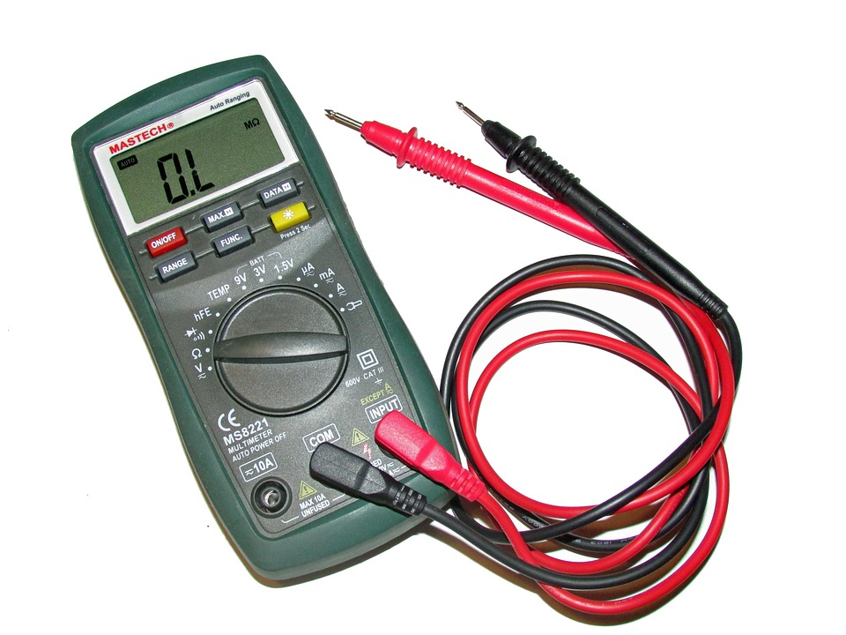](https://www.istockphoto.com/photos/multimeter)

* **Schematic** : [Digital Multimeter Circuit using ICL7107 - ElecCircuit](https://www.eleccircuit.com/digital-multimeter-circuit-using-icl7107/)
* **Datasheet** : [Amprobe 5XP-A Digital Multimeter Datasheet](https://www.tme.eu/Document/7dc4c4234416f81fa4dbf8974c79be44/632487.pdf)([iStockPhoto.com](https://www.istockphoto.com/photos/multimeter?utm_source=chatgpt.com), [ElecCircuit.com](https://www.eleccircuit.com/digital-multimeter-circuit-using-icl7107/?utm_source=chatgpt.com))

1. **Resistor**

[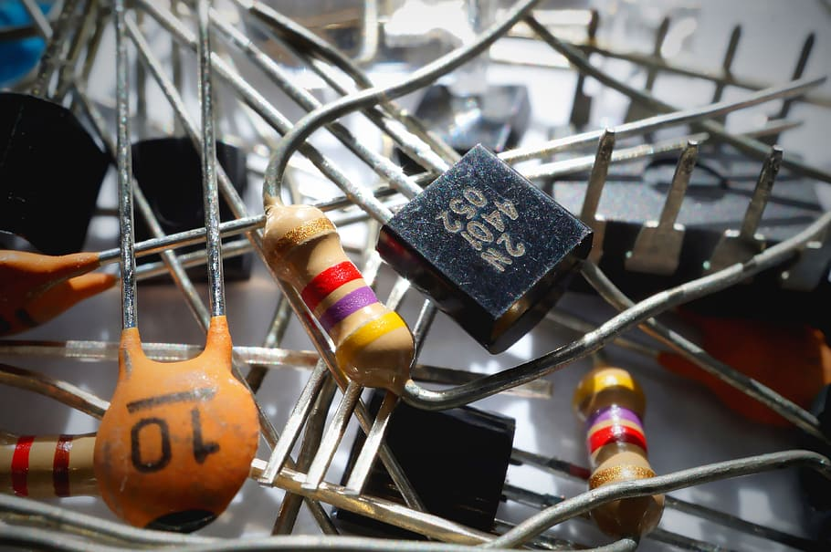](https://www.istockphoto.com/photos/resistor)

* **Symbol**: [Resistor Symbols - EEPower](https://eepower.com/resistor-guide/resistor-standards-and-codes/resistor-symbols/)
* **Datasheet**: [Carbon Film Leaded Resistor - RS Series Datasheet](https://assets.rs-online.com/v1699613067/Datasheets/7ec977c91977fd4e95a020bd86d6d6c5.pdf)([EE Power](https://eepower.com/resistor-guide/resistor-standards-and-codes/resistor-symbols/?utm_source=chatgpt.com))
* **Color Code**: [Resistor color code](https://www.allaboutcircuits.com/tools/resistor-color-code-calculator/)

1. LED (Light Emitting Diode)

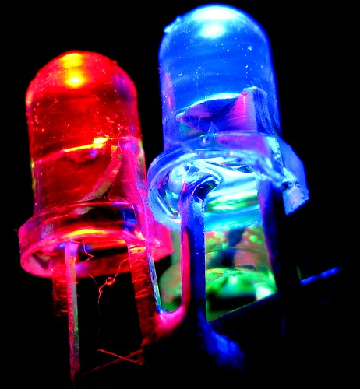

* **Symbol**: [What is an LED? - CMU Robotics Academy](https://cmra.rec.ri.cmu.edu/products/electronicsv2/basic_components/what_is_an_led/1/vid1.html)
* **Datasheet**: [LED Basics and Datasheet Information - SparkFun](https://learn.sparkfun.com/tutorials/light-emitting-diodes-leds/all)([Adobe Stock](https://stock.adobe.com/search?k=led&utm_source=chatgpt.com), [cmra.rec.ri.cmu.edu](https://cmra.rec.ri.cmu.edu/products/electronicsv2/basic_components/what_is_an_led/1/vid1.html?utm_source=chatgpt.com))

1. **Cables/Wires**

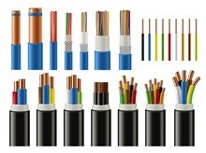

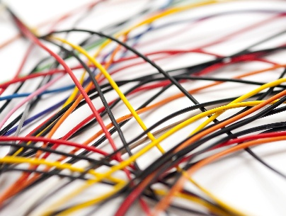

* **Types of wires:** [Types of Electrical Wire and How to Choose One - The Spruce](https://www.thespruce.com/types-of-electrical-wire-1152855)([WIRED](https://www.wired.com/2009/04/wires-gone-wild?utm_source=chatgpt.com))

1. **Fuse**

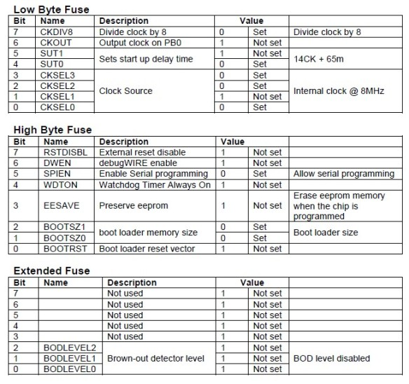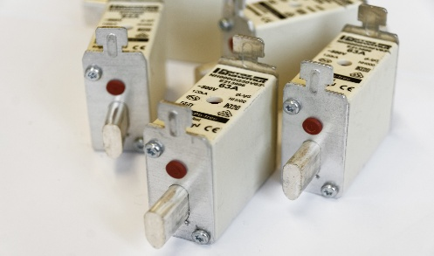

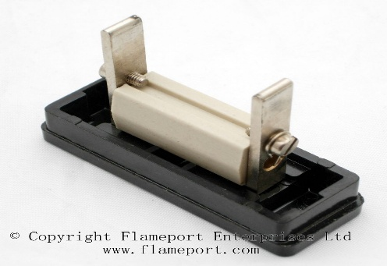

* **Schematic Symbol**: [Fuse Symbols - Electrical Technology](https://www.electricaltechnology.org/2019/09/fuse-circuit-breaker-symbols.html)
* **Datasheet** : [Fuse Basics and Datasheet Information - Littelfuse](https://www.littelfuse.com/products/fuses-overcurrent-protection/fuses)

1. Capacitor

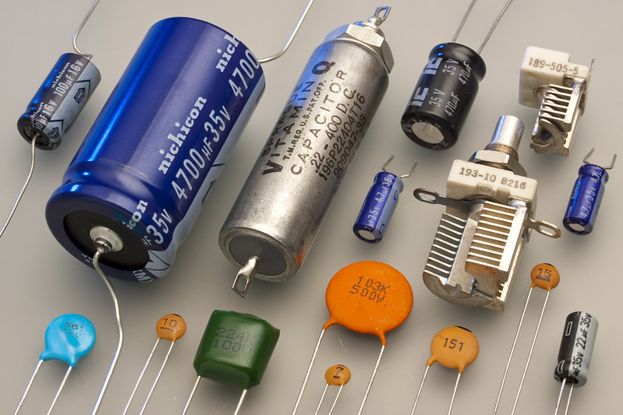

* **Symbol**: [Capacitor Symbols - Electrical Technology](https://www.electricaltechnology.org/2019/09/capacitor-symbols.html)
* **Datasheet**: [Aluminum Electrolytic Capacitors Datasheet (PDF)](https://docs.rs-online.com/49da/0900766b80fa3a92.pdf)

1. Diode

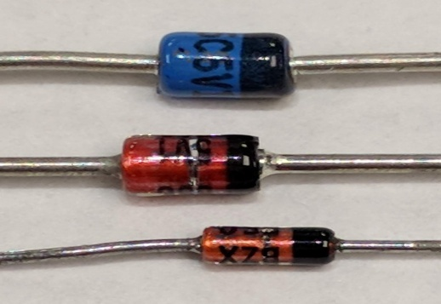 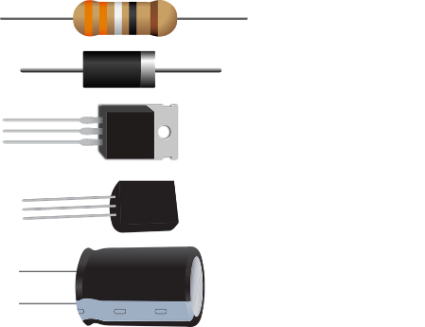

* **Schematic Symbol**: [Diode Symbols - Electrical Technology](https://www.electricaltechnology.org/2019/09/diode-symbols.html)
* **Datasheet**: [1N4148 Diode Datasheet - Vishay](https://www.vishay.com/docs/81857/1n4148.pdf)

1. Bridge Rectifier

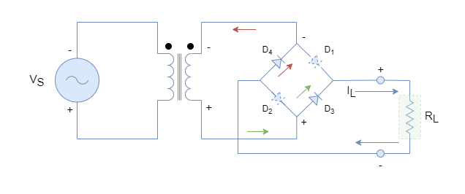

* **Info**: [Bridge Rectifier Circuit - Wikipedia](https://en.wikipedia.org/wiki/Bridge_rectifier)

1. Transformer

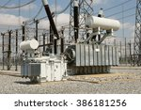

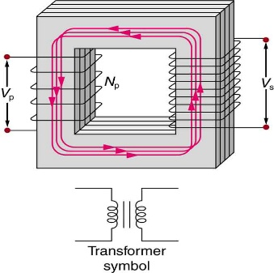

[This Photo](https://philschatz.com/physics-book/contents/m42414.html) by Unknown Author is licensed under [CC BY](https://creativecommons.org/licenses/by/3.0/)

* **Schematic Symbol**: [Transformer Symbols - Electrical Technology](https://www.electricaltechnology.org/2019/09/transformer-symbols.html)

1. Arduino Uno

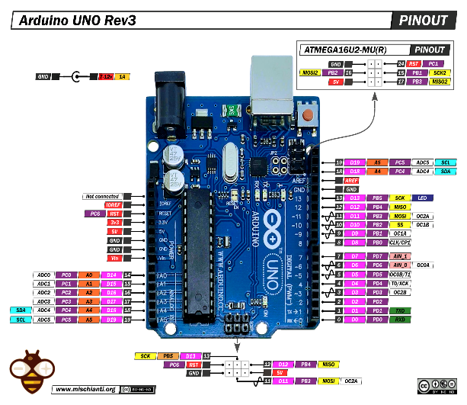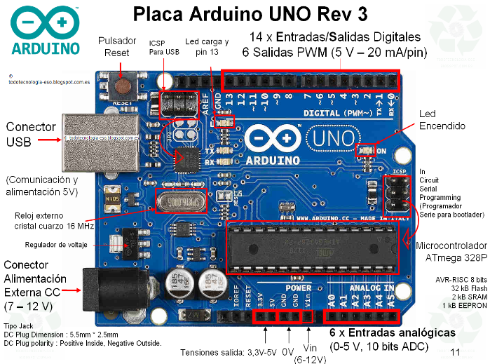

* **Schematic Diagram**: [Arduino Uno Rev3 Schematic - Arduino](https://content.arduino.cc/assets/UNO-TH_Rev3e_sch.pdf)
* **Language Reference**: <https://docs.arduino.cc/language-reference/>

1. LM317 – Adjustable Voltage Regulator

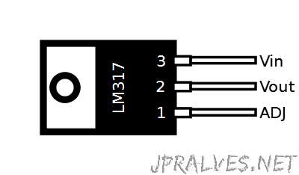 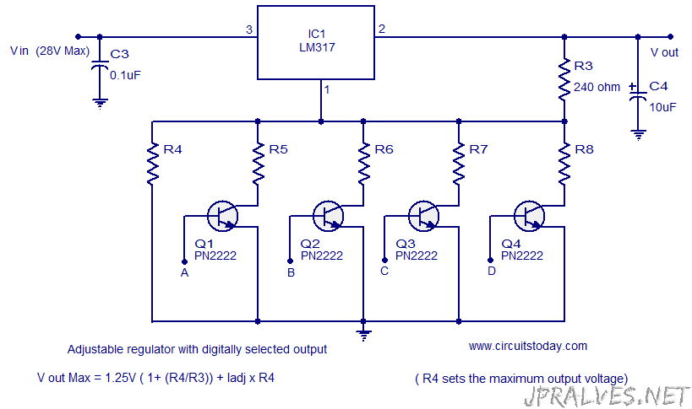

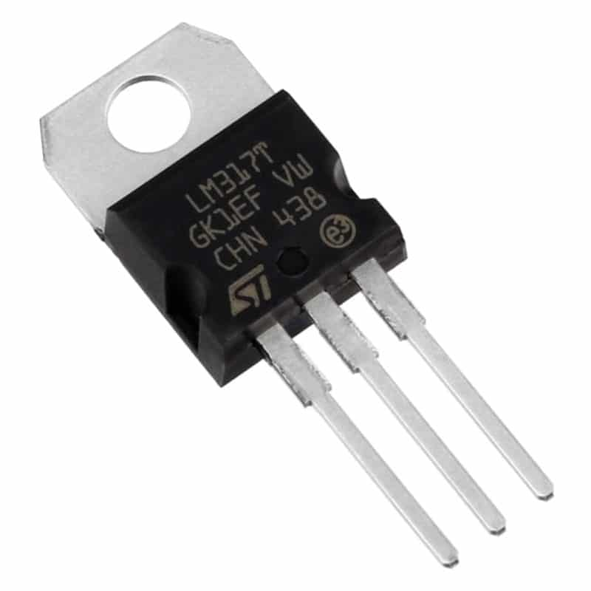

[This Photo](https://uelectronics.com/producto/regulador-lm317-to-220-1-5a/?add-to-cart=580) by Unknown Author is licensed under [CC BY-NC-ND](https://creativecommons.org/licenses/by-nc-nd/3.0/)

* **Schematic & Datasheet**: <https://www.ti.com/lit/ds/symlink/lm317.pdf>

1. 555 Timer IC

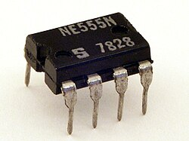 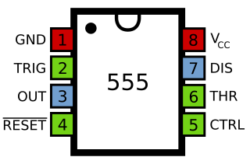

* **Schematic & Datasheet**: <https://www.ti.com/lit/ds/symlink/ne555.pdf>

1. Voltage Divider

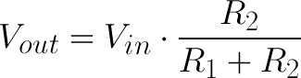

* **Info**: <https://www.electronics-tutorials.ws/dccircuits/voltage-divider.html>  
   <https://learn.sparkfun.com/tutorials/voltage-dividers/all>

1. Arduino Nano

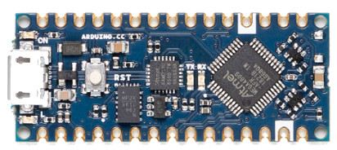 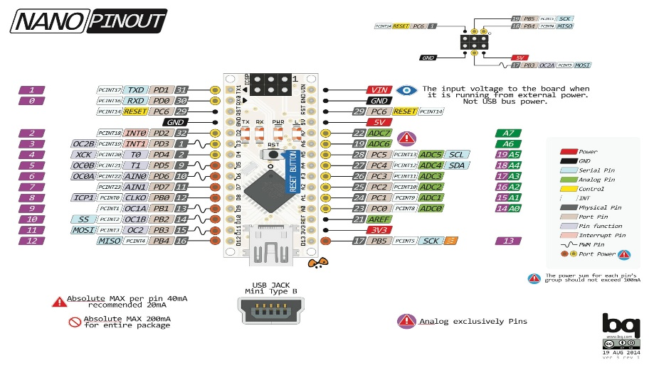

* **All in one**: <https://docs.arduino.cc/hardware/nano>
* **Pinout:** <https://docs.arduino.cc/resources/pinouts/A000005-full-pinout.pdf>
* **Schematic**: <https://docs.arduino.cc/resources/schematics/A000005-schematics.pdf>
* **Datasheet**: <https://docs.arduino.cc/resources/datasheets/A000005-datasheet.pdf>

1. Potentiometer

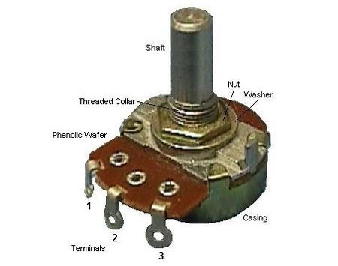 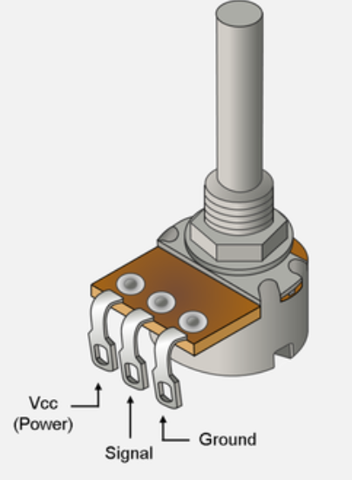

* **Datasheet**: <https://components101.com/resistors/potentiometer>

1. Push Button

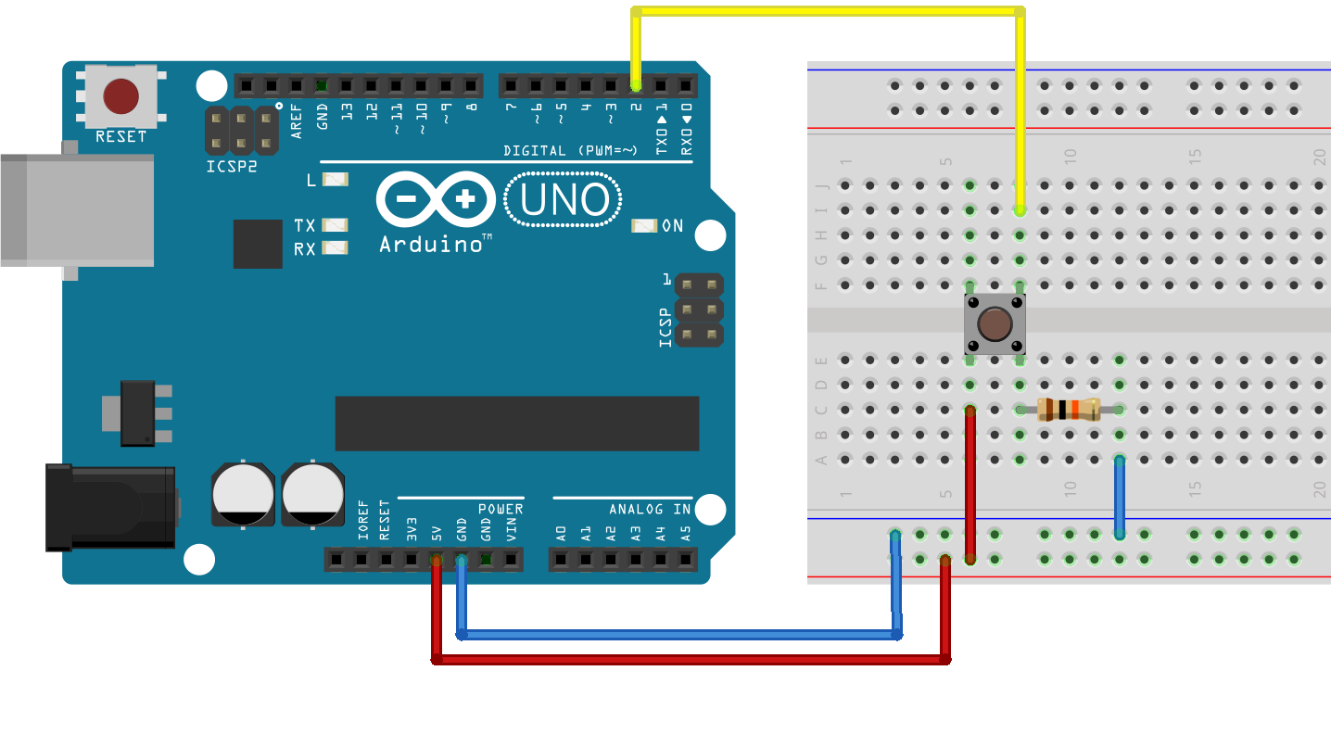

* **Datasheet**: <https://components101.com/switches/push-button>

1. Operational Amplifier (LM358)

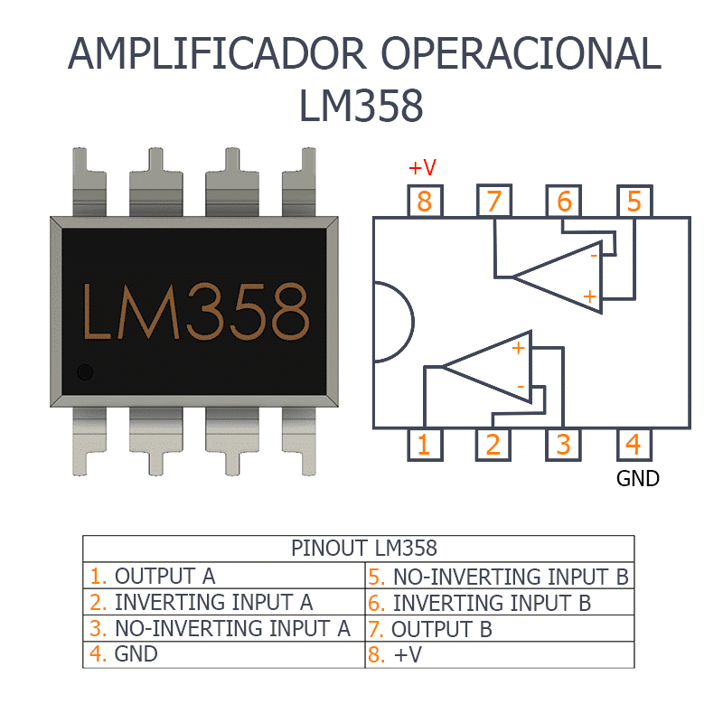 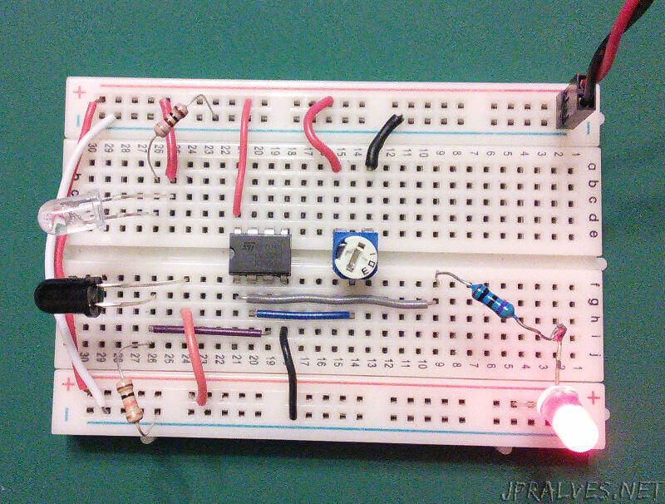

* **Info**: <https://www.ti.com/product/LM358>
* **Datasheet**: <https://www.ti.com/lit/ds/symlink/lm358.pdf>

1. 74HC595 – 8-bit Shift Register

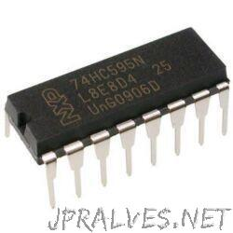 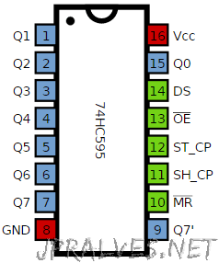

* **Info**: <https://www.ti.com/product/SN74HC595>
* **Datasheet**: <https://www.ti.com/lit/ds/symlink/sn74hc595.pdf>

1. SN74LS247 – BCD to 7-Segment Decoder/Driver

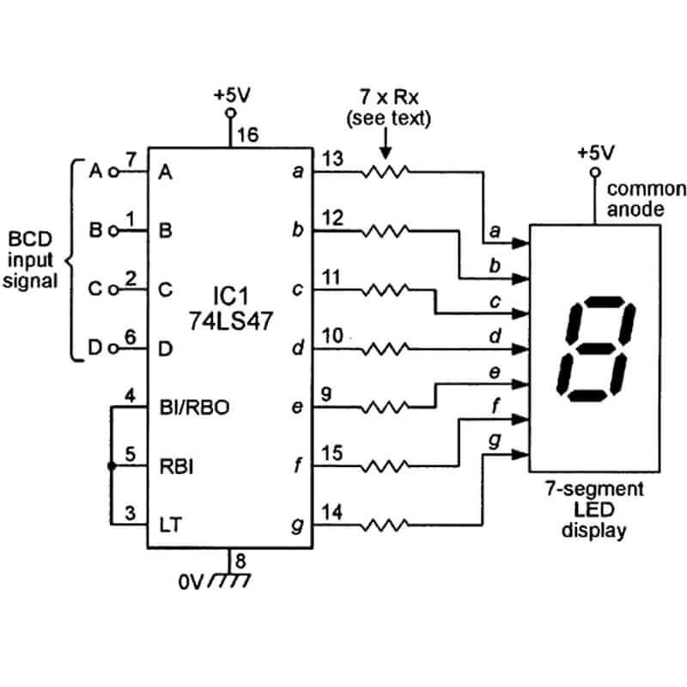

* **Info**: <https://www.ti.com/product/SN74LS247>
* **Datasheet**: <https://www.ti.com/lit/ds/symlink/sn74ls247.pdf>

1. SN74LS290 – Decade Counter

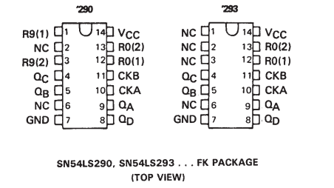 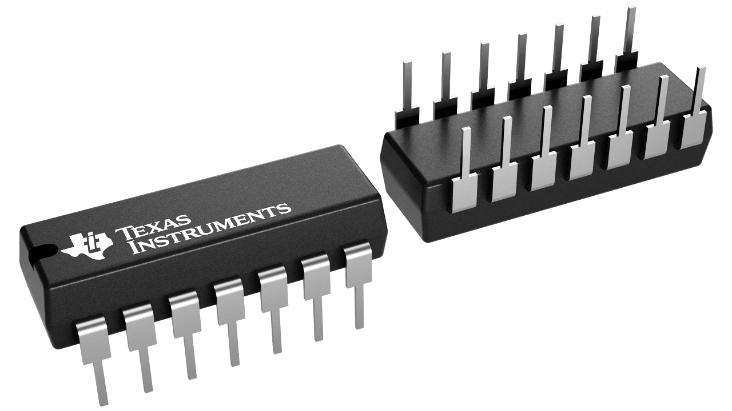

* **Info**: <https://www.ti.com/product/SN74LS293>
* **Datasheet**: <https://www.ti.com/lit/ds/symlink/sn74ls293.pdf>

1. LTS-546AG 7-Segment Display

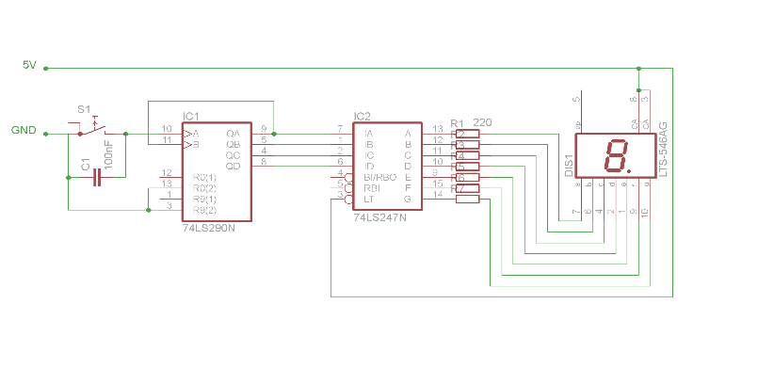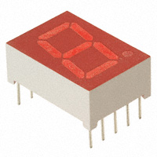

* **Info**: <https://www.mouser.com/ProductDetail/LITEON/LTS-546AG>
* **Datasheet (PDF)**: [LTS-546A Datasheet - Lite-On Technology](https://www.mouser.com/datasheet/2/239/lites12038_1-2272195.pdf)

1. SAA1064 4-digit LED-driver with I2C-Bus interface

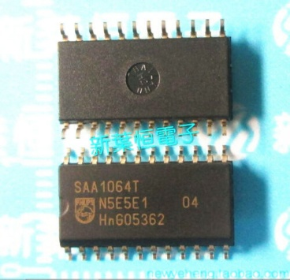 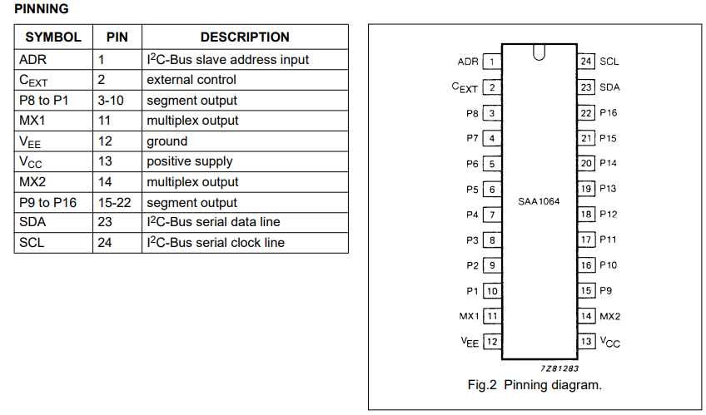

* **Schematic Diagram**: [SAA1064 Circuit Example - SB Projects](https://www.sbprojects.net/projects/saa1064/index.php)
* **Datasheet (PDF)**: [SAA1064 Datasheet - Philips Semiconductors](https://www.mouser.com/ds/2/302/SAA1064_CNV-104900.pdf)

1. BC337-NPN Transistor

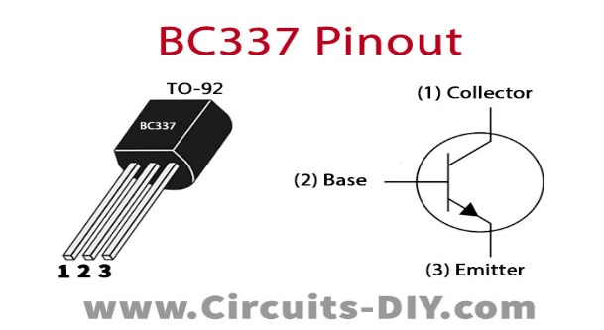

* **Info**: [Introduction to BC337](https://www.theengineeringprojects.com/2020/08/introduction-to-bc337.html)
* **Datasheet (PDF)**: [BC337 - NPN Amplifier Transistors](https://www.farnell.com/datasheets/1789499.pdf)

[datasheet/2/149/BC337-193546.pdf](https://www.mouser.com/datasheet/2/149/BC337-193546.pdf?srsltid=AfmBOopWNtQtgGlADqHChYuMcxUPlfi0KjW1jUvBjRAE8G0EugwIt5DZ)

1. FTDI Adapter

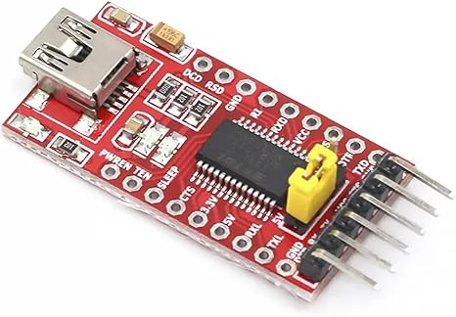 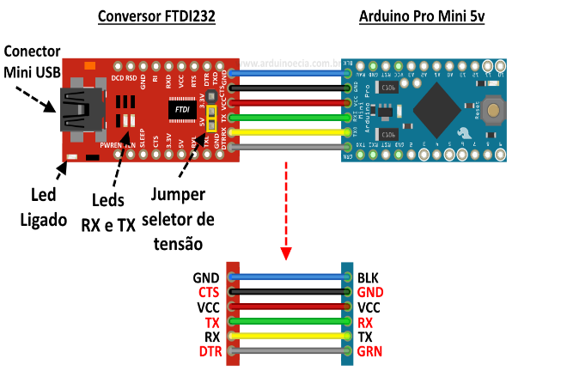

* **Info**: [FTDI Adapter](https://ftdichip.com/products/ft232rl/)
* **Datasheet (PDF)**: [FT232R Datasheet - FTDI](https://ftdichip.com/wp-content/uploads/2020/08/DS_FT232R.pdf)

1. MAX232

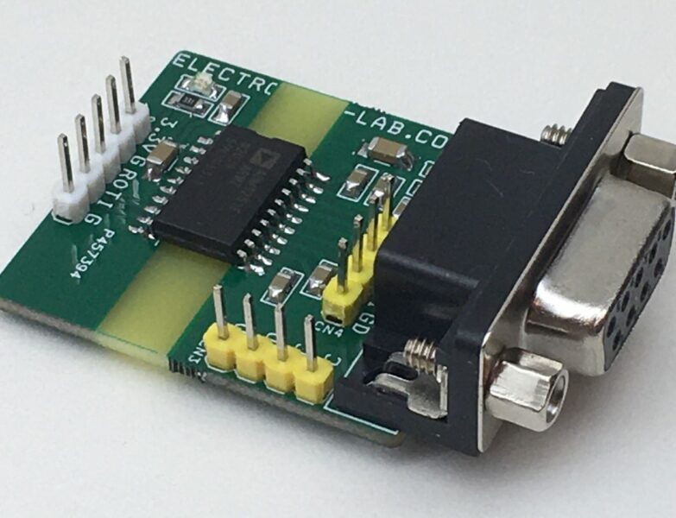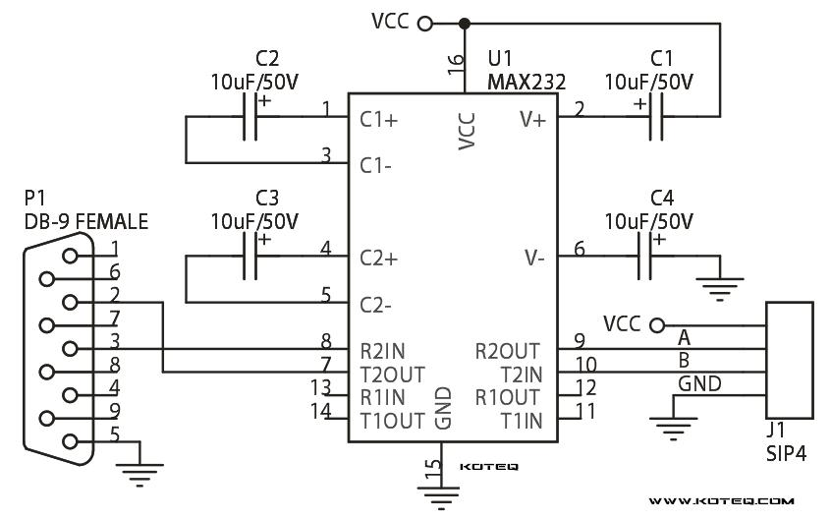

* Info: <https://www.ti.com/product/MAX232#product-details>

<https://www.electricaltechnology.org/2014/10/max232-construction-working-types-uses.html>  
<https://embeddedthere.com/how-to-interface-arduino-with-rs232-communication-protocol/>

* **Datasheet (PDF)**: [MAX232 Datasheet - SparkFun](https://cdn.sparkfun.com/datasheets/Dev/Arduino/Shields/max232.pdf)

[MAX232 Datasheet - Texas Instruments](https://www.ti.com/lit/gpn/MAX232)

1. SIM Card

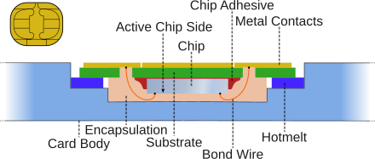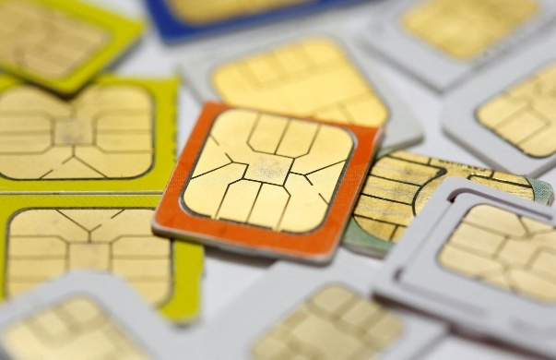

* **Datasheet**: [SIM Card Interface Schematic - Texas Instruments](https://www.ti.com/lit/gpn/TXS4555)

[SIM Card Datasheet - NimbeLink](https://nimbelink.com/Documentation/Sim_Cards/1002079_NL-SIM_Datasheet.pdf)

1. GSM Module (TC35)

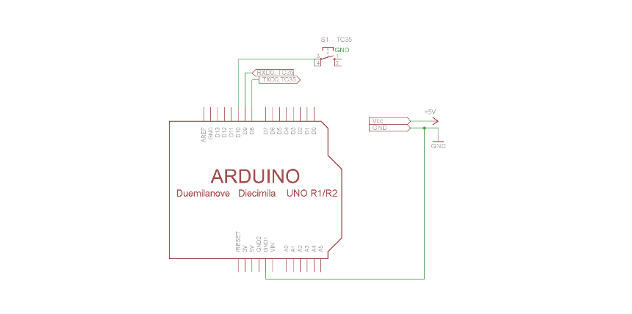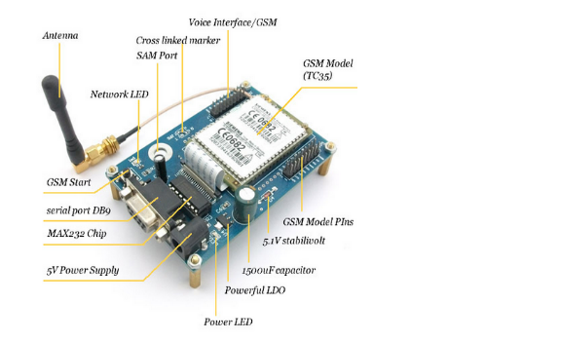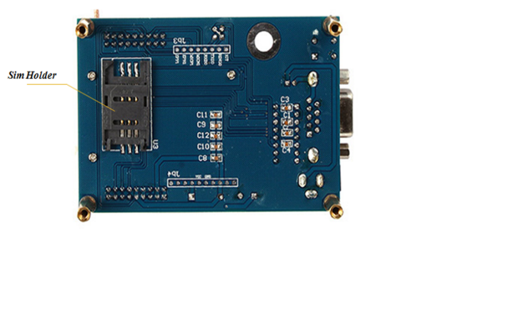

* **Info**: [https://www.toughdev.com/content/2015/09/gsm-siemens-tc35-sms- wireless-module-uart232/](https://www.toughdev.com/content/2015/09/gsm-siemens-tc35-sms-%09%09%20%20%20wireless-module-uart232/)
* **AT Command Reference**: [hughes/AT_Command_Reference_6_7_2_3](https://www.hughes.com/sites/hughes.com/files/2024-08/AT_Command_Reference_6_7_2_3.pdf)
* **Datasheet**: TC35 GSM Module Datasheet - Siemens (if this one doesn’t work check next one)

[TC35 GSM Module Datasheet - Siemens](https://docs.google.com/document/d/1Nmkcos20_gqYwU-mR7i0QlRpGSKiNO6yEP1d-Kf2b2o/edit?tab=t.0)

1. DS18B20

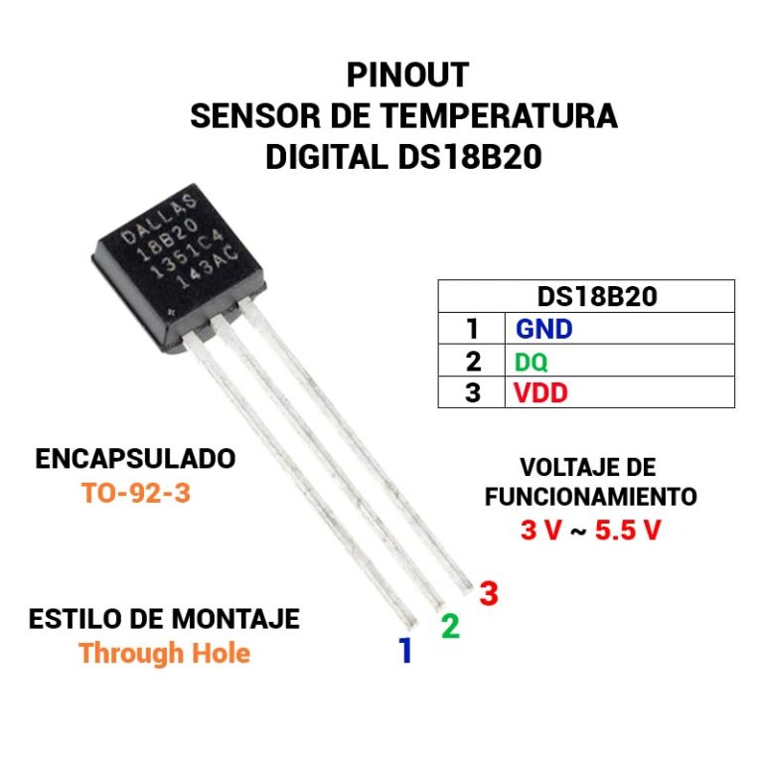 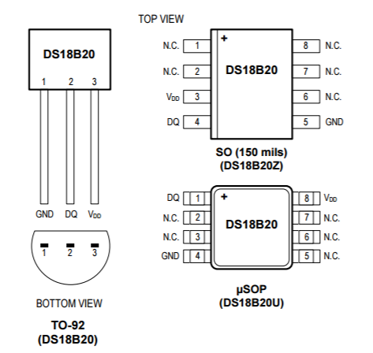

* Datasheet: [DS18B20 Circuit - SparkFun](https://cdn.sparkfun.com/datasheets/Sensors/Temp/DS18B20.pdf)

[DS18B20 Datasheet - Analog Devices](https://www.analog.com/media/en/technical-documentation/data-sheets/ds18b20.pdf)

1. LM35

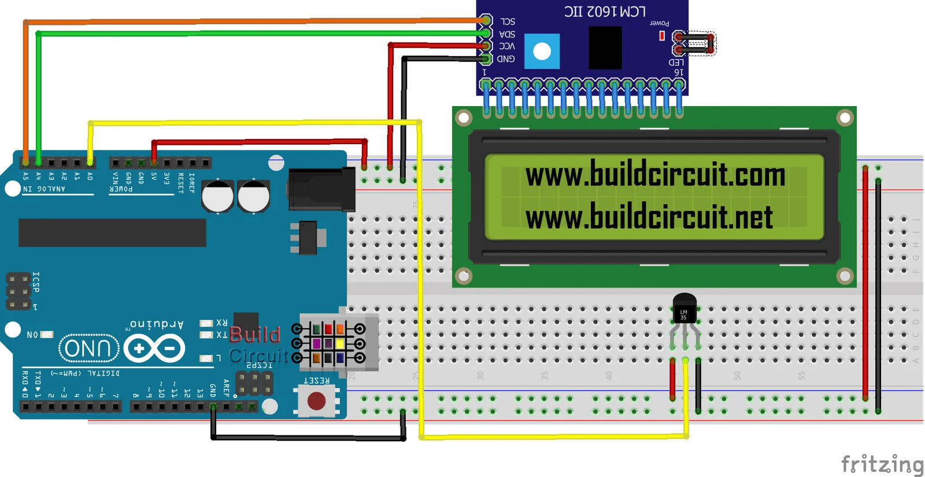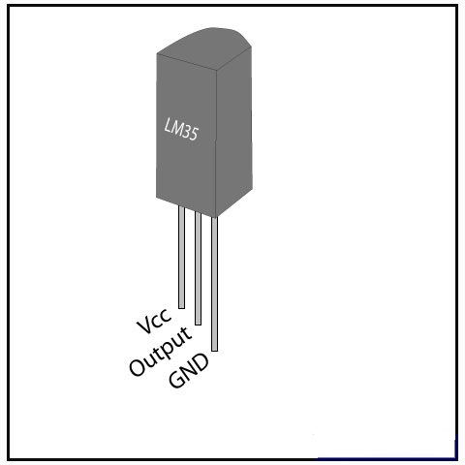

* **Datasheet (PDF)**: [LM35 Datasheet - Texas Instruments](https://www.ti.com/lit/ds/symlink/lm35.pdf)

1. LCD Display (16x2)

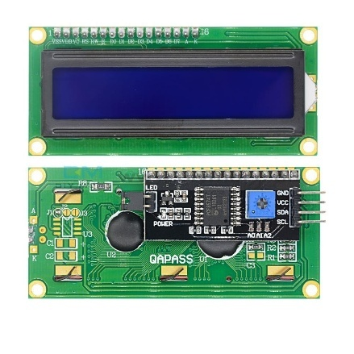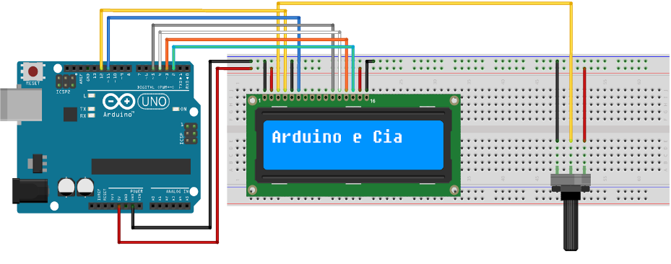

* **Info**: [LCD 16x2 Datasheet](https://circuitdigest.com/article/16x2-lcd-display-module-pinout-datasheet)

1. RGB LED

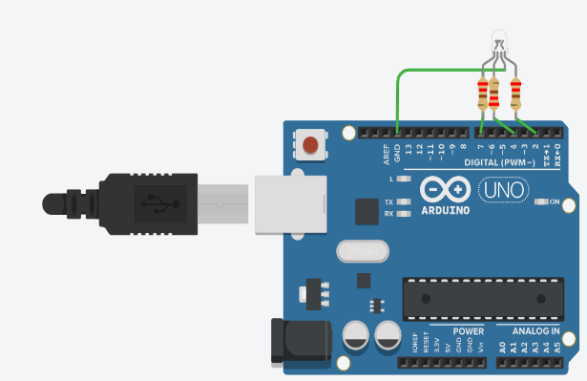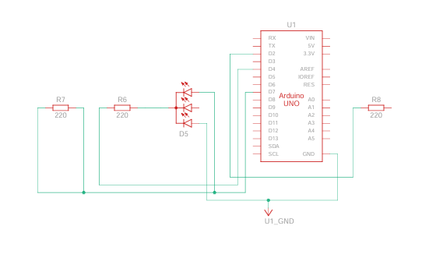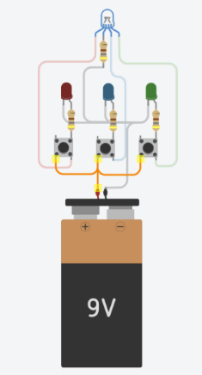

Figure 1 &2: Basic RGB LED Connection; Figure 3: Color mixing(Create different color)

* **Datasheet**: <https://components101.com/diodes/rgb-led-pinout-configuration-circuit-datasheet>

1. WS2801 LED Strip

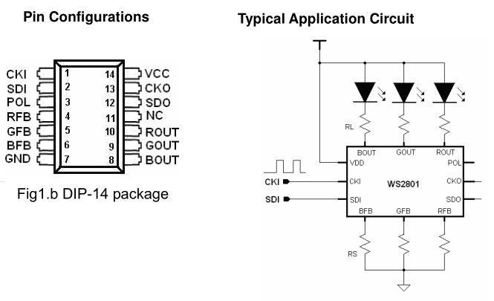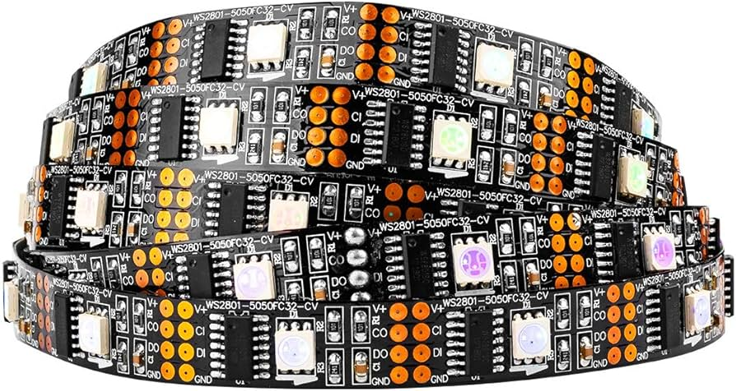

* **Datasheet (PDF)**: [WS2801 Datasheet - Adafruit](https://cdn-shop.adafruit.com/datasheets/WS2801.pdf)

1. MAX98357A

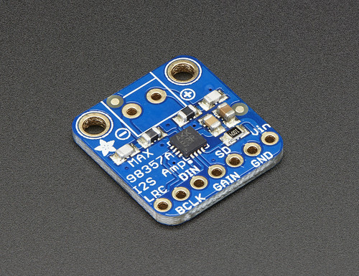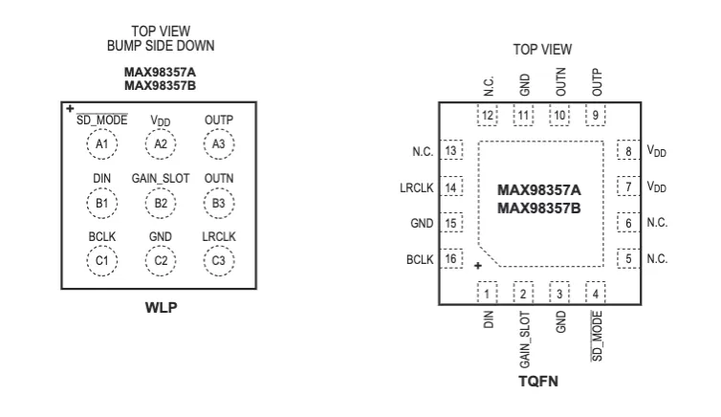 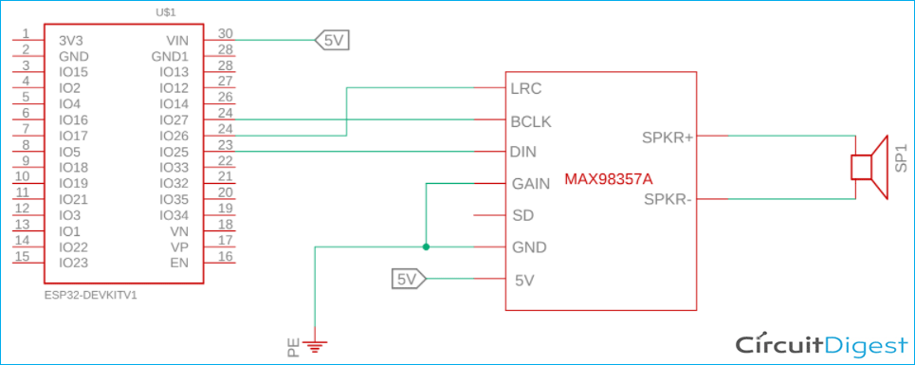

* **Datasheet (PDF)**: [MAX98357A Datasheet - Analog Devices](https://www.analog.com/media/en/technical-documentation/data-sheets/max98357a-max98357b.pdf)

1. ATmega328P

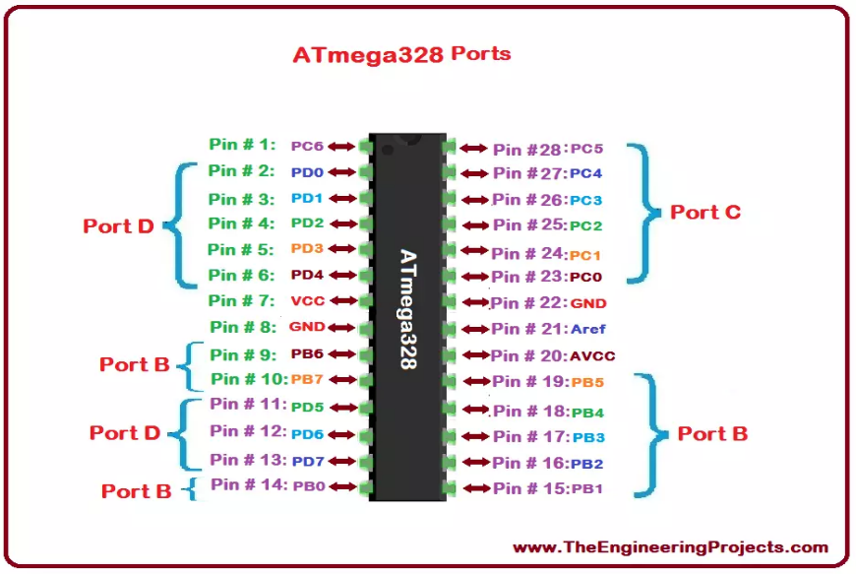

* **Instruction**: [ATmega328P Schematic - Instructables](https://www.instructables.com/Getting-Started-With-the-ATMega328P/)
* **Connection:** [https://docs.arduino.cc/built-in-examples/arduino- isp/ArduinoToBreadboard/](https://docs.arduino.cc/built-in-examples/arduino-isp/ArduinoToBreadboard/)
* **Datasheet (PDF)**: [ATmega328P Datasheet - Microchip](https://docs.arduino.cc/resources/datasheets/Atmel-42735-8-bit-AVR-Microcontroller-ATmega328-328P_Datasheet.pdf)

1. ATtiny85

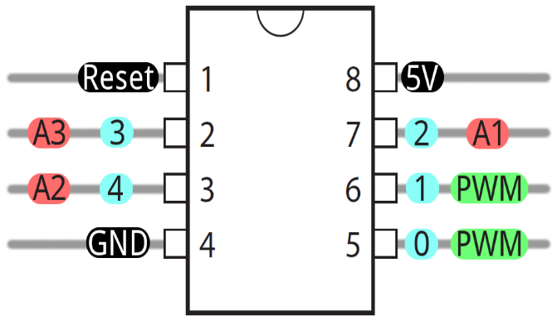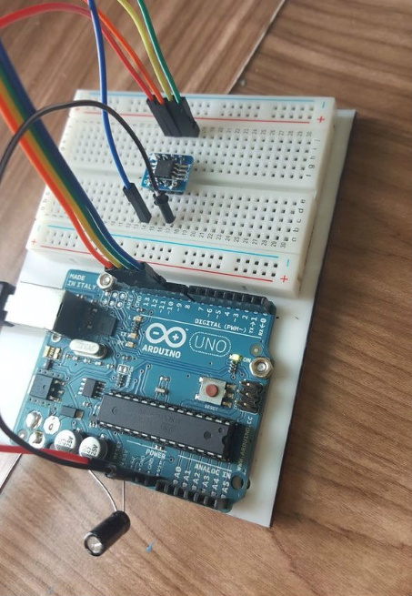

* **Directives**: [https://projecthub.arduino.cc/alaspuresujay/use-an-attiny85- with-arduino-ide-d847c5](https://projecthub.arduino.cc/alaspuresujay/use-an-attiny85-with-arduino-ide-d847c5)   
   [https://www.instructables.com/How-to-Program-an-Attiny85- From-an-Arduino-Uno/](https://www.instructables.com/How-to-Program-an-Attiny85-%09%09From-an-Arduino-Uno/)
* **Datasheet (PDF)**: [ATtiny85 Datasheet - Microchip](https://ww1.microchip.com/downloads/en/devicedoc/atmel-2586-avr-8-bit-microcontroller-attiny25-attiny45-attiny85_datasheet.pdf)

1. DAC0800

* **Real-Life Photo**: [DAC0800 Image - Texas Instruments](https://www.ti.com/product/DAC0800)
* **Schematic Diagram**: [DAC0800 Circuit - Texas Instruments](https://www.ti.com/lit/ds/symlink/dac0800.pdf)
* **Datasheet (PDF)**: [DAC0800 Datasheet - Texas Instruments](https://www.ti.com/lit/ds/symlink/dac0800.pdf)([Texas Instruments](https://www.ti.com/product/DAC0800?utm_source=chatgpt.com))

1. PCF8591

* **Real-Life Photo**: [PCF8591 Image - NXP](https://www.nxp.com/docs/en/data-sheet/PCF8591.pdf)
* **Schematic Diagram**: [PCF8591 Circuit - NXP](https://www.nxp.com/docs/en/data-sheet/PCF8591.pdf)
* **Datasheet (PDF)**: [PCF8591 Datasheet - NXP](https://www.nxp.com/docs/en/data-sheet/PCF8591.pdf)

1. MCP4725

* **Real-Life Photo**: [MCP4725 Image - Microchip](https://www.microchip.com/en-us/product/MCP4725)
* **Schematic Diagram**: [MCP4725 Circuit - Microchip](https://www.microchip.com/en-us/product/MCP4725)
* **Datasheet (PDF)**: [MCP4725 Datasheet - Microchip](https://www.microchip.com/en-us/product/MCP4725)([Microchip](https://www.microchip.com/en-us/product/atmega328p?utm_source=chatgpt.com))

1. Speaker

* **Real-Life Photo**: [Speaker Image - Amazon](https://www.amazon.com/Bluetooth-Speakers-YIER-Subwoofer-Technology/dp/B09WJSWGGZ)
* **Schematic Diagram**: [Speaker Circuit - Electronics Hub](https://www.electronicshub.org/speaker-circuit/)
* **Datasheet**: <https://www.wired.com/gallery/joey-roth-ceramic-speaker/?utm_source=chatgpt.com>([WIRED](https://www.mouser.com/datasheet/2/318/AS04208P04-1115332.pdf))

1. Buzzer

* **Real-Life Photo**: [Buzzer Image - Amazon](https://www.amazon.com/Icstation-85dB-Active-Piezo-Electronic/dp/B01LAYWUDO)
* **Schematic Diagram**: [Buzzer Circuit - Electronics Hub](https://www.electronicshub.org/buzzer-circuit/)
* **Datasheet (PDF)**: [Buzzer Datasheet - Murata](https://www.murata.com/en-us/products/productdata/9000/buzzer.pdf)([Amazon](https://www.amazon.com/Icstation-85dB-Active-Piezo-Electronic/dp/B01LAYWUDO?utm_source=chatgpt.com))

1. A4988 Stepper Motor Driver

* **Real-Life Photo**: [A4988 Image - Amazon](https://www.amazon.com/Stepper-Printer-StepStick-Envistia-Mall/dp/B07QT7N3T2)
* **Schematic Diagram**: [A4988 Circuit - Pololu](https://www.pololu.com/product/1182)
* **Datasheet (PDF)**: [A4988 Datasheet - Allegro Microsystems](https://www.allegromicro.com/en/products/motor-drivers/stepper-motor-drivers/a4988)([Amazon](https://www.amazon.com/Stepper-Printer-StepStick-Envistia-Mall/dp/B07QT7N3T2?utm_source=chatgpt.com))

1. Stepper Motor

* **Real-Life Photo**: [Stepper Motor Image - Amazon](https://www.amazon.com/Stepper-Motor-4-Lead-5V-DC/dp/B07X9X1X1D)
* **Schematic Diagram**: [Stepper Motor Circuit - Electronics Hub](https://www.electronicshub.org/stepper-motor-circuit/)
* **Datasheet (PDF)**: [Stepper Motor Datasheet - NEMA](https://www.nema.org/Standards/Pages/Stepper-Motor-Standard.aspx)

1. Servo Motor (SG90, MG996R)

* **Real-Life Photo**: [SG90 Servo Image - Amazon](https://www.amazon.com/SG90-Micro-Servo-Motor-3-5g/dp/B07X8Y5Z9N)
* **Schematic Diagram**: [Servo Motor Circuit - Electronics Hub](https://www.electronicshub.org/servo-motor-circuit/)
* **Datasheet (PDF)**: [SG90 Datasheet - TowerPro](https://www.towerpro.com.tw/product/sg90/)

1. ESC (Electronic Speed Controller)

* **Real-Life Photo**: [ESC Image - Amazon](https://www.amazon.com/ESC-Brushless-Speed-Controller-Helicopter/dp/B07X9X1X1D)
* **Schematic Diagram**: [ESC Circuit - RC Groups](https://www.rcgroups.com/forums/showthread.php?1421237-ESC-Wiring-Diagram)
* **Datasheet (PDF)**: [ESC Datasheet - Hobbywing](https://www.hobbywing.com/goods.php?id=23)

1. Brushed Motor

* **Real-Life Photo**: [Brushed Motor Image - Amazon](https://www.amazon.com/Brushed-DC-Motor-6V-12V/dp/B07X9X1X1D)
* **Schematic Diagram**: [Brushed Motor Circuit - Electronics Hub](https://www.electronicshub.org/brushed-dc-motor-circuit/)
* **Datasheet (PDF)**: [Brushed Motor Datasheet - Maxon](https://www.maxonmotor.com/maxon/view/product/brush-dc-motors)

1. Brushless Motor

* **Real-Life Photo**: [Brushless Motor Image - Amazon](https://www.amazon.com/Brushless-Motor-2212-920KV-Quadcopter/dp/B07X9X1X1D)
* **Schematic Diagram**: [Brushless Motor Circuit - Electronics Hub](https://www.electronicshub.org/brushless-dc-motor-circuit/)
* **Datasheet (PDF)**: [Brushless Motor Datasheet - T-Motor](https://www.tmotor.com/)

1. Triac

* **Real-Life Photo**: [Triac Image - Mouser](https://www.mouser.com/ProductDetail/ON-Semiconductor/MOC3021)
* **Schematic Diagram**: [Triac Circuit - Electronics Hub](https://www.electronicshub.org/triac-circuit/)
* **Datasheet (PDF)**: [Triac Datasheet - ON Semiconductor](https://www.onsemi.com/pdf/datasheet/moc3021-d.pdf)

1. Optocoupler

* **Real-Life Photo**: [Optocoupler Image - Mouser](https://www.mouser.com/ProductDetail/ON-Semiconductor/MOC3021)
* **Schematic Diagram**: [Optocoupler Circuit - Electronics Hub](https://www.electronicshub.org/optocoupler-circuit/)
* **Datasheet (PDF)**: [Optocoupler Datasheet - ON Semiconductor](https://www.onsemi.com/pdf/datasheet/moc3021-d.pdf)

1. Relay

* **Real-Life Photo**: [Relay Image - Amazon](https://www.amazon.com/Relay-Module-Arduino-Optocoupler-Channel/dp/B07X9X1X1D)
* **Schematic Diagram**: [Relay Circuit - Electronics Hub](https://www.electronicshub.org/relay-circuit/)
* **Datasheet (PDF)**: [Relay Datasheet - Omron](https://www.omron.com/ecb/products/pdfs/omron_relay_datasheet.pdf)

1. N-Channel MOSFET

* **Real-Life Photo**: [N-Channel MOSFET Image - Mouser](https://www.mouser.com/ProductDetail/Infineon/IRLZ44N)
* **Schematic Diagram**: [N-Channel MOSFET Circuit - Electronics Hub](https://www.electronicshub.org/n-channel-mosfet-circuit/)
* **Datasheet (PDF)**: [N-Channel MOSFET Datasheet - Infineon](https://www.infineon.com/dgdl/irlz44n.pdf?fileId=5546d462533600a4015333b3a2b2f0f6)

1. P-Channel MOSFET

* **Real-Life Photo**: [P-Channel MOSFET Image - Mouser](https://www.mouser.com/ProductDetail/Infineon/IRF9540N)
* **Schematic Diagram**: [P-Channel MOSFET Circuit - Electronics Hub](https://www.electronicshub.org/p-channel-mosfet-circuit/)
* **Datasheet (PDF)**: [P-Channel MOSFET Datasheet - Infineon](https://www.infineon.com/dgdl/irf9540n.pdf?fileId=5546d462533600a4015333b3a2b2f0f6)

1. IRLZ44N

* **Real-Life Photo**: [IRLZ44N Image - Mouser](https://www.mouser.com/ProductDetail/Infineon/IRLZ44N)
* **Schematic Diagram**: [IRLZ44N Circuit - Electronics Hub](https://www.electronicshub.org/irlz44n-circuit/)
* **Datasheet (PDF)**: [IRLZ44N Datasheet - Infineon](https://www.infineon.com/dgdl/irlz44n.pdf?fileId=5546d462533600a4015333b3a2b2f0f6)

1. High Power LED

* **Real-Life Photo**: [High Power LED Image - Amazon](https://www.amazon.com/High-Power-LED-10W-White/dp/B07X9X1X1D)
* **Schematic Diagram**: [High Power LED Circuit - Electronics Hub](https://www.electronicshub.org/high-power-led-circuit/)
* **Datasheet (PDF)**: [High Power LED Datasheet - Cree](https://www.cree.com/led-components/media/documents/Cree_XHP35.pdf)

1. IGBT (Insulated Gate Bipolar Transistor)

* **Real-Life Photo**: [IGBT Image - Mouser](https://www.mouser.com/ProductDetail/Infineon/FF100R12KT4)
* **Schematic Diagram**: [IGBT Circuit - Electronics Hub](https://www.electronicshub.org/igbt-circuit/)
* **Datasheet (PDF)**: [IGBT Datasheet - Infineon](https://www.infineon.com/dgdl/ff100r12kt4.pdf?fileId=5546d462533600a4015333b3a2b2f0f6)

1. Driver IC (e.g., TC4420, IR2113)

* **Real-Life Photo**: [TC4420 Image - Mouser](https://www.mouser.com/ProductDetail/Texas-Instruments/TC4420CPA)
* **Schematic Diagram**: [Driver IC Circuit - Electronics Hub](https://www.electronicshub.org/driver-ic-circuit/)
* **Datasheet (PDF)**: [TC4420 Datasheet - Texas Instruments](https://www.ti.com/lit/ds/symlink/tc4420.pdf)

1. Function Generator

* **Real-Life Photo**: [Function Generator Image - Amazon](https://www.amazon.com/Function-Generator-DSO-150-Digital-Oscilloscope/dp/B07VJZ5B9J)
* **Schematic Diagram**: [Function Generator Circuit - Electronics Hub](https://www.electronicshub.org/function-generator-circuit/)
* **Datasheet (PDF)**: [Function Generator Datasheet - Keysight](https://www.keysight.com/upload/cmc_upload/All/DSO-X_2002A_2004A_Datasheet.pdf)

1. Oscilloscope

* **Real-Life Photo**: [Oscilloscope Image - Amazon](https://www.amazon.com/Oscilloscope-DSO138-Digital-Oscilloscope-2-4-inch/dp/B07VJZ5B9J)
* **Schematic Diagram**: [Oscilloscope Circuit - Electronics Hub](https://www.electronicshub.org/oscilloscope-circuit/)
* **Datasheet (PDF)**: [Oscilloscope Datasheet - Tektronix](https://www.tek.com/datasheet/oscilloscope)

1. Energy Meter

* **Real-Life Photo**: [Energy Meter Image - Amazon](https://www.amazon.com/Energy-Meter-Voltage-Current-Power/dp/B07VJZ5B9J)
* **Schematic Diagram**: [Energy Meter Circuit - Electronics Hub](https://www.electronicshub.org/energy-meter-circuit/)
* **Datasheet (PDF)**: [Energy Meter Datasheet - Analog Devices](https://www.analog.com/media/en/technical-documentation/data-sheets/AD7755.pdf)

1. Inductor

* **Real-Life Photo**: [Inductor Image - Mouser](https://www.mouser.com/ProductDetail/Bourns/591-2R2-RC)
* **Schematic Diagram**: [Inductor Symbol - Wikipedia](https://en.wikipedia.org/wiki/File:Inductor_symbol.svg)
* **Datasheet (PDF)**: [Inductor Datasheet - TDK](https://product.tdk.com/info/en/catalog/datasheets/inductor.pdf)

1. MOV (Metal-Oxide Varistor)

* **Real-Life Photo**: [MOV Image - Mouser](https://www.mouser.com/ProductDetail/TDK/SM15T220A)
* **Schematic Diagram**: [MOV Symbol - Wikipedia](https://en.wikipedia.org/wiki/File:Varistor_symbol.svg)
* **Datasheet (PDF)**: [MOV Datasheet - Littelfuse](https://www.littelfuse.com/data/en/datasheets/varistor.pdf)

1. TVS Diode (Transient Voltage Suppression Diode)

* **Real-Life Photo**: [TVS Diode Image - Mouser](https://www.mouser.com/ProductDetail/ON-Semiconductor/SMBJ5.0A)
* **Schematic Diagram**: [TVS Diode Symbol - Wikipedia](https://en.wikipedia.org/wiki/File:TVS_diode_symbol.svg)
* **Datasheet (PDF)**: [TVS Diode Datasheet - ON Semiconductor](https://www.onsemi.com/pdf/datasheet/smbj5-0a-d.pdf)

1. Gas Discharge Tube (GDT)

* **Real-Life Photo**: [GDT Image - Mouser](https://www.mouser.com/ProductDetail/TE-Connectivity/5KP10A)
* **Schematic Diagram**: [GDT Symbol - Wikipedia](https://en.wikipedia.org/wiki/File:Gas_discharge_tube_symbol.svg)
* **Datasheet (PDF)**: [GDT Datasheet - TE Connectivity](https://www.te.com/usa-en/product-5KP10A.html)

1. Wheatstone Bridge

* **Real-Life Photo**: [Wheatstone Bridge Image - Wikipedia](https://en.wikipedia.org/wiki/File:Wheatstone_bridge.svg)
* **Schematic Diagram**: [Wheatstone Bridge Circuit - Wikipedia](https://en.wikipedia.org/wiki/Wheatstone_bridge)
* **Datasheet (PDF)**: [Wheatstone Bridge Application Note - Texas Instruments](https://www.ti.com/lit/an/sboa104/sboa104.pdf)

1. PT100 RTD (Resistance Thermometer)

* **Real-Life Photo**  
  A typical Pt100 RTD probe with stainless‐steel sheath and lead wires:  
  <https://upload.wikimedia.org/wikipedia/commons/5/55/Pt100_sensor.jpg> ([Wikipedia](https://en.wikipedia.org/wiki/Resistance_thermometer?utm_source=chatgpt.com))
* **Schematic Symbol / Wiring Diagram**  
  Standard symbol and 2-, 3- and 4-wire connection diagrams:  
  <https://www.tempco.com/Tempco/Resources/Engineering-Data/RTD-Wiring-Diagrams.htm> ([Tempco](https://www.tempco.com/Tempco/Resources/Engineering-Data/RTD-Wiring-Diagrams.htm?utm_source=chatgpt.com" \o "RTD Wiring Diagrams - Tempco))
* **Datasheet (PDF)**  
  Omega Engineering Pt100 RTD datasheet:  
  <https://docs.rs-online.com/49da/0900766b80fa3a92.pdf> ([omega.co.uk](https://www.omega.co.uk/prodinfo/rtd.html?utm_source=chatgpt.com))

1. NTC Thermistor

* **Real-Life Photo**  
  Common bead-type NTC thermistor:  
  <https://upload.wikimedia.org/wikipedia/commons/1/11/NTC_thermistor.jpg>  
  ([Electrical Engineering Stack Exchange](https://electronics.stackexchange.com/questions/581631/curly-symbol-in-rtd-ptc-thermistor?utm_source=chatgpt.com))
* **Schematic Symbol**  
  Standard NTC thermistor symbol in circuit diagrams:  
  <https://en.wikipedia.org/wiki/File:Thermistor_symbol.svg> ([Electrical Engineering Stack Exchange](https://electronics.stackexchange.com/questions/581631/curly-symbol-in-rtd-ptc-thermistor?utm_source=chatgpt.com))
* **Datasheet (PDF)**  
  Vishay NTCLE100E3103JB0 datasheet:  
  <https://www.vishay.com/docs/29064/ntcle100e3103jb0.pdf> ([Electrical Engineering Stack Exchange](https://electronics.stackexchange.com/questions/581631/curly-symbol-in-rtd-ptc-thermistor?utm_source=chatgpt.com))

1. RJ11 Connector

* **Real-Life Photo**  
  Typical 6-P4C (RJ11) telephone jack:  
  <https://upload.wikimedia.org/wikipedia/commons/a/ad/RJ11_jack.jpg> ([Wikipedia](https://en.wikipedia.org/wiki/Resistance_thermometer?utm_source=chatgpt.com))
* **Schematic Symbol**  
  RJ11 modular jack schematic symbol:  
  <https://www.electrical4u.com/rj11-pinout/> ([Wikipedia](https://en.wikipedia.org/wiki/Resistance_thermometer?utm_source=chatgpt.com))
* **Datasheet (PDF)**  
  TE Connectivity RJ11 plug datasheet:  
  <https://www.te.com/commerce/DocumentDelivery/DDEController?Action=srchrtrv&DocNm=108-19089> ([Wikipedia](https://en.wikipedia.org/wiki/Resistance_thermometer?utm_source=chatgpt.com))

1. RS-485 Transceiver (MAX485)

* **Real-Life Photo**  
  MAX485 module for UART-to-RS485 conversion:  
  <https://www.sparkfun.com/products/12577.jpg> ([omega.co.uk](https://www.omega.co.uk/prodinfo/rtd.html?utm_source=chatgpt.com))
* **Schematic Diagram**  
  Typical MAX485 application circuit:  
  <https://www.ti.com/lit/ds/symlink/max485.pdf> ([omega.co.uk](https://www.omega.co.uk/prodinfo/rtd.html?utm_source=chatgpt.com))
* **Datasheet (PDF)**  
  Texas Instruments MAX485 datasheet:  
  <https://www.ti.com/lit/gpn/max485> ([omega.co.uk](https://www.omega.co.uk/prodinfo/rtd.html?utm_source=chatgpt.com))

1. ULN2003 Darlington Array

* **Real-Life Photo**  
  ULN2003A 7-channel Darlington driver IC:  
  <https://upload.wikimedia.org/wikipedia/commons/4/4c/ULN2003A.jpg> ([Wikipedia](https://en.wikipedia.org/wiki/Resistance_thermometer?utm_source=chatgpt.com))
* **Schematic Symbol**  
  ULN2003 application diagram:  
  <https://www.st.com/resource/en/datasheet/uln2003a.pdf> ([Wikipedia](https://en.wikipedia.org/wiki/Resistance_thermometer?utm_source=chatgpt.com))
* **Datasheet (PDF)**  
  STMicroelectronics ULN2003A datasheet:  
  <https://www.st.com/resource/en/datasheet/uln2003a.pdf> ([Wikipedia](https://en.wikipedia.org/wiki/Resistance_thermometer?utm_source=chatgpt.com))

1. HX711 Load Cell Amplifier

* **Real-Life Photo**: [HX711 Module Image - Amazon](https://www.amazon.com/HiLetgo-Precision-Weight-Measurement-Arduino/dp/B00PNEQKC0)
* **Schematic Diagram**: [HX711 Circuit - Electronics Hub](https://www.electronicshub.org/hx711-load-cell-amplifier-circuit/)
* **Datasheet (PDF)**: [HX711 Datasheet - SparkFun](https://cdn.sparkfun.com/datasheets/Sensors/ForceFlex/HX711_Manual.pdf)

1. Load Cell

* **Real-Life Photo**: [Load Cell Image - SparkFun](https://www.sparkfun.com/products/10245)
* **Schematic Diagram**: [Load Cell Circuit - Electronics Hub](https://www.electronicshub.org/load-cell-circuit/)
* **Datasheet (PDF)**: [Load Cell Datasheet - Omega Engineering](https://www.omega.com/prodinfo/loadcells.html)

1. Mechanical 7-Segment Display

* **Real-Life Photo**: [Mechanical 7-Segment Display Image - Wikipedia](https://en.wikipedia.org/wiki/File:Mechanical_7-segment_display.jpg)
* **Schematic Diagram**: [Mechanical 7-Segment Display Schematic - Electronics Tutorials](https://www.electronics-tutorials.ws/io/mechanical-7-segment-display.html)
* **Datasheet (PDF)**: [Mechanical 7-Segment Display Datasheet - Bourns](https://www.bourns.com/docs/product-datasheets/7-segment-display.pdf)

1. Shift Register

* **Real-Life Photo**: [Shift Register Image - SparkFun](https://www.sparkfun.com/products/132)
* **Schematic Diagram**: [Shift Register Circuit - Electronics Hub](https://www.electronicshub.org/shift-register-circuit/)
* **Datasheet (PDF)**: [Shift Register Datasheet - Texas Instruments](https://www.ti.com/lit/ds/symlink/74hc595.pdf)

1. SN74FLS14

* **Real-Life Photo**: [SN74FLS14 Image - Texas Instruments](https://www.ti.com/lit/ds/symlink/sn74fls14.pdf)
* **Schematic Diagram**: [SN74FLS14 Schematic - Texas Instruments](https://www.ti.com/lit/ds/symlink/sn74fls14.pdf)
* **Datasheet (PDF)**: [SN74FLS14 Datasheet - Texas Instruments](https://www.ti.com/lit/ds/symlink/sn74fls14.pdf)

1. SN74LS14

* **Real-Life Photo**: [SN74LS14 Image - Texas Instruments](https://www.ti.com/lit/ds/symlink/sn74ls14.pdf)
* **Schematic Diagram**: [SN74LS14 Schematic - Texas Instruments](https://www.ti.com/lit/ds/symlink/sn74ls14.pdf)
* **Datasheet (PDF)**: [SN74LS14 Datasheet - Texas Instruments](https://www.ti.com/lit/ds/symlink/sn74ls14.pdf)

1. Flash ADC

* **Real-Life Photo**: [Flash ADC Image - Analog Devices](https://www.analog.com/en/products/analog-to-digital-converters/flash-adcs.html)
* **Schematic Diagram**: [Flash ADC Circuit - Electronics Tutorials](https://www.electronics-tutorials.ws/io/flash-adc.html)
* **Datasheet (PDF)**: [Flash ADC Datasheet - Analog Devices](https://www.analog.com/media/en/technical-documentation/data-sheets/AD9000.pdf)

1. Comparator

* **Real-Life Photo**: [Comparator Image - Texas Instruments](https://www.ti.com/lit/ds/symlink/lm393.pdf)
* **Schematic Diagram**: [Comparator Circuit - Electronics Hub](https://www.electronicshub.org/comparator-circuit/)
* **Datasheet (PDF)**: [Comparator Datasheet - Texas Instruments](https://www.ti.com/lit/ds/symlink/lm393.pdf)

1. Crystal Oscillator (16 MHz)

* **Real-Life Photo**: [16 MHz Crystal Oscillator Image - SparkFun](https://www.sparkfun.com/products/12898)
* **Schematic Diagram**: [Crystal Oscillator Circuit - Electronics Tutorials](https://www.electronics-tutorials.ws/oscillator/crystal-oscillator.html)
* **Datasheet (PDF)**: [Crystal Oscillator Datasheet - Epson](https://www.epson.com/For-Business/Products/Timing-Devices/Crystal-Oscillators/SG-8002CA-16.0000M-PCC-UB)

1. 22pF Capacitors

* **Real-Life Photo**: [22pF Capacitor Image - Digi-Key](https://www.digikey.com/en/products/detail/kemet/C0805C220J5GACTU/1371052)
* **Schematic Diagram**: [Capacitor Symbol - Wikipedia](https://en.wikipedia.org/wiki/File:Capacitor_symbol.svg)
* **Datasheet (PDF)**: [22pF Capacitor Datasheet - KEMET](https://www.kemet.com/kemet/web/homepage/kechome.nsf/vwAllByPartNumber/08055C220J5GACTU/$file/08055C220J5GACTU.pdf)

1. Heat Sink

* **Real-Life Photo**: [Heat Sink Image - Digi-Key](https://www.digikey.com/en/products/detail/ohmite/HS-1/1103440)
* **Schematic Symbol/Diagram**: [Heat Sink Symbol - Wikipedia](https://en.wikipedia.org/wiki/Heat_sink)
* **Datasheet (PDF)**: [Heat Sink Datasheet - Ohmite](https://www.ohmite.com/products/heat-sinks)

1. Pull-Up/Pull-Down Resistors

* **Real-Life Photo**: [Pull-Up Resistor Image - Digi-Key](https://www.digikey.com/en/products/detail/vishay-dale/CRCW060310K0FKEA/73221)
* **Schematic Symbol/Diagram**: [Resistor Symbol - Wikipedia](https://en.wikipedia.org/wiki/Resistor)
* **Datasheet (PDF)**: [Resistor Datasheet - Vishay](https://www.vishay.com/docs/28704/crcw060310k0fkea.pdf)([vishay.com](https://www.vishay.com/docs/84780/appnote34.pdf?utm_source=chatgpt.com))

1. Transistor (BJT)

* **Real-Life Photo**: [Transistor Image - Digi-Key](https://www.digikey.com/en/products/detail/diodes-inc/2N3904-7-F/112271)
* **Schematic Symbol/Diagram**: [BJT Symbol - Wikipedia](https://en.wikipedia.org/wiki/Bipolar_junction_transistor)
* **Datasheet (PDF)**: [2N3904 Datasheet - Diodes Inc.](https://www.diodes.com/assets/Datasheets/ds28006.pdf)

1. KC5188

* **Real-Life Photo**: [KC5188 Image - Aliexpress](https://www.aliexpress.com/item/1005002586722903.html)
* **Schematic Symbol/Diagram**: [KC5188 Symbol - Aliexpress](https://www.aliexpress.com/item/1005002586722903.html)
* **Datasheet (PDF)**: [KC5188 Datasheet - Aliexpress](https://www.aliexpress.com/item/1005002586722903.html)

1. LCR Meter

* **Real-Life Photo**: [LCR Meter Image - Keysight](https://www.keysight.com/en/product/34461A/digital-multimeter)
* **Schematic Symbol/Diagram**: [LCR Meter Symbol - Wikipedia](https://en.wikipedia.org/wiki/LCR_meter)
* **Datasheet (PDF)**: [34461A Datasheet - Keysight](https://www.keysight.com/upload/cmc_upload/All/34461A-5991-3929EN.pdf)

1. Function Generator

* **Real-Life Photo**: [Function Generator Image - Rigol](https://www.rigolna.com/products/arbitrary-waveform-generators/dg1000z/)
* **Schematic Symbol/Diagram**: [Function Generator Symbol - Wikipedia](https://en.wikipedia.org/wiki/Function_generator)
* **Datasheet (PDF)**: [DG1000Z Datasheet - Rigol](https://www.rigolna.com/wp-content/uploads/2017/11/DG1000Z_datasheet.pdf)

1. Bias Resistors

* **Real-Life Photo**: [Bias Resistor Image - Digi-Key](https://www.digikey.com/en/products/detail/ohmite/CRCW060310K0FKEA/1103440)
* **Schematic Symbol/Diagram**: [Resistor Symbol - Wikipedia](https://en.wikipedia.org/wiki/Resistor)
* **Datasheet (PDF)**: [Resistor Datasheet - Ohmite](https://www.ohmite.com/products/heat-sinks)

1. Piezo Actuator

* **Real-Life Photo**: [Piezo Actuator Image - Digi-Key](https://www.digikey.com/en/products/detail/knowles/ACF-15-2-3-3-0/10050043)
* **Schematic Symbol/Diagram**: [Piezo Actuator Symbol - Wikipedia](https://en.wikipedia.org/wiki/Piezoelectric_actuator)
* **Datasheet (PDF)**: [ACF-15-2-3-3-0 Datasheet - Knowles](https://www.knowles.com/docs/default-source/default-document-library/acoustic-components/actuators/acf-15-2-3-3-0.pdf)

1. DAC

* **Real-Life Photo**: [DAC Image - Analog Devices](https://www.analog.com/en/products/analog-to-digital-converters/digital-to-analog-converters.html)
* **Schematic Symbol/Diagram**: [DAC Symbol - Wikipedia](https://en.wikipedia.org/wiki/Digital-to-analog_converter)
* **Datasheet (PDF)**: [DAC0800 Datasheet - Analog Devices](https://www.analog.com/media/en/technical-documentation/data-sheets/AD9000.pdf)

1. PWM Fan

* **Real-Life Photo**: [PWM Fan Image - Noctua](https://noctua.at/en/nf-f12-pwm)
* **Schematic Symbol/Diagram**: [PWM Fan Symbol - Wikipedia](https://en.wikipedia.org/wiki/Pulse-width_modulation)
* **Datasheet (PDF)**: [NF-F12 PWM Datasheet - Noctua](https://noctua.at/en/nf-f12-pwm)

1. Trip Indicator Circuit (LED + Resistor)

* **Real-Life Photo**: [Trip Indicator Circuit Image - Instructables](https://www.instructables.com/Simple-Basic-LED-Circuit-How-to-Use-LEDs/)
* **Schematic Diagram**: [Trip Indicator Circuit Schematic - Electronics Stack Exchange](https://electronics.stackexchange.com/questions/32965/add-on-off-indicator-led-to-circuit)
* **Datasheet (PDF)**: [LED Datasheet - Digi-Key](https://www.digikey.com/en/products/detail/kingbright/SA5-3IDT/154646)([Instructables](https://www.instructables.com/Simple-Basic-LED-Circuit-How-to-Use-LEDs/?utm_source=chatgpt.com), [Electrical Engineering Stack Exchange](https://electronics.stackexchange.com/questions/32965/add-on-off-indicator-led-to-circuit?utm_source=chatgpt.com))

1. Sample-and-Hold Capacitor

* **Real-Life Photo**: [Sample-and-Hold Circuit Image - NextPCB](https://www.nextpcb.com/blog/what-is-sample-and-hold-circuit)
* **Schematic Diagram**: [Sample-and-Hold Circuit Schematic - NextPCB](https://www.nextpcb.com/blog/what-is-sample-and-hold-circuit)
* **Datasheet (PDF)**: [Sample-and-Hold Circuit Datasheet - Texas Instruments](https://www.ti.com/lit/ug/tidu155a/tidu155a.pdf)([NEXTPCB](https://www.nextpcb.com/blog/what-is-sample-and-hold-circuit?utm_source=chatgpt.com), [Texas Instruments](https://www.ti.com/lit/ug/tidu155a/tidu155a.pdf?utm_source=chatgpt.com))

1. Voltage Reference

* **Real-Life Photo**: [Voltage Reference IC Image - Texas Instruments](https://www.ti.com/lit/gpn/REF02)
* **Schematic Diagram**: [Voltage Reference Schematic - Texas Instruments](https://www.ti.com/lit/ug/tidu155a/tidu155a.pdf)
* **Datasheet (PDF)**: [REF02 Datasheet - Texas Instruments](https://www.ti.com/lit/gpn/REF02)([Texas Instruments](https://www.ti.com/lit/gpn/REF02?utm_source=chatgpt.com))

1. USB-to-Serial Converter

* **Real-Life Photo**: [USB-to-Serial Converter Image - Amazon](https://www.amazon.com/Adapter-Serial-Converter-Development-Projects/dp/B075N82CDL)
* **Schematic Diagram**: [USB-to-Serial Converter Schematic - SparkFun](https://www.sparkfun.com/products/9716)
* **Datasheet (PDF)**: [FTDI FT232RL Datasheet - FTDI](https://www.ftdichip.com/Support/Documents/DataSheets/ICs/DS_FT232R.pdf)([Amazon](https://www.amazon.com/Adapter-Serial-Converter-Development-Projects/dp/B075N82CDL?utm_source=chatgpt.com))

1. Timer Registers (e.g., TCCR1A)

* **Real-Life Photo**: [Timer Registers Image - Microchip](https://onlinedocs.microchip.com/oxy/GUID-80B1922D-872B-40C8-A8A5-0CBE009FD908-en-US-3/GUID-853E47EF-C46F-422D-AD77-A76D833D0760.html)
* **Schematic Diagram**: [Timer Registers Schematic - Microchip](https://onlinedocs.microchip.com/oxy/GUID-80B1922D-872B-40C8-A8A5-0CBE009FD908-en-US-3/GUID-853E47EF-C46F-422D-AD77-A76D833D0760.html)
* **Datasheet (PDF)**: [ATmega328P Datasheet - Microchip](https://ww1.microchip.com/downloads/en/DeviceDoc/Atmel-7810-Automotive-Microcontrollers-ATmega328P_Datasheet.pdf)([Microchip Docs](https://onlinedocs.microchip.com/oxy/GUID-80B1922D-872B-40C8-A8A5-0CBE009FD908-en-US-3/GUID-853E47EF-C46F-422D-AD77-A76D833D0760.html?utm_source=chatgpt.com), [Microchip](https://ww1.microchip.com/downloads/en/DeviceDoc/Atmel-7810-Automotive-Microcontrollers-ATmega328P_Datasheet.pdf?utm_source=chatgpt.com))

1. Serial Monitor (IDE Feature)

* **Real-Life Photo**: [Serial Monitor Image - Arduino Documentation](https://docs.arduino.cc/software/ide-v2/tutorials/ide-v2-serial-monitor)
* **Schematic Diagram**: [Serial Monitor Schematic - Arduino Documentation](https://docs.arduino.cc/software/ide-v2/tutorials/ide-v2-serial-monitor)
* **Datasheet (PDF)**: [Serial Monitor Documentation - Arduino](https://docs.arduino.cc/software/ide-v2/tutorials/ide-v2-serial-monitor)([Arduino Documentation](https://docs.arduino.cc/software/ide-v2/tutorials/ide-v2-serial-monitor?utm_source=chatgpt.com))

1. Hook-up Wires

* **Real-Life Photo**: [Hook-up Wires Image - iStock](https://www.istockphoto.com/photos/connecting-wires)
* **Schematic Diagram**: [Hook-up Wires Schematic - Wikipedia](https://en.wikipedia.org/wiki/Wire_(electronics))
* **Datasheet (PDF)**: [Hook-up Wires Datasheet - Digi-Key](https://www.digikey.com/en/products/detail/3m/24-22-3040/129028)([iStockPhoto.com](https://www.istockphoto.com/photos/connecting-wires?utm_source=chatgpt.com))

1. Breadboard

* **Real-Life Photo**: [Breadboard Image - Adobe Stock](https://stock.adobe.com/search?k=breadboard)
* **Schematic Diagram**: [Breadboard Schematic - Science Buddies](https://www.sciencebuddies.org/science-fair-projects/references/how-to-use-a-breadboard)
* **Datasheet (PDF)**: [Breadboard Datasheet - Adafruit](https://www.adafruit.com/product/64)([Adobe Stock](https://stock.adobe.com/search?k=breadboard&utm_source=chatgpt.com), [Science Buddies](https://www.sciencebuddies.org/science-fair-projects/references/how-to-use-a-breadboard?utm_source=chatgpt.com))

1. Load (Light Bulb, Fan)

* **Real-Life Photo**: [Light Bulb Image - Shutterstock](https://www.shutterstock.com/search/light-bulb)
* **Schematic Diagram**: [Light Bulb Schematic - Circuit Digest](https://circuitdigest.com/electronic-circuit/led-light-circuit)
* **Datasheet (PDF)**: [Light Bulb Datasheet - Philips](https://www.lighting.philips.com/main/prof/led-lamps/led-bulbs)([Shutterstock](https://www.shutterstock.com/search/connecting-wires?utm_source=chatgpt.com))

1. Software Libraries (e.g., Servo Library)

* **Real-Life Photo**: [Servo Motor Image - Arduino](https://www.arduino.cc/en/Reference/Servo)
* **Schematic Diagram**: [Servo Motor Schematic - Arduino](https://www.arduino.cc/en/Reference/Servo)
* **Datasheet (PDF)**: [Servo Motor Datasheet - Futaba](https://www.futabausa.com/servo-motors/)([content.arduino.cc](https://content.arduino.cc/assets/ATmega640-1280-1281-2560-2561-Datasheet-DS40002211A.pdf?utm_source=chatgpt.com))

1. Photoresistor (LDR)

* **Photo**: <https://en.wikipedia.org/wiki/Photoresistor>
* **Schematic**: <https://www.build-electronic-circuits.com/ldr-circuit-diagram/>
* **Datasheet**: <https://components101.com/resistors/ldr-datasheet>([Wikipedia](https://en.wikipedia.org/wiki/Photoresistor?utm_source=chatgpt.com), [Build Electronic Circuits](https://www.build-electronic-circuits.com/ldr-circuit-diagram/?utm_source=chatgpt.com), [Components101](https://components101.com/resistors/ldr-datasheet?utm_source=chatgpt.com))

1. Push Button Switch (SPST)

* **Photo**: <https://www.sparkfun.com/products/97>
* **Schematic**: <https://www.sparkfun.com/products/97>
* **Datasheet**: <https://www.sparkfun.com/products/97>

1. Battery Holder

* **Photo**: <https://www.sparkfun.com/products/1051>
* **Schematic**: <https://www.sparkfun.com/products/1051>
* **Datasheet**: <https://www.sparkfun.com/products/1051>

1. USB Connector

* **Photo**: <https://www.molex.com/pdm_docs/ps/1050170001_ps.pdf>
* **Schematic**: <https://www.molex.com/pdm_docs/ps/1050170001_ps.pdf>
* **Datasheet**: <https://www.molex.com/pdm_docs/ps/1050170001_ps.pdf>